**INFANT CLASSES**

**SUPPLIES REQUESTED**

* DIAPERS
* DIAPER CREAM/OINTMENT
* WIPES
* BOX OF TISSUES
* BLANKET SLEEPER (for naptime)
* 2 SHEETS FOR CRIB 1 will go home each day. Extra sheet to stay in cubby.
* 2 COMPLETE SETS CLOTHING (appropriate for current weather/climate)
* 2 Sippy Cups (milk/water)
* EXTRA SOCKS
* HAIRBRUSH & COMB
* LARGE BACKPACK/Diaper Bag

(to easily carry daily supplies)

* BOTTLES
* BINKIE
* BIBS
* INDIVIDUAL PICTURE OF YOUR CHILD
* CURRENT FAMILY PHOTO

**Please be sure to**

**LABEL ALL your child’s items with** **COMPLETE FIRST & LAST NAME**

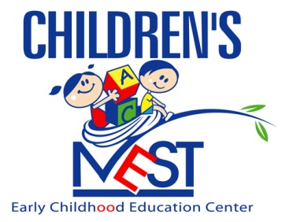

**“Nurturing Tomorrow’s Leaders”**

*Welcome to the new school year and “Let’s Dream it, Believe it,*

*And Achieve it!!!*