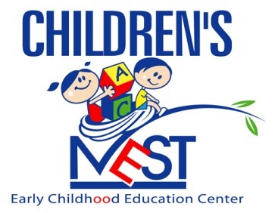
“Nurturing Tomorrow’s Leaders”

Holiday Schedule 2021-2022

2021
May 31st | Monday - Memorial Day - CLOSED
June 11th | TENTATIVE- Bridging over/Graduation (ALL Centers CLOSED)
July 5th | Monday – Independence Day Obsv. - CLOSED
August 27th | Friday – Staff Development Day - CLOSED
August 30th & 31st | Mon. & Tues.- Building Maintenance - CLOSED
September 1st | Wednesday- New School Year Begins!
September 6th | Monday – Labor Day - CLOSED
October 11th | Monday – COLUMBUS DAY - OPEN
November 2nd | Tuesday – ELECTION DAY - OPEN
November 11th | Thursday – VETERANS DAY - OPEN
November 24th | Wednesday – Early close @ 4:30pm
November 25th | Thursday- Thanksgiving – CLOSED
November 26th | Friday - CLOSED
December 24th | Friday – Christmas Eve - CLOSED
December 26th | Monday – Christmas Day Obsv. – CLOSED
December 31st | Friday– New Year’s Eve- CLOSED
2022
January 17th | Monday – MLK Day - OPEN
February 21st | Monday – Presidents Day - CLOSED
April 15th | Friday - Good Friday - CLOSED
May 30th | Monday - Memorial Day - CLOSED
June 10th | TENTATIVE- Bridging Over/Graduation (ALL Centers CLOSED)
July 4th | Monday – Independence Day - CLOSED

