Guarding Vision – How to Share a Device

- From the Main Users Phone open the Guarding Vision app.

- Click on the icon:

- Press “Share via QR Code”.
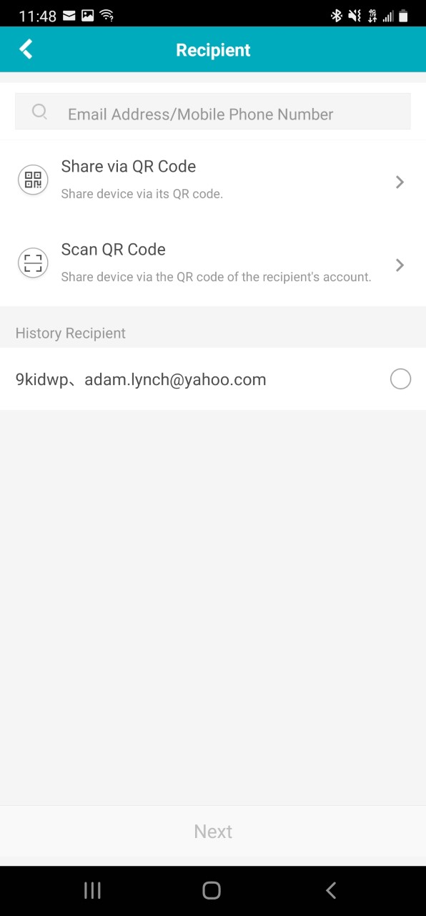

- Select “All Permissions” and then go to the Recipients Phone.
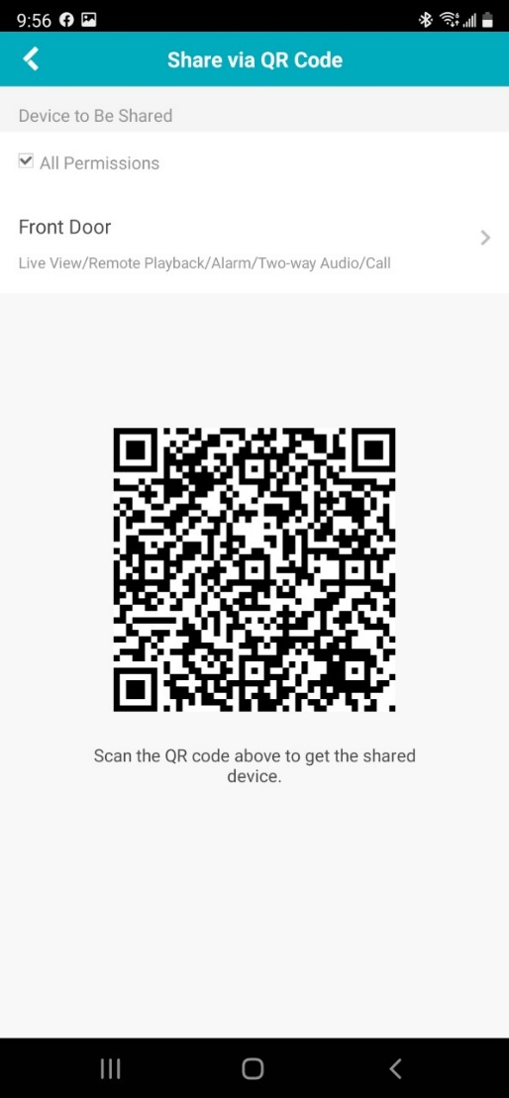

- From the Recipients Phone open Guarding Vision App
- Press Add Device.
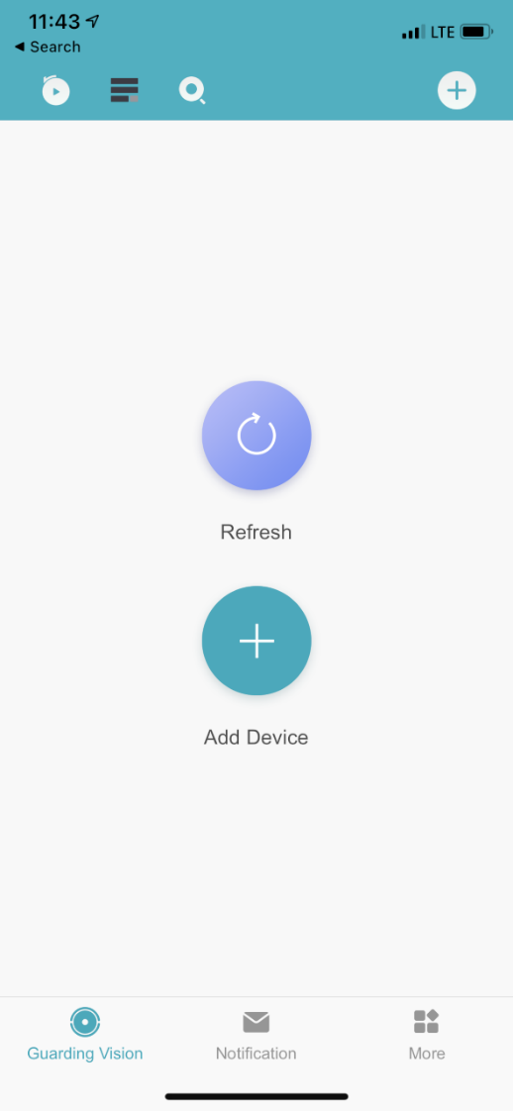

- Using the Camera Scan the QR Code from the Main Users Phone

- Press “Apply for Sharing”
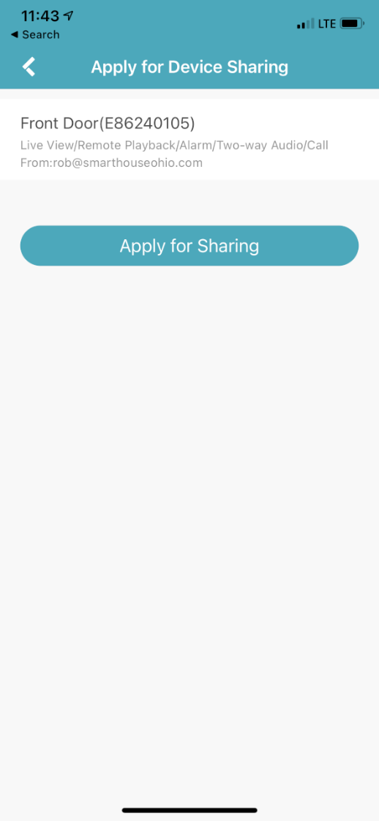

- From the Main Users Phone wait for a notification from Guarding Vision App that there is a new sharing request.
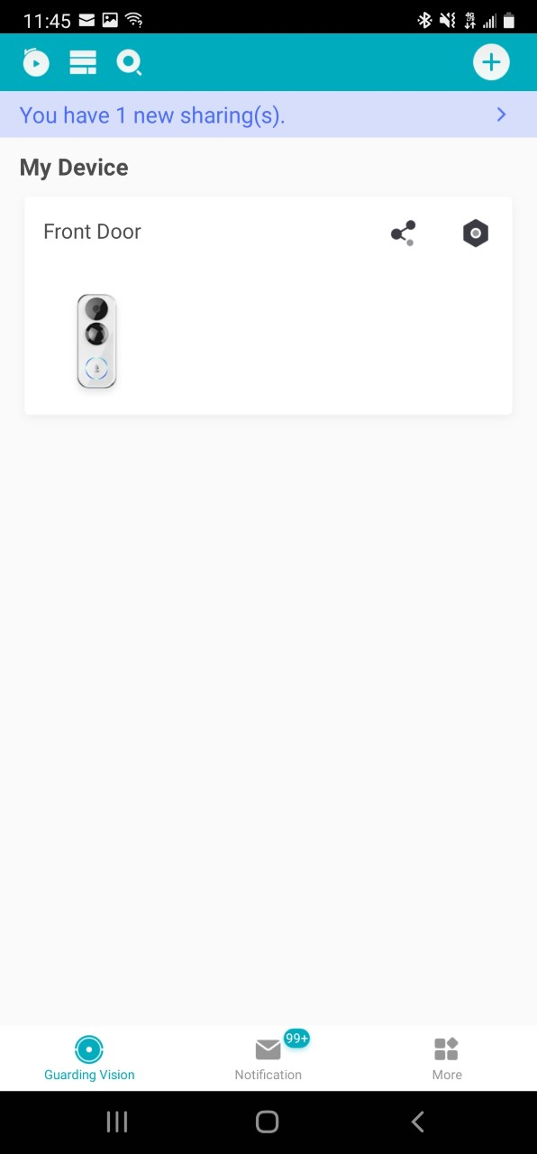

- Open the sharing request and press “Accept.”

