\Project: “Riding on a Cloud”
On July 10th, 2020 a classic Thunderbird Convertible
awaited outside of the Gosnell Memorial Hospice House in Scarborough.
The T-bird encapsulated the memory of Sharon,
a woman being transferred into hospice battling ALS.
Given very limited time left, all she wanted was the chance to sit in one again.
After connecting with the daughter, Candice knew she was up against time.
The goal...less than 24 hours!
“I contacted the Executive Committee of the York County Elder Abuse Task Force for their support.
Without hesitation they gave me the motivation to make this happen.”
With Kennebunk Police Elder Justice intern, Quinn, by her side they spent the day knocking on doors, visiting business after business, making phones calls, reaching out to friends and sending message after message.
“It was a rollercoaster ride” Candice said.
They say things happen for a reason.
“My last hope was Bentleys Saloon. I knew they had a classic car show.
I called, sent emails and crossed my fingers.” Candice said.
“After dinner I received a call from an unusual number. It was Lisa from Bentleys!! She told me that as luck would have it, Bentley himself owned a vehicle much like we had been searching for.
Even better, she said that he would be happy to help us make this happen!”
Candice said that she was thrilled but didn’t want to get too excited.
She called the daughter to tell her.
To all of their surprise, Bentley and the family were childhood neighbors! What a connection!
On the morning of Friday, June 10, Candice and Quinn paced the grounds of Gosnell Hospice
hoping and waiting to see their hard work come to fruition.
…
At about 11:00am the hum of the T-bird’s engine was heard as is entered the parking lot!
It is safe to say that both Quinn and Candice felt butterflies at that moment.
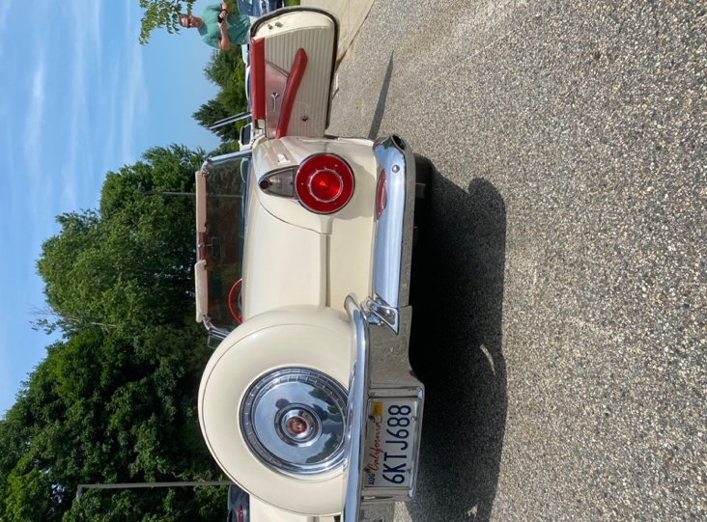
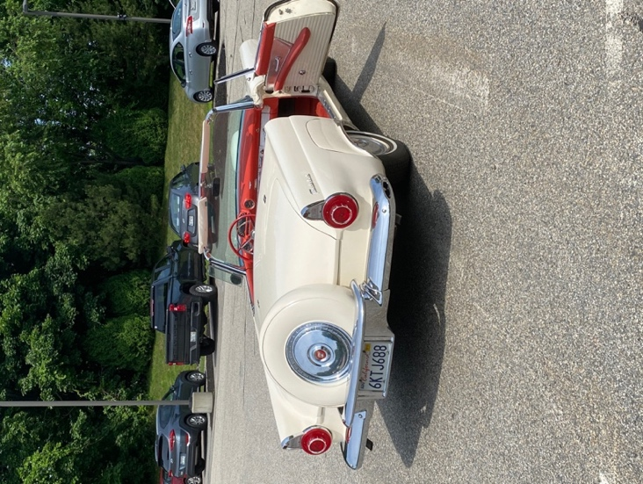
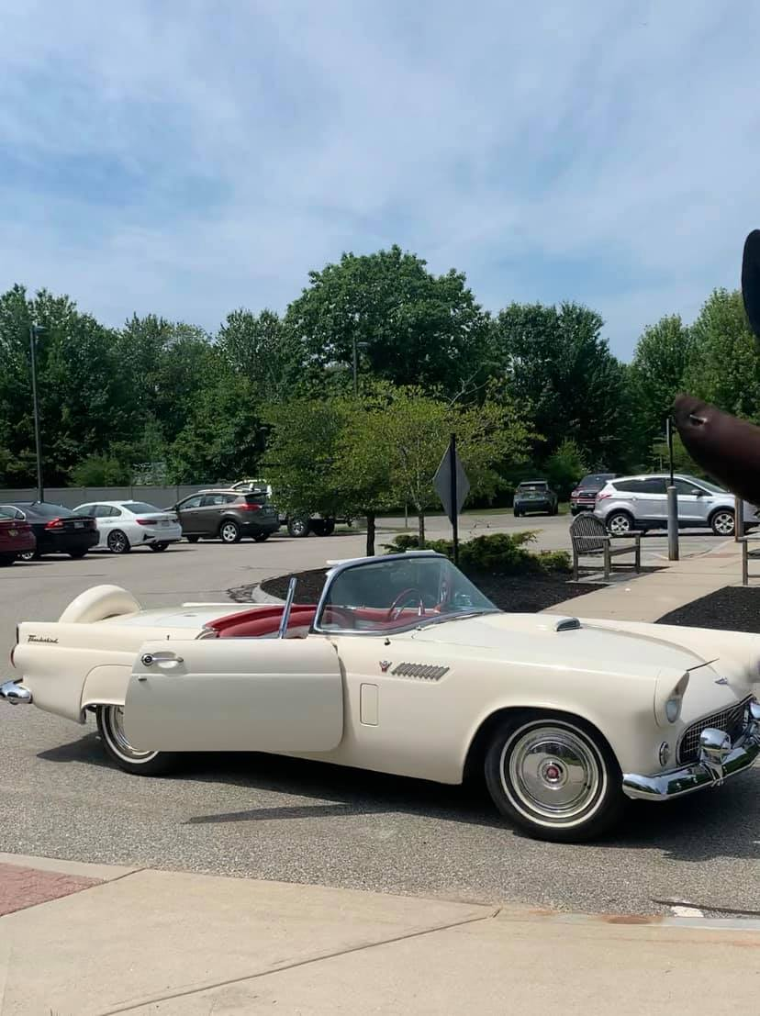
It was moments later that Sharon’s Chariot awaited her arrival at the Gosnell Memorial Hospice House.
Sharon was escorted out into the beautiful morning,
her face lit up as soon as she saw her dream car!
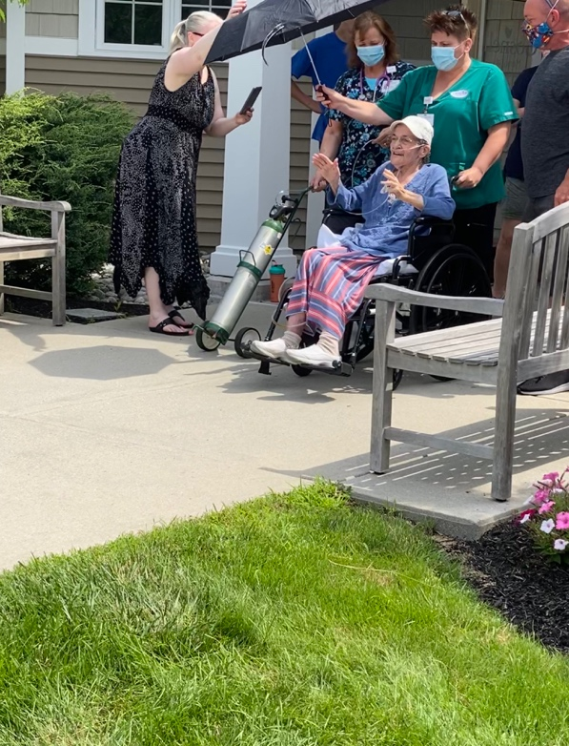
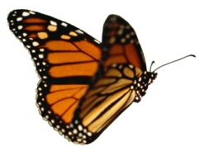
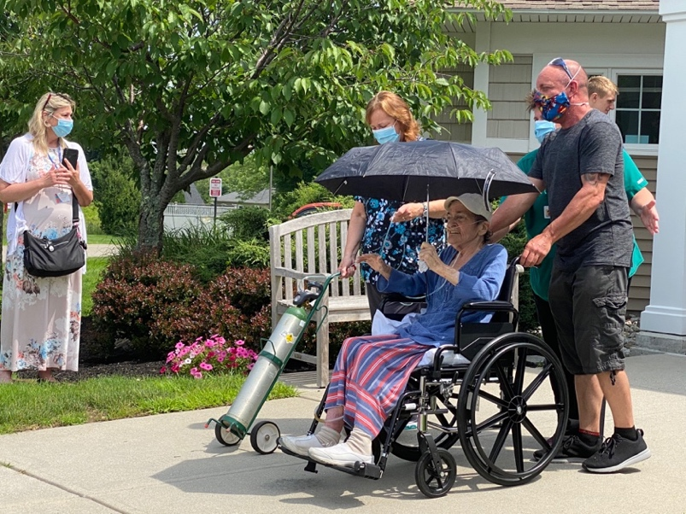
Assisted by the Gosnell Hospice staff and surrounded by her family,
Sharon was brought to the car she had waited to see!
She made sure to dress herself up to look wonderful for this spectacular moment!
This was her moment!
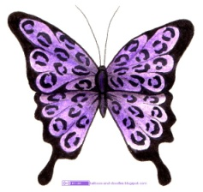
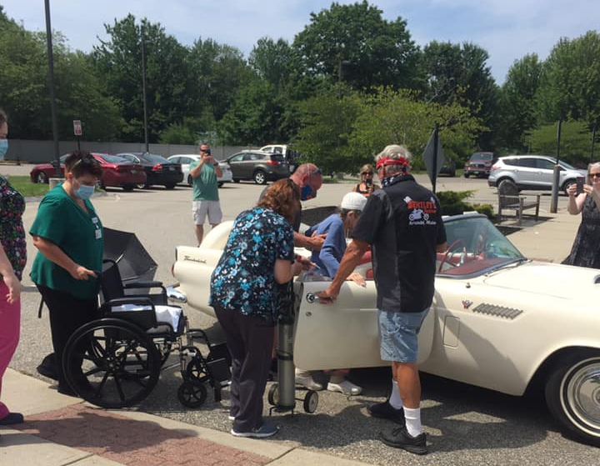
Helped inside the car by staff and friends, there wasn’t a dry eye.
With her son, Scott by her side, she was living in a dream she has had for a while.

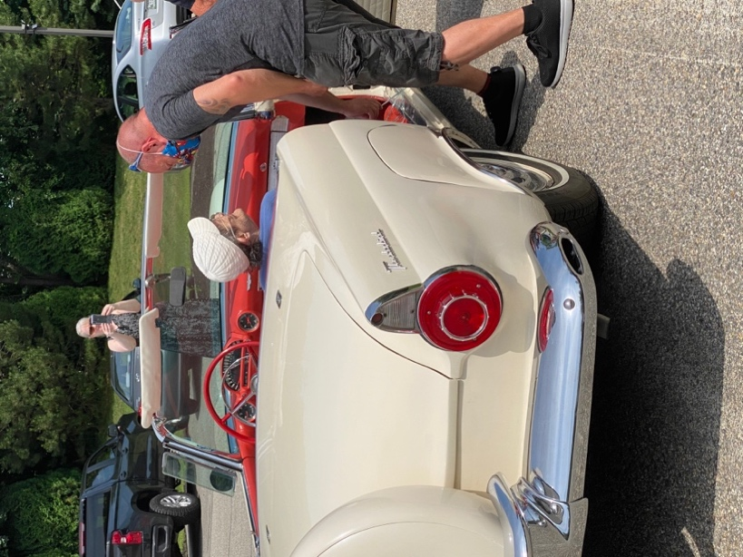
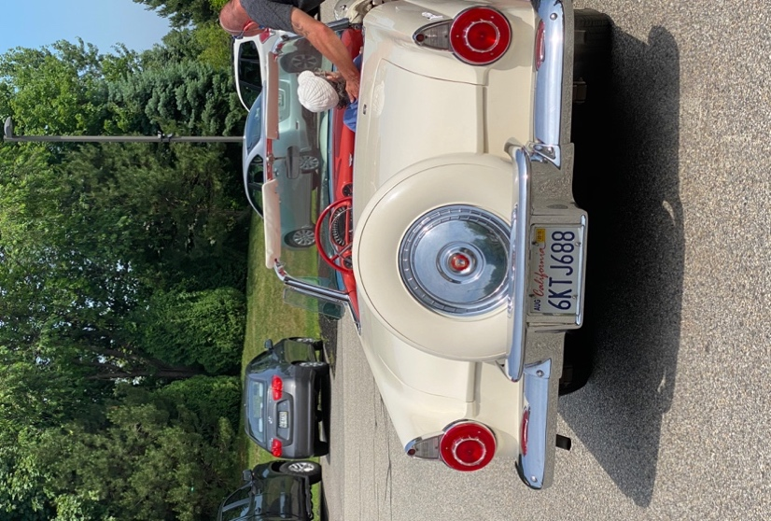
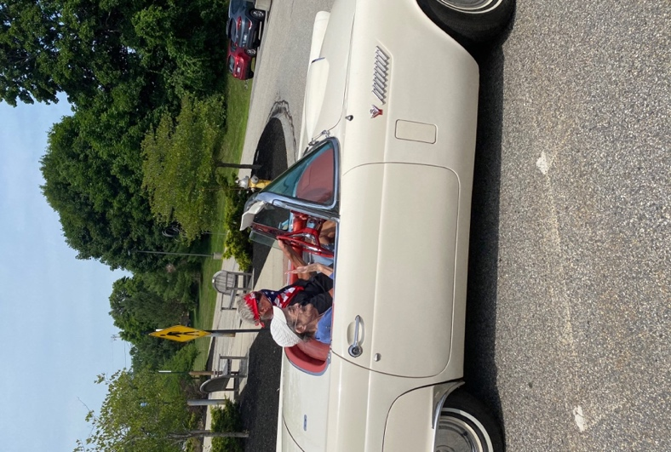

Off and away she went, driven by Bentley Warren himself…
on a beautiful stroll through the neighborhood!
As she left, she made sure to wave in all her glory to her friends and family around her.
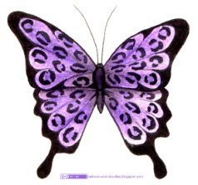
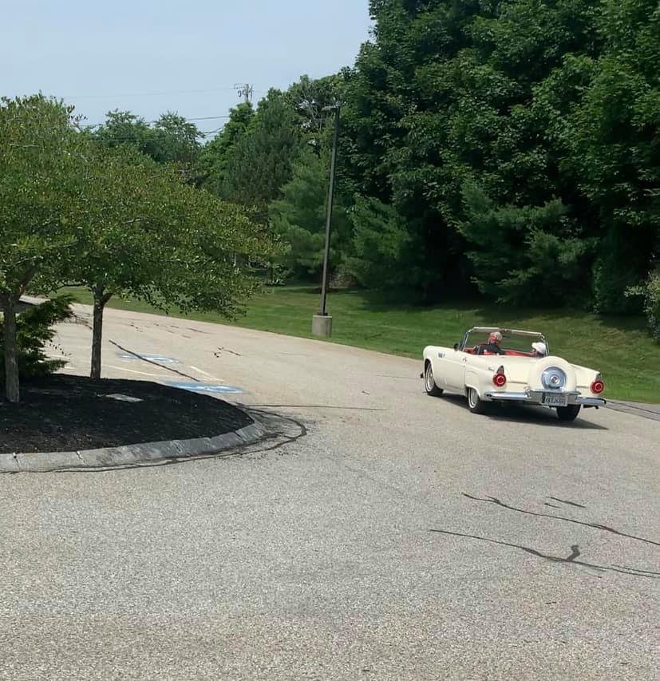
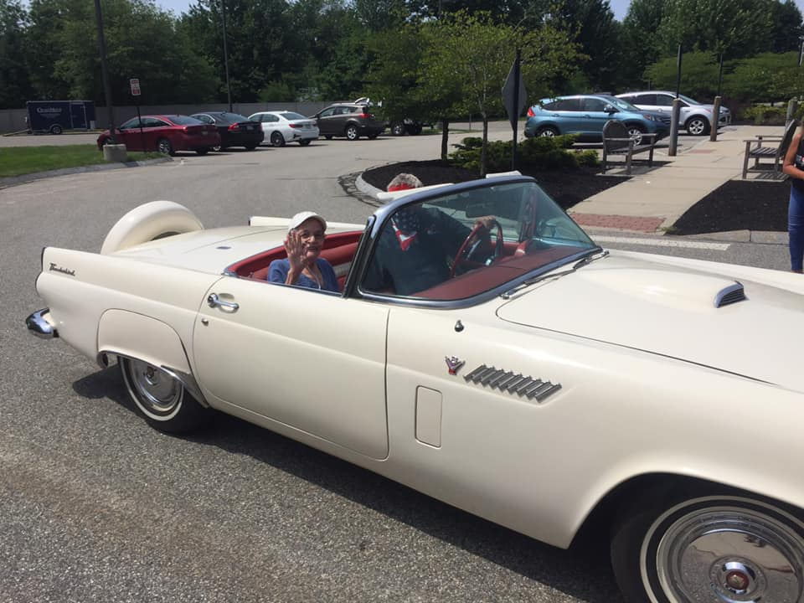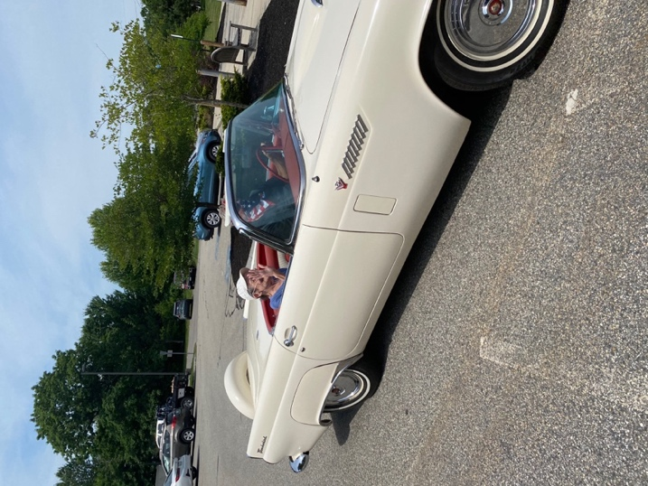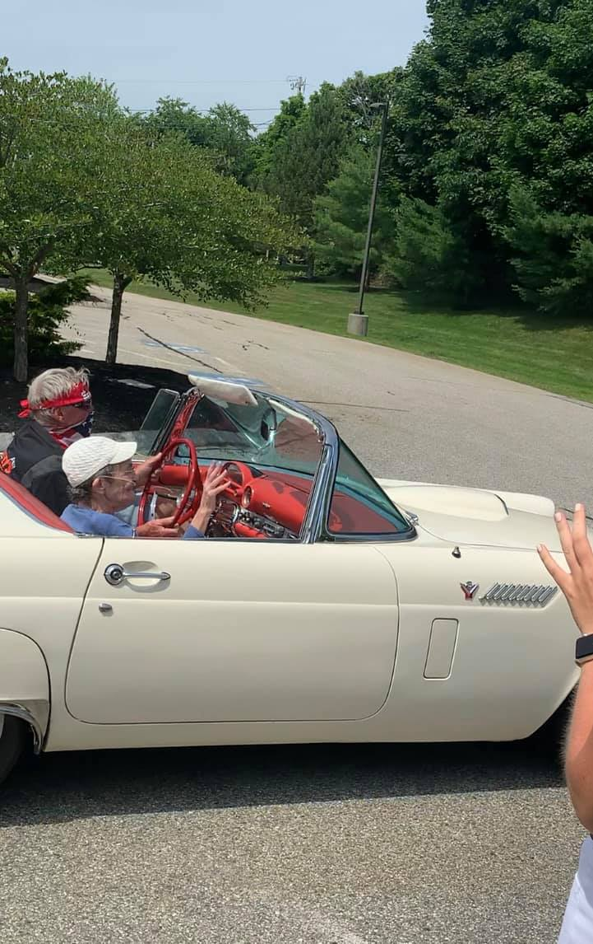

Coming back in from quite the ride, Sharon waved to everyone again!
You could hear Bentley tooting the horn and her crowd cheering her back
as they rounded the corner of the entrance.
Everyone was greeted by a beautiful smile on her face…
one of her dreams had come true!
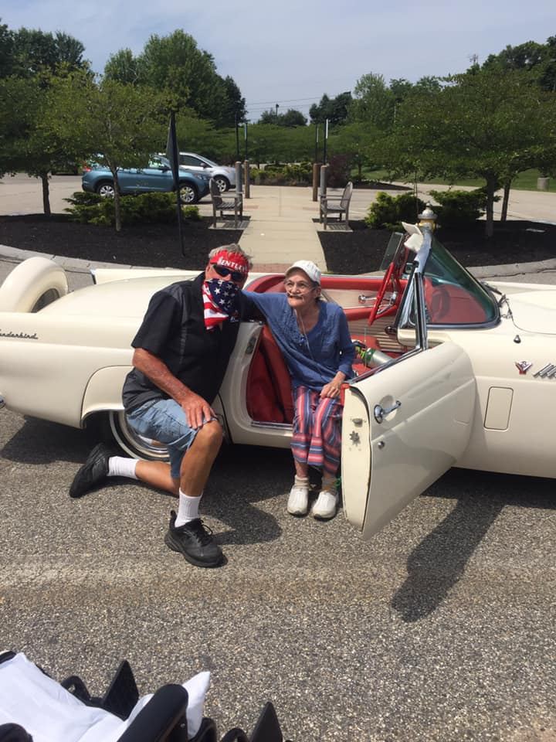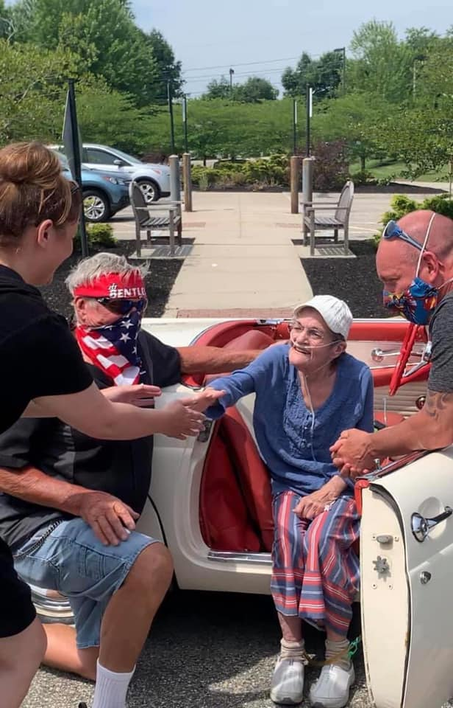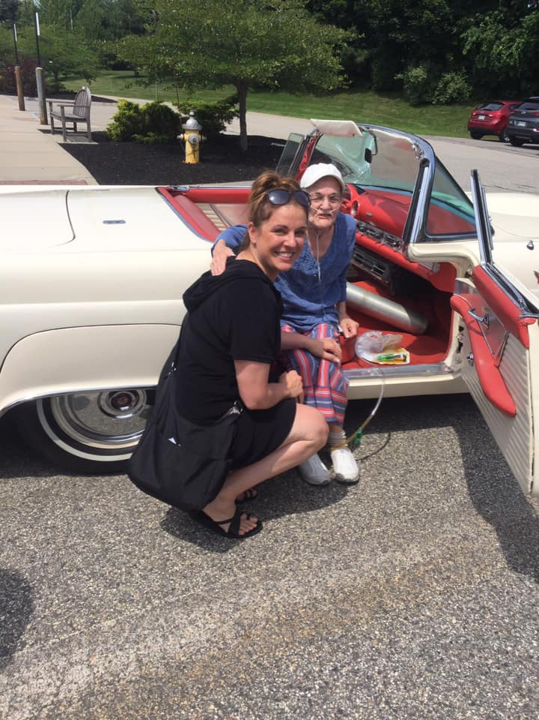
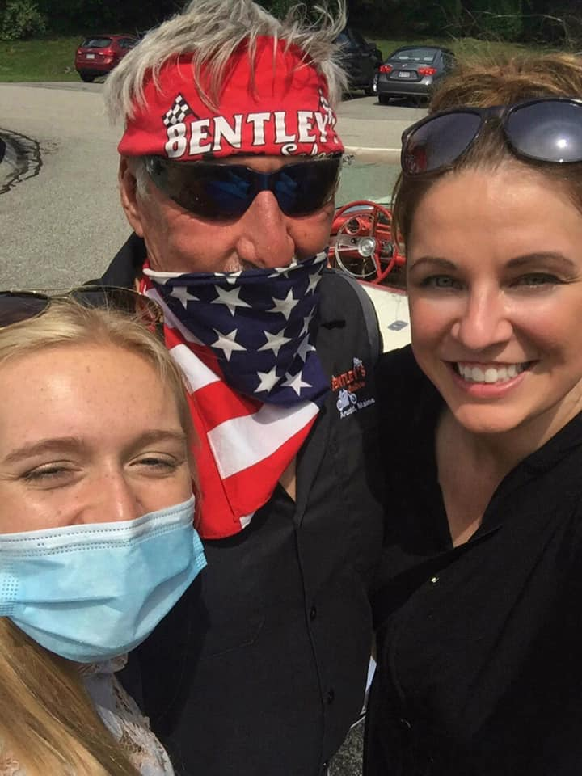
Quinn, Bentley and Candice
“The Wish Team”
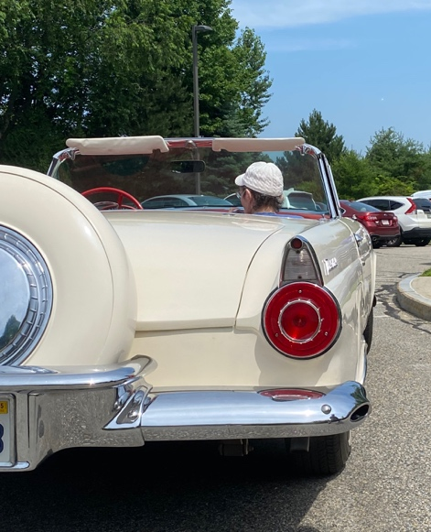

“Oh wow! It felt like I was like riding on a cloud,” Sharon recounts in a soft tired voice.
“Thank you and thank you for my beautiful flowers. Thank you all.”
No one involved will ever forget July 10th, 2020
when we watched Sharon’s last wish finally came true!
Rest in Peace, Sharon.
October 24, 1946 - July 15, 2020
We were so honored…
to have the chance to honor you.

