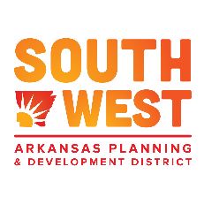
Southwest Arkansas One-Stop Committee
AGENDA

April 22, 2021
Committee Meeting – Conference Call
101 Harvey Couch Blvd
Magnolia, AR 71753
2:00 p.m.

Call to Order

Roll Call and Welcome

Selection/Appointment of Chairperson

Discussion of Goals
- One-Stop Operator Contract Renewal
- Review proven and promising strategies and initiatives for meeting the needs of employers, workers, and jobseekers (including individuals with barriers to employment) in the local workforce development system
- Best practices for monitoring continuous improvement within the workforce development system
- Best practices for establishing and maintaining the One-Stop Certification System

Set a date for the next Committee Meeting

Adjourn

