|  |  |  |  |
| --- | --- | --- | --- |
| **THE 5M5**  **INFORMER** | P3C2T1#yIS1 | P4C3T1#yIS1 | P5C4T1#yIS1 |

***April 2025 Make Your Mark!***

|  |
| --- |
| **IN THIS ISSUE** |
| Welcome New Members |
| Calendar of Events |
| Can Do Canines |
| DG Governor |
| DG-1st Vice |
| DG-2nd Vice |
| Diabetes |
| District Information |
| Event Flyers |
| GET-Global Extension Team |
| GLT-Global Leadership Team |
| GMT-Global Membership Team |
| GST-Global Service Team |
| KidSight |
| **LCI Marketing-New Members** |
| LCIF |
| Leader Dogs |
| LEO’s |
| Lion Story (Video Series) |
| Lions International Trading Pin Club |
| Lions Serving |
| MD5M Conv. Invite |
| MD5M Conv. Keynote Speaker |
| MD5M Conv. Schedule |
| MD5M Conv. Table Sponsorship |
| MD5M News |
| Special Olympics |
| Terms & Abbreviations |
| Vision |
| Web Sites & Links |
| Youth Exchange & Youth Camps |
| Zone Chairs |
|  |

|  |
| --- |
| ***Congratulations to***  ***St. Louis Park Lions celebrate 83 Years!!***  *(April 28, 1942)*  ***Eden Prairie Lioness’ celebrate 24 years!***  *(April 1, 2001)* |

**Let’s Keep PUMPING UP THE 5M-5 PRIDE!**

**STATS** (As Of 03/24/2025)

Total Clubs: 37

**District 5M5 Membership: 1,351**

Net Gain/Loss: +12

Membership update Added: 99

Membership update Dropped: -87

|  |
| --- |
| **WELCOME NEW MEMBERS!!!** |

**🎉 Way to go Lions and Clubs – We are GROWING! 🚀**

Thank you for all your dedication and commitment to strengthening our Clubs, our District, and Lions International. Your hard work is paying off, and our increasing membership means we can achieve even more together.

New Members = More Service!!

|  |  |  |
| --- | --- | --- |
| **New Member** | **Sponsor** | **Club** |
| Hollie Knutson | John Knutson | Dayton Lions Club |
| Jeff Daiker | Steve Zukowski | Maple Grove Lions Club |
| Nimrata Sandhu | Nell Campbell | Maple Grove Lions Club |
| Tim Doran | Phil Leith | Maple Grove Lions Club |
| Christine Friday | Kathi Hemken | New Hope Lions Club |
| Eric Hanson | Andrew Geier | New Hope Lions Club |
| Julia Bethke | Cindy Pennoyer | New Hope Lions Club |
| Robert Kruse | Michael Schon | New Hope Lions Club |
| Annelisse McIntosh | Ian McIntosh | Robbinsdale Lions Club |
| John Richard | Eric Hillman | Robbinsdale Lions Club |
| Kelly McDyre | Amy Sutton | Robbinsdale Lions Club |
| Lindsay Daniels | John Zieba | Robbinsdale Lions Club |
| *Congratulations! You’re now a part of the world’s largest humanitarian service organization.*  *This means that you’ve joined a global community of kind-hearted, service-minded people, dedicated to making a positive impact.*  *We couldn’t be happier to have you as a Lion!*  [*Click here for more information from Lions Club International*](https://www.lionsclubs.org/en/resources-for-members/new-members) | | |

**If you have been sharing the Lions opportunity with others and have recruited a New Lion in the past 6 months, make sure to attend our next All Club Meeting on April 7th, we have your PUMP UP THE PRIDE Pins and we cannot wait to Congratulate you in person and meet your New Member!!!!**

|  |
| --- |
| **CALENDAR OF UPCOMING EVENTS** |
| *If the Date (Month, Day) is blue and underlined, that is a link to more info, a flyer, an email, or a website.*  *If the Date (Month, Day) is black and not underlined, there is no link or further information at this time.* |
| [*Submit article*](mailto:lionsdistrict5m5@gmail.com)*s, news, photo for the next issue by the 25th*  To this email: [lionsdistrict5m5@gmail.com](mailto:lionsdistrict5m5@gmail.com) |

|  |  |  |
| --- | --- | --- |
| **APRIL 2025** | | |
| 04/01/2025 | Brooklyn Center Lions 70th Anniversary | | |
| 04/06/2025 | New Hope Lions Pancake Breakfast & Silent Auction | | |
| 04/07/2025 | All Club Meeting (RSVP by March 30) | | |
| 04/09/2025 | Crystal Lions Steak Fry | | |
| 04/10/2025 | Feed My Starving Children | | |
| 04/10/2025 | Circus Volunteers-Earn Money for YOUR club | | |
| 04/13/2025 | Osseo Lions Pancake All You Can Eat Pancakes | | |
| 04/23-24-25-2025 | Brooklyn Park Lions Smelt Fry | | |
| 04/25/2025 | MD5M Convention | | |
| 04/26/2025 | MD5M Convention-Invitation | | |
| 04/26/2025 | MD5M Convention-Keynote Speaker | | |
| 04/26/2025 | MD5M Convention-Schedule | | |
| 04/26/2025 | MD5M Convention-Table Sponsorship | | |
| 04/26/2025 | Minneapolis NE Lions Bowling for Charity | | |
| 04/27/2025 | Eden Prairie Pancake Breakfast | | |
| **MAY 2025** | | | |
| 05/02/2025 | Maple Grove Lions-Taco Dinner for Childhood Cancer | | |
| 05/05/2025 | Officer Training for Incoming Club Officers | | |
| 05/10/2025 | Maple Grove-Half Marathon | | |
| 05/12/2025 | Brews & Bingo, A Lions Club Social | | |
| 05/14/2025 | Maple Grove Lions – Legos at the Lookout | | |
| 05/14/2025 | Crystal Lions Steak Fry | | |
| **JUNE 2025** | | | |
| 06/11/2025 | Crystal Lions Steak Fry | | |
| **JULY 2025** | | | |
| 07/10/2025 | | Hamel Rodeo-MN Lions Childhood Cancer Night (7:30 PM) | |
| 07/11/2025 | | Hamel Rodeo (7:30 PM) | |
| 07/12/2025 | | Hamel Rodeo (1:00 PM and 7:30 PM) | |
| 07/13/2025 | | Hamel Rodeo (7:30 PM) | |
| 07/13/2025 | | LCI Convention, Orlando | |
| 09/13/2025 | | Maple Grove-Rock n Grove-Hairball | |

|  |  |  |
| --- | --- | --- |
| P308C1T9#yIS1 | **DISTRICT GOVERNOR**  Lion Kim Schommer | **P311C3T9#yIS1** |

Hello Lions

Spring has sprung!  I hope everyone is doing well and is enjoying the first signs of Spring!   Spring is a very busy time of year in our district as well.

I am enjoying my year as you DG and enjoy visiting the Lions of 5M5.   I have either visited or scheduled visits with most of the clubs in our district.  There are a few clubs that have not contacted me or responded to my attempts to reach them.  If your club has not net scheduled a visit, please do so as soon as possible as my calendar fills up quickly. In March i visited Eden Prairie, New Hope, Crystal, Minneapolis Northside Roaring, and Hamel.  I also attended Lions Day at the Capital, the 3rd Council of Governors meeting and the LCIF Go for the Gold Gala which raised funds for Lions Club International Foundation. We also held our last cabinet meeting for the 2024 -2025 Lions year.  I want to thank each of the Lions who served on the cabinet this year.  I appreciate your service in helping to lead our district.

There is a lot going on in 5M5 and the multiple in the next few months, be sure to review the upcoming events in this issue of the informer. A few upcoming events include: The Brooklyn Center Lions are celebrating their 70th Anniversary on April 1st, Several clubs have pancake breakfasts this month, the Bloomington Lions still are looking for volunteers for the Royal Canadian Circus which is April 10 -20 at the Mall of America, several clubs are planning environmental service projects and roadside clean ups and there are many projects be planned as well.

Please remember that you should be in the process of nominating and electing club officers for next year. Please be sure to log your officers in the portal as soon as possible after elections.

I hope to see many of you at the All-Club meeting on April 7th and at the MD5M convention at the Bloomington Airport Hilton, April 25- 27.

Thank you for serving your communities - you make a difference to many!

Yours in Lionism

Lion Kim Schommer

District Governor

|  |  |  |
| --- | --- | --- |
| P333C1T10#yIS1 | **1st VICE DISTRICT GOVERNOR**  Lion Sara McFee | P337C3T10#yIS1 |

***Lead to Serve. Serve to Lead.***

***What is District 5M-5’s future?***

Our future is the same as 5M-5’s past.

**Service.**

Our District is about Service. It is about caring about and for our communities and our world.

We care about makiing a positive impact – changing our world for the better. We want to help as soon as we see a need, as soon as a disaster takes place. We bring hope and healing. We change lives.

While our mission of the past, is the same for our future, we have changed throughout our decades of service.

We’ve welcomed men, women and youth to serve together. We’ve found new ways of performing service. We’ve identified new service to provide. We’ve welcomed new ideas.

Look around our District this month. We’ll be performing environmental projects, collecting to feed those who hunger, screening for vision, diabetes and hearing conditions, supporting families experiencing cancer, providing funding for humanitarian needs, encouraging our youth to make a difference through their service,

We are making our mark. You have the opportunity to expand the mark we make. Invite others – family members, friends, colleagues – to join you and your club in service.

I’m challenging each of our clubs to welcome at least one new member during April. Just think how we can expand our service impact by simply adding **1** new member to each club this month!

***Thank you – for everything you do to improve our world.***

Lion Sara

Sara McFee

5M-5 District Governor-Elect

5M-5 Co-Trustee, Minnesota Lions Diabetes Foundation

Minneapolis Ambassadors Lions Club

[LionSaraMcFee@gmail.com](mailto:LionSaraMcFee@gmail.com)

|  |  |  |
| --- | --- | --- |
|  | **2nd VICE DISTRICT GOVERNOR**  Lion Bruce Strachota |  |

Since the last Cabinet meeting I have been working with my fellow 2nd VDGs to

pick out the ties and scarves for the 2026-2027 Lions year.

We also have worked on creating the official pins for our time as DGs.

I have been attending zoom meetings with GLT, GMT, 2026 Multiple Convention committee as well as zoom meetings and in person meetings with members of the Multiple and Constitutional Area C.

I am eager to do more club visits so I can see what great projects our clubs are involved in.

Yours in Lionism,

2nd VDG Bruce Strachota

C:\Users\Owner\AppData\Local\Microsoft\Windows\Temporary Internet Files\Content.IE5\QMJYXRX8\MC900438095[1].wmf

|  |
| --- |
| **GLOBAL EXTENTION TEAM (GET)** |

The Global Extension Team (GET) has been working very hard on starting a new club within District 5M5 this Lions year. We are looking to develop traditional, specialty, virtual and campus-based Lions clubs.

* We have been researching communities within District 5M5 do not have a Lions Club so that we can plant a seed for a club.
* We currently have a solid 8 future Lions committed to sign up for a new downtown Minneapolis club. One is willing to serve as treasurer. Seven want to serve as Lions but do not have time to be club officers.
* We are actively working on starting a new club Minnetonka. (Currently there are no clubs in Minnetonka.). Two people are interested in putting boots to the ground and doing some door-to-door efforts to connecting with potential Lions members.
* We are still working on specialty clubs with two potential clubs.
* As of March 24, we have 2 new clubs in the multiple our goal is 13 by the end of the Lion year.
* A Zoom presentation will be held Wednesday, April 30th 7pm to share information about the “Join Together” partnership approach with 501c3 or 501c4 non-profit or corporate organizations to start new clubs with as few as 15 members.
* Join our 5M-5 GET team. We are seeking Lions to join our team to help us to continue to start new clubs in our District.

Connect with me about our GET team.

Lion Michael Crenshaw

5M-5 Global Extension Team Coordinator

[bplionmichael@gmail.com](mailto:bplionmichael@gmail.com)

|  |
| --- |
| **GLOBAL LEADERSHIP TEAM (GLT)** |

**This month’s Did You Know column focuses on Officer Elections!**

+**Did you know it is time to:**

* Recruit officers and share officer position descriptions with club members.
* Plan and hold a meaningful Club election.

**Elections can be done in different ways!**

* In-person balloting (voting with paper) and free online options such as
* SurveyMonkey.com.
* Nominate and elect club officers for the 2025 - 2026 Lion Year.
* Invite incoming officers and any Lion interested in future officer positions to District

**5M5’s Club Officer Training on May 5 at Can Do Canines! *(See flyer in Informer.)***

* Celebrate and mentor club officers into new club officer roles.
* Assign a mentor for each officer and attend 5M5 Club Officer training May 5
* List officers for upcoming Lion Year in Lion Portal by May 1
* Go to **My Club**
* in the **Member Actions** section on right select blue-colored **Manage Club Officers** tab
* select **Create New Assignment**
* select **Upcoming Lion Year**
* select **Officer**
* select **Official**
* select **Member Name**

|  |  |
| --- | --- |
| **P443C1T13#yIS1** | **GLOBAL MEMBERSHIP TEAM (GMT)** |

🎉 Big cheers for our unstoppable 5M-5 Lions and Clubs – we are on the rise! 🚀  
Your incredible dedication and commitment are turning ambitions into achievements. With our growing membership, we’re unlocking even more ways to make a difference together. More Members = More Service!

🌟 Let’s Celebrate New Lions! 🌟  
Have you been spreading the Lions magic and welcomed a new member to the pride in the past 6 months? Mark your calendar for the All Club Meeting on April 7th! We’ll have your PUMP UP THE PRIDE Pins ready and waiting to celebrate YOU and your newest addition to the pride. Can’t wait to see all the fantastic faces of our growing community! 🦁✨

📊 District Membership Stats (As of 03/24/2025): Total Clubs: 37  
* District 5M-5 Membership: 1,351  
* Net Gain: +12      * Members Added: 99      * Members Dropped: 87

**🎶 Brews & Bingo – Mark Your Calendars! 🍻**Get ready for a night of friendship, fun, and a little friendly competition with your fellow Lions!  
📅 Date: May 12, 2025  
⏰ Time: 4:00–7:00 PM (Bingo starts at 5 PM)  
🍻 Location: Wicked Wort Brewing Company, 4165 W. Broadway, Robbinsdale 55422  
Happy Hour specials run from 4–6 PM, so arrive early and let’s turn up the energy. Don’t forget to bring your Lion spirit! 🎉🎯

📣 Let’s Keep PUMPING UP THE PRIDE!  
The District 5M-5 Global Membership Team is here to help you and your Club soar to new heights. If you’re passionate about growing ideas, nurturing leaders, and amplifying service to others, let’s connect and make it happen together!

💡 Plus… We’re on the lookout for Lions and Membership Directors ready to join the super cool Global Membership Team. Reach out and let’s roar into action! 🌟

Yours in Lionism,

Your Global Membership Team,

Lion Judy Rue Lion Hannah Maxwell Lion Shari Thurston

Lion Denise Dietz GET Chair Michael Crenshaw PDG Kristine Morin

PDG Dick Kentzelman PDG Jennifer Marshall DG Kim Schommer

DGE Sara McFee 1st DGE Bruce Strachota

GMT Chair Lion Heidi Zaworski   
[LionHeidiZaworski@Gmail.com](mailto:LionHeidiZaworski@Gmail.com) 612.408.0242

https://lions5m5.org/gmt-global-membership

|  |  |  |  |  |  |  |  |  |  |  |  |  |  |  |  |  |
| --- | --- | --- | --- | --- | --- | --- | --- | --- | --- | --- | --- | --- | --- | --- | --- | --- |
| **GLOBAL SERVICE TEAM (GST)**   |  |  |  |  |  |  |  |  | | --- | --- | --- | --- | --- | --- | --- | --- | | ***WE SERVE IN UNITY*** | | | | | | | | | **P460C1T14#yIS1**  **Childhood**  **Cancer** | **P463C1T14#yIS1**  **Diabetes** | **P465C1T14#yIS1**  **Disaster** | **P467C1T14#yIS1**  **Environment** | **P469C1T14#yIS1**  **Humanitarian** | **P471C1T14#yIS1**  **Hunger** | **P473C1T14#yIS1**  **Vivion** | **P475C1T14#yIS1**  **Youth** | |

**Global Service Team**

April is time to freshen up outside after our long winter and so we are promoting Spring Clean Up. Help clean up your community by doing an Environmenal Service Project !!!!!!!

|  |
| --- |
| **ZONE CHAIRS** |

|  |  |  |
| --- | --- | --- |
| **ZONE 1 CHAIR** (terms ends 2027) |  | **ZONE 2 CHAIR** (terms ends 2027) |
| [***Laurie Carlson***](mailto:lauriecarlson@yahoo.com) |  | [***Regina Aiken (Gary)***](mailto:raiken@tonkafinancial.com) |
| Corcoran Lions |  | Eden Prairie Lions |
| Dayton Lions |  | Eden Prairie Lioness Lions |
| Hamel Lions |  | Hopkins |
| Loretto Lions |  | Northwest Tonka Lions |
| Mpls. Can Do Canines |  | Orono Lions |
| St. Louis Park Lions |  | Saint Bonifacius Lions |
| Wayzata Lions |  |  |
|  |  |  |
| **ZONE 3 CHAIR** (terms ends 2027) |  | |  | | --- | | **ZONE 4 CHAIR** (terms ends 2025 | |
| [***Amber Georgeson***](mailto:georgeson.amber@gmail.com) |  | ***Heidi Zaworski (Marty)*** |
| Camden Lions |  | Bloomington Lions |
| Crystal Lions |  | Minneapolis Northeast Lions |
| Edina Lions |  | Minneapolis Riverview Lions |
| Minneapolis Ambassadors Lions |  | Minneapolis Southwest Lions |
| Minneapolis Downtown Next Generation Lions |  | Minneapolis Special Olympics Minnesota Lions |
| Minneapolis Northside Roaring Lions |  | Richfield Lions |
|  |  |  |
| **ZONE 5 CHAIR** (terms ends 2025) |  | **ZONE 6 CHAIR** (terms ends 2026) |
| [***Judy Rue (Chuck)***](mailto:judyrue@icloud.com) |  | [***Vickie Parks***](mailto:vickiemparks@gmail.com) |
| Excelsior Lions |  | Brooklyn Center Lady Lions |
| Hopkins Noontime Lions |  | Brooklyn Center Lions |
| New Hope Lions |  | Brooklyn Park Lady Lions |
| Osseo Lions |  | Brooklyn Park Lions |
| Plymouth Lions |  | Maple Grove Lions |
| Robbinsdale Lions |  | Rogers Lions |

|  |  |
| --- | --- |
| **5M5 DISTRICT INFORMATION** | |
| P630C2T17#yIS1P630C2T17#yIS2 | P631C3T17#yIS1 |

|  |  |
| --- | --- |
| P634C1T18#y1 | 0B1B[Calendar of Events and Activities](https://lions5m5.org/calendar) - District 5M5’s calendar is your key source for information on what is happening at the club, District, Multiple, and International levels. The 5M5's District website calendar is updated throughout the month at [Lions5M5.org](https://lions5m5.org/) |
| P637C3T18#y1 | 1B2B[5M5 District Website Update](https://lions5m5.org/) - 5M5's website has a fresh look! Check out the website for information, resources, and calendar. Click on the above title to learn more. |
| P640C5T18#y1 | 3B**New Facebook page -** we have a new page. It’s: **Lions Service – District 5M5**  Check it out and “Follow” it! Here is the link to the page:  <https://www.facebook.com/profile.php?id=61570887245952> |
| P645C7T18#y1 | 2B4B**Lions License Plates for your cars -** After January 1, 2024, you will be able to purchase special Lions plates for your vehicles! Minnesota lawmakers approved a Lions Club special plate for use on passenger automobiles, non-commercial one-ton pickup trucks, motorcycles, and recreational vehicles. Ask to purchase the Lions plates at a Minnesota Driver and Vehicles office. The plate includes the Lions logo. |
| 3B5B**LCI’s Eight Global Causes**   While LCI’s website is still being updated, it is true that Lions Clubs International’s Eight Global Causes now include Childhood Cancer, Diabetes, Disaster Relief, Environment, Humanitarian, Hunger, Vision, and Youth. This is great info to share with your club, potential members, and your community! | |
| 4B6B**2029 Lions International Convention in Minneapolis** Volunteers will be needed before and after the Lions International’s annual convention in Minneapolis. From planning to hosting to help with airport arrivals and departures, there will be opportunities to welcome and connect with Lions from around the world. Watch for updates. (The last Lions International convention was in Minneapolis in 2009.) | |

|  |  |
| --- | --- |
| **MULTIPLE DISTRICT 5M NEWS-** | **P660C2T19#yIS1** |

**Lions Clubs International – Club Marketing Teams matter!**

Club marketing is so important to what we do as Lions. There are great opportunities for Lions to get involved in the planning and execution of their club’s promotion of activities and projects. There are even opportunities at the district and multiple district (MD) level for Lions ready to take on a bigger marketing role. Here is how you can put your passion for promotion to work.

Be a marketing champion in your club. Consider becoming a member of your club marketing team. Your team should have a chairperson and other members to cover the various methods of club marketing. These methods include Facebook/Social Media, Newsletters/Print, and Website. Help build a marketing culture within your club membership. Proudly wear your Lion gear when you serve and remember that you are a brand ambassador for your club and Lions everywhere.

For those inclined to take a more active role in promoting their Lions club, why not become the Club marketing chairperson? Energize and lead your club marketing efforts. Develop marketing plans for projects and membership drives, use social media to share your stories, and work with your Lions and community partners to put a spotlight on your service.

If your club currently does not have a marketing team, you are missing opportunities to promote your club events and activities in your community. This also means you are not reaching out to potential event participants as well as potential new members and community partners. Do not let other local volunteer organizations get the attention your Lions club needs and deserves in your community.

Please devote the time your Lions club needs to establish a club marketing team. With your club currently setting up its board of directors and chairpersons for next year, this would be the perfect time to establish a marketing team. This team, along with the new club leadership, can develop a marketing plan for engaging your community. To learn more about club marketing and the tools available to you, please visit the link below:

<https://www.lionsclubs.org/en/resources-for-members/resource-center/club-marketing>

Lion Lyle Goff MD5M Marketing & Lions Information Chair [gofflt@msn.com](mailto:gofflt@msn.com)

|  |  |
| --- | --- |
| **MULTIPLE DISTRICT 5M CONVENTION NEWS-**  **Invitation Letter** | **P665C2T20#yIS1** |

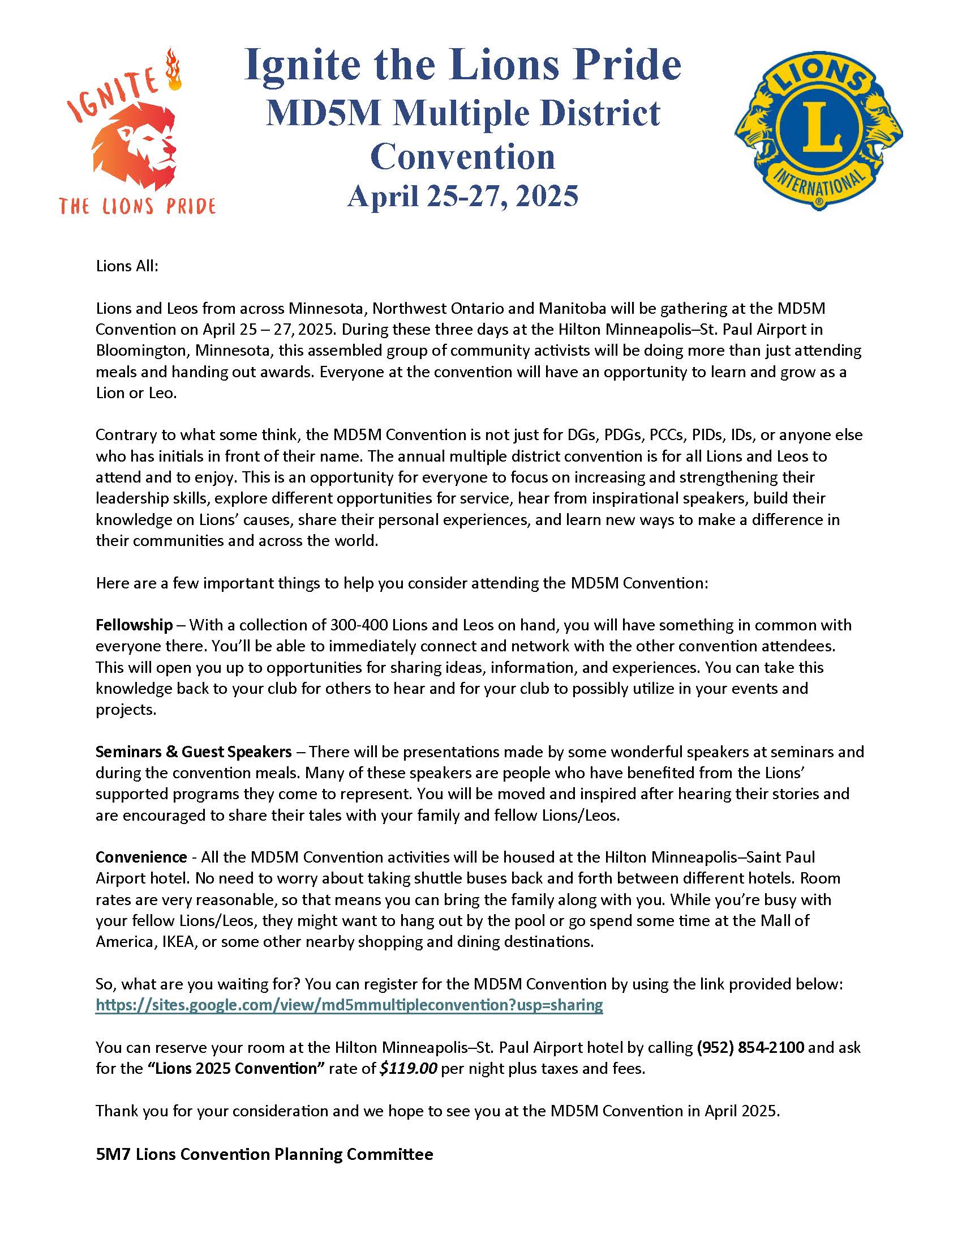

|  |  |
| --- | --- |
| **MULTIPLE DISTRICT 5M CONVENTION NEWS-**  **Keynote Speaker** | **P670C2T21#yIS1** |

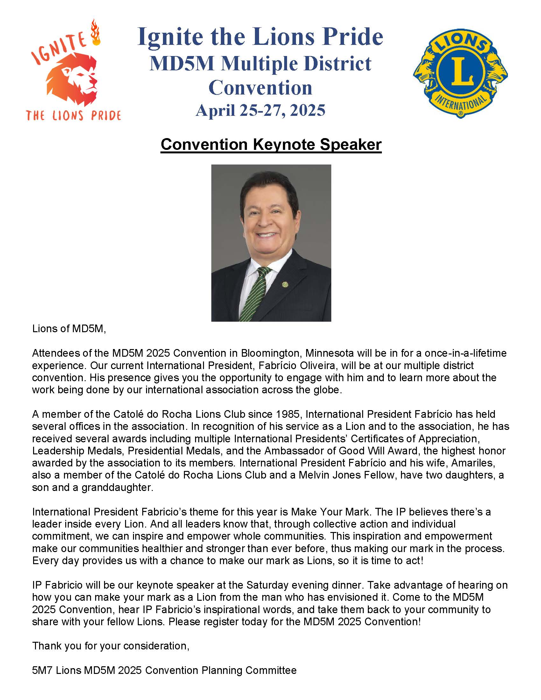

|  |  |
| --- | --- |
| **MULTIPLE DISTRICT 5M CONVENTION NEWS-**  **Schedule** | **P675C2T22#yIS1** |

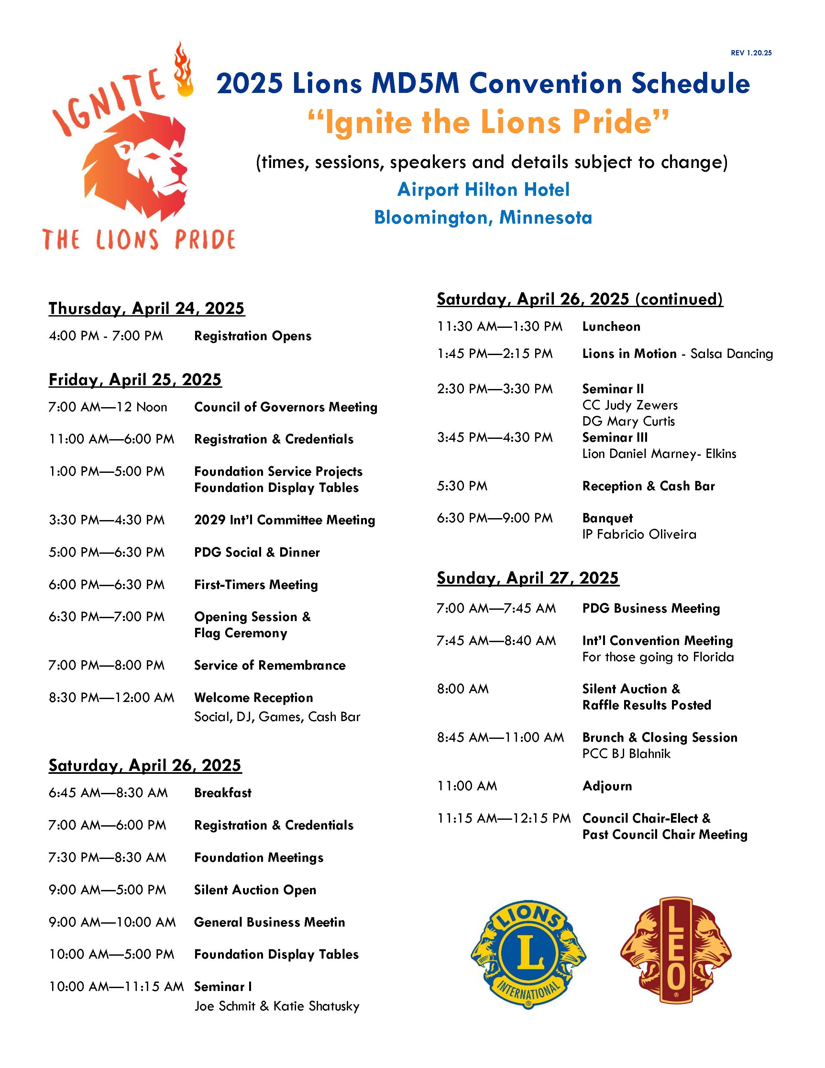

|  |  |
| --- | --- |
| **MULTIPLE DISTRICT 5M CONVENTION NEWS-**  **Table Sponsorship** | **P680C2T23#yIS1** |

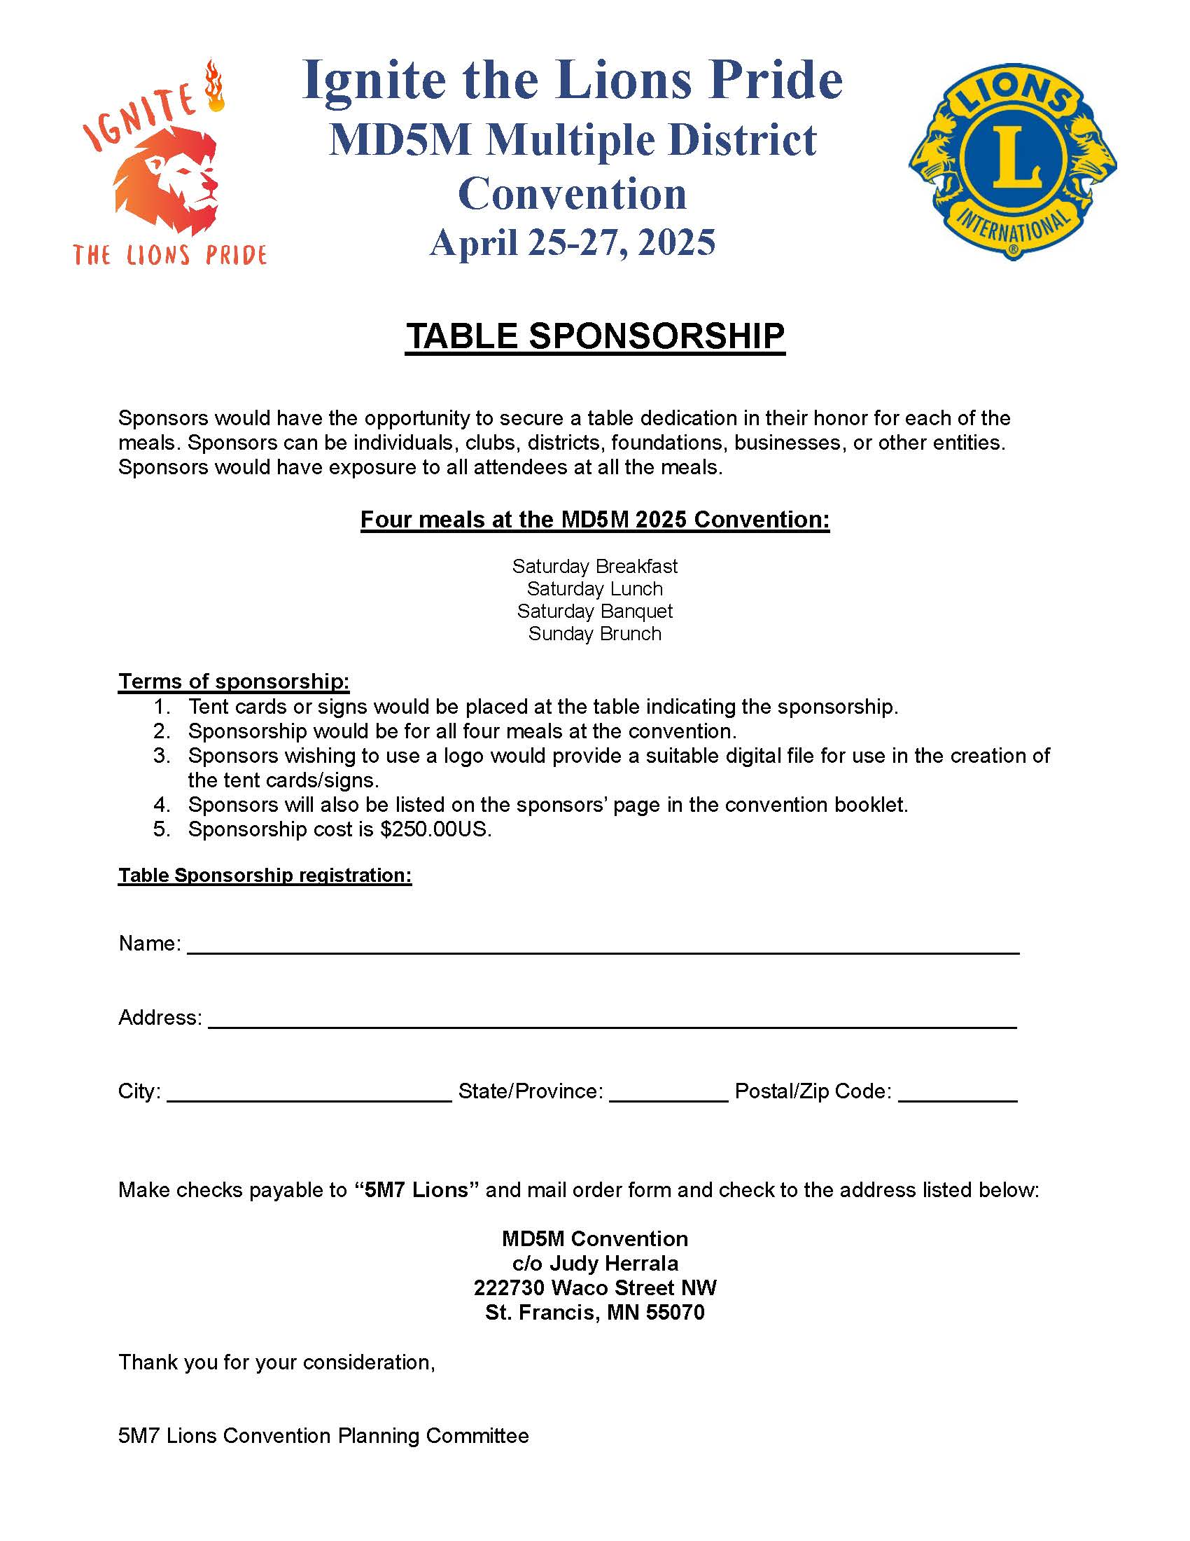

|  |  |
| --- | --- |
| **MULTIPLE DISTRICT 5M CONVENTION NEWS-**  **Convention Shirts** | **P680C2T23#yIS1** |

|  |  |  |
| --- | --- | --- |
| P683C1T24#yIS1 | **LIONS SERVING**  [Email Your Photos](mailto:lionsdistrict5m5@gmail.com) of your Lions in action.  Please include dates, names, locations etc. to this email: [lionsdistrict5m5@gmail.com](mailto:lionsdistrict5m5@gmail.com) | P688C3T24#yIS1 |

|  |  |
| --- | --- |
| *The Robbinsdale Lions Bingo and Meat Raffle event was a huge success. The Wicked Wort Brewing Co. was completely packed! Thanks to all who attended.* | |
|  |  |
|  |  |
| ***A group of people posing for a photo  AI-generated content may be incorrect.Robbinsdale Lions Newest Lions***  Annelisse McIntosh & Sponsor Ian McIntosh; Kelly McDyre & Sponsor Amy Sutton; Lindsay Daniels & Sponsor John Zieba; John Richard & Sponsor Eric Hillman | |

|  |  |  |  |
| --- | --- | --- | --- |
|  | |  | |
|  | **5M-5 Leos helping residents at St. Therese in New Hope plant things in the pots they decorated at the Midwinter Convention. They have plenty of pots left so if your club can use them for a service project please let me know.**  **Lion Mike Peach,**  **Leo Chair** | |  |
|  | | | |

|  |  |
| --- | --- |
| **Presentation of $25,000 to City of Maple Grove for Police Department badges. Change in state emblem required them to get new badges.** |  |

|  |  |
| --- | --- |
|  | **Three new Maple Grove Lions with their sponsors!** |

|  |  |
| --- | --- |
|  | |
|  |  |
|  |  |
|  |  |
|  |  |
|  |  |
| **Maple Grove Lions Sip & Sample on March 7th**  **had 322 attendees sampling food and drinks from area businesses.** | |

|  |  |
| --- | --- |
| **CAN DO CANINES** |  |



The Fetching Ball Gala was held on February 22nd and raised over $315,000! Please save the date of April 11, 2026, for next year’s event. This year’s speaker mentioned how her amazing Assist Dog improved her relationship with her partner. It takes some stress off the partner as the dog can perform some of the tasks the partner had to complete before. An example was tugging off the socks at the end of a long day.

An Open House was held on March 8th and it was exciting to see a full parking lot and friendly Lions helping direct traffic. The event is broken up into 20 minutes slots to hear about the program and see Assist Dogs working. If you are interested in attending the next one is on Saturday, May 17th, 12-2. No need to RSVP and It does not take the whole two hours, short as 25 minutes. Bring friends as there is something for nearly everyone!

25 clubs in 5M5 have already donated a total of $18,386 for 2025. Brooklyn Park Lady Lions have reached out to schedule a visit. My next step will be alerting clubs on the amounts of Top Dog Awards and the steps to do that process.

Lion Daren Johnson

|  |  |
| --- | --- |
| **LEADER DOGS** | **P721C2T29#yIS1** |

Leader Dogs for the Blind has been transforming lives for 85 years, providing independence and mobility to individuals who are blind or visually impaired. With more than **14,500 graduates across 49 states, 7 provinces, and 31 countries**, Leader Dogs impact extends far and wide. Each year, Leader Dog offers **12 guide dog training sessions**, with up to **24 clients per class**, ensuring that hundreds of individuals receive the support they need to navigate life with confidence.

**5M-5 Lions Support**

Lions Clubs have been long-time supporters of Leader Dogs for the Blind, and this year has been no exception. **25 5M-5 Lions Clubs** donated **$26,378 year-to-date**, surpassing last year’s total of **$24,820**. This consistent growth highlights the dedication of Lions members in ensuring that Leader Dog continues its life-changing work.

I have had the opportunity to spread awareness about Leader Dog’s mission by speaking at three Lions Clubs this year: **Brooklyn Center Lady Lions, Brooklyn Center Lady Lions and St. Louis Park Lions**,

Before the end of our current Lion year, I am also scheduled to meet at other 5M-5 Lions Clubs. I am available to come speak at your club. Connect with me to schedule a club visit.



Lion Michael Crenshaw

5M-5 Leader Dogs for the Blind Chair

651-500-9400

[bpLionMichael@gmail.com](mailto:bpLionMichael@gmail.com)

|  |  |
| --- | --- |
| **LEOS** | **P755C2T30#y1** |

As spring and graduation approaches the Leo year is beginning to wind down. Clubs completed their very successful service projects as we look to prepare for next year. Advisors, a word to the wise; encourage your graduating officers to pick their replacements before they graduate! I learned this the hard way.

The final Presidents Meeting for the year will be held on Monday April 7, 2025, from 5:00 to 6:30 PM at the Brooklyn Park Library. All interested Lions are invited to attend. Food and drink will be provided so be sure to let me know if you plan to attend. There will also be awards presented; long-time Champlin Park Youth Service Coordinator and Leo Liaison Jane Hansen will be retiring. Jane has been deeply involved with the entire 5M-5 Leo program as well as her own schools club for many years. She will be sorely missed!

The final district Leo service project will be once again held at Feed My Starving Children in Coon Rapids on Thursday, April 10 from 7:00 to 8:30 PM. Again any Lion can attend, there are positions only adults can fill and if you want to have fun with the Leos and see what they do, this is your chance! It’s a very impressive and rewarding experience seeing how many starving children the evenings work fed.

Finally, work continues to progress, albeit slower than I’d like with the developing Leo clubs. Armstrong was delayed by liaison issues and the Orono Lions have expressed an interest in starting a Leo club there.

As always please feel free to contact me if there is anything I can do for you.

Thank you!

Yours in Lionism,

Lion Mike Peach, District Leo Chair

Maple Grove Lions Club

|  |  |  |
| --- | --- | --- |
| P773C1T31#yIS1 | **MINNESOTA LIONS DIABETES FOUNDATION** | P775C3T31#y1 |

**We’re on a mission to support researchers in developing treatments, and a cure, for diabetes.**

During our quarterly meeting March 15, Minnesota Lions Diabetes Foundation trustees approved three grants totaling $76,000.

**Supporting University of Minnesota Research**

MLDF trustees approved a total of $70,000 for research at the University of Minnesota. $35,000 was awarded for research about which future islet transplantation clinical trial would be best for an individual (decision based upon strength and nature of transplant recipient immune system), and $35,000 was awarded for research focused on understanding the origins of autoimmune diabetes.

**Supporting Youth at Camp Sweet Life**

Trustees also approved a grant of $5,000 to support Camp Sweet Life scholarship fund. Camp Sweet Life is a non-profit organization that provides youth who have Type 1 Diabetes (T1D) an opportunity to connect with other kids who have T1D, learn how to take better care of themselves, and have loads of fun in a carefree summer camp environment.

*We look forward to talking with you at your club meetings and events and providing you with diabetes service project ideas.*

**Thank you for your support!**

Your contributions to Minnesota Lions Diabetes Foundation supports research and other diabetes-related programs and services that are improving the lives of many living with diabetes.



|  |  |
| --- | --- |
| **MN LIONS CHILDHOOD CANCER FOUNDATION** |  |

The **Minnesota Lions Childhood Cancer Foundation** is excited to partner with the **Hamel Rodeo** again this year! Last year, our Lions volunteers made a real impact by helping with food service and ticket scanning, and we are continuing this effort in 2025.

This year, we are specifically looking for volunteers on two key nights:

 **Thursday, July 10 (Childhood Cancer Night – Opening Night**

 **Sunday, July 13 (Closing Night)**

 **Shift Time:** 4:30 – 10:30 PM

 **20 volunteers to scan tickets**

 **10 volunteers to work in the food area**

As 5M5 Cabinet members, you have the first opportunity to sign up before we open this to Lions in other districts. If you're interested, please sign up using the Sign Up Genius link below:

 [Sign Up Here](https://www.signupgenius.com/go/20F0B49AEA62AA2FD0-55467956-hamel)-Feel free to share this opportunity with others who may be interested. The **minimum age to volunteer is 16**. If you have any questions, please reach out to Colleen or me.

**Can’t Volunteer? You Can Still Support!**

If you’re unable to volunteer, you can still support childhood cancer efforts by attending the event. **Tickets are $25** and can only be purchased online at:

 [www.hamelrodeo.org](http://www.hamelrodeo.org)

 Avoid searching on Google, as it may direct you to third-party sites with marked-up prices. **No one should pay more than $25 per ticket!**

Thank you for your continued support—together, we can make a difference!

|  |  |
| --- | --- |
| **MD5M LIONS KIDSIGHT** | **P807C2T33#yIS1** |

KidSight will show up early to the All Club meeting April 7 so clubs will have plenty of time to find out more about how they can participate in childhood vision screening.

We can come to your club meeting to do a brief presentation about the program, which provides fast, free, no-touch screening for kids 6 months to 18 years old.

We can do a training session for interested members of your club, or clubs in a specific area. The training session lasts about 45 minutes and goes into detail about all the steps in creating and putting on a KidSight screening at one of your club or community events.

A great way to learn about how KidSight works is to volunteer at a screening. KidSight is a Multiple District-wide program, and any interested Lion can volunteer at any screening regardless of club affiliation or which club is holding the event.

5m-5 KidSight Directors Lions Bill Thurston and Tim Conaway work with clubs all over the district and are always glad to follow up on your interest, whether it is a presentation, training, or at an event.

We look forward to seeing you at the All-Club, and throughout a busy summer or screenings.

Lion Bill Thurston Lion Tim Conaway

[wjthurston@comcast.net](mailto:wjthurston@comcast.net) [liontimconaway@gmail.com](mailto:liontimconaway@gmail.com)

612 790 7367 612 269 0027

|  |  |
| --- | --- |
| **SPECIAL OLYMPICS MINNESOTA** |  |

**Special Olympics Minnesota Summer Games Volunteers Needed**

Opening Eyes for the Summer Games is soon upon us! Registration is open and Lions can sign up now. Our Lions will be assisting the eye care professionals and doctors in providing a complete eye care examination with free glasses for the athletes. The screeners used in Kidsight will be used as part of the exam. Opening Eyes is a fun and needed service project being held this year at the U of M. The clinic well be held in the Field House at the U of M Minneapolis Campus on Saturday June 21 from 8am to 4pm, with set up Friday the 20th 9am to 1pm. This service project is funded in part by LCI and is a 5M Multiple service project. 5M5 volunteers may be working alongside Lions from other districts. There are 2 shifts available on Saturday and if volunteers want to stay the entire day, they can sign up for a shift for both periods.

Summer Games are fun for all involved. The athletes get to compete in a sport they love, they get to see friends from around the state, and they can get some health screenings alongside teammates. They might not easily get these screenings at another time as parents of athletes find their kids are difficult to get into medical professionals, that is unless… Unless they are with friends or teammates! For the volunteers, they’ll have fun interacting with the athletes as well as Lions from around the state. The athletes usually love to talk about their medals and many like jokes. It’s a fun time while helping others!

Volunteer For This Event here [Special Olympics Minnesota Event Listing & Registration](cerv.is/0101rlions)

Any questions, contact

Lion Ray Moonen 952.201.7031

Lion Jim Cain 763.232.0790

Lion Laura Maki 507.381.7417

|  |
| --- |
| **EVENT FLYERS** |

|  |  |
| --- | --- |
| **P842C1T36#yIS1** | **VP871C20T36#yIS1** |
| **P873C21T36#yIS1** | **P874C22T36#yIS1** |
| **P876C23T36#yIS1** | **P877C24T36#yIS1** |
| **P879C25T36#yIS1** |  |
|  | **P880C26T36#yIS1** |
| **P882C27T36#yIS1** | **P883C28T36#yIS1** |
| **P885C29T36#yIS1** | **P886C30T36#y1** |
| **P888C31T36#yIS1** | **MAPLE GROVE LIONS**  **Taco Dinner for Childhood Cancer**  **May 2, 2025**  **5:00 PM to 8:00 PM**  **Osseo Maple Grove American Legion**  **260 4th Ave SE**  **Osseo**  **$10 per person, all ages**  **cash only** |
|  | **P889C32T36#yIS1** |
| **P891C33T36#yIS1** |  |
| **MAPLE GROVE LIONS**  **May 14, 2025**  **12 Noon to 3 PM**  **LEGO’s at the LOOKOUT BAR & GRILL**  **8672 Pineview Lane North**  **Maple Grove** | **P892C34T36#yIS1** |
|  | **P895C36T36#yIS1** |
| **P897C37T36#y1** | **P898C38T36#yIS1**  [CLICK HERE FOR THE LINK TO ORDER](https://lions5m5.org/md5m-information) |
|  |  |

|  |
| --- |
| **TERMS & ABBREVIATIONS** |

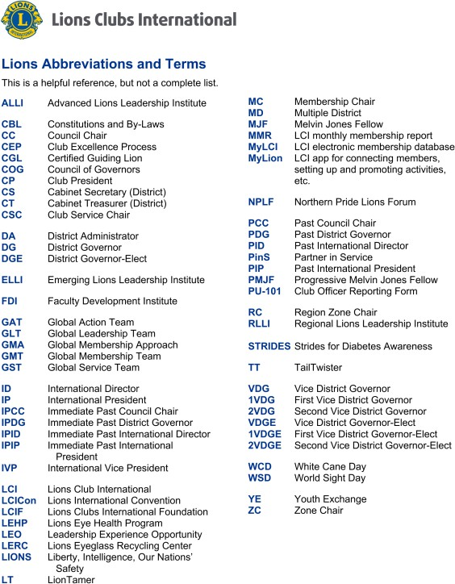

|  |
| --- |
| **WEB SITES & LINKS** |

Awards [**lions5m5.org/awards**](https://lions5m5.org/awards)

District 5M5 [**lions5m5.org**](http://lions5m5.org/)

Lions Clubs International [**lionsclubs.org**](http://lionsclubs.org/)

Multiple District 5M (MD5M) [**lionsmd5m.org**](http://lionsmd5m.org/)

**District Approved Projects & Links**

Can Do Canines [candocanines.org](https://candocanines.org/)

Confidence Learning Center [campconfidence.com](https://campconfidence.com/about/)

Leader Dogs for the Blind [leaderdog.org](http://leaderdog.org/)

Leos [lionsclubs.org/about-leos](https://www.lionsclubs.org/en/discover-our-clubs/about-leos)

Lions Clubs International Foundation [lcif.org](http://lcif.org/)-

MD5M Lions KidSight Foundation [kidsightmd5m.org](http://kidsightmd5m.org/)

Minnesota Lions Diabetes Foundation [mnlionsdiabetes.org](http://mnlionsdiabetes.org/)

Minnesota Lions Hearing Foundation [5mhf.org](http://5mhf.org/)

Minnesota Lions Vision Foundation [mnlionsvisionfoundation.org](http://mnlionsvisionfoundation.org/)

MN Lions Childhood Cancer Foundation [mnlionschildhoodcancerfoundation.org](http://mnlionschildhoodcancerfoundation.org/)

Project New Hope [projectnewhope.net](http://projectnewhope.net/)

Special Olympics Minnesota [specialolympicsminnesota.org](http://specialolympicsminnesota.org/)

TEAM Sheehan Charitable Foundations [facebook.com/groups/TEAM SHEEHAN](https://www.facebook.com/groups/1509813445712962/)

True Friends [truefriends.org](http://www.truefriends.org/)

Youth Exchange/Youth Camps [lionsclubs.org/youth/youth-camps-and-exchange](https://www.lionsclubs.org/en/start-our-approach/youth/youth-camps-and-exchange)