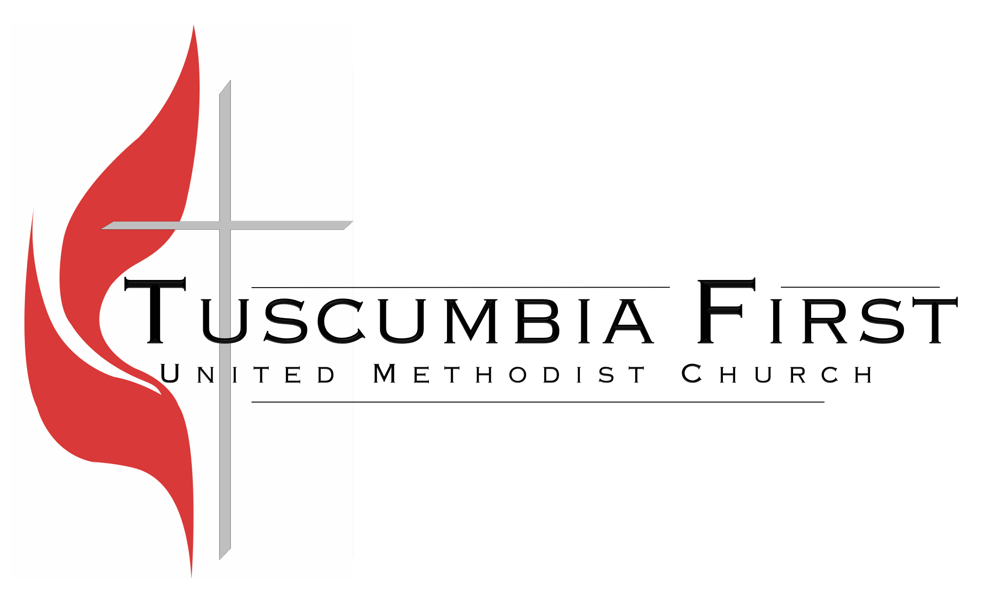

Tuesday, June 2, 2020

In-Person Worship Returns June 7

When we were asked to suspend in-person worship because of the pandemic, no one imagined that it would last 11 Sundays, but it has. But as God does, He has brought something good out of the bad. God has opened new ways of sharing the Gospel with those who do not or cannot make it into our building. God has taught me to see online worship as another means of ministering to people who cannot be physically present. We have people who have joined us online who will continue to do so after we open for in-person worship. So, we will continue to live stream our 9:45 and 11:00 worship experiences.

We will be offering in-person worship this Sunday, June 7, at 8:30, 9:45, and 11:00. Both the Sanctuary and Family Life Center have been cleaned, sanitized, and prepared for us to return. They have also been set up for social distancing guidelines. Attached are the guidelines for returning to worship that have been established based on CDC and Conference recommendations.

We understand that you may choose to continue worshiping online for a while longer. We are working hard to continue to make online worship a meaningful experience, even as some return to our campus to worship. If you have health issues that put you at risk, then certainly you should not return to in-person worship at this time.

While 8:30, 9:45 and 11:00 services will be offered, Shepherd’s Table will not return at this time. The reason is, it takes additional precautions to provide an in-person meal versus delivering a meal. It also takes more volunteers to help with Shepherd’s Table due to the necessary method of serving the meals and drinks. This may be a place God is calling you to serve. In the meantime, we will continue to take meals to those who had regularly worshipped at Shepherd’s Table.

While we are reopening for in-person worship on Sunday morning, there will not be Sunday School or Small Groups on Sunday mornings in the Church Buildings. We do have some classes who are meeting outside at homes and some looking at coming to the church building at a time other than Sunday morning. If you would like to look at your class meeting at a time other than Sunday morning, contact Rudy Guess, Chad Talley or Chad Kennington. You will need some volunteers to help with preparing this space each week.

To help us prepare for this Sunday, please let us know if you plan to be physically here for worship. You can let us know by completing the form on the church website or mobile app. You can also call the church office (256-383-2853).

Please understand that the COVID-19 pandemic is an ever-changing situation. These guidelines are subject to change.

In Christ’s Service

Rudy Guess

GUIDELINES FOR ATTENDING WORSHIP

Before you arrive:
You must be able to answer “NO” to these five questions;
- Have you been in close contact with a confirmed, active case of COVID-19
- Are you experiencing a cough, shortness of breath, or sore throat?
- Have you had fever in the last 48 hours? (please check everyone’s temp before leaving home to verify this.)
- Have you experienced new loss of taste or smell?
- Have you experienced vomiting or diarrhea in the last 24 hours?
These screening guidelines were provided by ADPH.
If you or a member of your family cannot say “NO” to each of these questions, please stay at home and worship online.
Arriving on Sunday:
- Please do not arrive more than 20 minutes before the service. The doors will open at that time.
- As you enter, be prepared to answer “No” to the five question when asked.
- For Sanctuary services, enter through the Main Street doors. They will be opened. Allow those in front of you to get inside before you enter. (Remember, Social Distancing.)
- For 9:45 service, enter through the Family Life Center Welcome Center. The doors will be opened. Allow those in front of you to get inside before you enter. (Remember, Social Distancing.)
- We strongly encourage you to wear a face mask, especially while singing. We will have extra masks if you need one.
- When you enter, use the hand sanitizer to sanitize your hands.
- Please refrain from shaking hands and hugging. This may seem rude, but we all understand the current situation.
- Go directly to a seat. Please maintain a safe social distance while finding your seat.
  - In the sanctuary, enter a pew that is not taped off and that no one is in or they are on the other end. You will find bulletins there with order of service and words of songs. There are also pews available in the balcony.
  - In the Family Life Center, find a group of chairs the size for your family, starting with the ones furthest from the entrance. There will also be chairs available on the track
  - We are planning for an overflow in the Student Building if needed. Please do not go there unless instructed to do so.
- There will be no nursery or children’s classes. All children will be with their parents. There will be children’s activity packets available.
- There will be no passing of the Offering Plates. Offering Plates/baskets will be available as you leave.
- At the End of the service, you will be dismissed by rows/sections. Please follow the directions after the benediction is offered.
- If possible, refrain from using the restrooms or walking in the halls.
Final Word:
These may seem like a lot of guidelines. The Church is attempting to follow the Health Guidelines that have been given. These are for your safety and the safety of others.

