***400 Patroon Creek***

***(518) 512-4005***

***Breakfast***

*Bagel or Toast*

*w/Butter*………….…………$1.50

*w/Cream cheese*

*or peanut butter*…………$2.50

*French Toast*…………..… $3.50

*w/side of meat*….……….…$5.50

**Breakfast Sandwiches**

*2 eggs, cheese & choice of meat*

*(bacon, ham, sausage) served on a hard roll or toast*…....$3.75

*Egg & Cheese*…………….$3.25

**Spinach & Egg White Wrap**...5.00

*(fresh spinach, egg whites, roasted red peppers & feta cheese)*

**Breakfast Burrito**…...…….$5.95

*Scrambled eggs, peppers, onions, cheese and choice of meat*

**Omelets (3 eggs)**

*Cheese omelet*……...……….…… $3.50

*Cheese omelet w/meat* $5.50

*additional toppings*…… ..$ .75

**Al a Carte**

*Egg*……………..…...….... $1.00

*Bacon/ham/sausage*…. $2.00

*Cheese*………………… $ .50

*Home fries*…..…………. $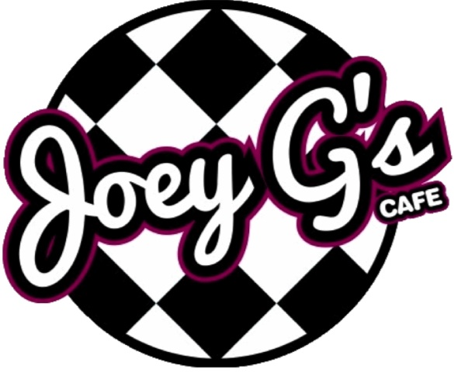2.00

***Soups & Salads***

***Soup of the Day………. $3.95***

**Garden Salad**…………. $7.95

*Romaine, tomatoes, cucumbers, red onions, peppers, black olives & shredded cheese*

**Classic Caesar**……… $8.95

*Romaine, parmesan cheese, croutons, Caesar dressing*

**Greek Salad**………..… $8.95

*Romaine, feta cheese, black olives, artichokes, red onions, cucumbers, roasted red peppers & Greek dressing*

**Oriental Salad**………… $8.95

*Mixed greens, mandarin oranges, craisins, cucumbers, tomatoes, red onions, crispy noodles & honey ginger dressing*

***Hours***

***7:30am – 2:30pm***

***Monday thru Friday***

***Delivery Available 9am to 11 30am***

***$25 Minimum for Delivery***

**Beet & Goat Cheese**…$8.95

*Romaine, beets, tomatoes, cucumbers, red onions, goat cheese & lemon vinaigrette*

**Buffalo Chicken Salad** $8.95

*Romaine, crispy Buffalo chicken, tomatoes, cucumbers & shredded cheddar & choice of ranch or blue cheese dressing*

**Chef Salad**………………$8.95

*Romaine, turkey, ham, roast beef, American cheese, tomatoes, red onion, cucumbers & choice of dressing*

**Antipasto Salad**………$8.95

*Romaine, ham, salami, pepperoni, provolone cheese, tomatoes, red onions, roasted red peppers, pepperoncini’s & choice of dressing*

***Ask about our catering services. View or download all of our menus online @ joeygscafe.com***

***Deli Sandwiches***

***$6.99***

*All deli sandwiches include lettuce, tomato & cheese (cheddar, Swiss, American, provolone, pepper jack)* ***and are served with chips and a pickle***

**Deli Meats / Salads**

*Roast Beef*

*Turkey*

*Ham*

*Grilled Chicken*

*Chicken Salad*

*Tuna Salad*

*Egg Salad*

**Bread choices**

*White/Wheat/Rye/Ciabatta/*

*Wraps (white ,spinach , Tomato basil wheat)*

***Grilled Sandwiches –***

***$7.99***

**Pesto Chicken Melt**

*Grilled chicken with basil pesto, roasted red peppers & provolone cheese on choice of grilled bread*

**Highlander Roast Beef Melt**

*Roast beef, grilled onions, Swiss cheese & horseradish mayo on choice of grilled bread*

**All American Melt**

*Ham, turkey & American cheese on choice of grilled bread*

**TBC Melt**

*Turkey, bacon, cheddar & Russian on choice of grilled bread*

**Tuna Melt**

*Tuna & choice of cheese on choice of grilled bread*

**BBQ Brisket Burger**

*Brisket, sautéed onions, lettuce & tomato*

**Joey G’s Big Reuben**

*Corned beef or turkey, sauerkraut, Russian & Swiss cheese on grilled rye*

**Spinach Artichoke Melt**

*Turkey or chicken breast, spinach, artichokes, parmesan cheese & mayo*

**Philly Cheese Steak**

*Roast beef with grilled peppers, onions & American cheese on a hoagie roll*

**Quesadilla**

*Choice of chicken or vegetarian option, prepared with peppers, onions & shredded cheddar cheese*

***Chicken………………….$8.99***

***Cheese Only……………$5.99***

**Joey G’s Grilled Cheese…**$5.00

w/Tomatoes…………….. $5.50

w/Bacon…………………… $7.00

***All sandwiches come with chips & pickle***

***Signature Sandwiches -$7.99***

**Joey G’s Chicken Salad Sandwich**

*Our signature house cooked chicken salad with cranberry sauce, bacon, provolone & lettuce on choice of bread*

**Mediterranean Wrap**

*Fresh spinach, roasted red peppers, black olives, cucumbers, artichokes, tomatoes, feta cheese & basil pesto*

**The New Yorker**

*House cooked roast beef, lettuce, tomato, red onion, Swiss cheese & horseradish mayo on an Asiago bagel*

**Strawberry Fields**

*Turkey, bacon, mixed greens, cheddar & strawberry mayo on choice of bread*

**OG Sheri**

*Turkey, coleslaw, Swiss cheese & Russian dressing on choice of bread*

**Waldorf Chicken Salad**

*Chicken salad, walnuts, craisins, apples & mixed greens on choice of bread*

**Joey G’s Big BLT**

*6 strips of bacon, lettuce, tomato and mayo on toasted bread*

**Buffalo Chicken Wrap**

*Crispy Buffalo chicken, tomatoes, cucumbers, shredded cheddar & romaine with choice of ranch or blue cheese dressing*