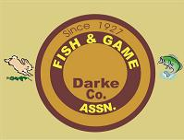

Annual Family Membership $35.00
Darke County Fish & Game Association
P.O Box 110
New Madison, OH 45347

Date: _________________________________________
Name:_________________________________________

Address:_______________________________________
______________________________________________
E-mail Address:________________________________
Phone:_______________________________________
Fill in your name, address E-mail and phone number, then mail this application along
with a check for $35.00 payable to Darke County Fish & Game Association. Your new
membership card will be returned to you in the mail.
Mail To: Darke County Fish & Game Association
P.O. Box 110
New Madison, Oh 45347
https://www.darkecountyfishandgame.com

