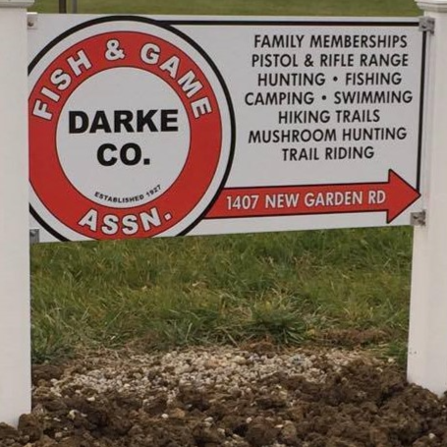**Did ya know 2019**

**Darke County Fish and Game Association**

1407 New Garden Road

New Paris, Ohio 45347

* LIKE US ON FACEBOOK

Visit us @ <https://www.darkecountyfishandgame.com/>

* Annual memberships are $35. That includes a married couple and children under 18 years old.
* Family memberships can be purchased at any Farmers state bank, New madison mini mart, by mail or at the club.
* There are over 93 acres to enjoy.
* There are 2 ponds stocked with Bass, Catfish, Perch, Bluegill and Carp.
* The clubhouse can be rented by members for $150 a day add the use of the kitchen for $100 with a deposit of $250.
* President: April Hicks
* Vice President: Aaron Eley
* Treasurer & Secretary: Dave Shives
* Chairman of the Board: Bob Fiste
* Board of Directors:
  + Bruce Mikesell
  + Rod Saylor
  + Keith Holsapple
  + Clint Shives
  + Tanner Kirchner
* Caretaker: Curtis Rike
* We have 6 fish fry’s a year: January 12th, February 14th, March 14th, April 11th, October 10th and November 14th.
* 2 kids fishing derbies this year: May 4th and October 12th.
* Hunters Meet & Greet- September 14th 6:00-8:00 PM. Please bring a covered dish.
* Members only Christmas party- December 7th 6:00 PM. Please bring a covered dish.
* Things to do:
* Swimming
* Hiking
* Primitive camping (Tents & campers)
* Fishing
* Pistol range- 25 yards
* Riffle range- 100 yards
* 4 archery ranges 10, 20, 30 & 40 yards
* Mushroom hunting
* Deer, racoon, rabbit and Squirrel hunting
* We have membership meetings the first Thursday every month except July and August
* On site CCW classes provided by Kyle Yount phone 937-533-9985 email surprisebreak@hotmail.com website [www.surprisebreak.com](http://l.facebook.com/l.php?u=http%3A%2F%2Fwww.surprisebreak.com%2F&h=ATO6LmRsDSx9T02OGchf0vGh1FQGH2C4b-JswUaLdQzHC3cjD9CDdoEJHdPQhsG8TdrH4TJPu_thATmcw2BWXtEDhFvI75C9j6CtO7MYSPEUN_--Qc3Vztj7b22_oLLntuaKZZY5KImqtg)
* On site Hunters education classes provided by ODNR <http://wildlife.ohiodnr.gov/education-and-outdoor-discovery/hunter-and-trapper-education>
* Texas holdem tournaments every Wednesday at 7PM
* Texas Holdem tournaments the first Sunday of the month at 2PM. Please bring a covered dish.
* Check our calendar for special occasions!!
* You must me a member to use our facilities!!