**CITY OF SAN LUIS OBISPO - RESIDENTIAL PARKING PERMITS**

Permits are **only available** **to the Property Owner or Authorized Agent**who currently reside at an address that is within Residential District boundaries.  Residential Parking Districts require a city parking permit during designated hours.

***AUTHORIZATION FORM HERE:***[**Residential Parking Authorization Form**](https://www.slocity.org/home/showpublisheddocument/34622/638307095895930000)

***Please fill out the Authorization Letter and email it to parkinginfo@slocity.org***

Click below to see a map of each district:

* [Anholm](https://www.slocity.org/home/showpublisheddocument/21628/636722629263400000): 7 days a week 8am-2am
* [Alta Vista](https://www.slocity.org/home/showpublisheddocument/3620/637885532583170000): M-F 2am-5pm or M-F 2am-10pm (see map)
* [College Highlands](https://www.slocity.org/home/showpublisheddocument/3622/635496671603230000)**:**7 days a week 10pm-10am
* [Dana Street](https://www.slocity.org/home/showpublisheddocument/26358/637618563395230000) - 7 days a week 8am-2am
* [Ferrini](https://www.slocity.org/home/showpublisheddocument/21630/636722631837370000)**:**7 days a week 12am-5pm
* [Mission Orchard](https://www.slocity.org/home/showpublisheddocument/3626/635496672767630000): M-F 6am-6pm
* [Monterey Heights](https://www.slocity.org/home/showpublisheddocument/26360/637340576865800000)**:** M-F 2am-10pm
* [Murray](https://www.slocity.org/home/showpublisheddocument/3630/635496687412870000)**:** M-F 8am-5pm
* [Palomar](https://www.slocity.org/home/showpublisheddocument/3632/635496687412870000)**:**7 days a week 10pm-6am
* [Park View](https://www.slocity.org/home/showpublisheddocument/3636/635496687412870000)**:** 7 days a week 12am-7am
* [Tassajara/South Tassajara](https://www.slocity.org/home/showpublisheddocument/3638/635496687412870000)**:**7 days a week 10pm-6am or 24hrs (see map)

**Click here for a map of the Adjoining Streets per District and Address:**[**Residential Adjoining Streets Map**](https://slocity.maps.arcgis.com/apps/View/index.html?appid=7e3f66f8f1184ef7ba2e1288ec84660f)

*Vehicles parked in these areas without a permit are subject to citation*. Click here for more information:  [Residential Rules & Instructions](https://www.slocity.org/home/showpublisheddocument/29071/637462330242030000)

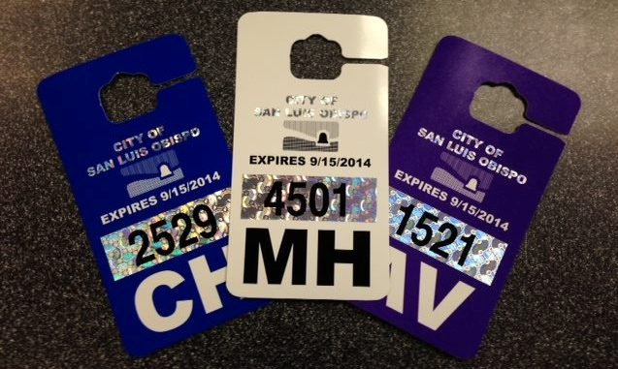

**PURCHASING RESIDENTIAL PERMITS**

**Current Residential Permits are $20 for each permit**.  Each residence within a district is entitled to a maximum of (2) permits per City Ordinance (Municipal Code 10.36.220).  Permits are pre-assigned to each address and are subject to the same rules regarding usage as in the past.  **The current permits will expire September 15th, each calendar year.** Permits for the coming year must be paid for prior to issuance.

Only a **Property Owner or Authorized Agent** on record will be issued the permits.  If the Property Ownership has changed, please provide a copy of the Transfer of Title/Grant Deed along with a copy of your Driver’s License to the Parking Services office.  If you are a Tenant or Property Management Company and are not listed as an Authorized Agent, you will need to have the Property Owner fill out an *Authorization Letter* and return it to the Parking Services office.   Please contact the Parking Services office for an *Authorization Letter* to either be mailed or emailed to the Property Owner.

**Options for purchasing the permits are as follows**:

* **Mail –**Include a copy of the Residential Permit Letter and send a check or money order (no cash) to our office at Parking Services, 1260 Chorro St., Suite #B, San Luis Obispo, CA 93401.**The permit(s) will be sent via US Postal Service only to the Property Owner or Authorized Agent on record, unless otherwise noted on the letter.**
* **In Person - (Photo ID is required)**. Our walk-up window hours are Monday and Wednesday 1-4pm, Tuesday and Thursday 9am-12pm and Fridays by appointment only 10am-3pm. Our office is located at 1260 Chorro St., Suite B. We accept cash, check, and credit/debit cards. AMEX is **not**accepted. **The permit(s) will be issued only to the Property Owner or Authorized Agent on record**.
* **Property Management Companies** - **Please call or email to schedule an appointment to purchase and/or pick up permits.**Please remember to bring any paperwork including a change in Property Ownership and/or Authorized Agents.

**TEMPORARY RESIDENTIAL PERMITS**

To obtain a temporary residential permit, please call or email the Parking Services office with Property Owner Name or Construction Company Name, Date(s) of Event, Type of Event, and # of permits needed.  Up to only six (6) temporary permits can be issued at a time.

*Please see form below for qualifications

**Click here for more information:**[**Special Event Parking Guidelines**](https://www.slocity.org/home/showpublisheddocument/29075/637462330257330000)