**Annotated Bibliography – Part 1**

**Search & Cite**

**Summary**

The first part of your annotated bibliography assignment will focus on formulating a search strategy, using appropriate citation format (APA), reflecting on your search process and understanding the anatomy of a research article.

**Formulating A Search Strategy**

**Step 1**

Define the key concepts for your search based on your research question.

***Example: What impact does social media have on kids’ learning?***

|  |  |
| --- | --- |
| ***1st Key Concept*** | ***2nd Key Concept*** |
| *learning* | *kids* |

**Complete the table with your key concepts.**

|  |  |
| --- | --- |
| **1st Key Concept** | **2nd Key Concept** |
| **Cybersecurity** | **Information** |

**Step 2**

Brainstorm other words that might be used to describe your key concepts. What are some words that have a similar meaning as your key concept?

***Example:***

|  |  |
| --- | --- |
| ***1st Key Concept*** | ***Alternative Keywords*** |
| *Learning* | *Education, pedagogy,* |

|  |  |
| --- | --- |
| ***2nd Key Concept*** | ***Alternative Keywords*** |
| *Kids* | *Toddler, infant, children, pediatrics* |

**Complete the tables with your key concepts and alternative keywords.**

|  |  |
| --- | --- |
| **1st Key Concept** | **Alternative Keywords** |
| **Cybersecurity** | **Security , analyst, high-tech, virtual** |

|  |  |
| --- | --- |
| **2nd Key Concept** | **Alternative Keywords** |
| **information** | **Data, evidence, behavior,** |

**Step 3**

Plan your search statements with AND/OR/NOT operators: **AND** connects separate concepts, **OR** connects synonyms, **NOT** excludes concepts.

***Example:***

|  |  |  |
| --- | --- | --- |
| ***1st Key Concept*** | ***Operator*** | ***2nd Key Concept & Alternative Kw*** |
| *Learning* | ***AND*** | *(Kids)* ***OR*** *(children)* ***OR*** *(Tweens)* |
| *Education* | ***AND*** | *(Kids)* ***OR*** *(children)* ***OR*** *(Tweens)* |

**Complete the table with your search statement.**

|  |  |  |
| --- | --- | --- |
| **1st Key Concept** | **Operator** | **2nd Key Concept & Alternative Kw** |
| Cybersecurity | **AND** | (analyst) or (behavior) or (security) |
| Information | **AND** | (behavior) and (analyst) or (security)(behavior) |

**Step 3B**

You may need to use the same search strategy to add a 3rd Key Concept to narrow your results.

|  |  |  |  |  |
| --- | --- | --- | --- | --- |
| ***1st Key Concept*** | ***Operator*** | ***2nd Key Concept*** | ***Operator*** | ***3rd Key Concept*** |
| *Learning* | ***AND*** | *(Children)* ***OR*** *(adolescents)* ***OR*** *(Tweens)* | ***AND*** | ***Social Media*** |

**Research**

**Step 4**

Use the search statements you created to locate **six articles** on your topic using the [USF Library Quicksearch](https://lib.usf.edu/) (<https://lib.usf.edu/>). **Filters**: available online, peer-reviewed, articles, dates

USF Library Quicksearch

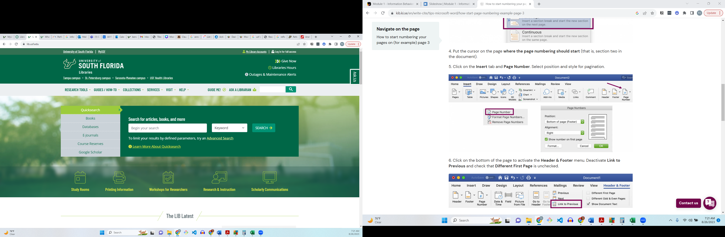

Advanced Search

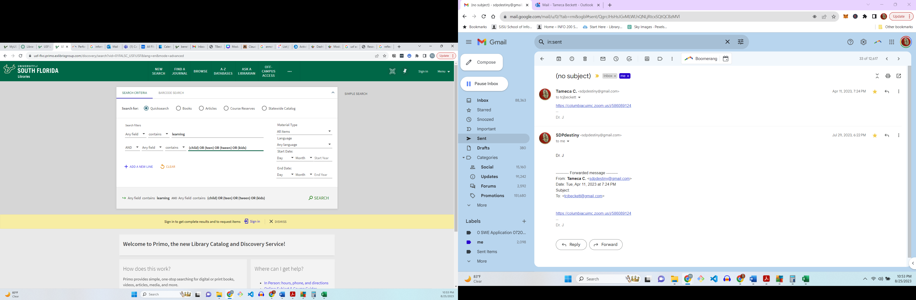

[USF LibGuide – Advanced Searching Tips](https://guides.lib.usf.edu/c.php?g=451607&p=6882185)

[Performing Advanced Searches](https://knowledge.exlibrisgroup.com/Primo/Product_Documentation/020Primo_VE/Primo_VE_(English)/150End_User_Help/02Performing_Advanced_Searches_in_Primo_VE)

**APA Citation Format (articles)**

APA citations for **articles** are formatted using the following structure:

**Author, F. M. (Publication Year). Article title. *Journal title*, *Volume(*Issue*)*, pp-pp. http://doi:xx.xxx/xxx**

Cummins, J. (2011). What Are Jewish Boys and Girls Made Of?: Gender in Contemporary Jewish Teen and Tween Fiction. *Children’s Literature Association Quarterly*, *36(*3*)*, 296–317. https://doi.org/10.1353/chq.2011.0033

Denny, H., Nordlof, J., & Salem, L. (n.d.). "Tell me exactly what it was that I was doing that was so bad": Understanding the needs and expectations of working-class students in writing centers. *Writing Center Journal*, *37*(1), 67–98. <https://www.jstor.org/stable/26537363>

**List 6 references you found during your search using APA article citations.**

Li, L., He, W., Xu, L., Ash, I., Anwar, M., & Yuan, X. (2019). Investigating the impact of cybersecurity policy awareness on employees’ cybersecurity behavior. *International Journal of Information Management*, *45*, 13–24. <https://doi.org/10.1016/j.ijinfomgt.2018.10.017>

Sulaiman, N. S., Fauzi, M. A., Wider, W., Rajadurai, J., Hussain, S., & Harun, S. A. (2022). Cyber–Information Security Compliance and Violation Behaviour in Organisations: A Systematic Review. *Social Sciences (Basel)*, *11*(9), 386–. <https://doi.org/10.3390/socsci11090386>

Ali, R. F., Dominic, P. D. D., Ali, S. E. A., Rehman, M., & Sohail, A. (2021). Information Security Behavior and Information Security Policy Compliance: A Systematic Literature Review for Identifying the Transformation Process from Noncompliance to Compliance. *Applied Sciences*, *11*(8), 3383–. <https://doi.org/10.3390/app11083383>

 Kannelønning, K., & Katsikas, S. K. (2023). A systematic literature review of how cybersecurity-related behavior has been assessed. *Information and Computer Security*. <https://doi.org/10.1108/ICS-08-2022-0139>

*Connolly, L. Y., Lang, M., & Wall, D. S. (2019). Information Security Behavior: A Cross-Cultural Comparison of Irish and US Employees. Information Systems Management, 36(4), 306–322.* [*https://doi.org/10.1080/10580530.2019.1651113*](https://doi.org/10.1080/10580530.2019.1651113)

Donalds, C., & Osei-Bryson, K.-M. (2020). Cybersecurity compliance behavior: Exploring the influences of individual decision style and other antecedents. *International Journal of Information Management*, *51*, 102056–16. <https://doi.org/10.1016/j.ijinfomgt.2019.102056>

**Search Process Reflection**

**Reflect on your search process:**

(What did you learn about your information behaviors? What surprised you about the search? Which search gave you the best results? Did you need to refine anything during the process?)

**I learned that information behaviors are mostly focused on what happens in the workplace environment or how humans interact with each other. What surprised me about the search is that people went and researched this with cybersecurity. The one that gave me the best result was Information behavior security research with the 3rd concept. I had to move the words around a bit and tried a few different combinations.**

**Anatomy of an Article**

**Summarize the difference sections of an article in your own words:**

Cyber–Information Security Compliance and Violation Behaviour in Organisations: A Systematic Review

Abstract – Organizations are vulnerable due to humans being involved and human behavior factors associated with Cybersecurity need to be further studied from a more theoretical perspective. It is going to focus more on violations with compliance and personnel.

Introduction – Humans essentially are the biggest cyber threat to organizations as they are the cause for cybercrimes.

Literature Review – Article mentions the other theories such as GDT and CET theory and explains further on the TPB model

Methodology –SCOPUS was used, as well as other databases that were listed as well as only using English language articles

Results - Shows that overall PMT was most frequently used after 14 studies

Discussion – PMT is the most fundamental theory in cyber security so organizations can protect their assets they must teach their employees how to prevent issues from occurring

Conclusion – overall shows that security policies need to be implemented to prevent attacks form happening in organizations and it starts with better educating humans on actions that can make the organization more vulnerable

TCB – Revised Aug. 2023