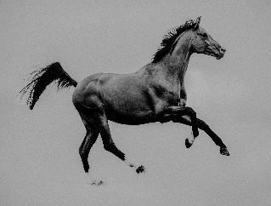
American Standardbred Adoption Program Inc.
S6039 Pedretti Lane
De Soto, WI 54624
harnessracers@gmail.com
608-792-5126
www.americanstandardbredadoptionprogram.com
I, __________________________________________, hereby give consent to and assign

Ownership of ________________________, which is a(n) ______ year old _________________

_________________________, with tattoo # _____________, to the American Standardbred
Adoption Program, Inc. Registration papers: _____Yes _____No Regardless of the delivery or non delivery of said registration papers, owner hereby transfers all of its right, title, and interest in said horse to ASAP Inc. Owner represents and warrants that it is the owner of the horse being donated and is free and clear of all encumbrances and claims by third parties.
ASAP Inc. guarantees that this horse will not be raced, sold, or transferred according to a signed agreement between ASAP Inc. and the adopter. Concerning mares, and the wish of the adopter to breed:
_______Owner hereby gives consent to breeding of the above-named horse
_______Under no circumstances should this horse ever be bred.
Date: ________________ Phone #: _________________________
Signature of Owner: ______________________________________________
Address of Owner: ______________________________________________
Phone: _______________________

