
VACATION BIBLE SCHOOL 2020
Daily Schedule- Day 1

Monday: Called into Community

Station  (Click name on for link to video or PDF explaining each activity in detail) | Activity | Photo | Materials | Instructions  (Watch the video for detailed instructions)
Opening Worship  (Video) | Singing, watching a skit, and listening to a message | 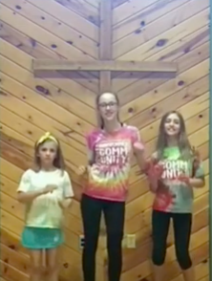 | Your great singing voice | Follow along with the video
Devotion  (PDF) | Reading, discussing, creating, and praying around a single Bible story. | 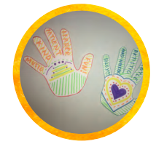 | Markers, scissors, paper | Read the Bible passage.  Discuss the reading and answer the questions listed.  Trace your hand and draw pictures or write the gifts you bring to the community. Decorate and cut out.  Hand prayer: each finger on your hand represents something different to pray for.
Arts and Crafts  (Video) | Paper Chain Dolls | 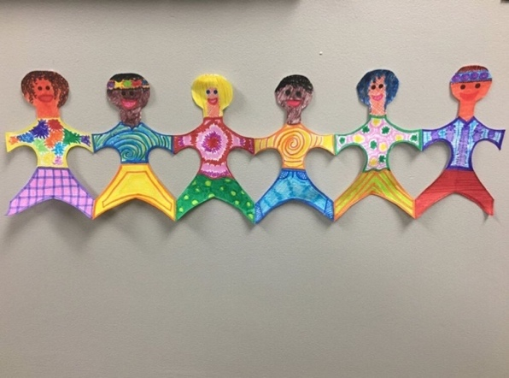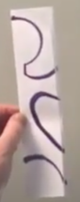 | Plain white printer paper, Pencil, Markers, Scissors, something circular to trace for head | Fold paper accordion style (about 1 inch per fold).  Draw an outline of a half a person on the top layer.  Cut it out and unfold the paper.  Decorate as you want.
Outdoor Explore  (Video)  Bingo Boards Ideas (PDF)  Bingo Boards  Blank (PDF) | Nature Bingo | 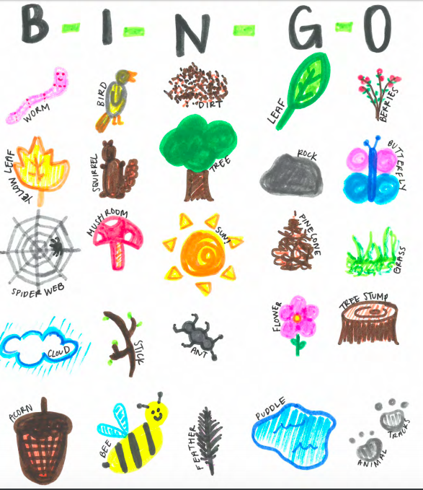 | Paper, Markers | Make a 5 square by 5 square table or print out a blank bingo board.  Fill the table by drawing or writing with things you would find outside. 1 item per square. Look at the PDF for ideas.  Go outside, take a walk, and try to get 5 in a row.
Snack  (Video) | Eat one of the snacks provided in your bag or make an apple yogurt parfait | 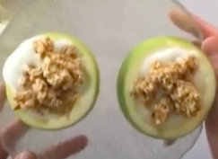 | Apples, Yogurt, Favorite yogurt topping (granola, fruit, etc.), Knife, Cutting board | Cut up apples- can either cut up apples into small pieces and put into a bowl OR cut apple in half horizontally and take the core out of the center. This apple will be your bowl.  Add yogurt to bowl.  Add toppings to bowl.
Service Project  (Video) | Cards and Letters | 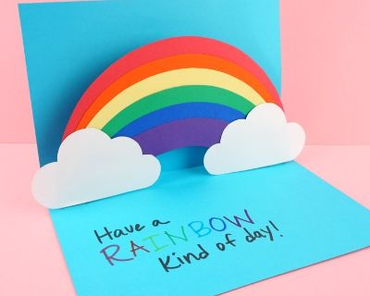 | Construction paper and markers | Make cards for people. Show God’s love to people that you love. Mail them or deliver them.
Closing Worship  (Video) | Singing, watching a skit, and listening to a message | 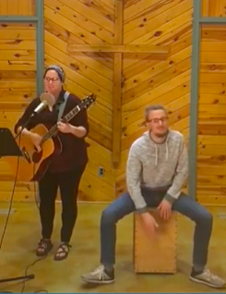 | Your great singing voice | Follow along with the video

