VACATION BIBLE SCHOOL 2020
Daily Schedule- Day 2

Tuesday: Bigger than a Building

Station  (Click on name for link to video or PDF explaining each activity in detail) | Activity | Photo | Materials | Instructions  (Watch the video for detailed instructions)
Opening Worship  (Video) | Singing, watching a skit, and listening to a message | 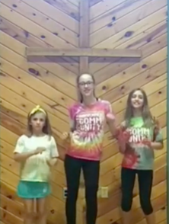 | Your great singing voice | Follow along with the video
Devotion  (PDF) | Reading, discussing, creating, and praying around a single Bible story. | 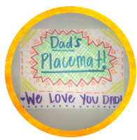 | White paper, Markers or crayons, Construction paper cut into strips | Read the Bible passage.  Discuss the reading and answer the questions listed.  Grab a piece of white paper and decorate it with your name, things you like, etc. This is going to be your placemat for meal time. Share a meal together (maybe dinner) and talk about three things that you are grateful for in your life.  Prayer for the church: Write down as many people you can think of from church on the construction paper slip and say a short prayer for that person. Make a paper chain out of all the pieces of construction paper. Hang it somewhere in your house and each time your pass it say a short prayer for the church.
Arts and Crafts  (Video) | Stained Glass Cross | 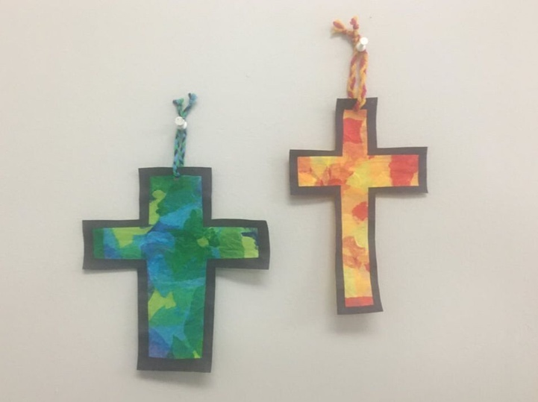  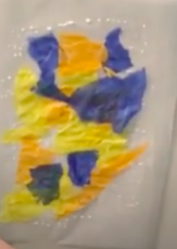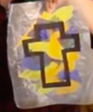 | Wax paper, Liquid Glue, Water, Small cup (to mix glue and water in), Paint brush, Tissue paper, Scissors, piece of construction paper, yarn, hole puncher | Lay your piece of wax paper down flat on a table.  Mix equal parts glue and water into a cup with your paintbrush.  Paint a layer of glue (in approximately a rectangular shape) onto the wax paper.  Stick your tissue paper pieces onto the glue in any pattern.  Add another layer of glue onto the top of the tissue paper to make it stick down.  Set aside for 20 minutes and wait for the glue to dry.  Fold your construction paper in half and cut out half of a cross. Unfold and hold it by your wax paper/tissue paper rectangle. Make sure the cross is about the same size as your wax paper/tissue paper rectangle. Cut smaller if needed.  Refold the construction paper cross in half and cut out the center of the cross, leaving about a ½ inch border or outline of the cross.  Unfold the cross and glue on top of the wax paper/tissue paper.  Wait for glue to dry and cut out the cross.  Hole punch the top.  Cut a piece of yarn about 6 inches.  Thread the yarn though the hole at the top of the cross and tie a knot.  Hang your stained-glass cross in a window.
Outdoor Explore  (Video)  Tic Tac Toe Rock Ideas (PDF) | Nature Tic Tac Toe | 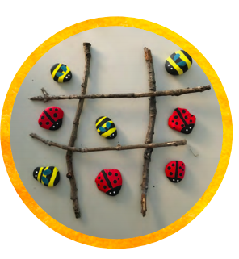 | 4 sticks about the same length, 10 rocks, Paint, and paintbrush | Paint 5 rocks the same pattern and the other 5 rocks a different pattern. It can be anything found in nature! Make a tic tac toe board using sticks. Play the game with a family member or friend.
Snack  (Video) | Eat one of the snacks provided in your bag or make a big sandwich | 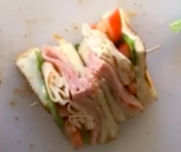 | Sandwich making supplies, Toothpicks, Knife, and cutting board | Make a sandwich with any toppings. Cut it in half diagonally. Then cut it in half again so the piece is ¼ of the entire sandwich. Stack the two pieces together and secure with a toothpick. Repeat with the other half of the sandwich.
Service Project  (Video) | Sidewalk Chalk | 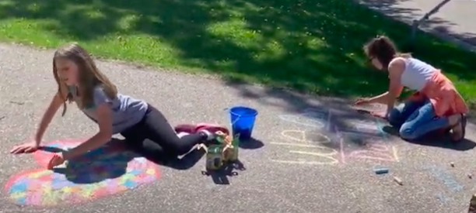 | Chalk | Write positive messages or draw inspirational pictures on your driveway or sidewalk. Draw them big so that the people walking by can see them and feel God’s love.
Closing Worship  (Video) | Singing, watching a skit, and listening to a message | 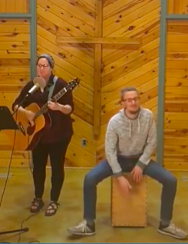 | Your great singing voice | Follow along with the video

