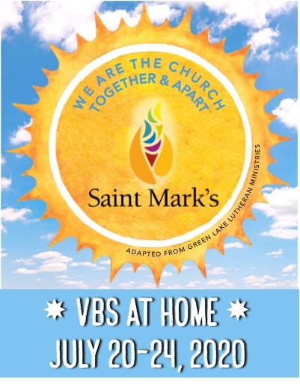
VACATION BIBLE SCHOOL 2020
Daily Schedule- Day 3

Wednesday: Following Our Faith

Station  (Click on name for link to video or PDF explaining each activity in detail) | Activity | Photo | Materials | Instructions  (Watch the video for detailed instructions)
Opening Worship  (Video) | Singing, watching a skit, and listening to a message | 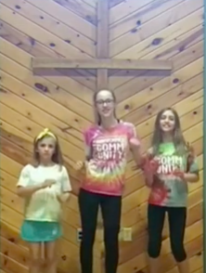 | Your great singing voice | Follow along with the video
Devotion  (PDF) | Reading, discussing, creating, and praying around a single Bible story. | 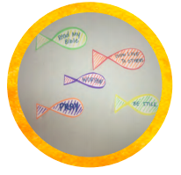 | Writing utensils, Scissors, white paper, blindfold (can use a bandana, towel, strip of construction paper)  Optional: crayons, markers, glitter, googly eyes, stickers, etc. | Read the Bible passage.  Discuss the reading and answer the questions listed.  Create an obstacle course with anything around your home. Go through the course blindfolded and have family members guide you with their voices. Trust your family to make it through safely!  Today’s prayer is for following Jesus.  Draw 5 fish on a piece of paper and decorate them.  Cut them out.  On each fish write something that you can do to follow Jesus.  Pray that you can work on doing these things to follow Jesus.  Put them somewhere in your house and each time you walk by them, you can be reminded to follow Jesus.
Arts and Crafts  (Video) | Tie Dye Paper Plates and Filters | 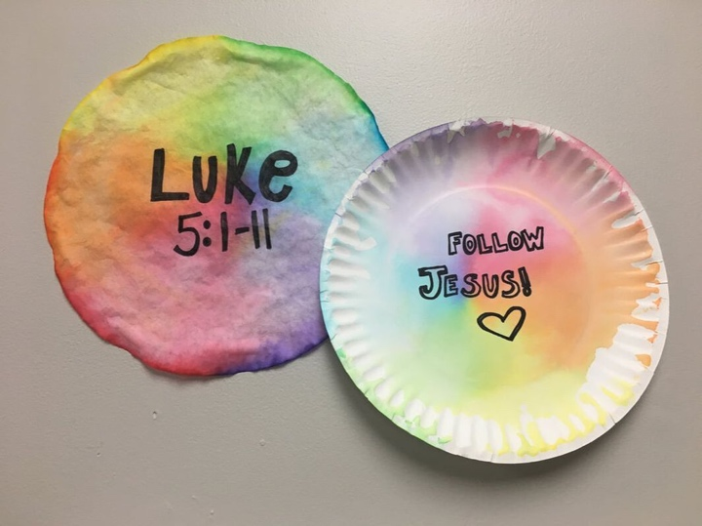 | Coffee filters, Paper plates,  Markers, Sharpie, Squirt bottle with water (or use a cup of water and paper towel to dab) | Fill your squirt bottle or cup with water.  Decorate coffee filter with marker. Fill with as much color as you can!  Set directly on top of paper plate.  Squirt or dab (with paper towel and water) the coffee filter. Get coffee filter pretty damp with water until color starts to bleed.  Press the coffee filter down with your fingers.  Repeat spray and press process 3 times.  DO NOT PEEL COFFEE FILTER OFF OF PAPER PLATE!  Set project aside to let dry for about 20 minutes.  After project is dry, take sharpie and decorate both tie dye projects. Decorate with words to help you remember to follow Jesus. Hang in house as a reminder.
Outdoor Explore  (Video)  Bird Feeder Ideas (PDF) | Bird Feeders | 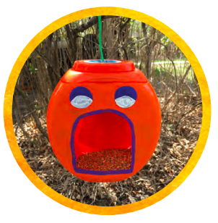 | Recycled containers (juice/milk carton, laundry jug, etc.), Paint, Box cutter or scissors, Bird Seed, Hole punch or tape, Yarn to hang finished project | Go through recycling bin and find a container that you want to use as a bird feeder.  Cut a hole in container that a bird could get through.  Paint container and decorate it.  Let container dry.  Cut about a 12-inch-long piece of a yarn.  Hole punch, thread, and tie a piece of yarn OR tape a piece of yarn on your container.  Go outside and find a spot to hang your bird feeder.  Fill your container with bird seed, hang it, and wait for the birds to come.
Snack  (Video) | Eat one of the snacks provided in your bag or make Chocolate Covered Pretzel Crosses | 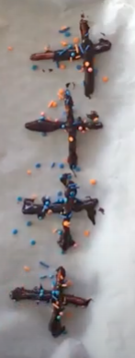 | Pretzels, Chocolate Chips, Milk, Pot to melt chocolate in (or microwave safe bowl), Sprinkles, Wax paper, pan (cookie sheet) or plate, Gloves | Line pan (cookie sheet) or plate with a piece of wax paper. Set aside.  Put a little bit of milk on bottom of pan. Heat up on stove using low heat.  Add half a bag chocolate chips using stove or microwave using low heat.  Make sure you keep stirring all edges of the pan to make sure the chocolate doesn’t burn! Add more milk or chocolate until it is the right consistency.  Transfer chocolate to bowl. Put on gloves.  Add pretzels to bowl and stir until pretzels are covered in chocolate.  Use two pretzels to make a cross.  Add sprinkles on top to decorate.  Put in fridge for about 15-20 minutes.  Once chocolate is solid and pretzels are sticking together, eat the crosses!
Service Project  (Video) | Plants | 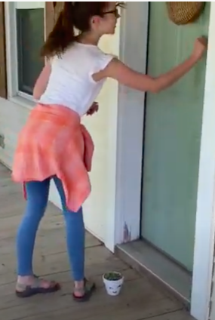 | A singing voice (doesn’t have to be good!), Flower pot (or a recycled cup or container), Paint, Markers, Seeds, and soil (or already planted flowers or grass) | Pick a song that your neighbors would enjoy and would show God’s love. Practice while working on planting.  Decorate flower pot with markers or paint.  Let dry.  Fill with soil and seed or preplanned flowers.  Go to a neighbor’s house, set the plant down on their front step, ring the doorbell, and take a step back.  When the answer the door, sing your song, and share God’s love!
Closing Worship  (Video) | Singing, watching a skit, and listening to a message | 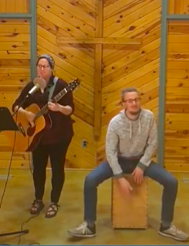 | Your great singing voice | Follow along with the video

