
VACATION BIBLE SCHOOL 2020
Daily Schedule- Day 4

Thursday: Following Our Faith

Station  (Click on name for link to video or PDF explaining each activity in detail) | Activity | Photo | Materials | Instructions  (Watch the video for detailed instructions)
Opening Worship  (Video) | Singing, watching a skit, and listening to a message | 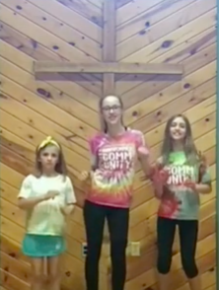 | Your great singing voice | Follow along with the video
Devotion  (PDF) | Reading, discussing, creating, and praying around a single Bible story. | 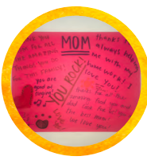 | Paper (any kind), markers, pen or pencil | Read the Bible passage.  Discuss the reading and answer the questions listed.  Create an affirmation sheet for each family member today. Each person should take a piece of paper and write their name at the top of it.  Take turns passing the papers around to the various family members, taking time to  write (or draw!) some affirmations (things you love, appreciate and value) about the  person whose name is at the top of the sheet.  Prayer for the world:  Go outside together and find a quiet place to sit. Try to spend 5 minutes in silence, just letting yourself take in what is  happening around you. After 5 minutes, share what you noticed.  Pray for these things together as a family!
Arts and Crafts  (Video) | Yarn and Paper Plate Hearts | 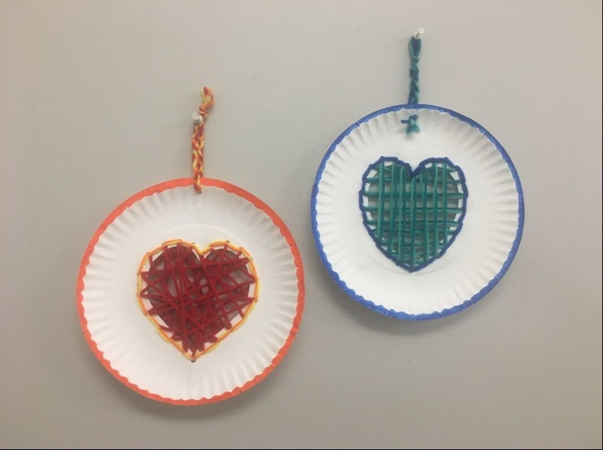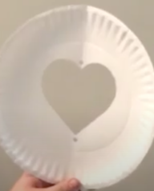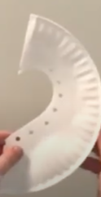  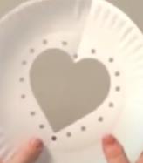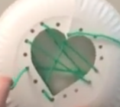  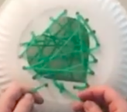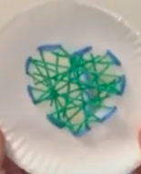  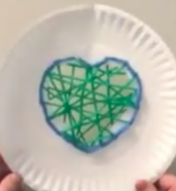 | Paper plate, Hole puncher, Yarn (two colors) Scissors, Markers | Fold paper plate in half.  Trace half of a heart in center.  Cut out heart on line drawn.  Unfold plate. You should see a heart in the center.  Hole punch 1 hole on the top center in between the two humps and the bottom center on point. (See picture)  Fold paper plate in half again.  Continue hole punching evenly spaced holes around the edge of the heart.  Unfold paper plate.  Take a piece of yarn (about 3 feet long) and start weaving it through the holes in the paper plate. Go back and forth across the heart in any order.  When you run out of string, flip paper plate over and tie a new piece of string onto the end. Continue weaving string until entire heart is filled.  Tie end of strings together and cut off extra yarn.  Take a piece of yarn that is a different color (about 4 feet long) and weave through holes to create a border that outlines the heart.  Weave through holes on border 1 more time to fill in the gaps.  Tie strings together and cut off excess string.  Decorate paper plate with markers or glue a piece of string around the edge of the circle border.  Hole punch a single hole in the top center of your paper plate.  Cut a piece of yarn (about a foot). *You could cut two pieces and braid together.  Thread yarn piece into single hole and tie a knot.  Hang paper plate heart.
Outdoor Explore  (Video)  Nature Journal (PDF) | Nature Journal | 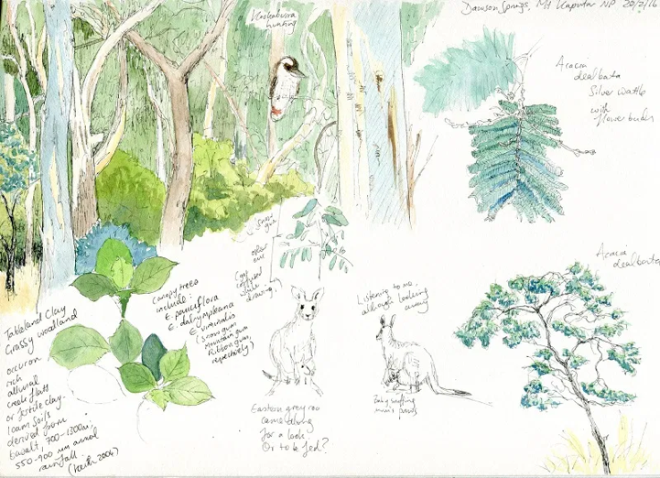 | Printed Nature Journal  OR  2 pieces of plain white paper and Stapler  ALSO,  Markers or Crayons, Pen or Pencil, stickers (optional) | Create a journal by folding two pieces of paper in half and stapling the edges.  Label each of the pages with the prompts.  First, decorate the cover with pictures and your name.  Then, go outside and fill up the pages by doing each activity. You can write or draw to answer  You can space out the activities throughout the day.
Snack  (Video) | Eat one of the snacks provided in your bag or make cinnamon roll hearts | 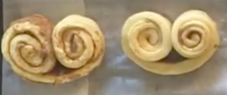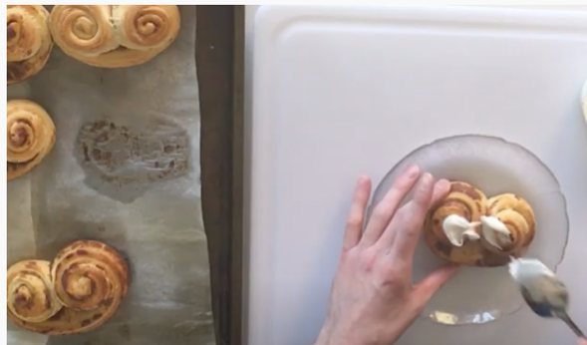 | Tube of cinnamon roll dough, Pan | Open can of cinnamon rolls.  Remove cinnamon rolls from can and unroll them.  Take one of the long strands and put it on its side.  Roll up the two ends at the same time towards the middle, creating a heart.  Bake for time directed on container.  Frost with frosting from can.  Eat, enjoy, and remember God’s love.
Service Project  (Video) | Creation Clean Up | 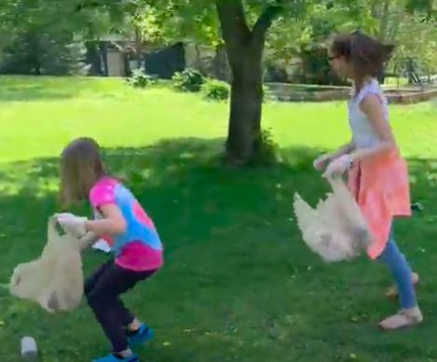 | Trash bag or plastic bag and gloves | Take a walk and look at God’s beautiful creation. Put on your gloves and bring your garbage bag with you.  On your walk, pick up garage or anything that you see that shouldn’t be in creation.  Serve your neighbor, show God’s love, and be the church wherever you are.
Closing Worship  (Video) | Singing, watching a skit, and listening to a message | 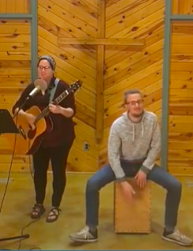 | Your great singing voice | Follow along with the video

