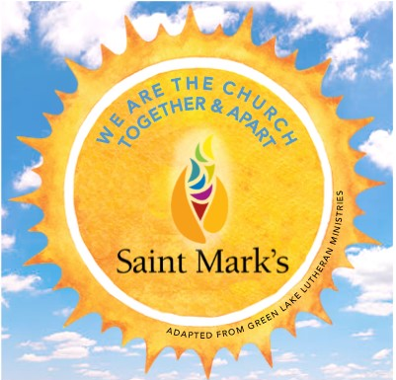

WELCOME TO ST. MARK’S LUTHERAN CHURCH’S AT HOME VACATION BIBLE SCHOOL 2020!

Check the church website (Under the “Resources” tab) or Facebook page daily to download the online schedule. The schedule lists the name of the activity, materials needed for the activity, and summary of how to complete the activity. The title of each activity contains a link to a video explaining the activity more in depth.

We are excited for you to join us on this awesome adventure! VBS can be completed at any time during the day. Don’t forget to share pictures of your family and friends participating on the Facebook page.

If you have any questions, feel free to contact Rachel Ericson at rachelericson1@gmail.com

WE ARE THE CHURCH: TOGETHER AND APART

