Hugo Arturo Verduzco
Professor Khadka
English 113B

26 October 2024

Seeds of Controversy
Genetically Modified Organisms (GMOs) have become one of the most significant innovations in modern agriculture. They offer the potential to enhance crop yields, reduce pesticide use, and improve food security in regions facing hunger. Despite these potential benefits, GMOs remain a deeply divisive issue, stretching far beyond questions of health and environmental safety. It raises profound concerns about corporate control over seeds, the impact on farmers. As companies like Monsanto and Bayer hold patents on genetically modified seeds, farmers are often caught in a cycle where they are forced to purchase new seeds each season, limiting their independence and economic stability. This issue is personal to me as I am currently studying for my BS in Biochemistry and plan to work with GMOs to improve our food supply but mainly our biodiversity.
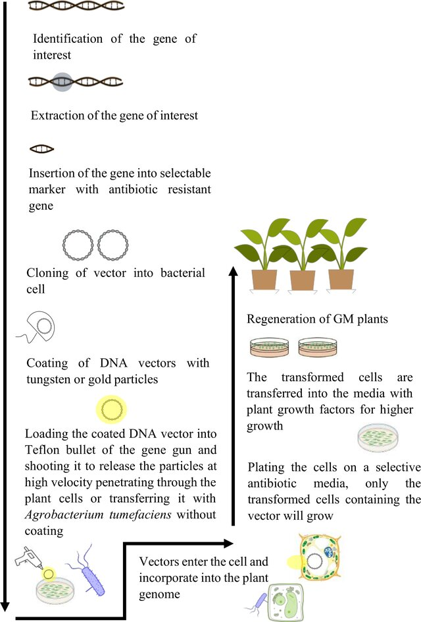
“A genetically modified organism (GMO) is any organism whose genetic material has been altered by using genetic engineering techniques; an organism altered in a way that does not occur naturally by mating and/or natural recombination" (Karapareddy 71). In the 1970s, the discovery of Agrobacterium tumefaciens; a bacteria that forms a tumor-inducing (Ti) plasmid into the plant cells, was used as a tool for genetic engineering. Scientists have exploited this natural mechanism by removing the genes responsible for tumor formation and replacing them with T-DNA, desired genes, usually through co-cultivation. After co-cultivation, the plant cells are transferred to a selective medium that promotes the growth of only those cells that have successfully integrated the T-DNA. These cells can then be regenerated into whole plants through tissue culture techniques. In agriculture, GMOs are primarily used to enhance crop yields, improve resistance to pests, and increase tolerance to environmental stresses such as drought or extreme temperatures.
Illustration of genetic modification of crops. Identification of gene of interest, its isolation, and insertion into the genome of a desired plant species. Plants are regenerated and commercialized.
The first genetically modified plant was created in 1983 when scientists inserted a gene into a tobacco plant, making it resistant to antibiotics. This experiment paved the way for further innovations, and by 1988, researchers had developed genetically modified tomatoes. The company Calgene produced the first GM crop to be commercially available in the United States was the FLAVR SAVR™ “a GE tomato that had a trait for delayed ripening ”(National Research Council) extending its shelf life and reducing waste. These breakthroughs demonstrated the potential for GMOs to revolutionize food production and distribution. In the 1990s, corporate involvement in developing and selling genetically modified crops surged. Monsanto introduced herbicide-resistant crops, most notably through its Roundup Ready seeds, which were genetically modified to withstand glyphosate, a herbicide Monsanto itself developed.
By patenting genetically modified seeds, Monsanto—now part of Bayer—dramatically altered agricultural practices. Traditionally, farmers saved seeds from previous harvests, but Monsanto enforces strict licensing agreements that legally bound farmers to purchasing seeds annually, strengthening Monsanto's control over the agricultural market. This corporate control over seed ownership has sparked significant legal and ethical debates, raising concerns about the monopolization of the global food supply. One well-known case involved Canadian farmer Percy Schmeiser, who was sued by Monsanto.
"In 1998, tests revealed that 95 to 98 percent of his 1,000 acres of canola crop was made up of Roundup Ready plants. The origin of the plants is unclear. They may have been derived from Roundup Ready seed that blew onto or near Schmeiser's land, and was then collected from plants that survived after Schmeiser sprayed Roundup herbicide around the power poles and in the ditches along the roadway bordering four of his fields"​(Cullet-MonsantovSchmeiser 84).
Schmeiser claimed the seeds had blown onto his fields without his knowledge, but Monsanto argued he had violated their patent by growing and harvesting the crop. The case brought international attention to the concern of seed patents, questioning the fairness of holding farmers liable for seeds they may not have intentionally planted.
The ethical debate surrounding seed ownership seeks to balance the need to reward companies for their innovation while ensuring that farmers can farm sustainably. Critics argue that patenting seeds commodifies a natural resource and gives corporations excessive control over the global food supply. Proponents, however, claim that patents are necessary to incentivize innovation and fund the development of new, more resilient crop varieties. While this debate centers on the ownership of genetic innovations, it is closely tied to the broader socioeconomic divide.
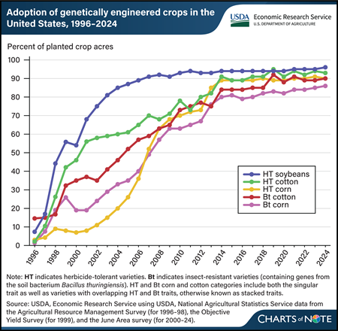
In countries like the United States, where GMO adoption is widespread, farmers benefit from increased crop yields and reduced reliance on pesticides. Supported by strong infrastructure and access to advanced technology, the U.S. agricultural sector has embraced GMOs on a large scale, with crops like GM corn, soybeans, and cotton dominating the market. This widespread adoption has allowed large agribusinesses to thrive, while biotech companies reap significant profits.
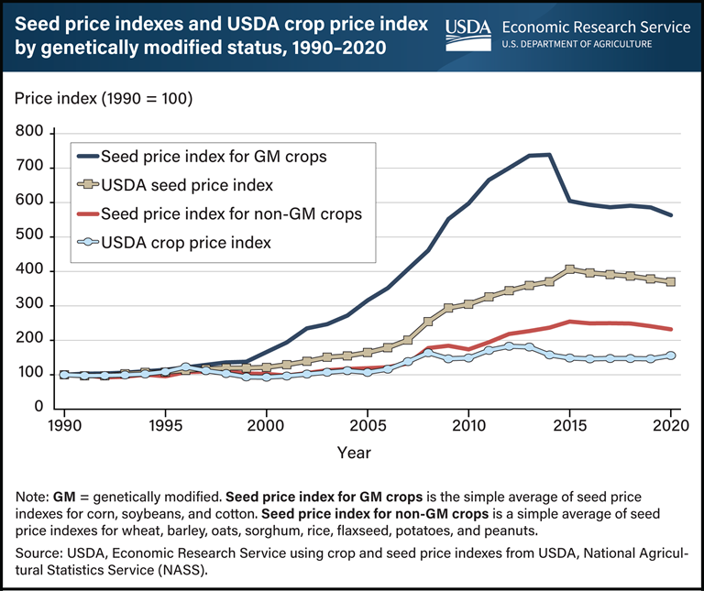
In contrast, countries like India face significant challenges in accessing and adopting GMOs. In India, while Bt cotton—the only legally approved GM crop—has led to higher yields for some, however many find themselves trapped in a cycle of debt, exacerbated by their dependency on purchasing new seeds each season. However, even in the U.S., small-scale farmers often struggle financial due to the recurring costs of purchasing seeds each season. The graph reflects the indexal price increase by percentage; 2020 about a 575% increase for GM crops. Moreover, ongoing resistance to GM food crops, such as GM mustard, further limits access to GMO technology. Despite GM mustard being developed by Indian scientists to increase yields and reduce reliance on imported edible oils, it has faced strong opposition from environmental groups, farmer organizations, and policymakers. The main valid concerns being potential health risks, biodiversity loss due to cross-pollination with non-GM varieties, and increased corporate control over agriculture.
I conducted a survey asking friends to answer ten questions about GMOs, instructing them to respond based on their existing knowledge without additional research. The responses reveal a notable skepticism toward GMOs. Many participants expressed concerns about seed patents held by major companies; as one respondent put it, "It keeps the little guys down and corporations on top" (@scat392). Additionally, several voiced unease over the artificial nature of GMOs, with one participant remarking, "I would think anything not natural in food would be very bad in the long run" (@alphasilverback), reflecting a broader view; that GMOs are unnatural and may carry unforeseen consequences.
The financial burden of GM seeds was another significant theme, with multiple respondents noting the inherent advantage of traditional seeds being "free." As one participant observed, "I guess in theory they should be cheaper than traditional because in theory, traditional is ‘free’… Plant the seeds and they automatically replicate" (@scat392). Some respondents suggested a balanced approach to seed ownership that would preserve both economic benefits and farmer independence. One respondent explained, “There probably is an economic benefit to GMO seeds but I don't think smaller farmers should be banned from seed saving just for corporate greed. I think there could be a balance; small farmers could keep seeds and have smaller orders in future years from corporations, to help reduce costs to small farmers” (@queenkris). These perspectives emphasize the cost-related challenges GMOs introduce, contrasting sharply with the self-sustaining model of traditional farming. While respondents recognized the potential agricultural benefits of GMOs, their answers suggest that current corporate and regulatory practices overshadow these advantages, deepening the economic divide within the farming community.
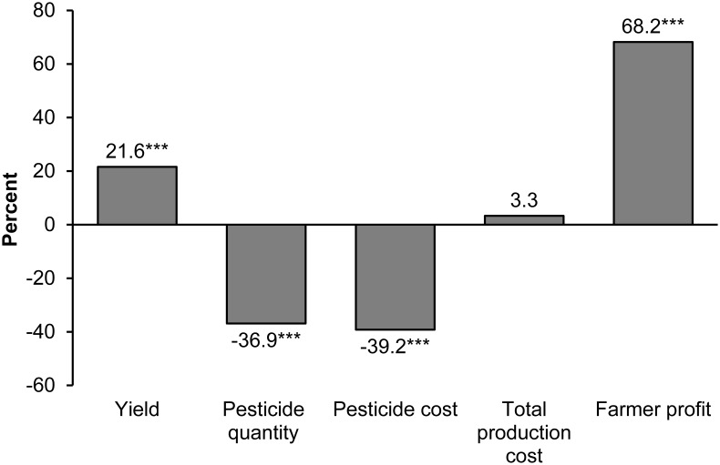
While perception of GMOs focuses on its risks, there are significant advantages that make them a valuable tool, specifically in addressing global food insecurity. One of the most commonly cited benefits of GMOs is their ability to increase crop yields, especially in regions prone to environmental stressors such as drought or poor soil quality. This increase in productivity has the potential to address food shortages in low-income regions, where agricultural production often lags due to limited access to technology and resources. This meta-analysis reviewed 147 studies examining agronomic and economic impacts of GM soybean, maize, and cotton. Findings indicate, the adoption of GM technology has been associated with a reduction in chemical pesticide use by 37%, an increase in crop yields by 21%, and a 68% rise in farmer profits (Klümper). Yield gains and pesticide reductions were notably greater for insect-resistant (IR) crops relative to herbicide-tolerant (HT) crops, and farmers in developing countries experience higher yield and profit gains from GM crop adoption than those in developed countries (Klümper).
Average percentage differences between GM and non-GM crops are shown. Results refer to all GM crops, including herbicide-tolerant and insect-resistant traits. The number of observations varies by outcome variable; yield: 451; pesticide quantity: 121; pesticide cost: 193; total production cost: 115; farmer profit: 136. *** indicates statistical significance at the 1% level.
Figure 2. Impacts of GM crop adoption.
In addition to improving yields, GMOs can also contribute to greater food security by reducing the need for chemical inputs such as pesticides and herbicides. Crops engineered to resist pests, such as Bt cotton and Bt corn, have significantly reduced the use of chemical pesticides in countries like India, China, and the United States. This not only lowers production costs for farmers but also has positive environmental impacts, such as reducing water contamination and preserving beneficial insect populations (Qaim). Given these advantages, GMOs have the potential to alleviate global hunger, especially in regions susceptible to climate change and population growth.
The use of GMOs in agriculture is not without controversy, particularly regarding their impact on biodiversity. Monoculture farming—growing a single crop over large areas—is often associated with GMO adoption due to the efficiency it offers in production. However as research highlights, "monoculture systems, particularly those using genetically modified crops, are more likely to suffer from biodiversity loss, which in turn weakens the ecosystem's natural ability to recover from pest outbreaks or changing environmental conditions"(Klümper). A clear example is Argentina's soybean industry, where in recent studies, "the widespread use of glyphosate, particularly in genetically modified crop systems, has led to significant biodiversity loss by harming non-target plant species and affecting soil microorganisms, which are essential for ecosystem functioning"(Hilbeck). The loss of biodiversity in such systems undermines long-term agricultural sustainability, leaving crops more vulnerable to pests and diseases.
Preserving biodiversity is essential for maintaining resilient food systems. Diverse agricultural practices, such as intercropping and crop rotation, help buffer against environmental shocks and reduce dependence. In contrast, monocultures supported by GMOs may erode the natural food systems, putting food production at greater risk in the event of a pest or disease outbreak. Finding a balance between GMO innovation and biodiversity preservation is crucial for sustainable agriculture.
The GMO debate is a complex balancing act between innovation and responsibility. While GMOs offer powerful tools to address global food insecurity by improving crop yields and reducing chemical use, their benefits must be fairly accessible to all; not monopolized by corporations. Balanced regulations are essential to ensure that GMO technology can expand without compromising biodiversity or undermining the independence of small farmers. Real progress requires cooperation between companies, governments, and the farming communities. Corporations need to recognize the broader impact of their patents and business models; even if it diminishes profit, and governments must enforce fair practices that allow farmers to thrive without sacrificing their rights. By focusing on solutions that address both the global food crisis and environmental sustainability, we can work toward a future where agricultural technology serves not only the interests of profit but the well-being of the planet aswell.

Work Cited
Aziz, Mughair, Faïçal Brini, Hatem Rouached, and Khaled Masmoudi. "Genetically Engineered Crops for Sustainably Enhanced Food Production Systems." Frontiers in Plant Science, vol. 13, 2022, doi:10.3389/fpls.2022.1027828.
Brookes, Graham, and Peter Barfoot. "Environmental Impacts of Genetically Modified (GM) Crop Use 1996–2018: Impacts on Pesticide Use and Carbon Emissions." GM Crops & Food, vol. 11, no. 4, 2020, pp. 215-241.
Cullet, Philippe. “Monsanto v Schmeiser: A Landmark Decision Concerning Farmer Liability and Transgenic Contamination.” Journal of Environmental Law, vol. 17, no. 1, 2005, pp. 83–108. JSTOR, http://www.jstor.org/stable/44248498. Accessed 26 Oct. 2024.
Discord users: @queenkris, @alphasilverback, @scat392, @armadillohole. Responses to survey about genetically modified organisms. Conducted by Hugo Arturo Verduzco, 22 Oct. 2024. Survey.
Hilbeck, Angelika, Hartmut Meyer, Brian Wynne, et al. "GMO Regulations and Their Interpretation: How EFSA’s Guidance on Risk Assessments of GMOs is Bound to Fail." Environmental Sciences Europe, vol. 32, 2020, https://doi.org/10.1186/s12302-020-00325-6.
Karapareddy, K. Sowndarya. "Genetically Modified Organisms." Volume 2 – Issue 6, June 2021, Department of Agricultural Biotechnology, College of Agriculture, Kerala Agricultural University, Vellayani, Thiruvananthapuram, 695522, India. ResearchGate, https://www.researchgate.net/publication/372947683. Accessed 10 Oct. 2024.
Klümper, Wilhelm, and Matin Qaim. “A Meta-Analysis of the Impacts of Genetically Modified Crops.” PLOS ONE, vol. 9, no. 11, e111629, 3 Nov. 2014, doi:10.1371/journal.pone.0111629.
National Research Council (US) Committee on Genetically Modified Pest-Protected Plants. Genetically Modified Pest-Protected Plants: Science and Regulation. National Academies Press (US), 2000. National Center for Biotechnology Information, https://www.ncbi.nlm.nih.gov/books/NBK424540/. Accessed 23 Oct. 2024.
Qaim, Matin, and David Zilberman. "Yield Effects of Genetically Modified Crops in Developing Countries." Science, vol. 299, no. 5608, 7 Feb. 2003, pp. 900-902. American Association for the Advancement of Science, https://www.jstor.org/stable/3833617.

Survey (Discord)
Hello Guys, I have a research assignment I could use your input on. It's a 10 question survey about GMO's. (Don't do any research, just answer with the current knowledge you have) General GMO Awareness and Perception:
- How familiar are you with genetically modified organisms (GMOs) in food production?
- Do you think GMOs are beneficial or harmful to society? Why?
Seed Ownership and Corporate Control:
- Are you aware that some corporations (like Monsanto/Bayer) own the rights to genetically modified seeds?
- Do you believe farmers should have the right to save seeds from one harvest to the next, or should companies be able to enforce patents on seeds?
(Follow-up: How do you think this affects farmers, especially small-scale or traditional farmers?)
- In your opinion, does corporate control over seeds and food production benefit or harm local and global food systems?
Socioeconomic Implications:
- Do you think GMOs increase or decrease global food inequality?
- How do you feel about the cost of seeds for farmers? Should GM seeds be priced differently than traditional seeds?
(Follow-up: Should governments or international organizations regulate these prices to help farmers in poorer regions?)
- Do you think the economic benefits of GMOs (such as higher crop yields) outweigh the costs to small farmers, such as being forced to buy new seeds every season?
(Follow-up: Do you believe there’s a fair balance between the profit for corporations and the benefits for farmers?) Personal Opinion on Solutions:
- What do you think should be done to ensure fair practices in seed ownership and global food production?
(Follow-up: Should there be more regulations on seed patents, or should companies have the right to control the seeds they develop?)
- Would you support policies that limit corporate ownership over seeds and promote the right for farmers to save seeds?
(Follow-up: Do you believe such policies would make a difference in reducing food inequality?)

Resposes to Survey
@queenkris
Qūeen — 10/24/2024 at 5:28 PM
Hello Ladies & Gents, I have a research assignment I could use your input on. It's a 10 question survey about GMO's. (Don't do any research, just answer with the current knowledge you have). Just answer what you can, Thank you! General
GMO Awareness and Perception: How familiar are you with genetically modified organisms (GMOs) in food production? somewhat familiar
Do you think GMOs are beneficial or harmful to society? Why? harmful because nature made it the way it should be, genetically modifying changes it from its original state which I believe can't be good.
Seed Ownership and Corporate Control: Are you aware that some corporations (like Monsanto/Bayer) own the rights to genetically modified seeds? Yes I am aware
Do you believe farmers should have the right to save seeds from one harvest to the next, or should companies be able to enforce patents on seeds? (Follow-up: How do you think this affects farmers, especially small-scale or traditional farmers?) yes I think farmers should have the right to save seeds. In addition, if companies modify these seeds I don't see why they couldn't keep a patent. I think it hurts small farmers a lot, being able to save seeds would definitely be much better for farmers.
In your opinion, does corporate control over seeds and food production benefit or harm local and global food systems? harm food systems, to much regulation on farming isn't good.
Socioeconomic Implications: Do you think GMOs increase or decrease global food inequality? decrease but I know many countries don't allow GMOs and we probably shouldn't either
How do you feel about the cost of seeds for farmers? Should GM seeds be priced differently than traditional seeds? (Follow-up: Should governments or international organizations regulate these prices to help farmers in poorer regions?) I think all seeds should be affordable so farmers can grow the food for everyone. I think the government has enough to do they should leave farming alone.
Do you think the economic benefits of GMOs (such as higher crop yields) outweigh the costs to small farmers, such as being forced to buy new seeds every season? (Follow-up: Do you believe there’s a fair balance between the profit for corporations and the benefits for farmers?) There probably is an economic benefit to GMO seeds but I don't think smaller farmers should be banned from seed saving just for corporate greed. I think there could be a balance, small farmers could keep seeds and have smaller orders in future years from corporations, to help reduce costs to small farmers.
Personal Opinion on Solutions:
What do you think should be done to ensure fair practices in seed ownership and global food production? (Follow-up: Should there be more regulations on seed patents, or should companies have the right to control the seeds they develop?) I think less regulation from the government and patents on seeds should be limited, and seed saving allowed.
Would you support policies that limit corporate ownership over seeds and promote the right for farmers to save seeds? (Follow-up: Do you believe such policies would make a difference in reducing food inequality?) Yes I would support policies that limit corporate ownership over seeds and promote farmers rights. I think more people would farm if costs were lowers so I think that would be a huge impact on food inequality.

@ alphasilverback
Silverback — 10/24/2024 at 6:38 PM
General GMO Awareness and Perception: How familiar are you with genetically modified organisms (GMOs) in food production?
1) Not very much at all.
Do you think GMOs are beneficial or harmful to society? Why?
2) I would think anything not natural in food would be very bad in the long run.
Seed Ownership and Corporate Control: Are you aware that some corporations (like Monsanto/Bayer) own the rights to genetically modified seeds?
3) I do. I know that they will sue other companies that have traces of those seeds in their corn and such.
Do you believe farmers should have the right to save seeds from one harvest to the next, or should companies be able to enforce patents on seeds?
4) I am not sure how I feel about this. I feel emotionally the answer is no. But logically, they own what they make and that make sense to me.
(Follow-up: How do you think this affects farmers, especially small-scale or traditional farmers?)
5) It absolutely does.
In your opinion, does corporate control over seeds and food production benefit or harm local and global food systems?
6) Hurts them. All corporations hurt small and local businesses. They just get muscled out.
Socioeconomic Implications:
Do you think GMOs increase or decrease global food inequality?
7) I honestly do not know. I would think the decrease would be due to the fact that food production without it would be outnumbered or under bid. Look how it’s cheaper to order MacDonalds than it is to make a fruit salad at home.
How do you feel about the cost of seeds for farmers? Should GM seeds be priced differently than traditional seeds?
8) I have no idea.
(Follow-up: Should governments or international organizations regulate these prices to help farmers in poorer regions?)
9) No.
Do you think the economic benefits of GMOs (such as higher crop yields) outweigh the costs to small farmers, such as being forced to buy new seeds every season?
10) No. Health of our people is much more important. We can better the economy in many other ways.
(Follow-up: Do you believe there’s a fair balance between the profit for corporations and the benefits for farmers?)
11) I am ignorant of this topic.
Personal Opinion on Solutions:
What do you think should be done to ensure fair practices in seed ownership and global food production?
12) Not sure how to answer that question. I know that Asia and Europe have a lot more laws that make sure you are not ingesting stuff that we do here in the US. But I am ignorant of the specifics.
(Follow-up: Should there be more regulations on seed patents, or should companies have the right to control the seeds they develop?)
13) I do believe they should have control over the seeds, but... that does not mean they have the right to sell them.
Would you support policies that limit corporate ownership over seeds and promote the right for farmers to save seeds?
14) Depends on the details.
(Follow-up: Do you believe such policies would make a difference in reducing food inequality?)
15) They could if done correctly.

@scat392
Cuda 10/24/2024 at 8:05 PM
1: I have a very basic knowledge of it. My knowledge is based off of what I come across in videos
- I think if its not natural then it’s harmful. People try to make things “better” or more “convenient” but end up doing more harm than good in the process
- Yes, I’m aware. This issue has been centuries in the making and we are beyond screwed
- Sadly, if the government doesn’t get the biggest cut then this is the result. Greed and control and breeding sheepole. Most of the crops are modified to produce sterile crops so farmers can’t even grow their own even if they wanted to. There’s probably a very small select group that can grow their own but not on a large scale to make a difference
- It keeps the little guys down and corporations on top. No different than what they do to mom and pop places. The small businesses have to raise their prices just to catch up and that price hike drives away the would be loyal customers to corporations
- In short, nothing that’s deemed basic human right shouldn’t be controlled. By that I mean, the ability to live and sustain yourself without the government shouldn’t even be a question. We did it to ourselves

- I guess in theory they should be cheaper than traditional bc in theory, traditional is “free”. Plant the seeds and they automatically replicate. It’s the GMOs that you have to keep planting every year and keep modifying
- No
I’ll have to fill you in on the rest. I’m at work and wasn’t expecting an essay

@armadillohole
Chromed Up — Today at 9:24 PM
- I am not super educated/informed/ knowledgeable on the topic
- I think a pro to having GMOs are that they can be tailored/specified to be more sustainable against natural diesters/inclement. So they can withstand more natural weathers, due to the chemical engineering. They also allow for higher production at lower costs. From what I know, they are also tested against normal allergens so people don't have to worry as much about allergic reactions.
I also feel like a con would be that, since they are chemically engineered, they could add to antibiotic resistance that causes problems for some peoples immunity/resistance to diseases and cures and could potentially lead to adding to "superbugs" as they can be immune to some pesticides.
- I did not know that some company's had patents on the seeds
- From my limited knowledge, I do believe farmers should be able to save seeds for next harvest. I'd assumed that they save the best seeds for cultivation the following year. I feel like properly saving seeds for the following year would a) decreased the cost of starting new plants/growth b) if it is a good batch, they would want to reproduce it
(I am tired, to be continued)

Bt stands for Bacillus thuringiensis, a soil bacterium that produces proteins that are toxic to certain insects. Bt cotton is a genetically modified (GMO) crop that contains genes from the bacterium, which causes the plant to produce insecticidal proteins.

