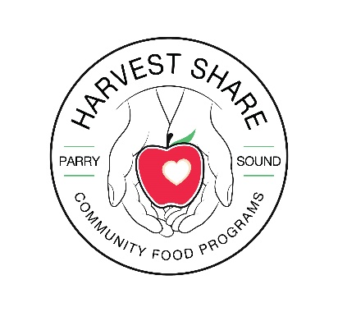
Food Bank Intake Form
First & Last Name:________________________________________________________
Phone Number:___________________________ Birth Date: ___________________
(YYYY/MM/DD)
Email: ____________________________________________________________
Source of income (Please mark one)
Ontario Works (OW)__ Canada Recovery Caregiver Benefit (CRCB)__ No Income__ OAS__ WSIB__
Canada Recovery Sickness Benefit (CRSB)__ Canada Worker Lockdown Benefit (CWLB)__ Other__
CERB (Canada Emergency Response Benefit)__ Child Support__ Child Tax Benefit__ CPP__ EI__
Employed Part-Time__ Employed Full-Time__ Private Disability__ Private Pension__ Student Loans__
Provincial Disability(ODSP)__ Scholarships__ Spouse/Family Support__ Universal Child Care Benefit__
Gender (Please mark one)
Female __ Male __ Transgender __ Other __ Prefer Not To Answer __
Ethnicity/Origin/Race (Please mark one)
Prefer not to answer__ Indigenous__ White__ South Asian__ Chinese__ Black__ Filipino__ Latin American__ Arab__ West Asian__ Korean__ Japanese__ South East Asian __ Other__ Didn’t Ask__ Don’t Know__
Disability (Please mark one)
Yes__ No__ Prefer Not To Answer__ Don’t Know__ Didn’t Ask__
Have you lived in Canada for more than 10 years (Please mark one)
Yes__ No__ Prefer Not To Answer__ Don’t Know__ Didn’t Ask__
(if the answer is no Month/Year of arrival in Canada______________)
Are you currently a University or College Student (Please mark one)
Yes__ No__ Prefer Not To Answer__
Highest Education Level Completed (Please mark one)
Grade 0-8__ Grade 9-11__ Highschool Diploma__ OAC__ Post Secondary(some)__
Trade Certificate/Professional Accreditation__ 2 Year Degree__ 4 Year Degree__
Masters Degree__ PHD__ Don’t Know__ Didn’t Ask__ Prefer Not to Answer__
Country of Education: ______________________

Address (include apartment or unit numbers & Postal Code)
_____________________________________________________________________________________
Housing type (Please mark one)
Emergency Shelter / Mission / Transitional___ Evacuee __ Own Home__ Private Rental__ Unhoused__ Public (Social) Housing __ Undisclosed__ Youth Home/Shelter__ Didn’t Ask__ With Family/Friends__ Other__ Don’t Know__ Prefer Not to Answer___
Referred By (Please mark one)
Client/Family/Friend__ EI__ Unions__ Media/News/Outreach__ ODSP__ OW__
Other Food Bank Agency__ Programs within agency__ Didn’t Ask__ Don’t Know__
Prefer Not to answer__ Other (Please Specify)_________________________
Dietary Considerations
Prefer not to answer__ Didn’t Ask__ Don’t Know__ Diabetic__ Other (please Specify)__
___________________________________________________________________________
Other Household Members
First & Last Name Birth Date(YYYY/MM/DD) Relationship Gender
_____________________________________ _________________ ______________ ____
_____________________________________ _________________ ______________ ____
_____________________________________ _________________ ______________ ____
_____________________________________ _________________ ______________ ____
_____________________________________ __________________ ______________ ____
Pets (cats/dogs please list how many and what kind): ________________________
Instant/Perked coffee(which do you prefer?): ____________________
Do you drink Tea (herbal, black, orange pekoe?): ____________________
Do you use Sugar or Whitener (please list): ______________________
Signature: ______________________________________

