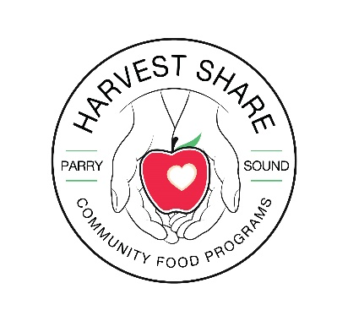**Food Bank Intake Form**

**First & Last Name:**________________________________________________________   
  
**Phone Number:**___________________________ **Birth Date:** ___________________  
 **(YYYY/MM/DD)  
Email: _______________________________________________________________**

**Gender** **(Please mark one)**Female __ Male __ Transgender __ Other __ Prefer Not To Answer __  **Address: (include apartment or unit numbers & Postal Code)**

**_____________________________________________________________________________________  
  
Housing type (Please mark one)**  
Emergency Shelter / Mission / Transitional___ Evacuee __ Own Home__ Private Rental__ Unhoused__ Public (Social) Housing __ Undisclosed__ Youth Home/Shelter__ Didn’t Ask__ With Family/Friends__ Other__ Don’t Know__ Prefer Not to Answer___  
 **Referred By (Please mark one)**  
Client/Family/Friend__ EI__ Unions__ Media/News/Outreach__ ODSP__ OW__   
Other Food Bank Agency__ Programs within agency__ Didn’t Ask__ Don’t Know__   
Prefer Not to answer__ Other (Please Specify)_________________________ **Ethnicity/Origin/Race** **(Please mark one)**   
Prefer not to answer__ Indigenous__ White__ South Asian__ Chinese__ Black__ Filipino__ Latin American__ Arab__ West Asian__ Korean__ Japanese__ South East Asian __ Other__ Didn’t Ask__ Don’t Know__ **Disability** **(Please mark one)**Yes__ No__ Prefer Not To Answer__ Don’t Know__ Didn’t Ask__  
  
**Have you lived in Canada for more than 10 years** **(Please mark one)**Yes__ No__ Prefer Not To Answer__ Don’t Know__ Didn’t Ask__   
**(if the answer is no Month/Year of arrival in Canada______________)  
  
Are you currently a University or College Student (Please mark one)**Yes__ No__ Prefer Not To Answer__  
 **Other Household Members   
 First & Last Name Birth Date(YYYY/MM/DD) Relationship Gender**_____________________________________ _________________ ______________ ____  
  
_____________________________________ _________________ ______________ ____  
  
_____________________________________ _________________ ______________ ____  
  
_____________________________________ _________________ ______________ ____  
  
_____________________________________ __________________ ______________ ____

**Highest Education Level Completed** **(Please mark one)**Grade 0-8__ Grade 9-11__ Highschool Diploma__ OAC__ Post Secondary(some)__   
Trade Certificate/Professional Accreditation__ 2 Year Degree__ 4 Year Degree__   
Masters Degree__ PHD__ Don’t Know__ Didn’t Ask__ Prefer Not to Answer__  
  
**Country of Education:** ______________________

**Source of income (Please mark one)**  
Ontario Works (OW)__ **Canada Recovery Caregiver Benefit (CRCB)__** No Income__ **OAS__** WSIB__  
**Canada Recovery Sickness Benefit (CRSB)__** Canada Worker Lockdown Benefit (CWLB)__ **Other__**  
CERB (Canada Emergency Response Benefit)__ **Child Support__** Child Tax Benefit__ **CPP__** EI__  
**Employed Part-Time__** Employed Full-Time__ **Private Disability__** Private Pension__ **Student Loans__**  
Provincial Disability(ODSP)__ **Scholarships__** Spouse/Family Support__ **Universal Child Care Benefit__  
  
Dietary Considerations (If this does not apply to you, please leave this section blank)**Prefer not to answer__ Didn’t Ask__ Don’t Know__ Diabetic__ Other (please Specify)__

___________________________________________________________________________

**Pets (cats/dogs please list how many and what kind):** ________________________   
  
**Instant/Perked coffee(which do you prefer?):** ____________________   
 **Do you drink Tea (herbal, black, orange pekoe?):** ____________________  
  
**Do you use Sugar or Whitener (please list):** ______________________

|  |  |
| --- | --- |
|  | HARVEST SHARE COMMUNITY FOOD PROGRAMS          Informed Consent Information Sheet |
|  |  |

Harvest Share Community Food Programs is always striving to improve our services for our clients. Through the collection of each client's information, we are able to view the larger picture.

This allows us to better serve the main needs of the community.

All personal information collected is also helpful in creating statistical data, which we share with Food Banks Canada so that they may help meet our needs.

All information that is collected is stored in a safe and private manner.

Please add your signature to show that you have understood this information and if there is anything you are unsure of, please ask for clarification.

**\*Please understand that deciding that you don't want your personal information used for any reason, does not affect your ability to continue to take part in our food programs.\***

Thank you for your help with this matter!

* Your Harvest Share Family

Signature: ______________________________________