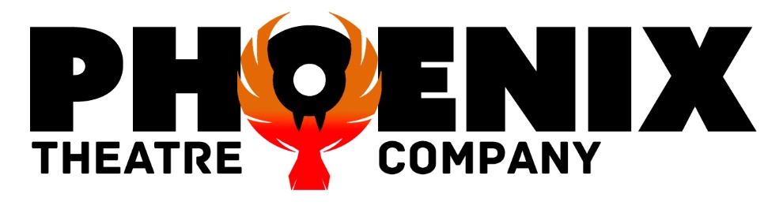

**PRESENTS**

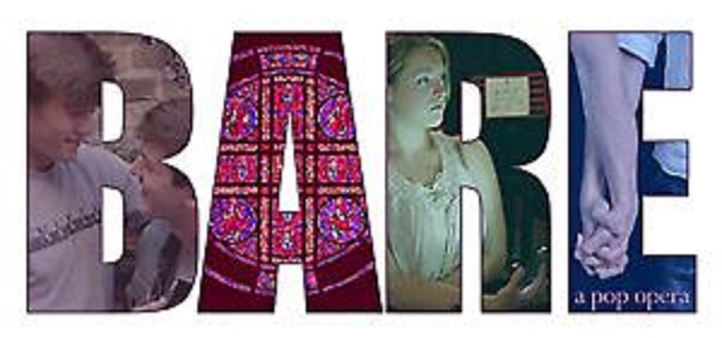

**YOUNG ADULT PRODUCTION**

A pulsating, electric contemporary rock opera, *Bare* follows a group of students at a Catholic boarding school as they grapple with issues of sexuality, identity, and the future. Peter and Jason have fallen in love with each other, but Jason, a popular athlete, fears losing his status if he is discovered to be gay. Unpopular Nadia, Jason’s sister, is contemptuous of Ivy, a beautiful girl with a questionable reputation. As the group attempts to put on a production of *Romeo and Juliet*, tensions flare, self-doubt simmers, and God’s path seems more difficult to find than ever. *Bare* rings with the sounds of youthful repression and revolt. With a unique sung-through pop score, heart-pounding lyrics, and a cast of bright young characters, *bare* is a provocative, fresh, and utterly honest look at the dangers of baring your soul, and the consequences of continuing to hide

At:

The Spire

Eastern Road

Brighton BN2 5JN

PERFORMANCES:

Wednesday April 10th 7:30pm

Thursday April 11th 2:30pm

Friday April 12th 7:30pm

Saturday April 13th 7:30pm

AUDITIONS:

Sunday November 25th, 6pm onwards

Hove (venue tbc)

REHEARSALS:

Sunday evenings 6pm – 9.30pm in Hove starting January 2019

(More may be added if necessary)

Technical rehearsal: 08/04/19

Dress rehearsal: 09/04/19

OUR TEAM:

Director: Amanda West 07764 713905

Musical Director: Marc Yarrow Marc@marcyarrowmusic.co.uk

Assistant MD

& Choreographer: Brogan West 07710 192415

Technical Director: Raefn Webber 07443 937558

Safeguarding/

Administrator: Harris West 07764709489

Show fee payable: £120 (£30 instalments on 01/01, 01/02, 01/03, 01/04)

All cast members will receive a free t-shirt.

You MUST notify one of the team if you cannot attend a rehearsal, preferably in time for scenes etc to be rearranged. If you are unwell, please contact one of the above to let them know as soon as you can.

We are looking for a vocally strong cast, aged 16 plus, who can pass for students.

Ability to move is useful. We will have a short rehearsal period and will expect all cast members to work on their characters and vocal lines before rehearsals start.

**Characters:**

Jason Male Baritone

Peter Male Tenor

Ivy Female Soprano

Matt Male Tenor

Nadia Female Mezzo-Soprano

Lucas Male Baritone

Claire Female Mezzo-Soprano

Sister Chantelle Female Soprano

Priest Male Baritone

Tanya Female Soprano

Kyra Female Alto

Diane Female Alto

Rory Female Soprano

Zach Male Baritone

Alan Male Tenor

Ensemble Male/Female Various

We do not hold audition prep, nor do we have any pre-conceived ideas about who we want to cast.

These are open auditions.

Please bring your own interpretation and originality.

Phoenix Theatre Company believes in the ability of cast members to contribute to direction, and to become involved in the shaping of the production.

Casting will be decided based on your audition performance on the day.

We will be using film during this production and cast members need to make themselves available to shoot on dates to be confirmed.

**AUDITION PIECES:**

Males: Role of a Lifetime

Females: All Grown Up

No Voice (opening)

You may be cast in a role you have not auditioned for as you may be more suited to a role you haven’t thought about!

Some named/featured roles may be cast as rehearsals get underway, once the directing team gets to know each cast member.

Please e-mail [phoenixthco@gmail.com](mailto:phoenixthco@gmail.com) to book a time slot for 25/11/18

AUDITION FORM

Name: …………………………………………………………………………..

Age: …………………… Playing age………………………………..

Contact Numbers: …………………………………………………………………………………………………………………………………………………………………………

Email…………………………………………………………………………….

Role/s auditioning for: ……………………………………………………………………………………

Vocal range: …………………………………….

Height: …………………………………………..

Dance experience:………………………………………………………………

……………………………………………………………………………………

Singing:………………………………………………………………………………………………………………………………………………………………

Previous roles/productions:

……………………………………………………………………………………………………………………………………………………………………………………………………………………………………………………………………………………………………………………………………………………………………………………………………………………………………………………………………………………………………………………………………………………………………………………………………………………

Any medical issues/additional needs we need to be aware of (confidential):

…………………………………………………………………………………………………………………………………………………………………………