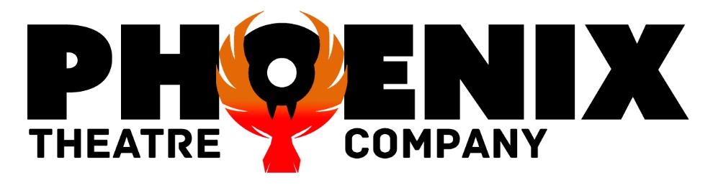

**\*\*\*MUSICAL THEATRE\*\*\***

**PERFORMERS**

**We are a fully inclusive youth theatre company and we love to sing!**

**We enjoy performing at rest homes, care homes and nursing homes, hopefully bringing an hour of joy to the residents.**

**We LOVE to sing songs from musicals such as My Fair Lady, Les Miserables, Phantom of the Opera, Oklahoma, Carousel, Oliver, The Sound of Music, Chitty, West Side Story, and so many more!**

**We also love to sing traditional pub songs, folk songs and singalong numbers. We hope you will join in with us.**

**We take requests, so if there is a particular musical you love, please let us know before we come along.**

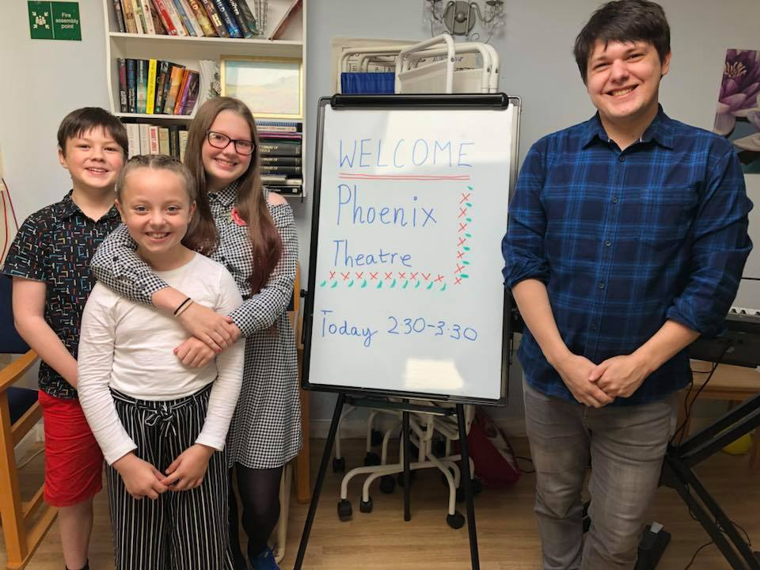

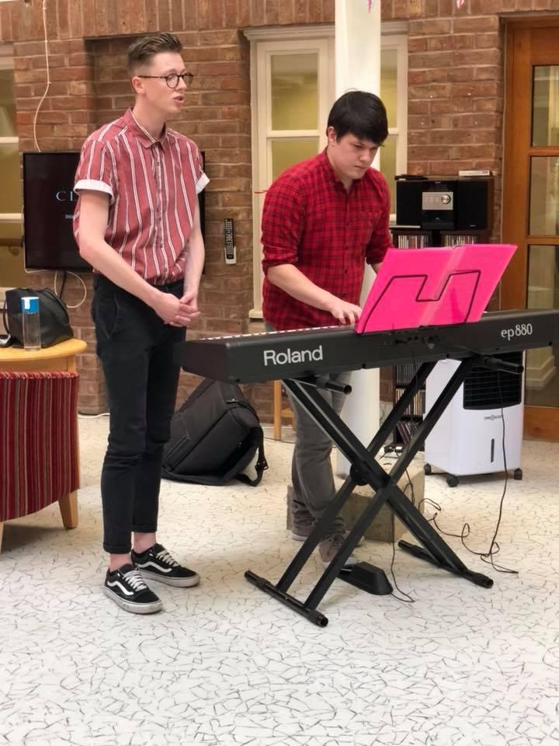

[**phoenixthco@gmail.com**](mailto:phoenixthco@gmail.com)

[**https://www.facebook.com/PHTHCO/**](https://www.facebook.com/PHTHCO/)

[**www.phoenixtheatrecompany.com**](http://www.phoenixtheatrecompany.com)

**07764 713905**