The History of Faith and Light USA East, from 1971 to 2021

Compiled by Kirt Bromley, Chaplain USA West

©2021 Faith and Light USA East

TABLE OF CONTENTS
Chapter One 3
Our National and Provincial Servants 3
Chapter Two Words from Our Leaders 5
A HISTORY OF FAITH AND LIGHT, U.S.A. by Pearl Cahoon 5
AN INTERVIEW WITH FATHER JIM O’DONNELL 11
AN INTERVIEW WITH BRIAN DAW 17
My History in Faith and Light – Maureen O’Reilly 23
A SUMMARY OF FAITH AND LIGHT HISTORY FROM BARBARA STEVENS 29
A REPORT FROM BILL AND DEBBIE CRAMSIE, 33
A REPORT FROM SISTER FLORITA RODMAN, C.D.P. 34
Chapter Three 36
History of some of the USA East communities over the past 50 years in alphabetical order 36
Chapter Four 44
A Parent Reflects 44
by Pastor Dave Gullman, Chaplain USA East 44
Chapter Five 46
A Faith and Light Pilgrimage to Lourdes, France 46
Jean Vanier’s Maundy Thursday Message 47
A Personal Journal of the Faith and Light Pilgrimage to Lourdes during Holy Week 2001 49

Chapter One

Our National and Provincial Servants

National Coordinators in order:
Pearl Cahoon
Rev. Cal Gengras,
Brian Daw,
Maureen O’Reilly,
Barbara Stevens
After 1994
USA East:
Sister Florita Rodman
Bill and Debbie Cramsie
Dolores Wilson and Fred Seagren
Maggie Demco
Joy Fuchs
USA West:
John and Diane Griffin
Ron and Lourdes Landry
Jerilynn Ciletti
Eileen Hermes
Michael Brault
Elizabeth Anderman
National Treasurer:
Eric Gauchat
Posie O’Connor
Salvatore LaBianca,
John O’Reilly,
Claire Butler,
After 1994
USA East:
Fred Seagren
Al Collassi
Becki Haller
USA West:
Edie Loughmiller
Bob Barnstable
National Chaplains:
Fr. Jim O'Donnell,
Fr. Bob Wagner,
Fr. Cal Gengras,
Fr. George Matejka
Fr. Jim Boyle.
After 1994
Provincial Chaplains for the USA East:
Fr. Giles LeVasseur,
Father Bob Malloy and
Father John Welch.
Pastor Dave Gullman
Provincial Chaplains of Faith and Light USA West:
Deacon Mike Ciletti, of Colorado Springs, CO, and
Sister Ursula Fotovich, CSJ
Kirt Bromley

Chapter Two Words from Our Leaders
Historical Reflections from the Founders

A HISTORY OF FAITH AND LIGHT, U.S.A. by Pearl Cahoon
the first National Coordinator of Faith and Light USA
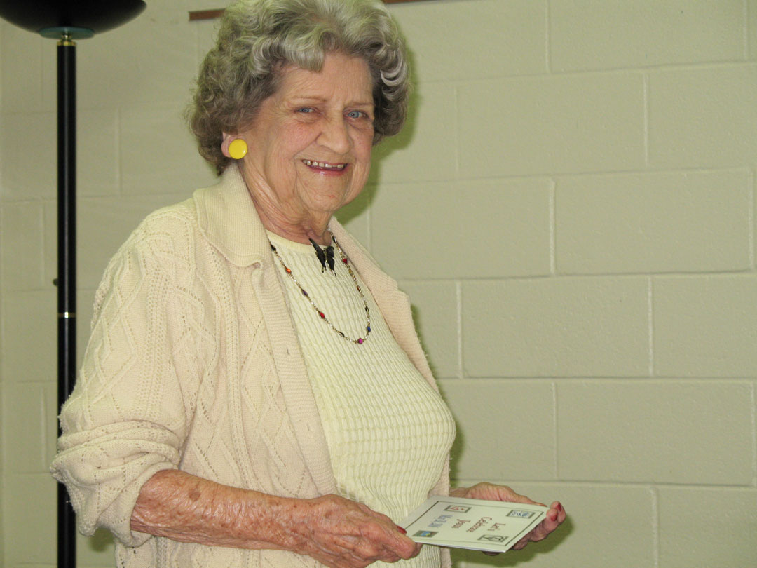
Faith and Light had its beginning in the United States with a Pilgrimage to Our Lady of Lourdes, France, in 1971. Fr. Jim O'Donnell was asked by his friend, Jean Vanier of France, to invite a group of persons with disabilities, parents and friends to join the pilgrimage with Faith and Light friends in Canada. Among those from Cleveland were Julie and Mary Elizabeth Ryan, Virginia and Mary Ann O'Brien, Dorothy, Todd and Colette Gauchat, Sr. Charles, Marge Gibbons, Marilyn Cunin, Richard Kohn and his mother, Richard and Beth Conway, Rosemary and Judy Smith, Delores and Marie McKinley, and David McDonald accompanied by his father and two brothers. In preparation for the pilgrimage, they met at the Chapel in Catholic Center, Cleveland, Ohio to become acquainted before the journey. Upon arrival in France, Jean Vanier and Fr. Bill Clark warmly greeted them. It was a wonderful spiritual journey ending with a Fiesta and the exchange of candies and small gifts. After the pilgrimage, Fr. Gillis from Hamilton, Canada invited the pilgrims to a special reunion at. St. Anne's in Hamilton, Ontario.
In 1973 Bishop James A. Hickey asked Fr. Jim O'Donnell and Fr. Phil Pritt to plan to take persons with disabilities to Rome in 1975 to pilgrimage with Faith and Light members from all over the world. A committee was formed and Posie O'Connor and Anita McEvoy were asked to coordinate the pilgrimage. I was chosen by the committee to represent the United States at the international preparation meetings in Rome. Meeting the representatives of so many countries, speaking so many different languages was an exhilarating experience. This was in the early days of Faith and Light before they were equipped with special radio headphones used for interpreting. Fr. Hvied of Helsingor, Denmark, was assigned to sit beside me and quietly translate while I put his words into shorthand. These meetings were intense and went from early morning into evening sessions. It happened about the third day that everyone broke into laughter and Fr. Hvied and I stopped. Jean Vanier, being very sensitive as to how exhausting this is for translators, pointed out to the members that he had switched to English and Fr. Hvied and I were so tired that we hadn't noticed. We joined in the laughter when we realized we were unconsciously treating the English language as one that needed translated for me.
Fr. Jim and Fr. Phil Pritt chartered two airplanes without knowing whether anyone would be interested. At departure time there were 410 pilgrims signed up and others who were disappointed because we had no openings. What better example of FAITH than to charter two planes and pray that people might be interested. Fr. Jim began a fund-raising campaign to assist families as well as to take individuals living in institutions on the pilgrimage. The campaign was successful. It was heartwarming to know individuals living in institutions would experience, not only their first airplane ride, but would have a never to be forgotten spiritual journey. The memories they would take back to the institution would warm and brighten their loneliest hours.
Fr. George Matejka and Fr. Ted Weiss were stationed in Rome at that time and were very helpful in making arrangements there. The Mass at North American College was one of the highlights of the Pilgrimage. The preparations were completed and we arrived in Rome and were greeted by Jean Vanier who helped with the myriads of luggage. Jean would drop the luggage to hug a friend he recognized.
0n Sunday the Pilgrims gathered for Mass at St. Peter's and at that time some handicapped pilgrims presented scrolls to Cardinal Poletti. After Mass, Pope Paul went among the pilgrims and talked with and blessed many of those in wheelchairs and showed much compassion for our brothers and sisters with handicaps. At the Torch Light Vigil in St. Peter's Square, he addressed the pilgrims from his window:
When our plane landed in Cleveland, Fr. Phil boarded the plane and called me to the front to tell me my son Ken, 31, had suffered a fatal heart attack the night before and he led me to my family who were sadly awaiting my return. I hesitate to mention this sorrow in my life and yet I feel it is important to share it with you. I loved my son who was a wonderful husband to Elaine and father to his two little girls, Chris 9 and Connie 5. If anyone told me I could continue to work in Faith and Light or the Apostolate after losing my son, I would have said, "impossible". I share this part of my personal experience only to stress the power of prayer. The 410 pilgrims remained on the plane when Fr. Jim announced what happened and they prayed for my family. Many cancelled their flights to other states to come to the funeral home the next evening. lnstead of falling apart, I had unbelievable strength and peace to do what had to be done. Through the years I have witnessed other Faith and Light families in times of serious illness or deaths and I have seen the power of prayer miraculously give them strength and acceptance -- with acceptance comes Peace!
Pope Paul VI: “You have a special place in the Church, where your simple faith, your prayer, the appeal for affection in your eyes, your generous heart, all remind Christians of the only ways which lead to God. You have a place in society where, thank God, you have many friends who love you and support you, and remember that they too depend on you.”
Jean Vanier asked us to return home to form small communities of people. Posie and I with friends would call the people together for a Celebration and 150 to 200 pilgrims who had been to Lourdes came together with their albums and memorabilia; friendships were forming at this time, but communities were not! In the meantime, at the request of International Faith and Light in France, we disseminated information to people through the United States and kept them interested in Faith and Light. These were seeds that were being planted, which would later bear fruit. In those days the literature came in French and had to be translated before we could type and xerox it for distribution. Today, everything comes in English and is beautifully printed.
In January 1977, Fr. Krasen, Posie and I went to a meeting in Chicoutimi, Canada with plenty of warm clothing. The Faith and Light meeting was well represented by people from Quebec, Newfoundland, Montreal, Toronto and the United States. Irene from Trosley, France was on hand to represent Jean Vanier. The people in wheelchairs gave us a picture they had drawn with a card attached giving the name, address and birthday of a person with a handicap. This was to encourage the recipient to respond with a birthday greeting and hopefully develop a friendship with the person. Neat idea! In 1978 the news came from International that another Pilgrimage to Lourdes was being planned for 1981. What would be different from the Rome Pilgrimage was that it would not be “x” number of strangers boarding the plane, but it would be open only to members of Faith and Light communities.
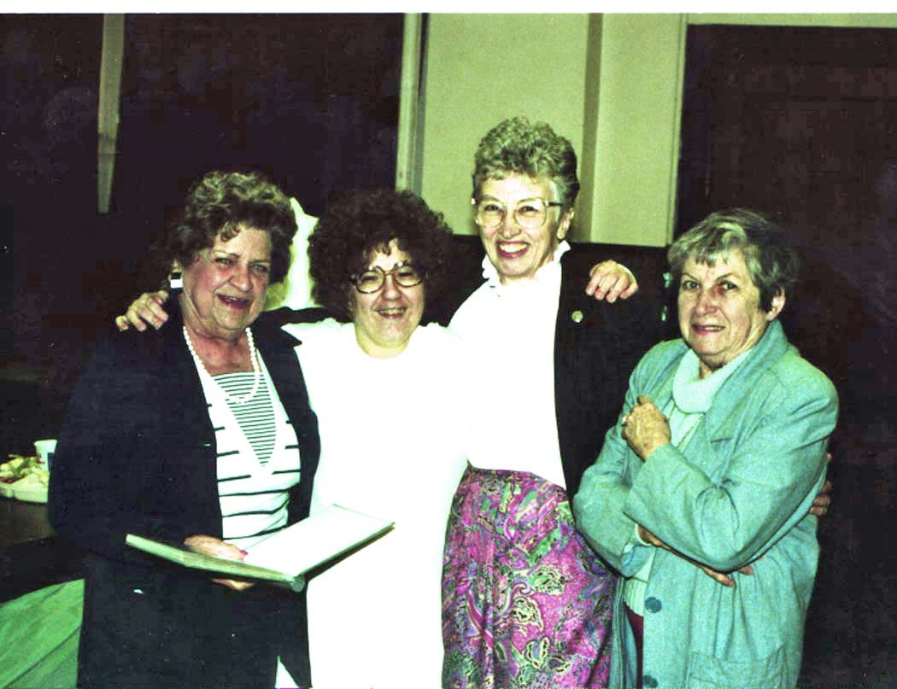
Pearl Cahoon, Tammy Fagan, _________ and Posie O’Connor
This was the magic that was needed. When this information went out, small communities began to form. Posie O'Connor with the Oden family were first to call people together at Oden's home, followed with Julie Ryan, the Murphy's, Virginia O'Brien, the LaBianca family, the Nose family, the Thomas family of Akron as well as communities in Wadsworth and Dayton. Not necessarily in that order, but in the same time frame, and all in Ohio. At the same time, communities were beginning to form through the efforts of Sr. Joan Magnani, Fr. Bob Wagner, Barbara Stevens, and, Sr. Pat Murphy in Massachusetts. In Connecticut, Kay Maloney and the Peterson's helped form the first community. In Jefferson, Wisconsin, Sr. Jeanne d'Arc started a community at St. Coletta Church. In California, Betty Britchgi (Diocese of San Diego)and Judi Garcia (St Rose of Lima, San Diego) helped start the first community. In Washington state, Sr. Mary Hurley, William Wightman, Adolph Meisch, and Danny and Teres Millar started communities. Later, Mark and Loretta Miller started a community in Witchita, Kansas. Again, the communities were formed about the same time, but not necessarily in that order.
In January 1978, Terry Gaydosh and her brother, Frank and I represented the United States at the Faith and Light Conference at Brussels, Belgium. Marie-Helene Mathieu was elected President of Faith and Light, giving Jean Vanier an opportunity to resign from the administrative work and to be free to travel and be more present to people. Betty Renaud of Canada was elected Coordinator of our Zone, the U.S. and Canada. After the Conference, we took a train to Trosley to visit with friends. The L'Arche homes in Trosley are located in a unique village with stone houses and narrow, hilly roads and dirt sidewalks. Jean Vanier started l'Arche with just two men many years ago and the village has hundreds of handicapped people living in homes through the village. L’Arche has spread throughout the world as a result of one man who believed people with developmental disabilities could live in harmony and enjoy richer lives by living in community. I really enjoyed sharing meals at these homes in such a peaceful and happy atmosphere and then watching everyone "pitch in" for the cleanup. In their simplicity, this community has truly found the secret of living amicably in community. That is not to say there are never problems, but when a person has anxieties, he is never alone ... he has his brothers and sisters to console him, just as they share their prayer, their meals, their leisure and their lives together.
The preparations for the 1981 Pilgrimage to Lourdes continued. Posie and I attended a meeting in Cork, Ireland in January 1979. Representatives of 17 countries were present, and leaders of Faith and Light stressed the importance of coming together in community at least once a month in preparation for a Pilgrimage to Lourdes in 1981. In Cleveland, a “Core Group” met regularly at Fr. Jim O’Donnell’s home for the 1981 Pilgrimage. Some of the people who came from out of state to join the Core Group were Kay Maloney and Fr. Cal Gengras from Connecticut, Fr. Bob Wagner from MA, and Sr. Paschal Nurre and Sr. Teresita from Iowa. Some of the Clevelanders were Terry Jungquist, Sandy Gross, Brian Daw, Dorothy Michaels, Ann Daw, Marge Gibbons, Fr. George Matejka, Pearl Cahoon, Eric Gauchat, Posie 0'Connor and Henry Oden. When the time of the Pilgrimage to Lourdes came, we were well prepared and had a wonderful experience of community, prayer and love.
In the early 1980s, Faith and Light was growing and some structure was necessary. A National Coordinator and National team were discerned in 1983. The first National Coordinators in order were myself from Cleveland, Ohio, Fr. Cal Gengras, from Hartford, CT, Brian Daw from Cleveland, Ohio; Maureen O'Reilly from Dearborn, Michigan and Barbara Stevens from Wellsfleet, MA. In my first years as National Coordinator, there were no communities. My term was spent in communication, writing letters, sending out materials and talking about Faith and Light to interested groups. That was followed with 17 years as National Secretary and 18 years publishing the National Newsletter.
Fr. Cal Gengras brought his gentleness, and was able to interest many people throughout the States when he talked at a NAMR Conference about Faith and Light. His term was cut short due to the serious illness of both of his parents.
Brian Daw was discerned Coordinator at a time when his special talents and expertise were needed. Brian was instrumental in incorporating Faith and Light as a non-profit with the IRS in April 27,1983. Once Faith and Light was given non-profit status, we applied and were awarded an annual grant from the American Bishops Catholic Mission. Under Brian’s leadership, we also began the National Newsletter and divided Faith and Light USA into regions.
Maureen O'Reilly was discerned as National Coordinator in 1986, and brought with her a quiet prayerfulness and the ability to make each person feel important. Maureen's term wasn't finished when she was discerned as International Co-Coordinator. It was a big challenge, but she managed it thanks to her many gifts and her great sense of humor.
Barbara Stevens was discerned National Coordinator in place of Maureen in 1989. She brought to the role, a deep sensitivity and understanding gained from personal experience. Her genuine honesty in expressing the love received from her son Paul, as well as her wisdom in relating some of the problems of parents, endeared her to all Faith and Light members. Barbara was unable to complete her term in order to care for her husband, Bob.
In 1994, the International Faith and Light council members recommended in view of the growth of communities in the USA, that our nation should split into two provinces. The partition was approved by the International Council in Poland in July 1994, and then at the Denver meeting in the fall of 1994, members voted to restructure into two parts USA East and USA West, taking the Mississippi River as the boundary. Sr. Florita Rodman, was discerned as the Provincial Coordinator for USA EAST. John and Diane Griffin were discerned as Provincial Coordinators for USA WEST.
Regarding the service post of National Treasurer, our first Treasurer was Eric Gauchat . He was followed by Posie O'Connor, the late Salvatore LaBianca, John O'Reilly, Claire Butler, Fred Seagren, Al Colassi and Becki Haller, the current Treasurer of USA East.
Our National Chaplains have been Fr. Jim O'Donnell, Fr. Bob Wagner, Fr. Cal Gengras, Fr. George Matejka, and Fr. Jim Boyle. After the split into two provinces, the Provincial Chaplains for the USA East have been Fr. Giles LeVasseur, Father Bob Malloy and Father John Welch, currently Pastor Dave Gullman of Broadway, VA. The Provincial Chaplains of Faith and Light USA West have been Deacon Mike Ciletti, of Colorado Springs, CO, Sister Ursula Fotovich, CSJ, and currently, Kirt Bromley of St Louis, MO.
Through the years Faith and Light communities have been blessed to have so many ministers, priests, religious, and bishops involved in their communities in the various locales. Each, in his/her own way, have made valuable contributions to the spirituality of Faith and Light through the years. We must keep in mind that leaders in Faith and Light are chosen through the discernment process and that involves a lot of prayer. Once again, the power of prayer has blessed us with inspirational leaders in Faith and Light.
I would be remiss if I didn't mention the gratitude, we owe the Diocese of Cleveland and the Apostolate in those early days. There was very little money coming in. I was able to use the facilities at my work and inform people through the Apostolate newsletter "Communique". I was able to use their equipment to get information out, and was given time to travel around the country to speak about Faith and Light. Thanks to Bishops James Hickey and Anthony Pilla, and the Apostolate Directors, Fr. Phil Pritt and Griff Hogan for the important role they played in planting seeds of Faith and Light in the United States.
I have touched on some history of Faith and Light, but volumes could be written about the hundreds of members whose efforts and dedication have contributed to the growth of Faith and Light USA, as well as the friendships and joys that members have experienced along the way. It is important to remember that the strength and rationale for Faith and Light lies in the small communities who come together in friendship to nurture, support and celebrate one another. The many blessings we have received are evidence that we are being guided by the Holy Spirit. Let us continue to pray for one another in the International family of Faith and Light.

AN INTERVIEW WITH FATHER JIM O’DONNELL
First chaplain of Faith and Light USA
Interviewed by Kirt Bromley at Camp Christopher in Bath, Ohio 2015

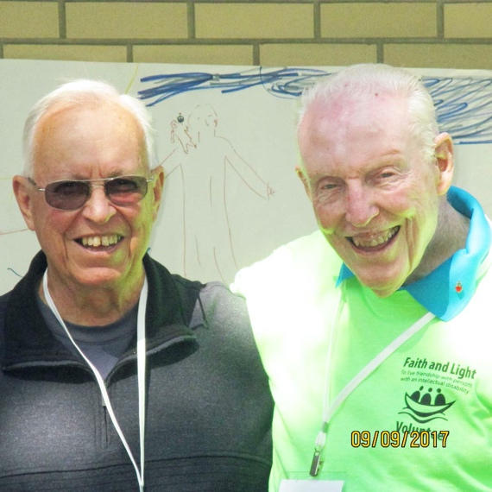
Ray Thomas of Akron and Father Jim O’Donnell, 2017
Kirt: How did you meet Jean Vanier?
Fr. Jim: On August the 4th 1969, a priest friend of mine, Father Tom McKillop, was a diocesan youth director for the Diocese of Toronto, and he and I had come together because of some mutual thinking. When I was appointed diocesan youth director, I didn’t think my role should be just taking care of youth athletics, and high school clubs, and camps and things. I felt we were called to challenge our youth to something greater than that. So, I saw he was doing the same thing; he started this group called Youth Corps. Because I had already talked to him about that, he told me that there was a man coming to Toronto from France, and he thought I should come and hear him. So, I arrived there August the 4th, and there were over a hundred people there and it was my first exposure to that reality, not just L’Arche, but people with disabilities and parents who were carrying a heavy burden with their own mentally challenged son or daughter. And I was just happy to be there. And Jean Vanier sent word through someone to come and get me. So, I had a visit with Jean.
He said to me, “Have you ever read the life of Brother Charles (de Foucauld)?” So, I said that I had; it was in the Seminary. He said, “I want you to go back and reread it.” Then he took my hands, and said, “Now, don’t you see?” And I said, “See what?” “You are called to live your life with poor people.” And that is where our journey began, and we’re still together. And we still communicate.
It’s been a wonderful, wonderful friendship, and that led me to his brother who was a Trappist monk, who just died last year, and his brother guided me from 1972 until his death in May of 2014. And Jean and I were both present for his brother’s death, and it was again a precious moment. So, all through these years then, after that retreat, came Faith and Light.
Sue (Mosteller) was then involved with L’Arche Daybreak with her friend Marie, who just died. Marie and Sue began the Faith and Light in Toronto, and they organized the Canadian pilgrims going to Lourdes in 1971. We had 25 people from Cleveland. Among the group from Cleveland were Dorothy Gauchat and Todd. Dorothy told me, “Todd is your responsibility. You take care of him.” Well, I’d never been involved in caring for a person with a disability. He had cerebral palsy, and she said to me, “I’m going to be with you on this pilgrimage. But I’m not going to do a thing to help you. You are on your own.”
Kirt: That reminds me a little bit of Jean’s experience in being given two men to care for.
Fr. Jim: Well, as you know, Marie-Helene Matthieu brought Jean into Faith and Light. She had already started a lot about Faith and Light already. She was already working in the field, and thinking about going in this direction. They knew each other, but then they got together, and then look what happened. That first pilgrimage in 1971 was powerful. It was a powerful experience for me to be with Todd all weekend, just to be with him and make sure all of his needs were being taken care of.
His first night, I’m already a nervous wreck and we get him into the hotel in Lourdes, and I go down this hall for one minute, and I hear this terrible thud. I came running back to the room and there is Todd; he had fallen out of his chair and he is lying there on the floor, and he was laughing. He couldn’t talk; he could only communicate by this board, pointing to the letters. So, he started pointing and spelling the letters on his board, which read, “Cool it baby, this is the way I always get out of my wheelchair.” “Cool it baby!” That was my beginning with Faith and Light and Todd…that whole week, never having cared for someone, how you dress them, what should you do, what shouldn’t you do, how you want to treat them with all the dignity if possible. For me it was a powerful thing. So, it began with that Faith and Sharing retreat in August of 1969, and with that I’ve been moving ever since.
After that I became involved more and more with L’Arche. In 1972 we started to think more and more about (starting L’Arche in Cleveland), and Jean came to Cleveland to run a retreat to celebrate Jesus. That was August 1972; it was a retreat we gave out in the streets, out every night on east 79th and Euclid. That’s where we began. I was still diocesan youth director, and I had this big youth center on the east side and all of the people that were coming on the retreat from other places, I housed them there and a bus would take them back and forth to the city. And while Jean would be giving his presentation or visiting a nursing home, they would be on the grounds where Jean was preaching. Bill Clarke (was there), and he conducted the retreat. Bill Clarke wrote, Enough Room for Joy. In 1974 Father Phil Pritt, and also Posie O’Connor and Pearl Cahoon got involved planning the Faith and Light trip to Rome. I was so “challenged” on that trip when our pilgrims’ luggage became lost. I said to Pearl, I’m so out of it. I was down on my hands and knees (searching the airport for it). Pearl and Posie were so good. It has been with me all these years.
My priesthood has been a very joyful one, a very happy one and because of Faith and Light Faith and Sharing and because of L’Arche. People often ask me, “How are they the same and how are they different?” I always tell them it is like a big tree with many branches. The one branch is Faith and Light and another branch is L’Arche, but it is the same tree, and gives life in different ways. And Faith and Sharing has never taken off the way Faith and Light and L’Arche have.
Kirt: It’s growing in Texas. New communities are starting there. Faith and Light has a special chrism; it’s not a curriculum; it’s relationships and love.
Fr. Jim: I wouldn’t be where I am without them.
Every human being on the face of this earth has a heart with which to love. If we did that, our world would be different. That’s my prayer always, that some kind of light would come to those countries like Syria.

What is your favorite activity in Faith and Light?
Just being with them. I had an experience here last Thursday where they’re making bookmarkers, as part of the L’Arche’s 50th anniversary. So, they asked me to be part of their project to make bookmarkers. So, I went to one of the L’Arche homes and BJ, she’s been there a long time, she said,
“Sit next to me.”
And I said, “I will.” So, I sat with BJ.
And then Jessie said to me, “Do you know about me?”
And I said, “Jessie, I really don’t.”
“Well, I was hit by a car when I was six years old.” Of course, she’s is quite incapacitated now, but she is bright.
And I said, “Jessie, I didn’t know that. Thank you for telling me.”
And there was Diane Bosman; she’s been there like BJ for a long time. Just coming out and then being with them is enough. So then my job was to stand with them and take a picture with them. I was there an hour and a half, and it was joyful and fun. I don’t get there very often. I wish I could get there more often than I do but again, it was a simple thing. It was a joyful moment, sitting around the table, listening to each one’s story, where they had been today.
I asked Jessie, “What do you do?”
And she said, “I sort out cloth.”
And I said, “You mean you sort out clothes.”
“No,” she said, “I sort out cloth.”
“O.K., I said, “what kind of cloth?” And she said,
“Some are yellow, and some are orange, some are brown, and I separate them.” Again, I just love the honesty…”I said cloth, not clothes!”
“O.K., I got it.”
So you know, it’s so simple. And then I have a group who come to my Mass at St. Malachi’s every Sunday. I have this girl Janet who repeats everything I say from the back of the church. So, if I say, “the Lord be with you,” she will say, “and the Lord be with you.” And she repeats everything I say. If I say, “Our Father,” she will say “Our Father.” So, she is my echo. It’s simple.
So, what do I enjoy? I just enjoy the simplicity of their presence.
Last Thursday just taking pictures for their 50th anniversary was joyful. I was so glad they asked me to do that, and be part of that. So I thought over and over again, it’s those kind of experiences (that are precious.)
It’s all about, “Pay attention to me”, and if you don’t, they’ll find ways. It’s moments like that, teaching me something. Teaching me to just recognize them.” Or their need to be with you, or my need to be with them.
What’s the most joyful thing?
Again, I think it’s just being in their presence and paying attention, and let whatever is going to happen, happen. Let it flow; just let it flow, you know. Maybe it means singing a song, or like at a Faith and Sharing Retreat somebody just got up and danced, and we danced with them. There is so much spontaneity. In their life there is so much spontaneity; we don’t know how to be like that. They sing. They laugh. We complicate life so much in this world. So I guess the most joyful time is when we are together, and everything happens in a very spontaneous way. And to just jump in with them and do whatever that is.
You have fun and they have fun.
We’re all born all children of God. I talked about the whole idea of compassion and forgiveness, and we all have it.
Kirt: It’s really a grace, I feel. Joyful Witness Faith and Light community is so aptly named. I would drive home from a meeting, driving a member, Tammy, back home to her group home, and I would feel so joyful. You know I didn’t fully understand it, part of me, from my background, emotions are at a distance, at least since joining Al-Anon I’m a little bit better with that I’d feel so joyful, but I couldn’t really articulate it. I was so free! And we went through times too, in the 1990s, as I became more involved in Faith and Light, and Hilda too, she had the medical problems, I could be at the Joyful Witness community meeting, and just be myself. I’ve got these little social antennae in my mind, they register how people will react to what I say or what I do, and at Faith and Light meetings, I would just leave it at the door. I would just be honest with the community; I’d just tell them how I felt. “I’m feeling really lonely today. I’m feeling really upset.” Whatever. And that was freedom for me. And in doing that, that’s finding joy too. Finding an environment where you can totally be yourself, and let people know how you’re feeling, what’s going on inside. You’re free, but also joyful because you’re really connected with God’s love.
Fr. Jim: Yes, you can say, “I don’t have it all together. And I need help. I’ve heard that all the time, with the kids, and Maggie… It’s great for me. It’s very good.
b Yes, our schooling takes a little while.
Fr. Jim: It’s hard.
Fr. Jim With the Garden, when someone comes along to see the garden, you just stop what you’re doing and be present. Let’s not be worried about whether I get all this planted today or not, It’s O.K.; or if you want to help me get it planted, we can plant. It’s all right.

What was your most memorable moment in Faith and Light?
Being the first National Chaplain for Faith and Light, when the plane was coming into Lourdes, it was my role to go out and greet them all. We were able at that time, 1971, to go out on the tarmac and greet the people coming in from different countries, and a very powerful memory for me was when I greeted the plane from England and this man was getting off the plane and he with a great big smile, he took a deep breath and said, “This is the first time I’ve been out of the institution since 1918!”
I thought to myself, “From 1918 to the present in 1971!”
And that was one of the most powerful memories I had of that time, as well as being in that shopping area of Lourdes, and watching these two mothers, one from France and one from England, with their two boys who had Down Syndrome, and the two boys were talking with each other with great enthusiasm, and I watched this. Neither mother knew what the other was saying because neither mother could understand the other’s language, but the two boys in front of them were communicating without knowing the other’s language. For me, it was a little miracle of Faith and Light in Lourdes. It was an incredible moment. And I thought now, “Where else in the world would you find this!”
Kirt: Yes, it’s true that feeling of belonging here, and identity.
Fr. Jim: And there was Richard Kohan who came to our Faith and Light pilgrimage from St Augustine’s parish on the west side of Cleveland, and he had cerebral palsy from birth. The only thing he could do, in his day, to make a living was to sell pencils and shoelaces from his suitcase, which he could hardly carry because of his palsy.
And he said to me before I lowered him into the waters of Lourdes, “I am never going to sell pencils and shoelaces again. I am going to become the president of St Vincent Society in my parish.”
After Lourdes, he went back to Cleveland, and he told his mother, “I’m not going to live with you anymore.”
And of course, she was upset with me, and I told her, “I’m sorry, but he has to try it. He’s 41. I know you’ve been so faithful to him since his birth, and that you’ve been all alone since the death of your husband, but you gotta let him try.”
And he did, for six months and then it didn’t work out, and he had to move back home. But in the meantime, he became president of his parish’s St Vincent de Paul Society. So that to me was another miracle of Lourdes. It was the joy of Faith and Light. And he came home, and he was able to do what he set out to do. So, this is another memory I have from that first pilgrimage.
Fr. Jim: in that first pilgrimage in 1971, we were something like 6,000. Which was still incredible, but from that the seed was planted. And it’s continued to grow.
Kirt: I was there in 2001, and we were 17,000, and we were told that the population of Lourdes in the off-season was 17,000. We doubled the population of Lourdes at Faith and Lights 30th anniversary pilgrimage to Lourdes! It’s a witness or a statement that a place that couldn’t accept people with developmental disabilities in a restaurant, thirty years later, they can’t turn them away. It’s the economy of God, taking someone like, Bernadette, or the Mother of Jesus, or the Fatima children, or Charles de Foucauld; it’s the economy of God in choosing the weakest and the poorest, …and the people flocking, needing, hungry coming to them. So, it’s amazing! An amazing, amazing God!
Fr. Jim: It’s just a precious gift, a flower. Like the reading at last Sunday’s Mass about the little mustard seed, that gave life to all the birds of the air. I think that Faith and Light, L’Arche and Faith and Sharing, they are like little tiny seeds that were planted, in 1964 for L’Arche, in 1968 in Faith and Sharing, and 1971 for Faith and Light. And now, with this gigantic big mustard seed, we’re still the same tree, and it’s still providing places for everyone to come. So that’s what I’d like to think today, that we are that mustard seed, and through God’s goodness and love for us, He blessed us and allowed us to plant those seeds. He didn’t plant them; the littlest among us planted them. They just needed the soil. They needed to be shown where they could be planted.
And now we are at our age in our life where we are able to see the fruits of that. I am now 85, and I don’t worry about it. I just take each day, and know that when the end comes, it will be fine. As they say in French it will be “tout a grace”, it will be all grace.
I live in the moment again. I am out here with my children again, and watch them grow. They call me Abba. (Father Jim and Sister Maggie are raising three children: Martin, Caroline, and Josie.)
It is pure grace, amazing grace. And joy is such a part of that, isn’t it?
I sure would like to pass this on to as many priests as I can before I go, because this will enrich their priesthood. They’ll be priests closer to their people, which is what our people need today. It’s not how much education you have, or what your skills are electronically.
We are given a great gift.

AN INTERVIEW WITH BRIAN DAW
Second National Coordinator of Faith and Light USA
Interviewed by Kirt Bromley on June 16, 2015 at Avon Lake, Ohio

“We must realize that not only do the weak need the strong, but also that the strong cannot exist without the weak. The elimination of the weak is the death of fellowship.” Quote from Dietrich Bonhoeffer, which appeared in an early Faith and Light brochure created by Brian Daw in 1985.
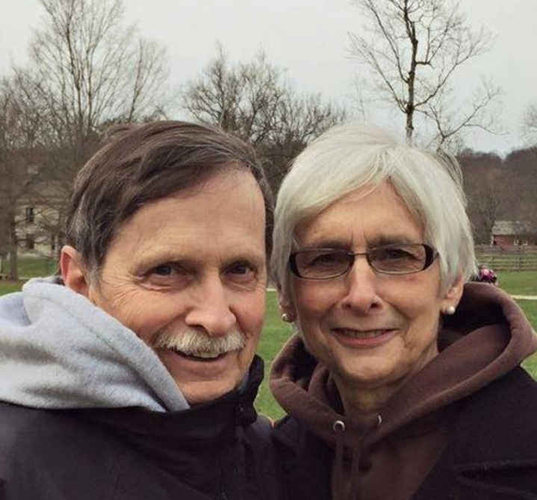
Brian and his wife
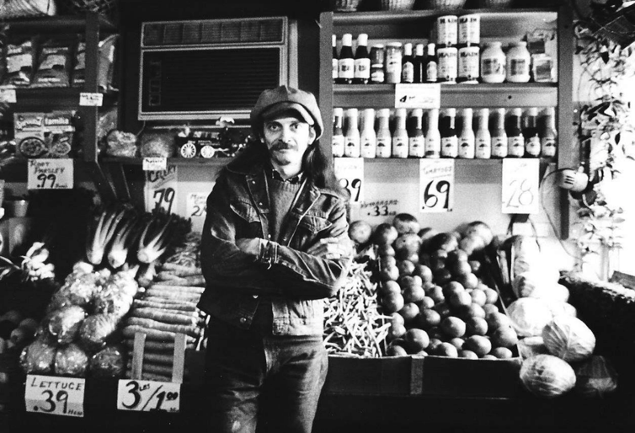
Brian in the food coop

How did you come to Faith and Light?
Through L’Arche… when we were setting up our organization, Cornucopia, we had heard about Jean Vanier because the family of my first wife Ann had met Jean during the first Faith and Light Pilgrimage to Lourdes. Of course, I had known Pearl Cahoon through my work with the Cleveland Diocese…
Kirt: with Father Phil Pritt
Brian: Yes, and before him it was Father Goebel. And anyways, when I was planning Cornucopia, I wanted to go to L’Arche and see how they did it. And the retreat “Celebrate Jesus” had happened here in Cleveland, another Vanier type of movement; it happened even before anyone had gone over to Lourdes. So, we went and visited the L’Arche communities in Erie and in Iowa, (Clinton, Iowa) and spoke to them about the idea of L’Arche and what they were doing. We kind of started our organization going already (The Bin and Cornucopia), so we had written to Jean about The Bin becoming a L’Arche community, and at that time there was a L’Arche community in Cleveland which we didn’t even know about, kind of a whole other group of people that were involved and we didn’t even know it. All of us were coming from a parish, St Malachi, where Father Jim was quite active, and he had come back from his retreat with Mother Therese, and he is talking about Jean Vanier and Mother Therese, and we are talking about Jean Vanier and L’Arche. Cleveland was definitely at the heart of L’Arche USA at the time. We had come to understand what L’Arche was about at that time, and Jean discerned that it would not be good to have two organizations running L’Arche in Cleveland, so he advised us that it would be best for us to start with Faith and Light. So we started a Faith and Light community at Corpus Christi House, which was one of our community homes. There was Jonah House and Corpus Christi house.
Kirt: Did you have contact with the Odens at that time?
Brian: Yes, through regular visits to The Bin, but they also knew my wife Ann and her family. Yes, so we began Faith and Light through the Corpus Christi community. It was probably 1979. And prior to that I had gone to a Faith and Light Sharing Retreat with Father Jim in Canada (Lake St Mary’s Retreat House), and Father Jim and I had lunch with Jean Vanier and some Canadian Bishops. Following that, I met Jean in Detroit and discussed our having a L’Arche home. He had told me then that it would be best if we moved toward creating a Faith and Light community rather than a second and separate L’Arche home. At that time too, I was quite involved with Pearl Cahoon and what she was doing for people with developmental disabilities. I was involved with her since high school actually, through the day camps. It was in 1966 that I first started working with the diocese, the Apostolate (outreach to people with developmental disabilities).
It was then that I think Pearl hooked me up with Father Cal Ganreas…the national chaplain after Father Jim. Father Cal then asked me to go to the International in Weatherby in Yorkshire, England March 1982. We had been active in the Faith and Light for several years. And at that conference Jean asked me to go back to the USA and help get Faith and Light more firmly organized there. Sister Pat Murphy also came; she was the regional coordinator for the East Coast. So when I came back, then Pearl and I and Terry Jungquist called a national meeting held at the St Joseph Retreat House in Euclid, Ohio probably in late 1982 or early 1983.
What I have found is that Faith and Light, like other spiritual movements, has grown more from the message of the Gospel, and the retreats, and the coming together of people informally, than it has from an organizational structure like the Scouts, or something… There’s no chapters and no big formal applications…
Kirt: it’s people…, maybe it’s individuals. Maybe they “catch it”… connecting a parent to other parents and getting them going. They may call and say, “I’m a parent and I feel isolated, but I like the message of Jean Vanier, and can you offer any help?”
And we say, “Oh yea. We can.” So, it’s connecting her to some similar parents, and getting them going, and people joining. But kind of helping them just kind of get the ball rolling a little bit
Brian: You were talking about that new group where there are only two or three people, really, that’s a nice little group to start. I hope people sense that there’s no requirement (for numbers), when there’s three families together, they’re strong enough to be a community. And we’re always open to new people joining us, and having new growth. It’ll come on its own when someone else hears your message and sees your witness. Pearl and I often talked about growth, and Faith and Light always seems to be growing.
When we returned from England, Pearl and I saw that we needed to structure this a little bit. We needed to pull people together, and talk about the larger community, the national community. To come (to a perspective of who we are nationally), and we brought people in from Faith and Light communities in other parts of the USA that Pearl had been in correspondence with. We needed to nourish each other and form a national committee. What we came to do there was discern leadership, and purposes. We discerned a whole new national team then, myself as National Coordinator, Pearl Cahoon as the National Secretary, and Eric Gauchat was the new Treasurer. Father George Matejka was the National Chaplain. Following that meeting and the discernments, then I prepared legal documents. We registered Faith and Light USA as a 501c3 non-profit corporation.

How has Faith and Light blessed your life?
Brian: It’s pretty evident from what we have spoken about already, that the community of people (in Faith and Light, Cornucopia and The Bin) meant an awful lot to me; and it gave me a real purpose. Since the first time I met people with handicaps, I had a real purpose. Up until then, I didn’t know what I wanted to do. I had no clue. I thought I was going to be a computer scientist. I loved Math, but when I met people with handicaps, I said “This is cool.”
My first association happened when a religious brother at my high school said, “I want you to do something this summer; I’m going to find opportunities for you. He then told us they needed someone down at Lakewood Park to teach swimming to kids. I said, “Great. I love swimming. I love kids. I’ll do that.” I walked down and there, and I saw a lot of kids with developmental and physical handicaps. I didn’t know what I was getting into, but I said, “This is great.” But from then on, I had a purpose in life, and it has been like that ever since.
My purpose in life was very directed until I left Faith and Light in late 1987. Since that time, my life has been taken up with my children and grandchildren. There’s more than 40 of us together when we celebrate. This is wonderful. It has been something that I have shared for over 30 years in a different way. And my extracurricular activity has been coaching kids. I was a high school coach for 25 years, and for the past 5 years coaching my grandchildren. I’ve been able to share the idea of community, the importance of each person, and the continuity of the team. So for me, Faith and Light has been something that affected my whole entire life, and now has given me a chance to live and enjoy and share community, whether it’s with family or work; it’s a vocation. And yet I have sense right now at this time in my life, that there may be something else. So I’m open that, but I know that whatever it is that it will involve some community, that it will involve sharing of my life with other people in the Body of Chris and my family and I are open to that.
The Faith and Sharing Retreat coming up this month may open a door to something new. It will be a time of quiet to just listen to God, and if there is an answer, then I am open. It may or may not happen, and we will wait.
Kirt: God loves you, that’s for sure.
Brian: Yes, I know that, and that He is a forgiving and loving God. It is an amazing thing if we can remember that more than anything else. That is what Faith and Light has brought to me, that community of love, the message of Love, the message of the Gospel.

Tell a story about a memorable person you’ve met in Faith and Light
There are so many people…Father Jim O’Donnell and Pearl, Danny and Therese Millar. I’ve always maintained communication with the Millar’s; they’re in Tacoma. There very welcoming people. They’re a married a couple and Pat and I were able to share a lot with them. Father Jim Boyle at the time, George Matejka…
Probably the most influential person was a guy by the name of Ray Hill; he had different colored eyes, one blue and one black. He was paralyzed from his waist down and mentally challenged. He had lived in institutions his entire life until he came to live with us at Cornucopia. But singly the most influential person in the creation and change of our institution was Ray. Almost everything that happened within Cornucopia, I can tell you, happened because of him. Ray was an exceptional person, in our Faith and Light community. They were changing his colostomy bag and he died during the operation. He was young too, 26 or 27 years. He was the single most influential person because he spoke to us of what he needed. We thought we knew what he needed, but he (knew better.) He told us what we could do together; he saw ways that we could give him things that he could do. But it was really creating so much more. One day he is frying doughnuts; months later we are running a deli-bakery because everybody liked his doughnuts. One day he was making straw flowers for us; we ended up becoming the largest producer and distributor of straw flowers east of the Mississippi. It happened because one day he was making straw flowers and we said, “You know you can do this, Ray. We’ll just keep giving you straw flowers.”
We started the farm because of him. We always wanted to go farming. That was the original dream of Cornucopia. When we brought him out of the institution, there was no way that I was not giving him a job and a home. We had a plot about the size of the back ground of my house. So, we told him,
“O.K. Ray, we are going to grow pickles back there. You can scoot along the ground and plant them and weed.” And he did. It was our very first crop.
There was so many things that we did that he had a hand in. He needed a house. We got a house, actually two houses next to each other, they were named Jonah House. We bought the houses because of Ray, and it gave us room for more people with handicaps and staff to live there.
Kirt: That’s great! God chooses the weak to move the world, whether it’s Bernadette at Lourdes, or the children at Fatima, or Mary the Mother of God.

Brian: Ray had every strike against him, you know, but he did things. There was nothing he wouldn’t attempt. I remember a snowstorm. He lived all the way over in Warrensville Heights, on the other side of Cleveland. He had to take several buses and with transfers to get here on the west side of Cleveland and on this particular day, and there was deep snow. People were calling me up and canceling. People who lived five minutes away were canceling coming to work, and here comes Ray as faithful as could be, on his crutches, through the snow, after riding the buses from the east side of Cleveland. Here he is coming down Madison Avenue in the snow, plugging along with his crutches. Meanwhile, people are calling off who live a mile down the road.
Another time, we had a building across the street and he was packaging Brussels Sprouts, that was another job we did. We began packaging our own line of vegetables, and we had boxes that would come to us packed with donated fruit and vegetables. We had to get rid of the boxes that the supply of fruit and vegetables came in, so we would take them down the street and a guy would cut them up and use them for his coal furnace, before it got out-lawed. It benefitted him and us. It was a good walk; maybe 500 feet down the street. There would be 40 or 50 boxes out there at the end of the day, and somebody would take them down the street. And on this day, toward the end of the day, I was in a meeting and Ray comes up to me and says, “Is there something I can do?”
Since I needed to be at the meeting, I said, “If you could take care of those boxes out there, it would be great! Get somebody to help you.”
Well, he couldn’t get anybody to help him. I had forgotten about it until I came out of the meeting and saw all of the boxes removed.
I asked him, “Ray, who helped you?”
He said, “Nobody. I got it done.” Here he is, a guy on crutches, moving all these cardboard boxes 500 feet down the alley. That’s the kind of guy he was. I get emotional about thinking about him.
Share one of your most memorable moments
I think one of the most memorable moments was at the national Faith and Light conference in Seattle in 1984. The whole meeting was such a special time; it was the first time that the national team was able to meet in a retreat atmosphere… it was more than a meeting; it was really good. Father Jim Boyle was there. We had a great time. It was a typical Faith and Light time; we relaxed together, we prayed together, we shelled oysters together…we just knew that this fellowship was really happening. The Pilgrimage to Our Lady of the Snows began to be formed at this meeting. The First National Pilgrimage and it was really a good one.

In Rome 1984, we met with the Pope (John Paul II). We were Faith and Light representatives from about 18 countries. And he spoke with each one of us in our own language, only a minute or two for each of us. He was very focused. He only wanted to know one thing; he wanted to know what was going on in your country to bring people with handicaps into the life of the Church. Then he addressed everybody as a group as to his position and his beliefs about how the life of the Church needed to grow with the handicapped person and the handicapped person through the life of the Church. And it was wonderful. I’ll never forget that meeting. First of all, that you are in the presence of the leader of the Church, and the leader of Christ’s body here on earth, Then to hear him speak to us, and listen to each of us. It was amazing! The Pope wants to know what is happening … to bring handicapped people into the life of the Church. And what happened after that was a large movement to bring people with handicaps to visit the Pope in Rome. He was very heartfelt about what we were doing and what he was addressing us to do.
June 16, 2015 at Avon Lake, Ohio. Interviewed by Kirt Bromley

My History in Faith and Light – Maureen O’Reilly
National Coordinator of Faith and Light USA 1986 – 1987
International Coordinator of Faith and Light 1987 – 2002
International Nominating Team 2012-2018

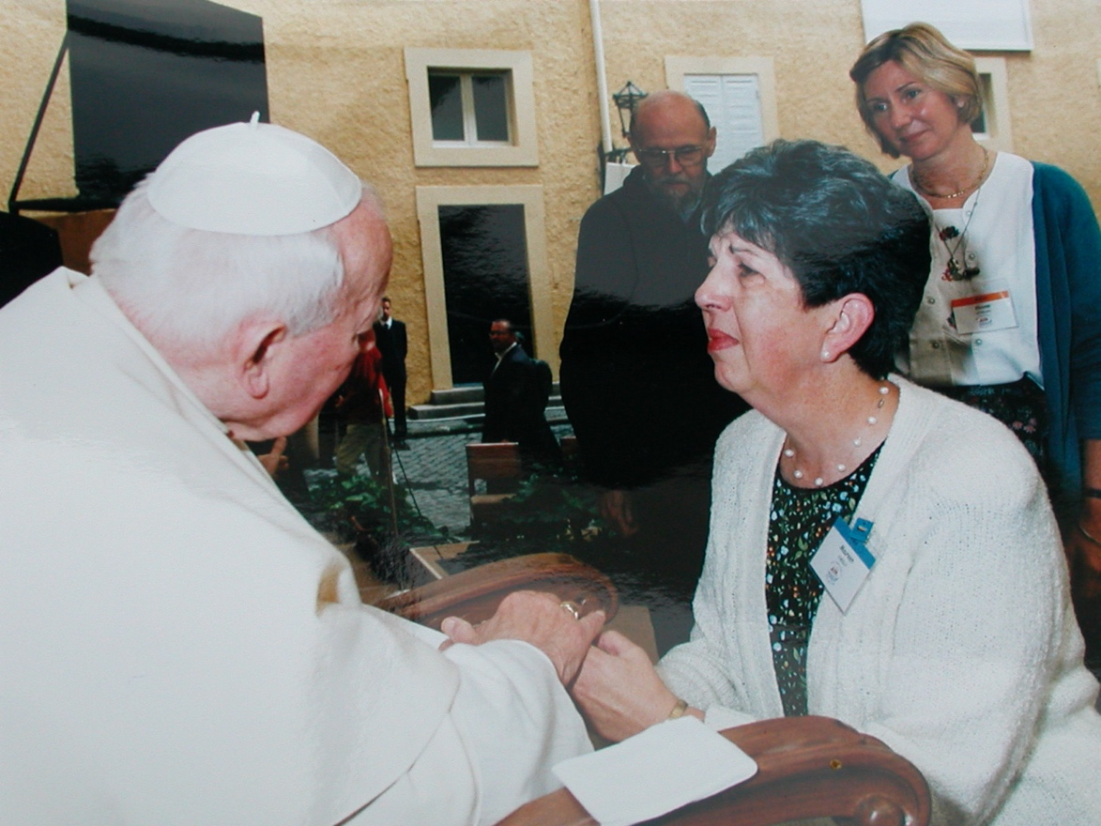

Pearl Cahoon has written this of Maureen:
“Maureen O'Reilly was discerned as National Coordinator in 1986, and brought with her a quiet prayerfulness and the ability to make each person feel important. In 1987 Maureen was discerned as International Co-Coordinator. Pearl recounts, “It was a big challenge, but she managed it thanks to her many gifts and her great sense of humor.” Maureen’s served as International Coordinator until 2002, and then was asked to become part of the International Nominating Committee in 2012. She served on this committee through 2018. This committee presented the nominations for the Board of Directors and International Coordinating Team at the General Assembly in Lebanon in 2018. Maureen has faithfully served our fellowship since 1982. Here is her story:

My History in Faith and Light – Maureen O’Reilly
It was through our cousin – Faith and Sharing Retreats – that I learned about Faith and Light in 1982, as did my then fellow employee at the Archdiocese of Detroit, Rose Marie Massey. She coordinated our parish Special Religious Ed program and we shared a flat in St. Alphonsus Parish, Dearborn. We had spread news about this new concept around other Special Religious Education programs in the area, but finally realized we needed to begin ourselves. So, in 1984 the first (and sadly, only) Faith and Light community gathered in our home. (Back then, it was the common understanding that, FAITH AND LIGHT should meet in member’s homes rather than at church, lest families see these new communities as substitutes for parish involvement, especially if they had not felt welcome there.)
And thus began our connection with our mentors in Cleveland and across the U.S.A. It was at regional formation sessions and meetings that we gradually met such pioneers as Pearl Cahoon and Posie O’Connor, Brian Daw, the LaBiancas, Danny and Teres Millar, George Matejka, and Betty Renaud from Montreal, our Zone Coordinator, along with so many others I’m embarrassed to say are remembered only by face, not by name. I was even honored to be present at a National Council meeting in Puget Sound, WA.
Rose Marie passed away suddenly, in July 1986 and I’ll always remember how one of our friends, Jim Arsenault (later a priest) handled our first meeting that fall. He proposed a simple, non-threatening solution by asking each person to share who it was that told them of Rose Marie’s passing, where they were and what they were doing when that call came. In this way, Jim found a means by which even our most challenged members could share their response to this sudden, tragic loss.
Later that fall Jim represented us at the National Meeting in Cleveland, as I was down with the flu. But during that weekend, I received a call asking me to consider allowing my name to go forward for discernment as National Coordinator to follow Brian Daw. Serious prayer followed, and in the end, I was called to that role. A bit later, Maria Cecilia de Freitas Cardoso, former Brazilian Coordinator (and later International Vice President with her husband Tim Buckley), pioneer in FAITH AND LIGHT who was studying in Wisconsin, invited me for a weekend during which she guided me through the FAITH AND LIGHT Charter and Constitution. Talk about superb tutoring!
In January 1987 we joined many from FAITH AND LIGHT in Central and South America for a Pilgrimage to Our Lady of Guadalupe in Mexico City, a wonderful event at which Marie-Helene Mathieu was also present! This first experience with our larger family was followed that summer by a request that I participate in the Formation Session for French-speaking leaders held in France. Obviously, my French was non-existent then so Betty Renaud came from Montreal as my translator.
At this point, may I pause and say that, like is probably the case for each of you, I could write a book about the people met, serious issues and lessons learned, and perhaps most of all, the hilarious experiences we shared! Which is why some of us are still in touch electronically, brought together again by the passing of a dear friend, or another’s serious illness, or the wonderful (pre-Covid and hopefully after) opportunity to be visiting the state or country of one of our old Faith and Light colleagues! All of us agree that when we first came to Faith and Light, we never dreamed that we would be finding so many lifelong friends, as well!
As was the case with all those in leadership, our meetings were squeezed into our vacation and personal days and we on the “Bureau” or Management Committee had three gatherings each year:
- Two meetings of the Bureau were generally held at l’Arche in Trosly Breuil, an hour’s drive from Paris. And though translators were provided for non-French speakers, and I took a few French classes here in Dearborn, I hadn’t the time to make much progress. In time I could understand a fair amount of French when it had to do with Faith and Light!
- The Annual International Council meeting (the Bureau plus all 15-16 International Vice Coordinators representing all the zones of Faith and Light around the world – a total of around twenty-five, plus translators for French, Spanish and English.) Those IC meetings were held in various locations, mostly in the European area.
Additionally, I was asked over the years to help with Formation Sessions or Discernments of regional and national councils worldwide. Very practical ways were created for me to get to know Faith and Light at its basic level as you have – by staying at other members’ homes if not at simple convents or retreat centers. I often wish that world leaders could stay at “regular“ citizens’ homes as they travel, too. Somehow, I think our world would be much more peaceful as a result!
Folks at home rightly envied all the traveling this provided me, though I had explained those meetings occupied us morning to evening, with perhaps one free afternoon and evening for some sightseeing. A definite highlight was always some kind of fiesta or gathering with local communities – a privilege most travelers never get!
2002 ended my third mandate, as as time went by and Faith and Light continued to grow – especially in the financially poorest, most troubled countries, the structures holding Faith and Light together needed change. You can read that process in Marie-Helene’s marvelous, well-named book, Never Again Alone! The Adventure of Faith and Light…
In late 2012, then Board-President Henri Major, husband of long-time friend and former North American Zone Coordinator, Louise Sauriol-Major, asked me to chair the four-member International Nomination Committee (INC) to prepare for and preside over the discernment of the Board of Directors and International Coordinating Committee. That discernment was to take place at the International General Assembly in July 2013 in Leeds, England. You can read about the process set up at that time and later modified in the Charter and Constitution revised in 2018 for yourself, so I won’t detail it here.
I’ll just say that all our work in preparation for the 2013 Assembly was done by email and Skype, and at its conclusion I was asked to serve a second term, this time with the INC responsible for the nominating process for any International Council members whose terms would end between 2013 and 2018, and in preparation for the discernments of the Board of Directors and International Coordinating Committee, as had been done in 2013. We were able to meet in person twice during those years, including times with the ICC. Both International Nomination Committees with whom I served provided the skills, experience, team spirit and dedication that made often challenging work possible.
Reflecting on work with the INC I’m reminded of two points that actually apply to my whole life in Faith and Light and probably yours, as well:
- Life/leadership was not always a bed of roses. Many times, this line from a John Denver song came to mind – “Anywhere is where I’d rather be!”
- EACH person is unique, and has something to contribute that’s absolutely necessary for the whole. Likewise, the very best group of people, whether local community, or leadership at every level, still couldn’t be fruitful were it not for the Holy Spirit. (And by the way, if you want a practical, delicious example of that, just ask me to guide you through the making of Irish Soda Bread! I’ve used it in so many contexts I believe I could even coach a soccer team that way!)
From the millions of memories, a few you might appreciate…
While at the International Assembly in Edinburgh in 1990, we were divided into small groups, each of which was taken along with a local Faith and Light community to a Mass and luncheon at a local church. Seated for lunch with several mothers and their adult daughters, I was speaking with one of the young women with disabilities when she asked if I was married. My “No” brought more questions. Was I a widow? Divorced? A nun? Hearing all my “No’s”, she finally reached out her long, slender arm and pointed directly at me with the triumphant conclusion, “YOU’RE a SPINSTER!” It took a huge amount of self-control not to just burst into laughter, but I was glad to have given someone the pleasure of meeting another “victim” if that’s how she felt.
Years later, while the International Council was meeting in Bruges, Belgium, we went to a local fairly small restaurant for dinner. We were placed at a long table in the center, surrounded by others seated in booths. As the evening went on, people would stare at us, no doubt trying to figure out where this VERY diverse group – different races, clothing, languages – could ever have come from and what we were about. And had they asked, would our answer have left them any less puzzled?
There’s no single most memorable moment in Faith and Light for me. Instead, I marvel at how God has gathered together and gifted each of us with such a variety of wonderful people. In Faith and Light, we’ve been taught so much, and despite the pains and misunderstandings along the way, we are still so grateful for all the wonders God has done.

Excerpts from Maureen’s sharings in the Faith and Light Newsletter
In 1987, Maureen attended a ten-day formation session in France for Faith and Light leaders. She shared her experience in the August 1987 Faith and Light Newsletter.

“My friends, let us sing all our joy, God is alive, Alleluia. Sing of Jesus, our God of Light. Alleluia. Alleluia!”
This is the refrain of a song which many of you have heard in the films of Faith and Light pilgrimages, and which I heard and tried to sing often during the last two weeks in France.
…the International Council asked me to come to France for the Formation Session for leaders from French-speaking countries. Knowing that my French was “tres petite” they assured me of translators.

The verses of Amis, Chantons Notre Joie” will help me describe what those ten days were like:
Verse 1: On joyful holiday we come…together drawn from every race…that we may all with lively love…encounter Jesus face to face.
Verse 2; Our God is love, our God is light…we think of absent friends and pray…that God will bless them, one and all…who cannot be with us today.
Verse 3: In Jesus’ presence now we live…we share the bread broke for us…the Bread of Life is our true hope…and He is really ‘God with us.”

[During this time…} The Spirit allowed us to communicate with each other despite great cultural, political and language differences. What joy in preparing a mime together, learning new dances to bring back home, playing musical chairs with such energy that people wer almost getting into shoving matches to gain possession of a chair!! And it MUST have been Jesus who carried us through each day, which began with a 7:15 am meeting and went well into the evening hours.
We walked with Mary on our pilgrimage to the Cathedral in Chartres. What a time of special blessings it was, as we quietly meditated on Mary while walking through the wheat fields, then sag the Rosary together, and finally celebrated mass in the crypt, built in the fourth century.
On the last evening, each country presented one another a picture, icon or statue of Our Lady. We gave a picture to the people of Cyprus, and received a beautiful statue from the people of Belgium.
Our greatest hope is that the rich experiences of community which we enjoyed can somehow be channeled back to each member of Faith and Light. All of you made it possible for me to be fed by Marie-Helene Mathieu, Roland Tamraz from Lebanon, Marcia from Poland, Mariangela Bertollini of Italy and Jean Vanier. Below are some gifts for you from those tend days:

From our International Coordinator, Marie-Hélène Mathieu:
“Little by little, sometimes pushed by winds and storms, Faith and Light has grown. Ask Mary for the desire to give birth to new communities. A large community may not want the pain of separation.
One think can help…confidence in Jesus. ‘Faith alike a mustard seed…can move mountains.’ The desire in the Heart of Jesus is for this change.
Don’t stay all alone. The flame goes out. There needs to be three, four, five logs together for a fire. That’s the wisdom of the Faith and Light teams at the local, regional, national and international levels. We must pray for all these branches.”

From Jean Vanier:
“Faith and Light was founded on suffering, therefore there will be suffering in our communities.
The cry of the poor (which is all of us), is the cry for a friend. Who will be with me?
We have to discover we’re in Faith and Light not just because it’s fun. We’re called to Faith and Light by God. When the storms, divisions, and failures come, we won’t be there if we’re there because it’s fun.
We didn’t choose to be in Faith and Light. God chose us!
Jesus says, ‘What I am asking of you is impossible, but I will be with you. I love you. I will give you my Holy Spirit.”

Maureen closes with: “Let us all pray together, ‘Glory to God, whose power at work in us can do infinitely more than we can ask or imagine.’”
As International Coordinator, Maureen had travelled around the globe and shared the love of Faith and Light with many people, some of whom had important roles, such as a Cardinal from Vienna. Maureen wrote her reflections in the Faith and Light Newsletter of March/April 1998:
“What a room looks like, what the food is, what people’s roles are, matter very little compared with what we have in common, and why we are together. [As I think about]…all of our ancestors who are now with God, [I believe that they are] amazed only at how wonderful it is that God has called us to Faith and Light…to the discovery that in weakness there is so much of God’s presence…that we all need one another! Enjoy your next meal with Faith and Light, and let us keep looking for more to invite to the table!

A SUMMARY OF FAITH AND LIGHT HISTORY FROM BARBARA STEVENS
our Fourth National Coordinator of Faith and Light USA

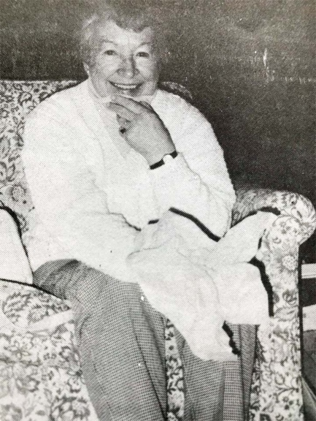
Actually, there were people form the United states involved in Faith and Light from the very first pilgrimage to Lourdes in 1971. Jean Vanier had asked Fr. Jim O’Donnell of Cleveland, Ohio to bring people to join a group in Canada for this very first pilgrimage. Twenty-eight pilgrims from the United States made that first journey, including Julie and Mary Ryan.
In 1973 Bishop Hickey asked Fr. Jim and Fr. Phil Pritt to coordinate a pilgrimage to Rome in 1975. A committee was formed and Pearl Cahoon was chosen to represent the U.S.A. at the International preparation meetings in Rome. Talk about FAITH…Father Jim and Father Phil chartered two planes without knowing whether a single person would join them to go to Rome! However, 410 people from the United States went on this pilgrimage in 1975.
In 1979 it was announced that a second pilgrimage to Lourdes was to take place in 1981, and this time only members of Faith and Light communities could attend. It was then that the first Faith and Light communities were formed in Cleveland and Akron, Ohio.
Before Faith and Light became incorporated as a non-profit in 1983, and before there were National Team meetings, there were Core Committee meetings being held, mostly in Cleveland. The Core Committee members were people who were involved with that first pilgrimage and others who became interested and involved in the 1975 and 1981 pilgrimages. Little by little Faith and Light in the U.S. was becoming a reality and organized to the point where national officers were discerned. The first Core meeting was held in May 1982 in Cleveland, Ohio. Attending this meeting held in Fr. Jim’s house in Cleveland, were Kay Maloney and Father Cal Gengras of Connecticut, and Fr. Bob Wagner of Massachusetts. Among the Clevelanders who were present were Dorothy Michaels, Cathy LaBianca, Posie O’Connor, Julie Ryan, Pearl Cahoon, Brian Daw and Henry Oden.
During the formation of Faith and Light in the U.S., Pearl Cahoon was the National Coordinator. Fr. Cal Gengras was the next National Coordinator, but his term was brief because of the serious illness of both his parents.
In 1982, Brian Daw was discerned National Coordinator, and he was instrumental in incorporating “Faith and Light, USA” as a non-profit. Brian was also successful in writing the first proposal for the American Bishops’ Catholic Mission Grant which Faith and Light continued to receive into the early 2000’s. Brian also was responsible for initiating the Faith and Light Newsletter, with Pearl Cahoon as editor, and Posie O’Connor in charge of mailing. During this time, Pearl Cahoon was discerned as the National Secretary, a post she held for 17 years until Claire Butler took over in the 1990’s. Eric Gauchat was the first discerned Treasurer, followed by Posie O’Connor, Sam LaBianca, and John O’Reilly.
In 1987 Maureen O’Reilly was discerned as National Coordinator at a national meeting held in Cleveland, Ohio. After fulfilling the first three years of her responsibility Maureen was reaffirmed National Coordinator again in 1990, but that term was cut short when she was called and said, “Yes” to being International Coordinator for Faith and Light later in 1990.
I was discerned as National Coordinator to replace Maureen in October 1990.
Our National Chaplains have been Father Jim O’Donnell, Father Bob Wagner, Father George Matejka and Father Jim Boyle. Each one, with his special gifts, have enriched the spiritual grow of Faith and Light members. Members have been blessed to have many priests, ministers and Bishops from all over our nation involved with our communities throughout our history.
Pilgrims from the United Sates attended the 1991 Pilgrimage at Lourdes. We also had a national pilgrimage to Our Lady of the Snows in Belleville, Illinois in 1985. This was a very fulfilling experience, but it was more important at that time for the growth of Faith and Light to put emphasis on leadership workshops which were conducted in various states.
In the late 1080s, we had 90 communities in the U.S., which were spread across the country, and International Faith and Light began advising us to multiply into three parts. In recent years our national team considered this possibility, but we resisted until 1994. In the Spring of 1994, our National Team met and voted to restructure our national organization into two provinces, USA East and USA West.
We notified the International about our decision and asked to be officially recognized as two provinces. This recognition was given by the International council meeting in Poland in 1994. Delegates from our U.S. communities endorsed this changed at the national meeting held in Denver, Colorado over the weekend of October 20-23, 1994. At this time, we have 53 communities, 33 of which are in USA East, and 20 in USA West, 14 of which are recognized and the remaining 6 communities in formation.
The following account is excerpted from her obituary:
Barbara was born in 1931 in Lawrence, MA, the daughter of the late Margaret (Gage) and Joseph Sholik. She grew up in Methuen, graduated from the Edward F. Searles High School, and moved to New York City, where she began her career at the new Albert Einstein College of Medicine. Barbara married Bob Stevens in June 1957. They made their home in Hamden, CT where they raised their five children. Creating opportunities for their youngest son Paul, born with Down Syndrome, launched Barbara’s lifelong career as a tireless advocate for Paul and other young people with developmental disabilities. She served as the executive director of the New Haven Association for Retarded Citizens and worked every day to open classrooms and educational systems for Paul and his peers. For this work, she received awards and recognition, but her most important achievement was seeing Paul graduate from Nauset High School in 1986 and supporting his independent life in Wellfleet. Barbara, Bob and Paul moved to Wellfleet in 1984, making their home near the beaches they loved so deeply. Barbara continued her volunteer work in Wellfleet, doing home visits with elderly neighbors, and becoming a national leader of Faith and Light. She was an active member of Our Lady of Lourdes Church.

Claire Butler, National Secretary
[In addition to writing the above history, Barbara wrote the following appreciation of Claire Butler our National Secretary and Treasurer.]
Claire Butler has done a yeoman’s job with all the secretarial tasks that have needed to be done on a national level. She has also voluntarily assumed the job of National Treasurer and has kept the financial records so organized that it is a snap to provide, not only monthly reports to me and biannual reports to the National Team, but financial statements which are necessary to send to our grantors (the annual grant from the Bishops’ Mission).
Claire has been a neighbor and friend of mine since she moved next door to our family in 1987. As I struggled with the task of being National Coordinator trying to type, copy and mail all my correspondence and reports by myself because I had no secretary nearby, I began asking Claire to type letters and reports which I felt had to look more professional than I was able to do. She was willing and able to do this from me in between the two part-time jobs she was holding down at the time. I did not feel I could ask her to do more, although I felt the need for more and more help.
However, as we all know, God works in strange and wonderful ways. While it was an unfortunate ailment for her that made Claire decide to leave on of her part-time jobs, it was a fortunate opportunity for me and Faith and Light, USA because all of a sudden Claire had time on her hands and was looking for something to do to fill that time. I asked if she would be National Secretary. She accepted and for the past three years she has been an involved, interested and committed National Secretary. Somewhere along the way, she also volunteered to assume the responsibility of being National Treasurer since bookkeeping and accounting were just other gifts she had to offer. We truly do appreciate you very much, Claire!

A REPORT FROM BILL AND DEBBIE CRAMSIE,
NATIONAL COORDINATORS 2000-2006

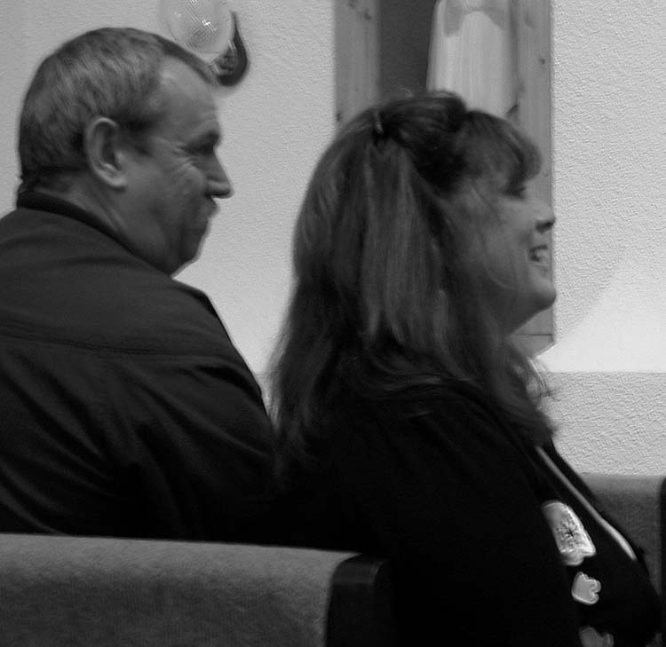

FAITH AND LIGHT USA/EAST NEWSLETTER, July 2000
We are Debbie and Bill, and we are very excited about becoming the new National Coordinators for Faith and Light USA East. Also, we are really excited to be on the team with Fr. Bob, the new Provincial Chaplain for USA East. We want to thank Sr. Florita and Fr. Giles, they will be missed! But we know that Faith and Light is still very dear to them and they will be active in many ways!
We want to introduce ourselves. We are married (to each other) and we have three great children. Lauren who is entering her last year at Flagler College in St. Augustine, Florida. Courtney who is entering her second year of college at the University of South Florida in Tampa, and Nicole who is in her Junior year of high school at Spanish River High School in our home town of Boca Raton, Florida. Lauren wants to work with autistic children when she gets out of college. Courtney is thinking of being a marketing major, and Nicole aspires to be an actress. We also have two doges, Samantha and Kailey, the mostly hang out with Debbie.
We were introduced to Faith and Light by our friend, Sr. Rita Baum, and have been in love with it since our first meeting in April of 1994. We are lucky enough to participate in two communities. The Boca Raton Faith and Light in which Debbie is the community coordinator, and the West Palm Beach Faith and Light. Our communities take the summer as a break, and then begin again in September with a Fiesta, and Fr. Bob has agreed to come down and help us this year. It is an all-weekend affair with a Faith and Light meeting on Friday night, a leadership day on Saturday, and a Fiesta on Sunday, including a talent show. It is a wonderful time and we usually get other Florida communities to join us, including Lakeland and Ft. Lauderdale.
Bill works for IBM, and Debbie takes care of the house, plus Bill, plus the girls, plus the Council of Catholic Women, plus support for Nazareth Homes, a local community based on the principles of L’Arche, and now as National Co-coordinator she will really be busy!
Right now, we are concentrating on the Pilgrimage to Lourdes, and hope everyone who wants to go to Lourdes gets a chance to go! We promise to greet you there with a great big smile!

A REPORT FROM SISTER FLORITA RODMAN, C.D.P.
National Coordinator from 1994 to 2000

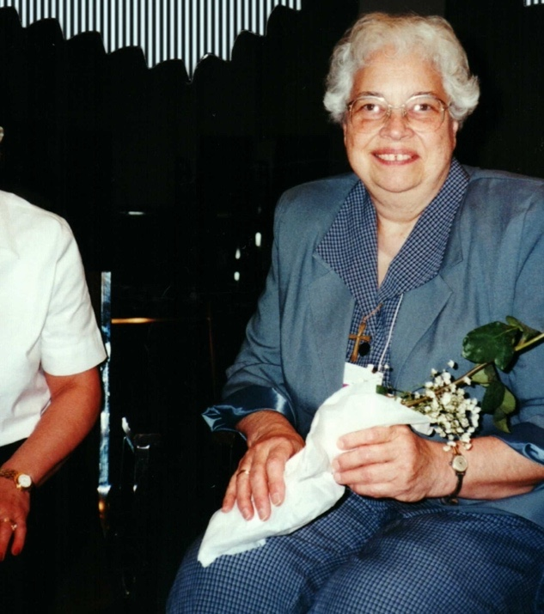
Sister Florita in 1998

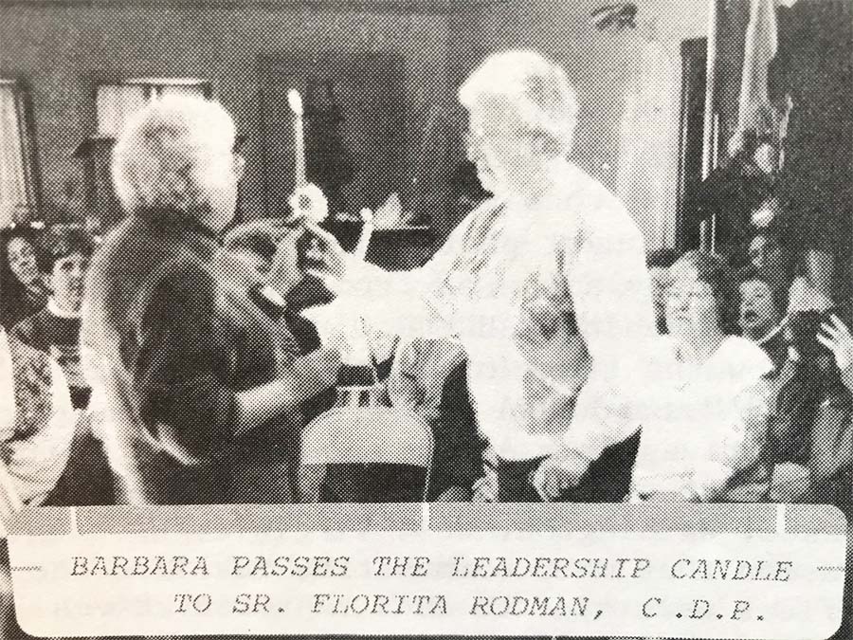
The following letter is taken from the December 1994 issue of the Faith and Light USA Newsletter
Dear Sisters and Brothers of our Faith and Light Communities,
The Denver Gathering was Very Spirit-filled for me. The prayer and discernment were a meaningful process. I could feel the movement. I thank those who through discernment were led to choose me for the National Coordinator of USA East, and I thank God for the gifts that I have been given. Equally, I am thankful for the gifts of the National team who will supply what I am lacking.
Since that moment of shock, I have felt the prayers and love of the big family of Faith and Light. I am most grateful to all of you for the prayers, cards, and messages of support and encouragement. With you and God’s grace, I believe we can further the fullness of life for Faith and Light Communities in USA East.
On my return from Denver, I found that my good friend, one of our Sisters had died. A week later another Sister friend went to God, and last week my Uncle George returned to his God. In between wakes and funerals and all the greetings from Faith and Light members, the reality of Denver began to take hold. I called Barbara Stevens and asked, “What should I be doing?” Barbara advised me to ease into the job; I would know what I am to do. A few days later in a phone conversation and a letter, I received my first directive, “A special newsletter is in the making (if you think this is a good idea) and the deadline to Pearl will be December 1st.” Who could object to such a good idea?
Thanks to all for everything. With God’s grace, I am willing to serve Faith and Light communities, especially the Regional Coordinators and our Region in Formation in whatever way I am needed.
For the rest of the month, in your bread and salt time, as you light your candle and remember those who have died, please include Sr. Mary Florence, Sr. Evelyn, George cook and their families.
During this Advent Season, may you experience the Lord Jesus becoming more and more a part of your life. This journey will give a deeper meaning to Christmas. May this Christmas be an Emmanuel experience…God be with you.
Blessings in Jesus’ Name, Sr. Florita Rodman, C.D.P.

Chapter Three

History of some of the USA East communities over the past 50 years in alphabetical order

Delaware Small Wonder Community Joanne Huhn Hockessin, DE 19707

Florida Currently Disbanded Lakeland Community

Georgia Faith and Light Greater Atlanta Janet Grzeszkowiak Marietta, GA 30062
Faith and Light of Greater Atlanta, Marietta, GA
"At Faith and Light we believe all people have gifts to share, regardless of how the package is decorated. Our co-founders, Fr. John Welch and Joy Fuchs, understood that each and every person is sacred and started St. Ann’s Faith and Light Community in 1999. Father John learned about Faith and Light during his seminary days in Washington, D.C. His experience and willingness to share his knowledge was an answer to Joy’s prayers.
Her prayer was to find a way for young people with disabilities to have a place to gather for spirituality and fellowship, especially after they had moved on from the educational system. (Gretchen Fuchs was the first Core Member of Faith and Light of Greater Atlanta and the Fuchs' family was the first family of our community.)
For many of our Core Members, once their school years are complete, options for socializing and maintaining relationships ends abruptly. Father John and Joy set us on a journey to build and continue lifelong friendships."

Georgia Transfiguration Community Suzie Barkley Marietta, GA 30066
Transfiguration Faith and Light of Marietta, GA formed in 2013 with the Fuchs, Barkley, and Tedeschi families and the encouragement of Deacon Ed Santis as Chaplain. It has grown to 21 active families and friends.

Maryland Holy Redeemer Faith and Light Community, Kensington Vicki Geiger
Silver Spring, MD
Faith and Light Community, Our Lady of Mercy in 2014 Potomac, Maryland reached out to form a Faith and Light community to other parishes in Montgomery County.
Peg Kolm, Special Needs Ministry of Catholic Archdiocese, Tim Weins Executive Director of Jubilee, the late Althea and Bob Wallace of Potomac Faith and Light community, and Dolores Wilson of Bethlehem House assisted to communicate to families to forming Kensington Holy Redeemer Faith and Light Community. The Jubilee Office in Kensington paved the way for the first Kensington F&L Meetings in 2015. Peg Kolm invited Kensington F&L members in 2016 to meeting Father Mark Hughes Parish Priest of Holy Redeemer Catholic Church, Kensington, Maryland.
Holy Redeemer Faith and Light Community 2016- April 2020 (No Meeting March 2020 Pandemic) invited to Community Meetings friends from Blessed Sacrament Catholic Church, Jewish Foundation, Islamic Community Center, and other Christian denominations.
Father Hughes gave permission for Kensington (Holy Redeemer) F&L Community Meeting from September-May to hold the meeting at the Church Meeting Room.
In the near future, when the Pandemic is resolved, Kensington Faith and Light Community is hopeful to resuming community meeting in person.
Thank you Peg and Delores Bethlehem House Foundation, thank you Jubilee Association of MD Inc., and many thanks to Father Mark Hughes your kindness to Faith and Light Community transform lives.
Narrative provided by Vicky Geiger

Maryland Potomac Faith and Light… Michael Bradley Bethesda, MD 20817
Potomac Community in Washington, DC
Founded by Bob and Althea Wallace in 1998.

Maryland St. Patrick's Community Teresa Perez and Paula Kearney Rockville, MD St. Patrick’s Community in Rockville, MD
Founded by Theresa Perez, Deacon Jim Nails, Paula Kearney and Mary Sue Metrey in 2013.
Teresa, Deacon Jim Nalls, and (Paula Kearney) were the founders, Mary Sue Metrey also helped us in the beginning. Following 2.5 years of planning, St. Patrick held its first Faith & Light meeting in January 2013. Parishioners Paula Kearney, Mary Sue Metrey, Deacon Jim Nalls (Chaplain), and Teresa Perez were the founding coordinating team. St. Patrick Faith & Light has been meeting monthly ever since and currently has approximately 25 active members. It was officially recognized as a Faith & Light community in May 2016.
Current coordinating team: Paula Kearney, Mary Ann Krumenacker, Deacon Jim Nalls (Chaplain), Darlene Piacesi, Teresa Perez
Maryland Joy and Hope Community Dr. Robert Dodadio Columbia, MD 21044

Massachusetts
Special Journey to God Theresa Esper Norwood, MA 02062
Special Journey to God Community,
Theresa Esper, the Community Coordinator shared: “I was not a founding member, but spoke with Pat Malloy. She shared that Fr. Bob Bowers, Fr. William Lucey, Judy Starr (first leader), and John Chute (core member, deceased) were among the first members of A Special Journey to God Community, probably in late 1994 or early 1995.
We had three staff people that worked with our core members: Marty, Ruth, and Carol. I joined in 1995.
I attended a pilgrimage with the group in 1995, to Washington, DC. We shared a bus with Sr. Florita Rodman and a group from Weymouth, I think. We have a video of parts of the event. They taught us the melody to the Community Song on the bus ride.
In 2019, some of us attended the 40th Anniversary pilgrimage to Our Lady of the Snows in St. Louis, MO. Mike and Pat Malloy, Karen Chute, Jean and Nolan Palmateer, Joanmarie Huistis, Felix Kaputu, Elise Macdonald, and I were among the participants.”
Information supplied by Theresa Esper in 2021

Massachusetts Jericho Sunbeams Laura Fitzell Holyoke, MA 01040
The founding members of Jericho Sunbeams were Father Robert Wagner and Sr. Joan Magnani SSJ. It was founded in 1974, a year before we traveled to Rome for the International Pilgrimage. We meet one year before the pilgrimage monthly to prepare ourselves for the trip. We prayed, shared and celebrated in preparation for our journey. I believe our community was discerned in 1976-77. Through the years many members have passed away, but new ones have joined us. We continue to meet the first Sunday of the month.
Information supplied by Sister Joan Magnani SSJ in 2021

Massachusetts Wayland Faith and Light Mary d'Amonville Wayland, MA 01778

Michigan Sacred Heart Community in Dearborn MI Currently Disbanded
Maureen O’Reilly and two others, since gone to Heaven, were instrumental in its founding and included two of her brothers. There were a number of members from group homes who regularly attended. Everyone really kept the community together even as the number of members dwindled.
Minnesota Family of Friends Sara McFee Richfield, MN 55423
Lucille Skluzacek was instrumental founding the Family of Friends Community in 1985. Her son, Joe and others joined her in starting three communities in the Minneapolis/St Paul area. As of 2021, Family of Friends is the only community still meeting. Another started in Minnesota with Lucille Skluzacek and Maggie, etc. in 1985 with Brother Jim. Lucille wanted friends other than family to help accompany her children (Joe and Missy) in a safe environment. Joe is still active in Family of Friends, as is Patricia Pavlak (97yrs, young); Patricia’s daughter, Virginia, died 2005.
Dr. James Sweeny & daughter, Kathleen are still active, too. James was first discerned leader of the community.

New York Infant Jesus Community Ann Dellow Port Jefferson Station, NY 11776
Infant Jesus Community in Port Jefferson, NY
Infant Jesus community was recognized June 6, 2002. It was started by Ann Dellow and Fr. John Worthley of Infant Jesus parish (). Other founding members include Patti Bock, Eleanor McGuire, Sabrina Glass (Ann’s daughter, Lucy's sister) and Diana Thomas. Ann also led a previous community in North Carolina for 3 years, but doesn't remember the name of it. That NC community met at the local Newman Center. I am sure Ann got involved to help her daughter Lucy, who has an intellectual disability.
Information supplied by Diane Marley in 2021

New York Nesconset, NY
New Hope Community in Nesconset, NY
In 2012, the community now known as New Hope held their first meeting at Holy Cross Church in Nesconset, NY. It was started by Marcia Gaudet, whose husband Jack later got involved. Their son, John Paul, has a developmental disability. They started the group in order to be able to meet closer to where they all lived. Holy Cross is my home parish, so I got involved there from the start, but never left the Infant Jesus community. Kevin (my son who has autism) was used to the Infant Jesus community, and was not interested in the new one for quite a while. Other founding members included the Helen and Owen Farley (Owen was a deacon at Holy Cross and became the chaplain of that community), the Russo family (at the time Mary Ann Russo was the director of special needs for the diocese of Rockville Centre) and Gil and Allie, whose last name I don't remember. I don't remember the exact date, but New Hope community must have been recognized sometime in 2011.
Information supplied by Diane Marley in 2021

Ohio Aqua Viva Community: Carmen Garcia Maria Roman Angelita Santiago Cleveland, OH Cleveland, Ohio
The Faith and Light Community “Agua Viva” was organized on August 24, 1987, by Mrs. Rosa Alvarado and Sister “sister” Gloria M. González, a pastoral member of the then San Juan Bautista, now La Sagrada Familia. Doña Rosa, mother of two “special children” Carmencita and Georgie, saw the need in our community, and they took the initiative to form a group to help these young people and help the parents as well. It included people from other religious denominations. This group is the only one in Cleveland and the Spanish-speaking eastern area. For 33 years this group, Fe y Luz, Agua Viva, has continued the work that Doña Rosa started, different coordinators have made this group the support center for parents and relatives with children, youth and adults with special needs. Throughout the year different activities are planned and developed for our participants such as; painting workshops, games, dances, walks and outings, integrated into the Christian Faith. Our monthly gatherings end with a tasty meal that is everyone's delight. We also go to a spiritual retreat at a camp every summer. It is a blessing to have our community of Faith and Light, “Agua Viva”.
We have lost some members of our group. The group is small now; we have not had meetings since February last year, although we went bowling. Angelita Santiago and Maria Román currently are coordinators. We look forward to have camping
Information supplied by Carmen Garcia in 2021

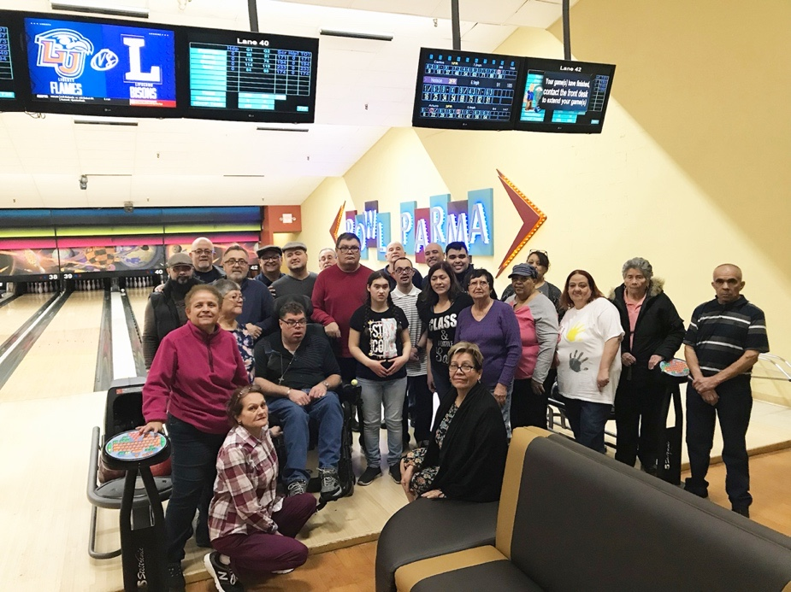

Ohio Sanctuary Community Ron Zybura Cleveland, Ohio
Sanctuary Community,
We started in 2016 and became recognized in 2019. Our eastside group was organized by Pearl Cahoon and met monthly informally at restaurants with Fr. John Uhaus, Fr. Jack Valley, the Rogers Family, Kathy Cottman and other friends. Tom and MaryAnn Andel, Matt and McLarty, their sons and Tom Greiner are core members of our group. Ginny and I were members of Henry and Esther Oden's Ephrathah Community. Joan and Alex Kosiewicz are members of our current group, but health keeps Joan from most meetings.
Information supplied by Ron Zybura in 2021

Ohio Joyful Witness Community Raymond & MarieAnn Thomas Akron, OH
Joyful Witness Community in Akron, Ohio
The Joyful Witness Community was founded in February of 1982 when Sandy Lovelace organized the first meeting at the home of Ray and MarieAnn Thomas in Akron. Joining them were Molly Casper and Tammy Fagan. The membership continued to grow and included the Bachmans, the Macdonald family, the Bordenkircher family, Tommy Chuey, the Puderbaughs, the Bromleys, Lucille Reyman, Tom Canan, the Wagner family with Theresa, David Cook, the Kennedys and the Demboski family.Father Phil Pritt was an early chaplain for our community. Our celebrants for Mass have included Fr. Jim O'Donnell, Fr. John Mc Donough, Fr. Bill Karg, Fr. Neil Walter, Fr. Peter Kovacina, Fr. Anthony Simone, Fr. Steve Valenga, Fr. Tom Dekemper, Fr. Tom Gallagher and even Bishop Gilbert Sheldon!
Kirt Bromley took over as Coordinator when Sandy married and moved to Lorain. When Kirt took responsibility as Regional Coordinator, then Linda Bordenkircher took over. After Linda died of cancer, Peggy Macdonald and MarieAnn took over. Currently, Patti Wagner and Gretchen Kennedy are coordinators.
Kathleen Thomas has served as a Eucharistic Minister at St. Sebastian since 2010. Jim (2003) and Marie McDonald are in the choir in heaven. Andrea Bordenkircher continues to join us for many events. Andrew Martin has joined a local K of C council but is a very faithful attendee at F&L meetings and events. Tom Canan (2002) too is in heaven, with Bob from the Ardmore Group Home. Puderbaughs moved out of state. Lucille Reymann is retired and still resides in Mich. with her sister Selma. She checks in a couple of times a year. The Bachmann Family returned to Akron area and we are so happy they have reunited with us. Angela Bachmann, Andrea Bordenkircher and Kathleen Thomas have been a trio since grade school Religion classes at St. Sebastian in the 80's. Tommy Chuey was their teacher.!!!!
Meets 3rd Friday at 7 PM The Joyful Witness community helped start the Faith and Light community in the Altoona, PA area. They joined the Good News Seekers, Aqua Viva and other nearby Faith and Light communities for activities. Currently they meet once a month on the third Friday at St Sebastian Church, Akron.
Information supplied by MarieAnn and Ray Thomas in 2021

Loyola Retreat House in Clinton, OH Becki Haller, Coordinator
At the suggestion of Ray Thomas of the Joyful Witness community, Kirt Bromley called the Loyola of the Lakes Jesuit Retreat House in January of 1990 to inquire whether it would be possible to have a Faith and Light Retreat there. Kirt met with an enthusiastic response from the Director of the Retreat House, Becki Haller. Together, Kirt and Becki planned a retreat for Faith and Light for the Spring of 1990. An invitation to join the retreat went out to all of the Faith and Light communities in northeast Ohio. The retreat was a great success. Longtime members of Faith and Light attended with many families who had never heard of Faith and Light. Youth from area high schools attended to be the friends of the families. It was so successful that Becki and Kirt planned a second retreat a few months later in the summer. This became an annual event. The retreat was so well received that families and volunteers came back year after year. Although some participants did not follow up to join area Faith and Light communities, the experience was so uplifting to all that a real Faith and Light community developed. Very often the number of retreatants exceeded 80 people. In 2019, Loyola Retreat House hosted the 30th annual Faith and Light retreat. Due to the pandemic, the retreat was cancelled for 2020.
Information supplied by Kirt Bromley in 2021

Ohio Disbanded communities
Marigold Community in Dayton, Ohio
Founded in the 1980s with long time community coordinator Terry Trzaska. After Terry passed, the community struggled for a few years, but had disbanded by 2010.
Information supplied by Kirt Bromley in 2021

Rays of Glory in Erie, PA Disbanded community
Founded in the 1990s by Jackie Johnson, a diocesan director of services to people with developmental disabilities. The community had a number of members from the L’Arche homes in Erie. Lynne Martin and Roberta Morrison were community coordinators discerned in 2007. The community had disbanded by 2015.
Information supplied by Kirt Bromley in 2021

Pennsylvania Indian Creek Community Pastor John Hank Souderton, PA 18964
The community at Indian Creek Foundation was started by Rev. Barbara Shisler when she worked there as the Pastor. The community was recognized July 1, 1990 by Delores Wilson.

After Barbara left Indian Creek Foundation the community was led by Pastor Dawn Nelson who has passed away, after Dawn Nelson Pastor Pam Landis led the community for 16 years.
Currently the community is being led by John Hanks.

Pennsylvania Circle of Hope Community Reverend Barbara Shisler Souderton,
Founded by Barbara Shisler, Becky Tirpole and Judy McLoughlin in 2005. Faith and Light Circle of Hope - Pennsylvania

On October 7, 2005, the first meeting of the Faith and Light Circle of Hope met at Perkasie Mennonite Church, Perkasie, Pennsylvania, with twelve persons attending. We continued monthly meetings on second Fridays with attendance averaging fifteen persons. Approximately one third was core members, one third families, and one third friends. Pastor Barbara Shisler and parent Becky Tirpok assumed leadership.

On February 8, 2008, Coordinator Pam Landis attended for a discernment of leadership. Barbara Shisler was chosen and we became a recognized community. A team of five also provided supporting leadership. On our 10th anniversary the group led the Sunday morning worship for the congregation to much appreciation and enjoyment.

Today we have twenty-one regularly attending members. Judy McLoughlin has joined Barbara in team leadership. Perkasie Mennonite Church continues support for the community. We are a diverse group of churched and unchurched people, family members and friends. We held a retreat in September of 2016 at Mariawald Retreat Center that was a highlight for the community. We continually celebrate the love and care we feel among us within the community.

Barbara Shisler was the founder of Indian Creek Faith and Light in 1990 and when she was no longer involved there, felt a desire to start a new group connected to her home church in Perkasie.

Pennsylvania How Beautiful on the Mountain Gaye Boyer

Faith Overflowing in Pittsburgh, PA Disbanded Community
Founded by John and Jane Pillar with their daughter Susan in 2001. Most members were from the area’s group homes. The Pillars received inspiration to start a Faith and Light community when Susan’s sister began working in a L’Arche home in Washington state. The community had disbanded by 2012.
Information supplied by Kirt Bromley in 2021

Virginia SHENANDOAH VALLEY COMMUNITIES (2)
Shenandoah Valley Community, Gwen Carr Waynesboro, VA 22980
and
Shenandoah Valley Community, Preston Suddeth Elkton, VA 22827
Room at the Table
A candle is lit as we pray for the light of Jesus to fill our hearts and our community. Someone wanders through the group looking for a place to sit. Another person wants us to pray for her as she misses a loved one who passed away. Still another asks us to sing her favorite song, “Lord, I lift your name on high.” The drama has to do with becoming a friend of Jesus like Zacchaeus, whose heart was changed as Jesus entered his home and ate with him. Together we reflect on the many people in our society who no one seems to like and we begin to understand that Jesus invites them and us to a table where all belong.

We are the Shenandoah Valley Faith and Light communities. In the late 1990s, a few families with children with disabilities gathered monthly at a local Mennonite Church for an opportunity to share our lives with each other and to feel like our children had a place to thrive. As we continued to meet, Dave Gullman, one of the parents in that group, began work as a pastor at Pleasant View, Inc. an agency that supports individuals with disabilities. We opened our hearts and our gathering to many individuals from local group homes and our group grew.

As Dave began exploring the possibility of joining Faith and Light, he contacted Dee Wilson in Washington DC. She graciously offered us the space and resources we needed to explore this option at our own pace. In September 2007, Dee joined us at Camp Still Meadows to officially recognize us as a Faith and Light community. A few years later, we had grown to the point it was necessary to form two groups. Since that time, we have been meeting separately throughout the school year and together during the summer months where we gather outdoors at Camp Still Meadows.
Some highlights for our communities over the years include:
- The 40th anniversary Pilgrimage to Our Lady of the Snows in 2011 when we drove 3 vans from Harrisonburg, VA to St. Louis and immersed ourselves in the broader community of Faith and Light. The trip took two days each way and the journey was truly an enriching part of the pilgrimage.
- A daylong retreat to which we invited people from a L’Arche community in Lynchburg, Virginia. What a joy it was to make new friends from a community a few hours away.
- Two summer weekend retreats, which included drama, art and music as means of expressing our faith in Jesus. Everyone enjoyed the opportunity to relax in a beautiful mountain setting and sitting around the tables long after our meals were over.
- An annual Christmas worship service. Each year we give everyone present a chance to hold the doll baby representing Jesus. Many do so with deep affection and joy. Some want to hold him for a long time. Others give him a kiss and hold him with the affection of a mother for her child. It is always a holy moment for our communities.

It has been deeply moving to see the way that many of our core members truly have made room in their hearts for Jesus. Our faith is strengthened as we have seen how the light that came into the world has shone into the lives of our families and friends at Faith and Light and through our communities to the world. When there is room at the table for everyone, everyone benefits.
Narrative provided by Dave Gullman - Chaplain

Washington, DC St. Anne Dolores Wilson
St Anne Community and Hearts of Peace Community in Washington, DC
Founded by Dolores Wilson in 1986. Most of the core members came from the two Christian group homes which Dolores founded in Washington, DC. There were many friends and assistant from the group homes involved in the communities. Dolores hosted the Provincial Meetings and Assemblies in Washington, DC in 1998, 2000, 2002, 2004, 2006, 2010, 2016, 2017,2018, and 2019. Dolores was Vice Provincial Coordinator from 1998 through 2021, and Provincial Coordinator from 2006 to 2010 with Fred Seagren.
Information supplied by Kirt Bromley in 2021

Our Lady of Peace
Our Lady of Peace community in Washington, DC was started by Dee Wilson in
1986. The Draper, Bovich, Lewis, Kline, Mann and Ruppert families made local
Pilgrimages to the Lincoln Memorial, and members were active as church usher,
Knights of Columbus member, volunteer in church office, Eucharistic Minister,
Parish choir member, and working member of Bishops Conference Office for People
With Disabilities. The community even attended the Pilgrimage in Lourdes.
In 2001 three Washington communities attended the Pilgrimage to Lourdes with Fr. Bob Malloy, National Chaplain for Faith and Light, Fr. Joseph Sileo, Director of Inclusive Programs for Catholic Schools, and Fr. John Welch.

Chapter Four

A Parent Reflects

by Pastor Dave Gullman, Chaplain USA East

On the cusp of a new year, I reflect on God’s faithfulness and the incredible story of Faith and Light. 25 years ago, our daughter, Hannah was born. Shortly after her birth her doctor told us that she probably had Down syndrome. I had known people with this genetic condition but to be given the task of raising a child with Trisomy 21 seemed impossible. Fortunately, we did not know all that we would encounter along the way and we began to settle into the daily routine of caring for someone with a few extra needs along with that extra chromosome. We had a caring family and deeply compassionate friends who helped us along the way, especially when things got really tough for us. We also had a church that helped sustain our faith as we faced what seemed insurmountable obstacles to health and well-being. God provided for us in multiple ways and we emerged from those early years with faith intact and a deep sense of call to help others on similar journeys.
Unbeknownst to us at the time, a movement was born years earlier that addressed some of the deep emotional and spiritual needs of families like ours. That movement was Faith and Light. Faith and Light was born because many, many families like ours had experienced hurt and rejection because of the difference disability had brought into their lives. They did not have the support of family, friends or church when they needed it most and the places of healing were declared “off limits.” In response, a pilgrimage to Lourdes for people with disabilities, their families and friends was organized. We now know that story of 12,000 pilgrims making their way to Lourdes on Easter weekend, 1971 as the birth story of Faith and Light. Since then, thousands of people have found a place of refuge, acceptance and love in Faith and Light.
As we cross the threshold into a new year let us be mindful of our individual stories along with the bigger story of Faith and Light. How has God’s faithfulness been expressed in your life? Where have you seen God at work in and through Faith and Light. I don’t normally make New Year’s resolutions. I prefer, instead, to let the awareness of God’s faithfulness carry me into the new year. It is God who will sustain me as the coming year unfolds. We are told in scripture that “God who began a good work in you will bring it to completion.” (Philippians 1:6) The good work of God begun in you and in Faith and Light will continue to bear fruit in this coming year and I am already grateful.
In gratitude,
Dave Gullman

Chapter Five

Flying with the Best

A Faith and Light Pilgrimage to Lourdes, France
Holy Week 2001
A Journal by Kirt Bromley

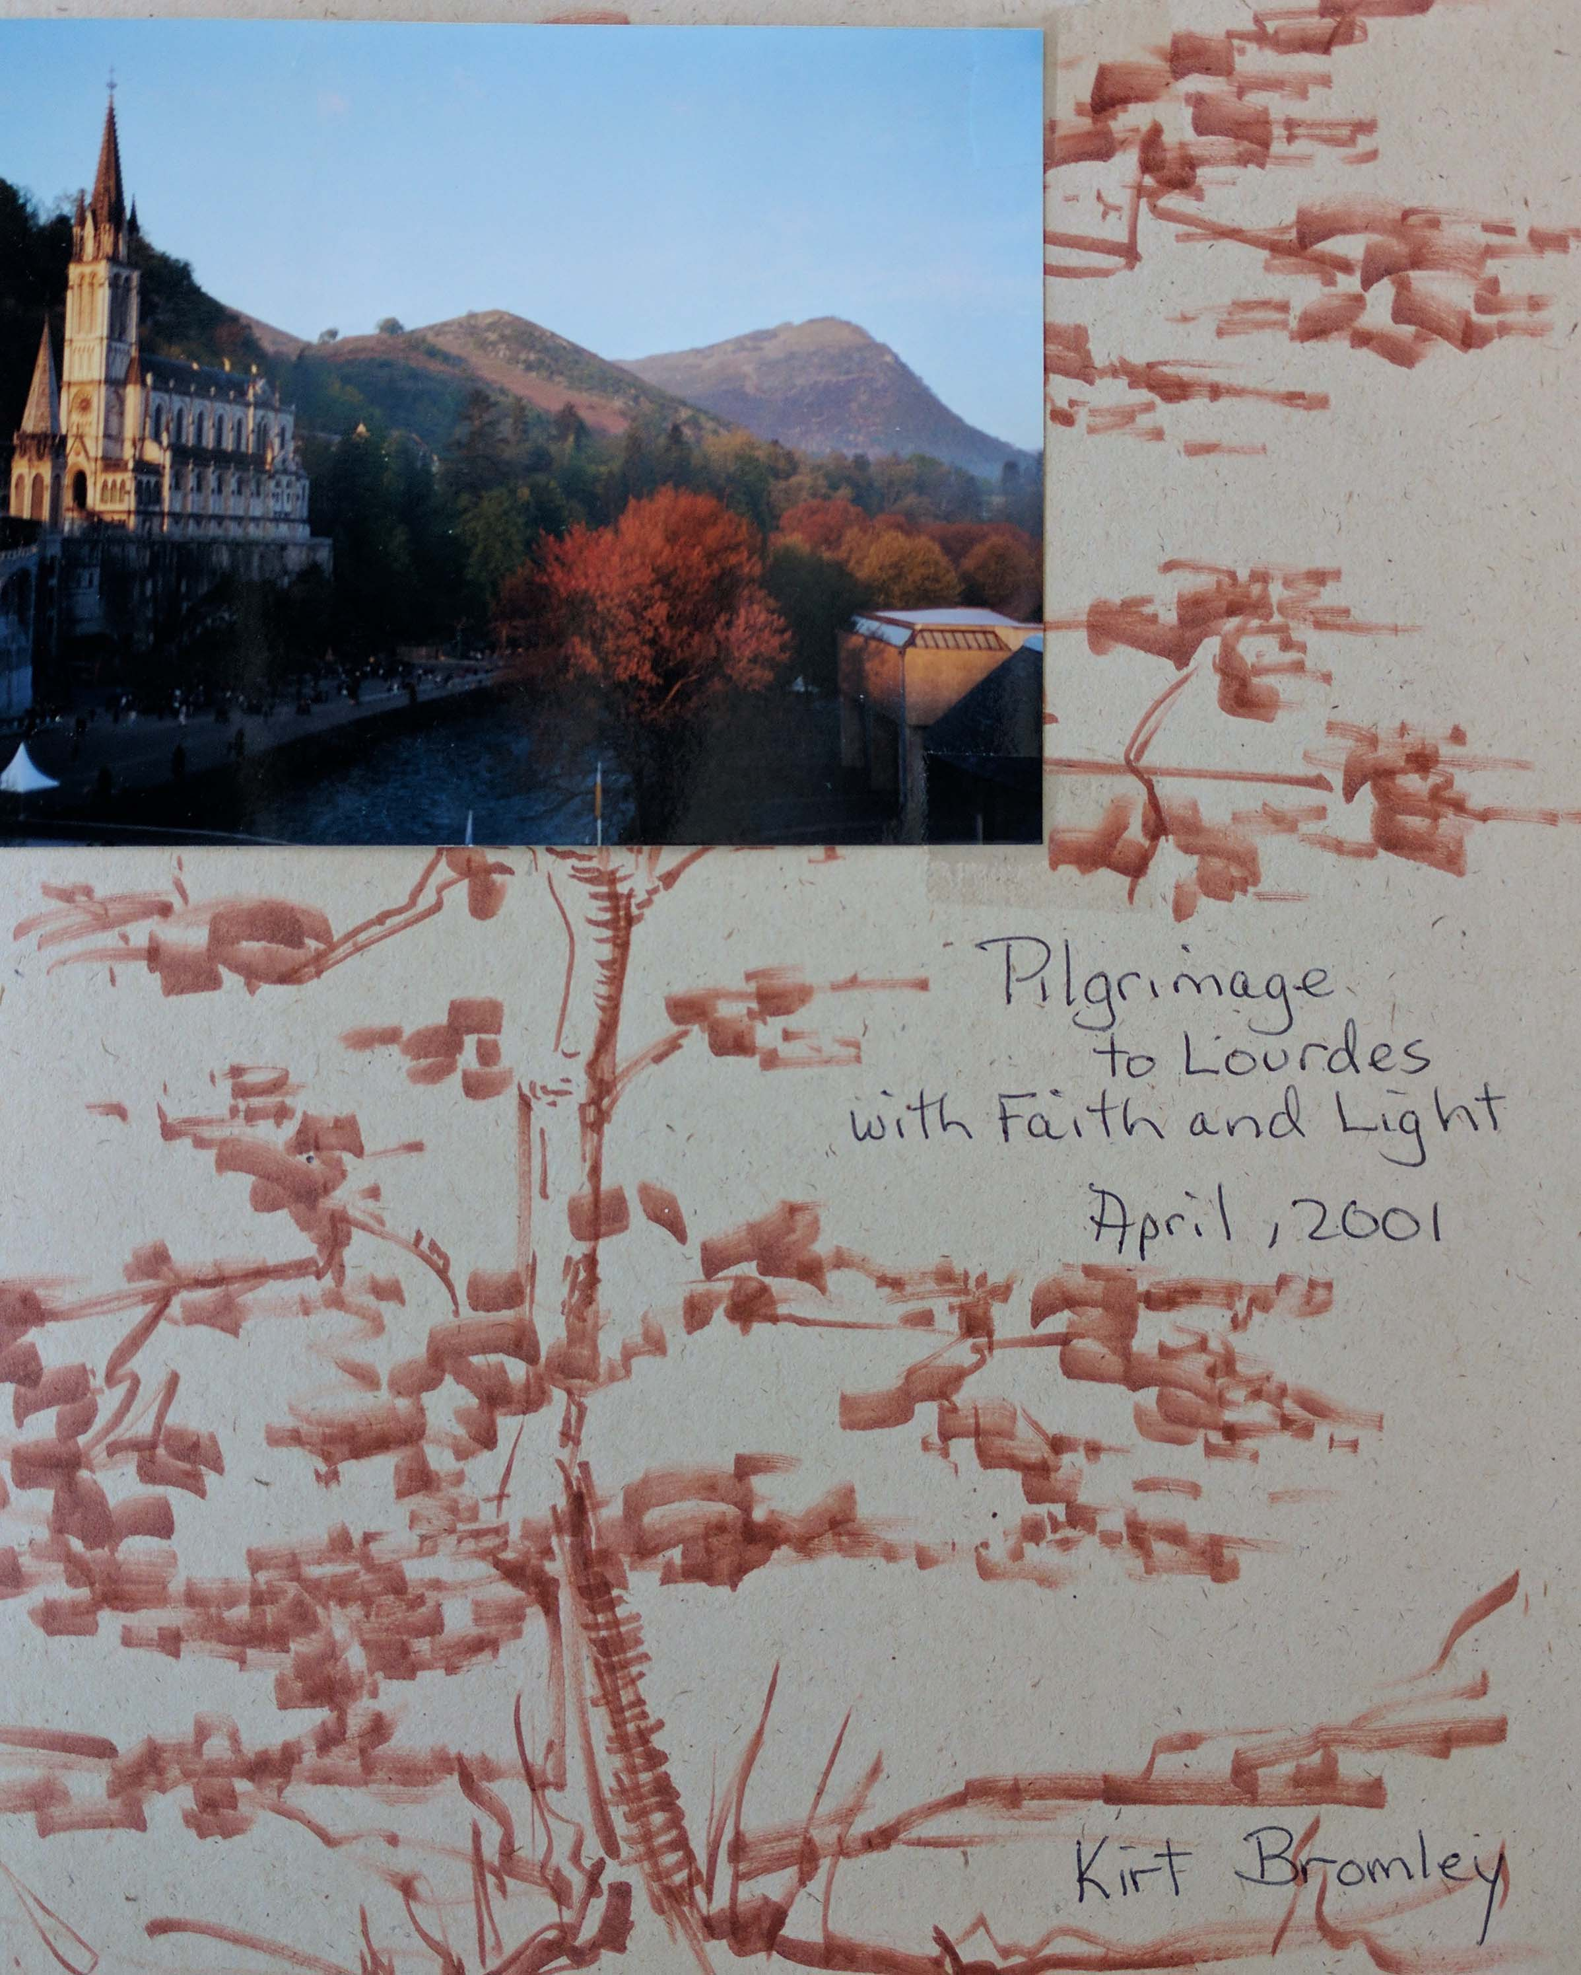

Flying with the Best

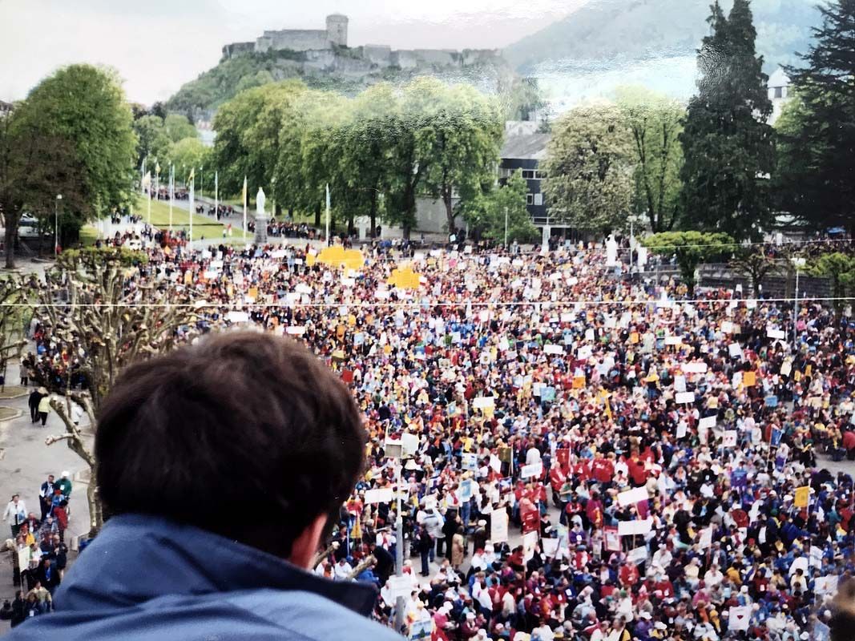

Jean Vanier’s Maundy Thursday Message
Given in Lourdes April 12, 2001
From my notes

“We have seen the deep wounds of humanity. The terrible suffering of people,
    - the deep wounds of slavery. African men and women carried against their will to the Americas,
    - the evil of the concentration camps and the gulags,
    - the destruction of traditional cultures by misled missionaries
    - the ostracism, the locking away, the fear and the hatred shown toward men and women with mental disabilities.
We have now learned to thank those who carry their fragility so openly.
Faith and Light was born of the beauty of the person.
We believe everyone is capable of meeting God.
We have seen that God has chosen those who are weak to reveal to us our humanity.
We believe they are also an incredible source of life.

Today Faith and light is at a turning point.
Thirty years ago, Faith and Light was a source of consolation. For the past two pilgrimages, Faith and Light has focused on the recognition of the value of every person.

Today with this pilgrimage, we are focused on the revelation and resurrection.
We discover and reveal to people that those with mental disabilities have something to contribute. They teach us to love. They teach us compassion. They teach us that to be human is to love.
And we are called to change. We have seen that friendship with the fragile and weak can change us. And we can change the world.
We are called to go forth to announce a message to the world.
The message is the incredible beauty of people who are weak.
The message is that God has blessed us by the presence in our midst of our weaker brothers and sisters. Our mission is, “Come! Come to those who are weak, and behold the treasure.”
The Grotto of Massabielle, Lourdes
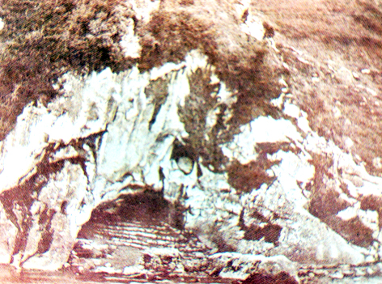

A Personal Journal of the Faith and Light Pilgrimage to Lourdes during Holy Week 2001
with 17,000 members of Faith and Light communities
from 54 countries, April 9-19, 2001
Very auspicious this title above! Where is God leading me? We will see.
7:30 AM I begin my pilgrimage filled with faith and doubts. Faith that God is always with me, and that He will take care of me in so far as I let Him, or remember to invite Him to take care of me.
Doubts arise as I breathe. Am I doing the pilgrimage correctly? Why am I still thinking the same way as yesterday? Of course, the whole spirit/mind/body is of one piece. God is the same yesterday, today and tomorrow, and the way I have been thinking in all my yesterdays affects my today, now.
I got up this morning and did things that I have done on other mornings. Mundane things and spiritual things, I washed and dressed. I gave 20 minutes to God by stopwatch to attempt to focus on Him in Centering Prayer. And I am on my way to morning Mass as soon as I get out of this chair and go shave.
Oh, I forgot. I have a “to-do” list, amongst them getting the phone working before I leave the house at 12:30 PM to catch the first leg of the flight to Paris.
9:15 AM We passed a phone truck on the way to Mass – the line was burnt out the night before, and they were repairing it.
At Mass this morning the priest told a story during the homily to the effect that the way we see things is not the way they really are. Our views, our perceptions are skewed. This is the benefit of viewing faith through the eyes of the Church. The millions/billions of people who have lived before us have refined the truths of our salvation so as to be highly accurate, in reference: the theology, the Christian values. Who is God? What is God’s Creation? And how are we related to each other? We know justice and mercy by revelation from God and refined interpretations of men and women who have gone before.
Back to the moment of today, I need to make a wooden cross for the Maundy Thursday/Good Friday celebration. The cross is to measure five feet tall, two feet wide and has to fit in my luggage.
I am remembering my mother. She died less than a month ago. Our family gathered from different parts of the States to celebrate her life. We came from different places, but were united in our love and memories of her. She lived to be 79. On her death bed she seemed to pause on her final journey until my wife, my son and his wife arrived from Ohio. Twenty minutes after they arrived by her bedside, she passed on.
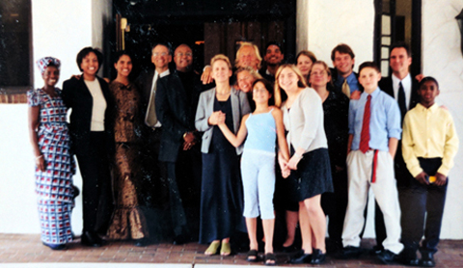

Somehow, my mother’s passing is part of this pilgrimage journey. Life is a bit raw. It has not been that long since a loving person that I have known all my life, left this life. People enjoyed knowing my mother. She made friends easily. In the last months of her life, she had trouble with mobility. Cancer radiation destroyed the marrow in her hip bones, she had several falls and several hip replacements. When my wife and I visited her several months before her death, we drove her from her home in Naples, Florida in an excursion to look at the architecture in South Beach, Miami. The time in the car with her was precious.
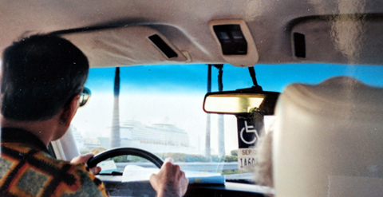
Time to Embark on the Pilgrimage
2:20 PM At the airport with the Oden family: Carol Mary, our member with developmental disabilities, her sister Joan, her mother Esther, Joan’s daughter Joy and son Keith, Joan’s husband Alex and Carol Mary’s other sister Dorothy. Alex and Keith are not travelling with us, but helping us get Carol Mary on the plane. Carol Mary has a huge wheel chair because of her cerebral palsy. We are missing Henry, Carol Mary’s great-hearted father who passed a few years before.
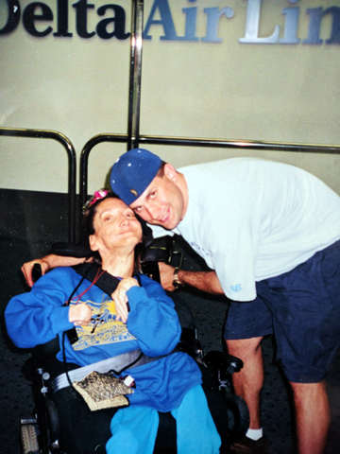
Carol Mary and her cousin Keith at the Cleveland Airport

Keith, Joan’s son, has such a beautiful relationship with his aunt Carol Mary. Carol’s face just lights up when Keith talks to her. I have the picture. Joan’s husband Alex is a great one too; he’s quiet, but so attentive to pick Carol Mary out of her wheelchair when necessary.
We are joking about the plane because it only has 50 seats. Alex says that it’s got rubber bands for engines. It really is no joke because the plane has not pulled up to a passageway for wheel chairs to roll down. We wonder how we will get Carol Mary up the stairs and into the plane.
This is no joke.
I finished my wooden cross earlier; it’s cut, sanded, drilled and bolted with machine screws. It is now packed into my main bag. But the banner that Becki made is in my carry on; that’s too important to trust to the checked baggage. I also decorated my banjo case with big “Faith and Light” nametag written with “White Out” solution.
5:57 PM Well, Alex, Carol Mary’s brother-in-law, carried her up the stairs for our first leg trip to Atlanta airport. It was a very unusual sight in this “day and age.” Standing on the runway by the plane, there were some six steps from the tarmac to the plane’s door, and Alex carried Carol Mary the whole way. The airlines really haven’t made any facilities available for people in wheel chairs; the aisles and the stairs are barriers to people in wheel chairs. 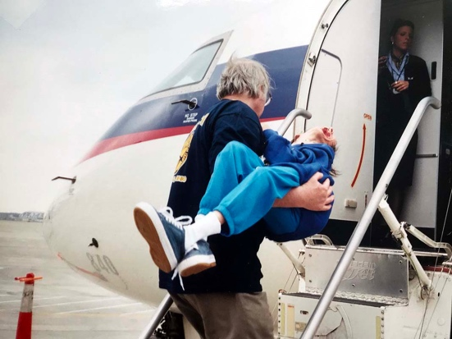
We are now on the transcontinental Boeing 777 on the way to Paris. Ester and Carol Mary are in the middle section, several rows ahead with the bulkhead immediately in front of them. It gives them more room, but Esther must hold Carol Mary the whole time. Carol Mary uses a form-fitting wheelchair and there is no way that these Delta seats will conform to her spine. We will probably take turns holding Carol on the eight-hour flight across the Atlantic.
We’re not thinking any particularly profound thoughts now, only how to help each other and make each other comfortable. Carol Mary has about 5 pillows, so I think we’re O.K.

To be a pilgrim is to make do, and make pleasant the uncomfortable and the unexpected.
To be a pilgrim is to wait, but not alone, for there are other pilgrims next to you, and there is Jesus.

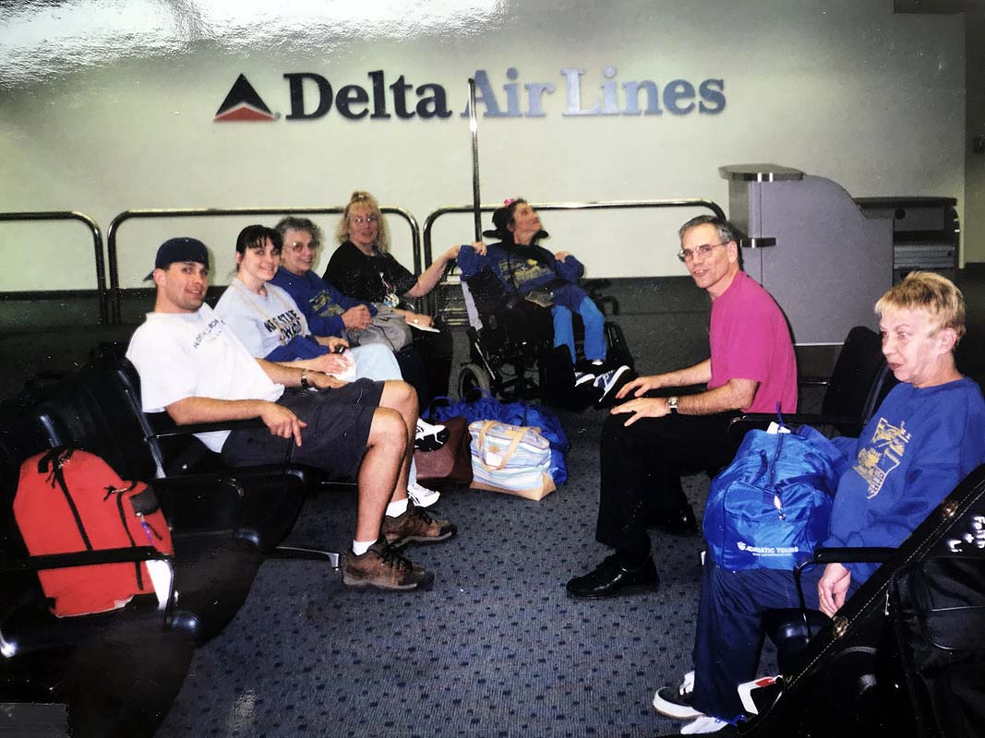
At the Cleveland Airport, waiting to leave for France
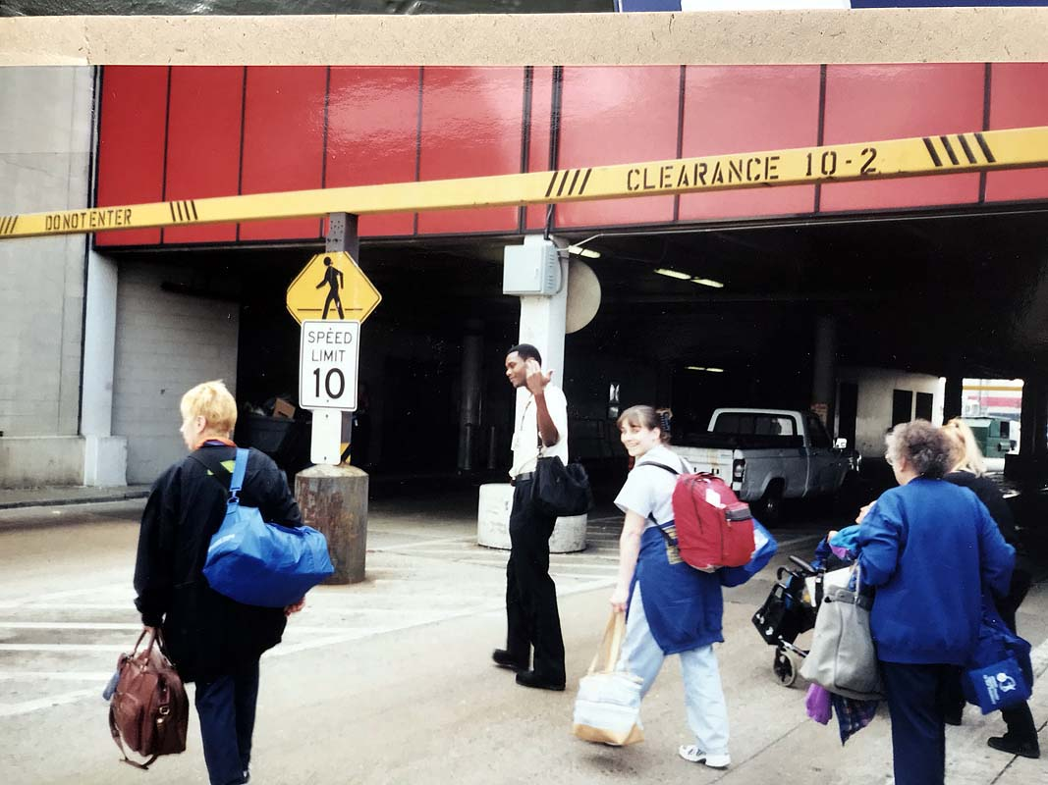
Walking across the pavement of the Atlanta International Airport with Carol Mary’s wheelchair

April 10, 2001
Up early in the morning. We jumped the clock ahead six hours. Did I sleep more than 2 hours…2 to 4 AM? I caught a Sci-fi film about Mars, and then forced myself to close my eyes for the rest of the flight. We had a quick breakfast before landing at 8:30 AM, Paris time. Our little group gathers with other Faith and Light members from other parts of the USA. We had a Dutch lady named Elle, who was our tour guide from Charles de Gaulle airport to the Chapel of the Miraculous Medal. We had Mass there. I was with my partner for the pilgrimage, Joe Skluzacek.
Lucille and Joe, mother and son from Minneapolis, MN and myself make up the trio that forms the model for all Faith and Light pilgrimages, parent, child with developmental disabilities and friend.
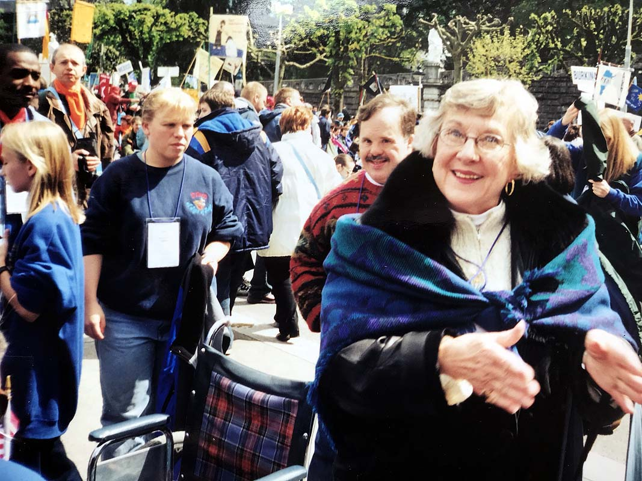
During Mass at the Chapel of the Miraculous Medal, Joe and I volunteered to collect monetary donations at the Offertory. Reflecting on God’s Grace and mercy, and God’s persistent choice of the poor and despised of the world as His messengers. What is it in this devotion? Is it part of my life? Wait and see.
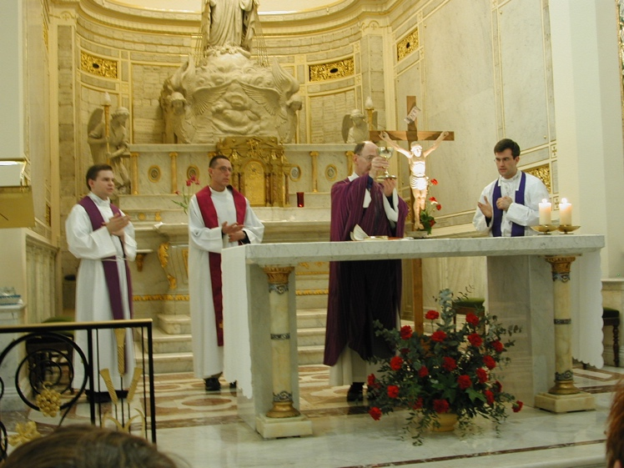
Chapel of the Miraculous Medal, Paris
We rejoined the bus tour after Mass, saw the Eiffel Tower, the Seine, Montmartre, the World Cup stadium. We proceeded to Gare Montparnasse, a huge train station in the middle of Paris. We proceeded to the train, had our luggage loaded for us, and then Lucille, Joe and I, our trio, went to lunch. We wanted real French food. No “Quick Lunch” hamburger places. We wandered in the station looking for a good restaurant, but finally found one on the sidewalk outside. There were a few tables in the front and a fancier setting indoors. Lucille was tired, we were hungry and not really up to further searches, so we went with it. The menu had recommended and quick lunches around 79 francs ($10 USD). I chose one that had a selection of pork. It was a great lunch with big portions! Lucille and Joe had big portions of lamb for 89 francs each.
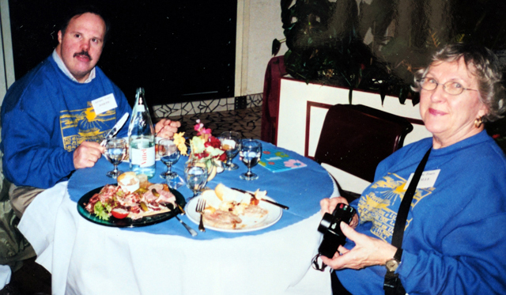
As I write this, we are now on the express train from Paris to Lourdes. It shakes a bit, but on the whole is pretty smooth for a high-speed train.
4:30 PM We are ripping through the countryside of Bordeaux with a car full of pilgrims. We are “en route”, joking, and some of us catching up on lost sleep from our quick night on the plane.
I’ve alighted in Bordeaux. Five minutes on the train platform. The city of Bordeaux looks like any other large city around the world; there are many stories to be told in their old buildings with signs of former residents and businesses. “Le Taco” a sign in front of a run-down row building states, with a picture of a fighting bull on a black background, a sign that might have been formidable at one time, but now is forlorn. And graffiti. Every major town we pass through has had graffiti on their buildings…a sight of people not respecting their town, who they are or where they are.
We’re still two hours from Lourdes and I haven’t had my second prayer time for today. Amidst the teeming throng in this railcar, I will close my eyes and pray.

6:44 PM I napped. That is, I closed my eyes to do centering prayer, and woke up 30 minutes later. I must have been tired. The people in the railcar are settling down. We’re quieter.
8:30 PM We’ve arrived at the railway station in Lourdes, in the rain. A bus has transported us to a hotel, but some confusion entails as the bus driver is not sure that this is the correct hotel. Serving my fellow American travelers on the train, I speak French with Caroline, the concierge, her assistant, and the bus driver. We finally establish that this is the correct place, and we start to unload. I am the only one in our group who speaks French. It was challenging and fun; I was pulling vocab from my memory that I didn’t even know I remembered.
Our hotel is a special building, named Accueil Notre Dame, with accommodations for people with disabilities. The bedrooms are wheelchair accessible, and every floor has dining facilities and meeting rooms. It is also directly across the river from La Gave, where Bernadette had the apparitions of the Virgin Mary.
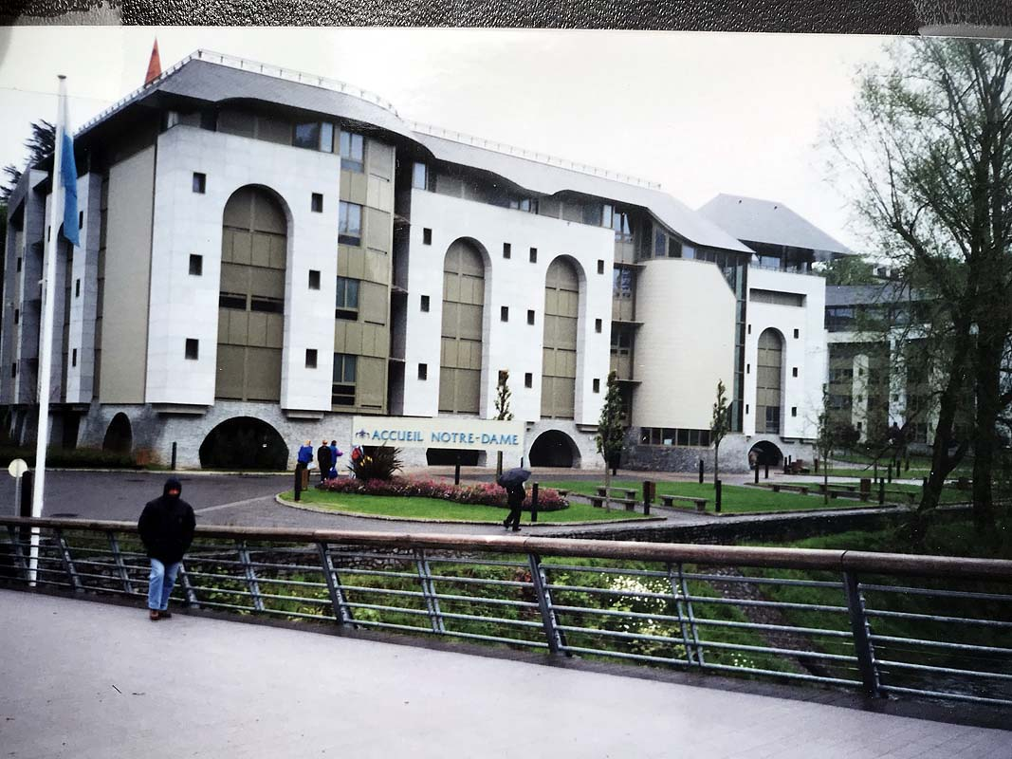
Accueil Notre Dame, a unique hotel for pilgrims who are disabled
After a five-course dinner (this is France! ), we get everyone settled in their rooms on the fourth floor. Their needs met, I slept.
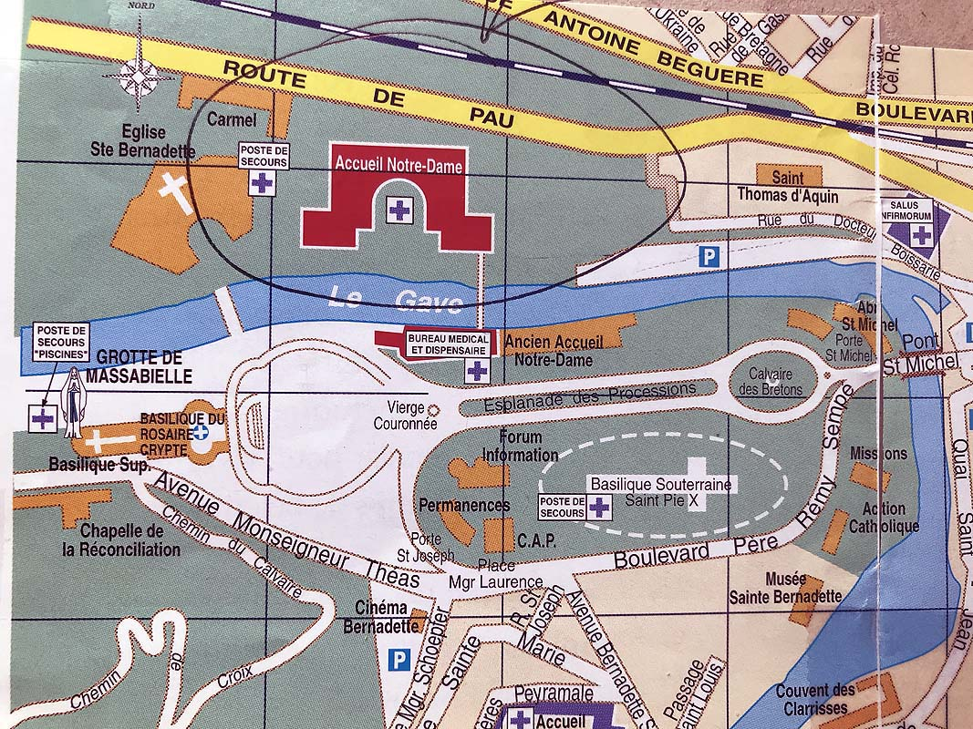
Accueil Notre Dame marked in red, the Basilica of the Rosary and Esplanade in white, the Grotto to the left of the Basilica, and the huge underground Basilica (elliptical circle in green)
Wednesday of Holy Week, April 11th
8:05 AM The morning started with a bang! Breakfast started at 8:00, and I wake up at 8:05; the alarm on my watch was set at 6:55. What happened? I had breakfast with our American group. We are about 35 Faith and Light Pilgrims from America on this floor. Another group of Faith and Light Americans are at another hotel in Lourdes; we’ll probably meet up later for activities. We also understand that Faith and Light groups from Russia and England will be joining us on the fourth floor of our special building. I took a few minutes after breakfast to join Joe and Lucille in a walk down the esplanade in front of the River Gave, on the other side of which is the alcove where Bernadette saw the Mother of Jesus.
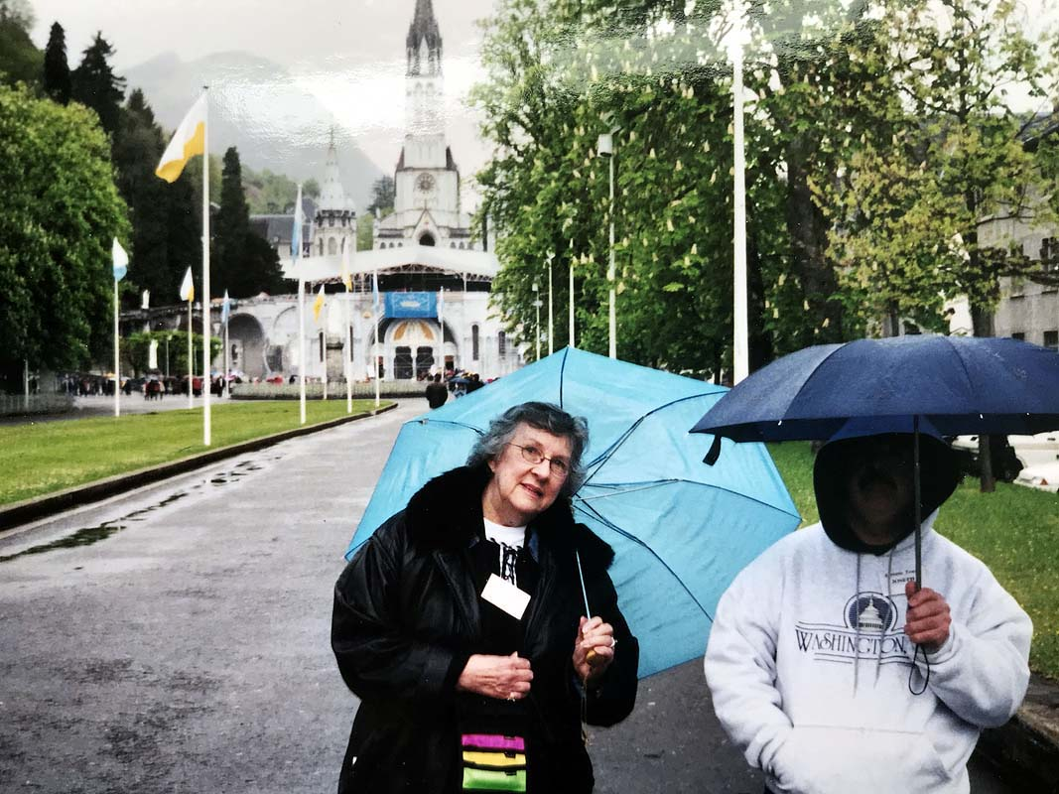
Lucille and Joe Skluzacek on the Esplanade with the Basilica behind
Soon we joined our American pilgrims for a tour of Bartrés, the mountain village where Bernadette was wet-nursed by her aunt because her mother had burnt her chest. When she was an older child, Bernadette came to her uncle’s “bergerie” or sheep farm, to help with the sheep during the summers.
I took many shots of picturesque mountain vistas. It was cool weather and damp with passing showers. The whole scene was pastorale, and revealed a simple rural life in this elevated and remote mountain environment.
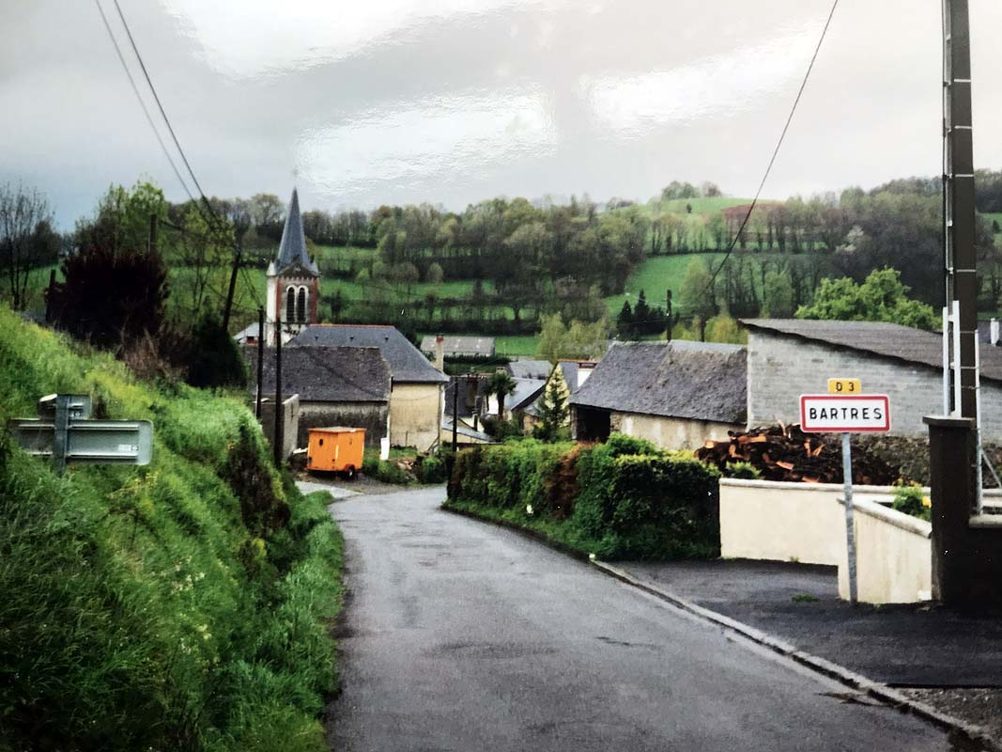

11:15 AM On our return we stopped at a convent where Bernadette went to school, received her first communion, and later took her first vows of professed religious life.
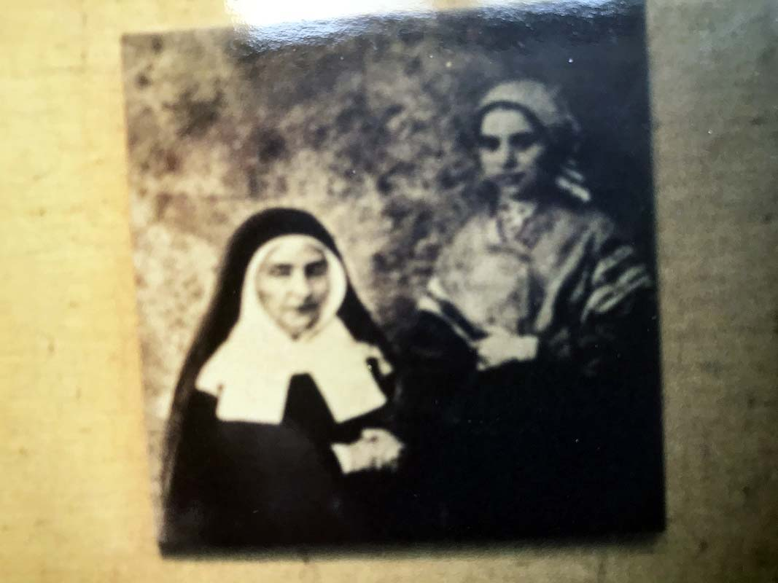
We had lunch at 12:15, and then hurried out to the tour bus to go up into the Pyrenes Mountains above Lourdes. The interest of this trip is to retrace the pilgrim steps of those who ascend the mountains, cross over to Spain, and walk the miles of the great Middle-Aged Pilgrimage of St. James Compostela into Portugal. The road up the Pyrenes very quickly ascended another 5,000 feet with many turns and dizzying heights. Finally, we arrived at the small village of Gavarnie, the source of the River Gave that flows out of the mountain glaciers and down through Lourdes. The small town is surrounded by high mountains; it was cold and we had some light snow.
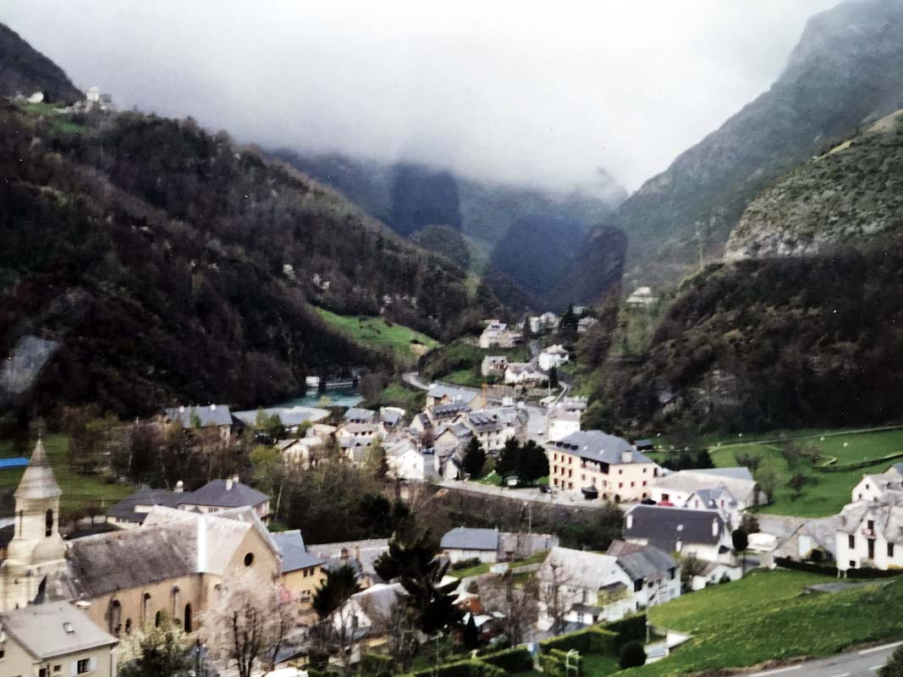
Gavarnie in the High Alps crossing to Spain
History of Notre Dame du Bon Port Chapel at Gavarnie
Gavarnie is a small town at the height of 4600 feet above sea level. There are 200 permanent residents. During the Middle Ages Gavernie was an important passageway for pilgrims intent on making the Pilgrimage to Santiago de Compostela in Portugal. People would undertake this 7-to-9-month passage on foot from France as a holy journey, or to seek pardon for a sin, or for a special intention or a Grace from God. It was also called “The Way.”
Many pilgrims would visit the Chapel of Our Lady of Good Passage/Safe Arrival (Notre Dame du Bon Port) to worship before making the perilous journey over the mountains. The original altar is there, with a Statue of Our Lady to the left, which dates from the 14th century.
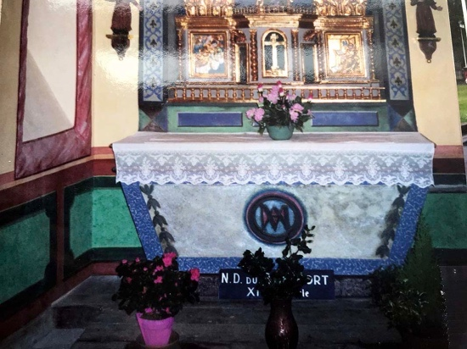
This is the small chapel of Notre Dame du Bon Port inside the church in Gavernie
Pilgrims would come from the direction of Toulouse via Arles, or over the Massive Central (Auvergne,) through the town of Le Puy, or via Vézelay and Périgueux, or finally via Tours and Bordeaux. Upon arrival at Gavarnie, pilgrims would be sheltered by an organization called the Knights of St John of Jerusalem. They would be guided over the Alps to Spain, and then along the northern border of Spain to Portugal and then to Santiago de Compostela to the grave site of St James.
I was so impressed when Esther Oden lifted Carol Mary her daughter up and carried her down the steps of the bus. Soon the bus driver had Carol Mary’s form-fitting wheelchair out of the luggage department, and Carol Mary was ready to tour the village. Esther is in her 80s.
The highlight of the day for me was a visit to a special church for those making the journey over the mountains into Spain. In a small niche was a shrine to Notre Dame du Bon Port.
This title “Notre Dame du Bon Port” was so meaningful to me on my life journey that I would translate the shrine in any of the following ways:
Our Lady of Good Passage/ Our Lady of Homecoming/ Our Lady of Final Port
Our Lady of Good Rest and Final Ending to all of the trials and temptations of this life.
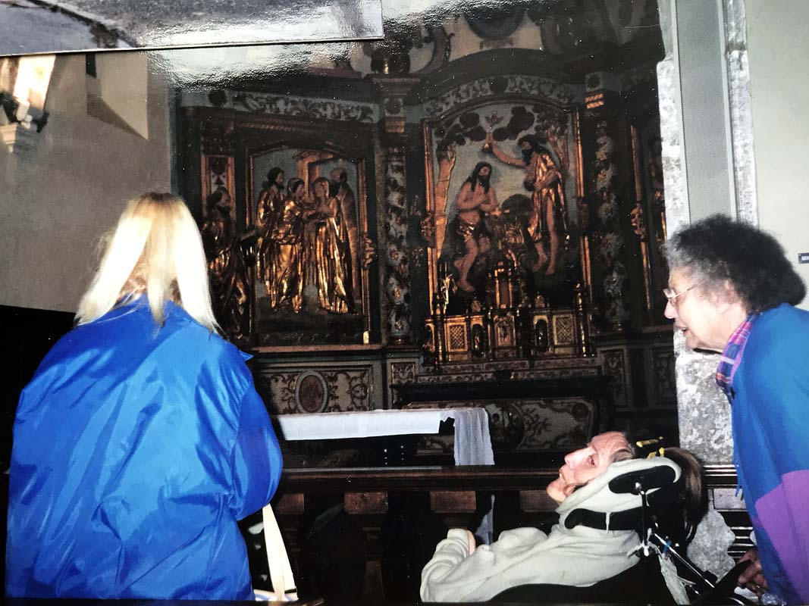
Joan, Carol Mary her sister and their mother Esther at the Notre Dame du Bon Port Chapel

This speaks immensely to me, for one of my goals is to reach the end of my life with no major sin for which I would be ashamed of as I stand before my Creator, and the LORD of my soul. How ashamed I would be to remember a wanton sin of great discredit to the spirit of my life.
May it be not so, Oh Lord of my life!
May Notre Dame du Bon Port and my other spiritual friends living or with the LORD pray for a safe passage for me through this life to the end.
And the little sins that chip away at faith, from these keep me clear.
Preserve my conscience clear, my eyes not turned aside in shame, hiding a private sin! Keep my soul and vision clean and pure of LORD!
Yes! Notre Dame du Bon Port is meaningful to me!

4:25 PM Returning from Gavarnie, I sat with Bill Cramsie and Alisha, a young 4th grade girl with some cerebral palsy. We talked the whole way back down the valley. She was nervous and kept up a chatter.
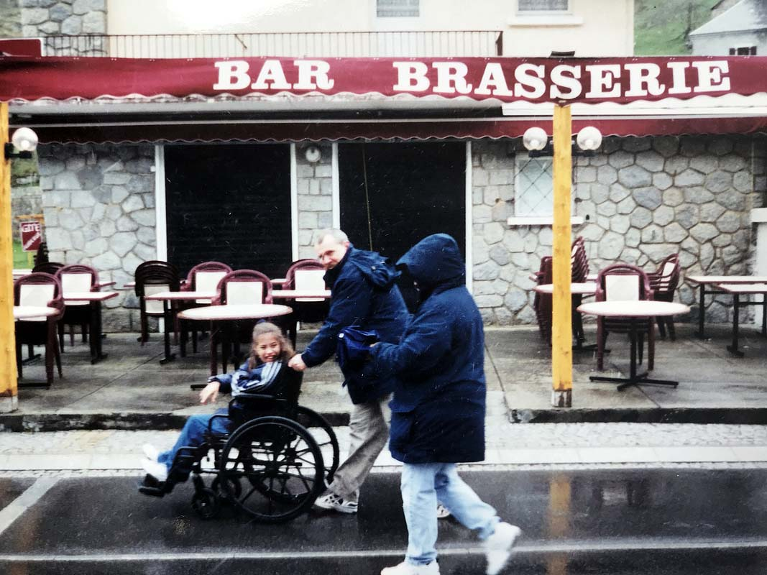
7:30 PM Dinner was earlier than expected. I spent it next to Louis, the birthday boy. It was his 16th birthday today. We got into conversation, and soon I was teaching the rest of the dinner table some French phrases and table manners.
8:45 PM This evening I went with a small group of pilgrims to a Mass at a hotel some distance from ours. It was an inconvenience, and I struggled with some incidents during the evening. I needed to calm my emotions and respond to my annoyance. This was a spiritual journey after all. To help me with this, I took recourse to the prayer that my spiritual director, Sister Therese Dush, had taught me nine months before. The Welcoming Prayer, taught by the centering prayer group Contemplative Outreach, allows a person to let go of their own false programs for happiness”, and accept their present circumstance and the people in it. I learned it, now I had to practice it. The Welcoming Prayer helped me to enjoy the people there and accept my own weaknesses, which too often reflected my own personal issues rather than what was going on with other people.

April 12th Maundy Thursday
4:00 AM Awake. Prayed a little
6:20 AM Got out of bed, dressed and went to the Grotto across the River Gave, about a five minute walk.
At the Grotto, I knelt and prayed the Rosary as the sun came up. Despite all the pomp and glory of the buildings, the spirituality comes down to the humble spirit of the pilgrim, and his/her faith in “Le Bon Dieu”, the Good God. The pilgrim brings the faith; everything else is trimmings.
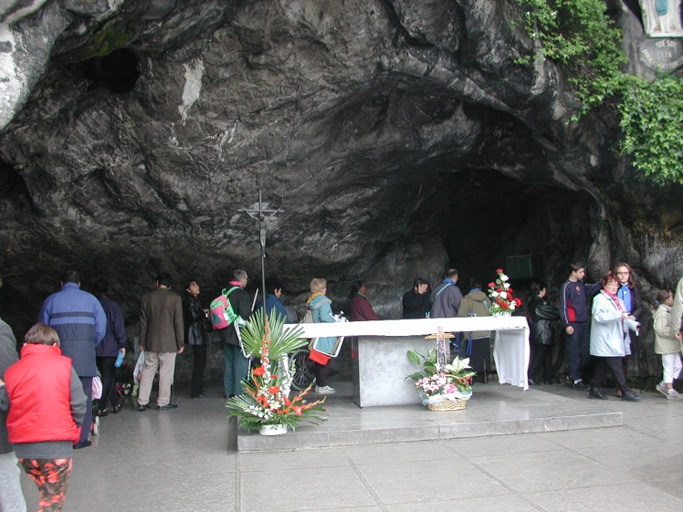
The passage from the 4th mystery, quoting the reaction of receiving the infant Jesus: “And he received Him into his arms and blessed God,” says it all for me.

The Grotto in Lourdes
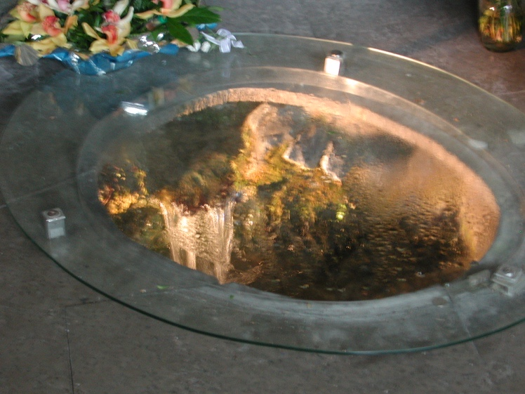
The Spring in the Grotto from which flowed water with healing properties

8:30 AM My life is enriched as I serve others. My strength comes from the Graces of faith that God gives me.
10:25 PM It has been a full day. No time for notes. Could it be that the Pilgrim has no time to stop and pray, except as above in the early morning?
The Pilgrim prays while he/she walks…everything he/she does and says is prayer.
This was my day: Breakfast with my friends: the Odens (Cleveland); Marie, Tricia and their family (West Palm Beach), Lucille and Joe, (Minneapolis).
The Russians came to breakfast, so I stopped some of their members and asked where the leader was. They led me to Olga, slim, ascetic, intense and holy. She could speak some English, and some French. We spoke a little of both. I proposed a joint foot washing. She liked the idea. However, she had to handle a problem that had popped up, right away. One of their members needed to have their food pureed or they couldn’t eat. We quickly got some yogurt and mashed fruit from the kitchen. They wanted cereal too. Enter Patrick, a Parisian with ancestors from Ireland. He is one of the volunteers who help serve at the Accueil Notre Dame where we are staying. He is fluent in English, and very kind.
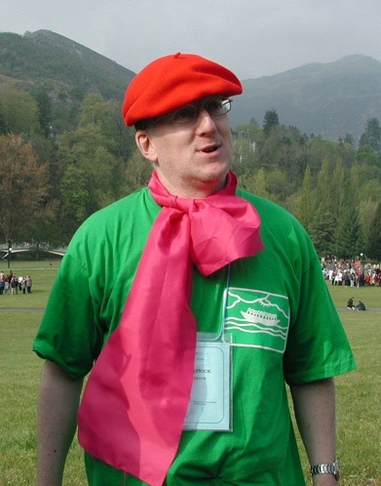
We talked with Olga about the kind of cereal which might work and we came up with Instant Oatmeal. I said I would go to town to buy some Instant Oatmeal and Patrick volunteered to go with me. There was still the problem with lunch and dinner, however; then I thought of the food processor that Carol Mary’s mother uses for her. I quickly asked Esther if it could be borrowed. She agreed and the problem was solved.
I wanted to continue planning the foot washing for Good Friday so I next went to the British Faith and Light community, which also resided on our floor. Since I was a close friend of June Dante, the Faith and Light coordinator from Rochester, I asked them first if they knew her. They replied in the negative, and then I met with Bernadette, the leader of the British community. She led me to Bob, an Anglican minister who was planning the foot washing for their community. I proposed that the British community join the American and Russian communities for a joint foot washing. They liked the idea. We agreed that we would start the planning of the event after our lunch. I went back to Olga, informed her, and then I was done except for the errand to buy oatmeal.
As I walked the streets of Lourdes with Patrick, we would see other pilgrims with Faith and Light name tags. Their names and their countries were prominently displayed…Mexico, Mauritius, Hong Kong, Wales, the Philippines. When I noticed these tags, I would call out “Faith and Light”, and they would wave back. It was great!
Patrick and I visited Le Cachot, the damp, unhealthy, cramped quarters in which Bernadette lived with her family at the time of the apparitions.
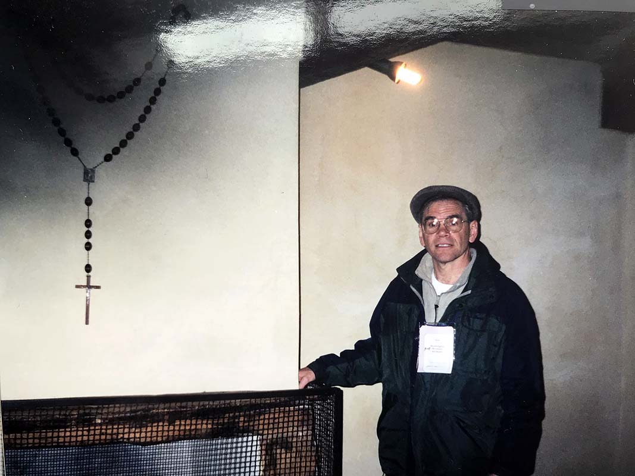
The family was very poor. Isn’t it amazing how the God of all Creation choses those of humble origin, like Bernadette and the Blessed Mother of Jesus!
We bought the oatmeal, and then returned. I was tired…the flight to Paris, the train ride, the first night, the translations and the new friends. I laid down and took a nap for 20 minutes.
I awoke and quickly went down the hall for lunch. The head of the caterers, Caroline, immediately grabbed me and asked me whether we wanted to have packed lunches to take with us on Monday when we were due to leave. She approached me as a leader of the group probably because I was the one who spoke French. I was willing to coordinate and help the group make the decision, but Caroline was unable to tell me whether the lunches were part of the meal plan or whether we had to pay for them. I decided that if they were free, we would order them; otherwise, not.
After lunch, I gathered Bob and Bernadette from England, Olga the leader, and Olga the mother of the girl, whose food needed to be mashed, and Lucille and Tricia from the USA. I led the group in prayer, and then gave it to Bob. He went over what he had already planned for the foot washing, and we all agreed to follow it. Next, we addressed the question of music for the event. We chose Taize songs, and then we were done. It was time for the Maundy Thursday Gathering of all the Faith and Light communities in attendance, some 17,000 of us in Lourdes. We had doubled the population of Lourdes for Holy Week!
I led our North Coast contingent of the USA group onto the Esplanade in front of the Basilica of the Rosary. We had a colorful North Coast banner, which was designed by Becki Haller and carried by Carol Mary’s aunt Dorothy Grys.
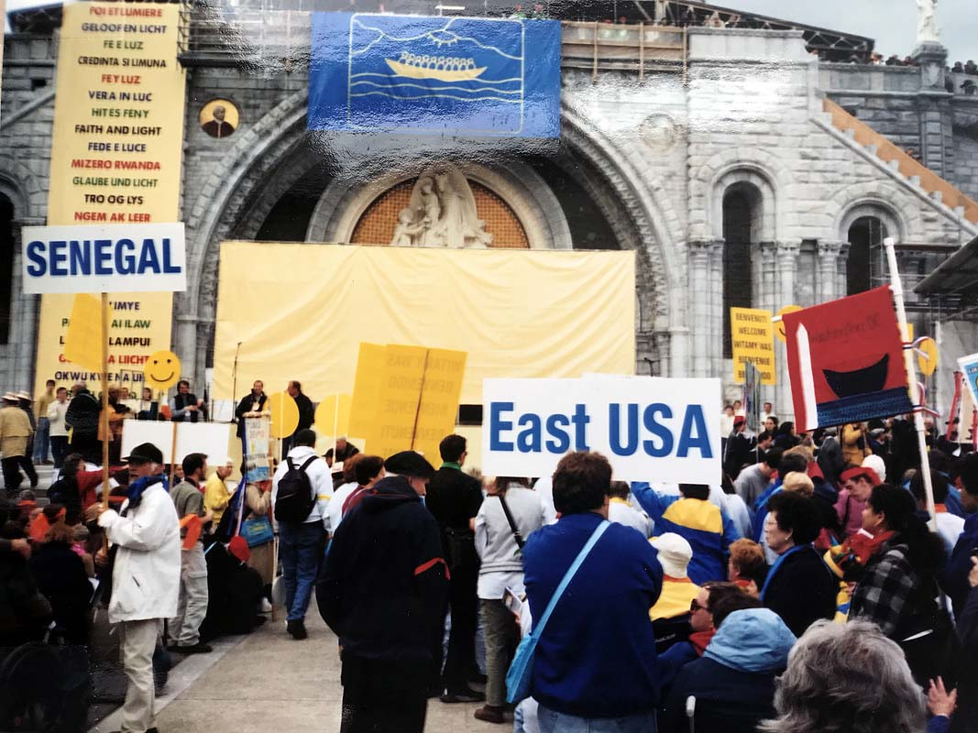
The group leading the music was set up on top of a balcony in front of the church. Before them on the Esplanade were the Faith and Light communities from over 70 countries with colorful banners and signs. One by one, our International Coordinator, Maureen O’Reilly, read off the countries. It was very moving. As the names were read, people would clap and the flag of their country was displayed above the Basilica. As Maureen read off the African countries, Rwanda, Congo, Senegal, Cote d’Ivoire, and Burkina Faso, I wept. I was very moved. The people of these nations are precious to me, and they have so many challenges.
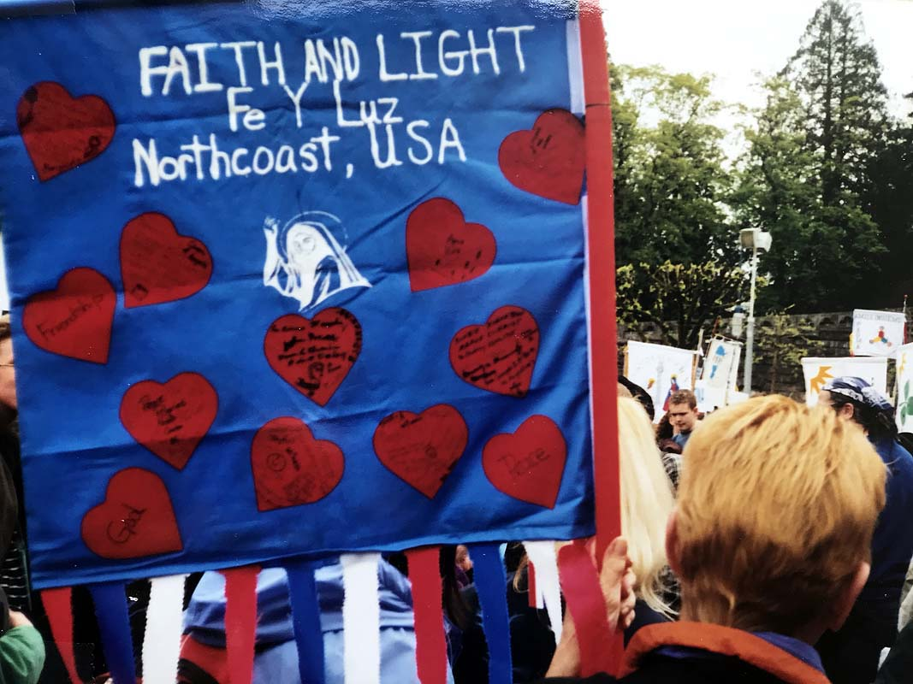
After Maureen’s introduction, the co-founder of Faith and Light, Marie-Hélène Mathieu, spoke. She spoke in French, and I made a rough translation for Esther and Joan.
Jean Vanier spoke next, so beautifully and authoritatively in English and in French. I took notes. He has given us a new vision. We are to spread the word that people with handicaps are needed in the world. Out of them comes the living water of God. We need them because they show us their poverty, and our need for God.
4:30 PM I was tired, so after Jean’s speech, as the people began to go to the huge underground gathering space close to the Basilica, I told my group that I needed rest and was going back to lie down.
As I waited for the crowd to disperse to the underground space, I talked with Walt from the Atlanta Faith and Light group. Suddenly there was a tap on my shoulder. I turned around and there was Martin Dante, my Faith and Light friend from Rochester, whose family I befriended during a visit to the area in 1994. Immediately behind him stood his mother, June and a friend. I was joyous and moved to tears at the same time. It was so good to see them. It had been seven years of correspondence and trying to visit them in England. June had been treated for breast cancer and survived. I was so glad that God had moved me to stay behind from the group, and that we were able to find each other among 17,000 pilgrims!
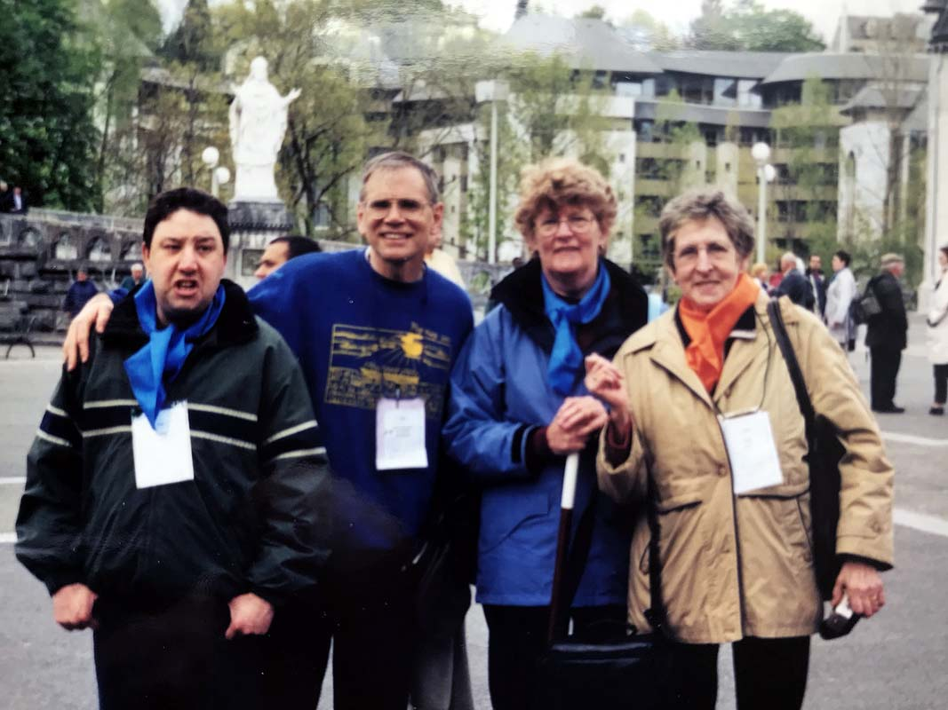
We talked for 45 minutes, then moved to town for a hot chocolate. It was great! As we moved up the avenue to the restaurant, Martin would stop at the various stores and greet the sales people. After going into one, he came back out with a piece of chocolate. We all laughed. This is just what Jean Vanier said of our brothres and sisters with developmental disabilities. We need them! They break down the pretentions of society, and encourage us to take off our masksso that we respond to life more genuinely. For an hour and a half, we shared then parted company.
7:30 pm I came back to sleep for an hour and then, “Pop!” it was time for dinner. People were gathering, and I needed to make the final arrangements for the evening’s foot washing.
8:15 pm We had a good dinner. I delegated clean up to Joy, and went back to the room to practice the music.
8:30 pm The time had come. Patrick, Tricia and the Russians had set up the chairs in 6 semi-circles facing the place where Bob would lead us. I sat beside him to lead the music.
We began with music our Taize music. The Russians started another Taize song as we washed the feet. It was prayerful, peaceful and united.
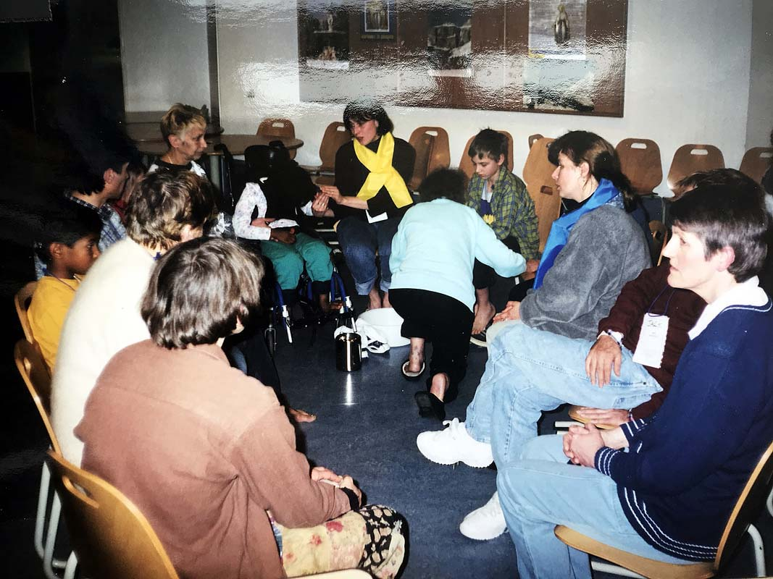
I believe it gave glory to God. Brothers and sisters from so many countries worshipping God. This was the vision that God gave me, and as I asked, they responded and came. Russians, British and Americans…communicating with gestures, signs and love. We cared about each other, were compassionate, sang Taize songs in French, Latin and English, and worshipped together!
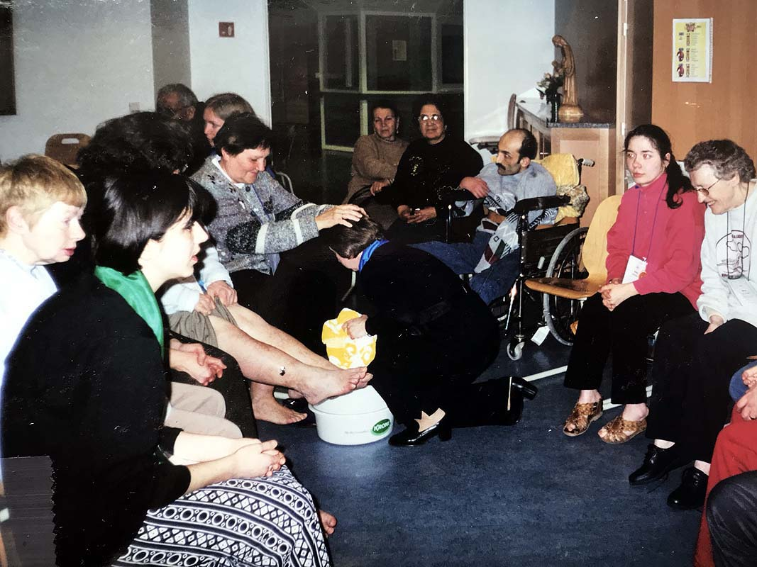
Our evening foot washing was executed with Grace. It flowed with an energy of cooperation. But it was personally a blessing. People thanked me for my part. And I overheard Joan comment, “Kirt is like a mother to us.” It was at the end of the foot washing while we were going around and giving everyone a greeting of peace. I came up to Carol Mary in her wheelchair and said kind words to her and held her hand.
Jesus said, “I am meek and humble.” So it is with us…not weak, but meek, gentle in spirit and firm in faith.
And the ego, the false self, that insists on its own way to the detriment of interpersonal and international relations…that one, I let go. I let go of insisting on my own way. I let go of the inflexibility. It is not strength. It is foolishness. This is part of my journey.
Strength is trusting in God to take care of you, and being strong enough to stand against temptations of pride…I do not serve for the pats on the back, or the perks of a good name and praise of the crowd.
Denying ourselves in this way, we let His will be done and follow Him.

9:30 pm Louis and I went for a walk with a candle. He needed companionship, and I think a father figure. I played the role, was “laid back,” and let him talk.

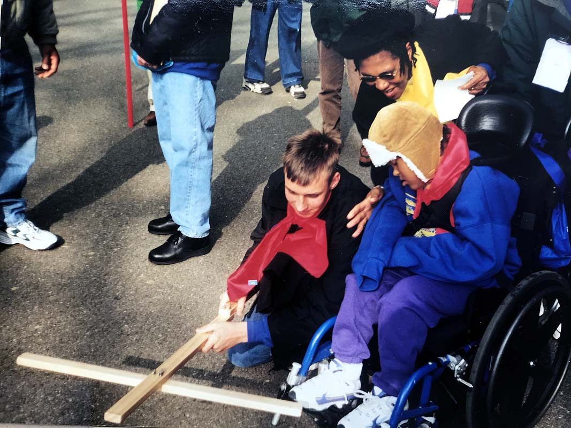
April 13th, Good Friday

“Let the processions come here,” said Our Lady to Bernadette.
Why did Our Lady request this of the people?
We need ways to express our faith outwardly in our devotion to God.
Our devotion to God must find expression…
in acts of love,
in acts of charity,
in acts of piety.
In these ways we confirm to ourselves that we are sincere.
This is a very real desire of the human heart. In other words, it is natural that we should desire this.
By acknowledging the dignity of the weakest amongst us, we express our love for our Creator. In doing so, we preserve our own dignity.

8:00 am I had a good rest last night…until 7:25 am. It was much needed. I prayed some intercessory prayers. They have been few so far on this pilgrimage. I remembered Hilda, David, Afua, their families, Helen from St. Bernard Church in Akron, who asked for my prayers, and Alfred Havde, an RCIA candidate who will be confirmed at the Easter Vigil at St. Bernard.
After breakfast, we Americans planned our own Stations of the Cross. Joy and Marie wrote them out. I led the organization of it, and we all had parts, including Patrick, our Parisien adoptee who wrote his name on our North Coast banner.
We began our Stations of the Cross at 10:30 am with the other groups of USA East, who were staying at a hotel in the center of Lourdes. We began at the top of a hill overlooking a meadow, which was beside the River Gave and across from the Grotto where Bernadette encountered Mary.
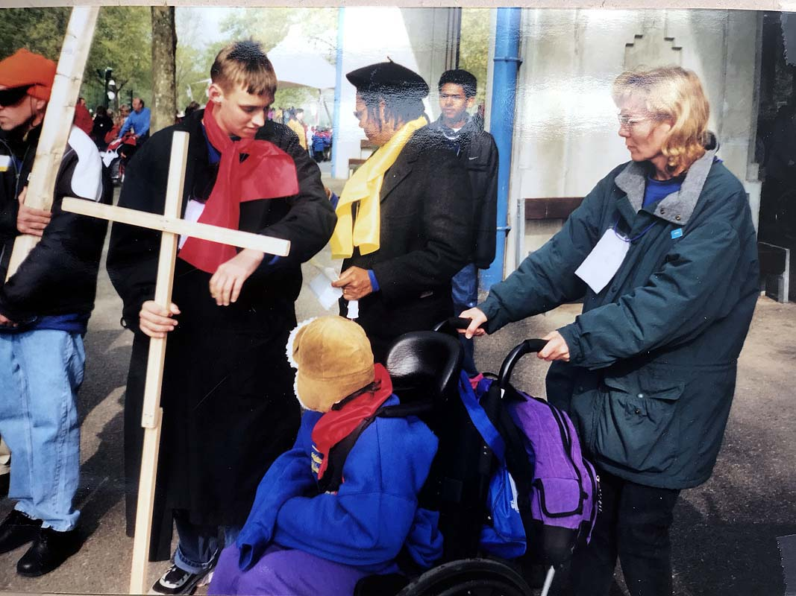
At each station, we would read a Gospel passage, read a reflection on it, and then reread it while miming the action. Finally, we would conclude that station with common prayers, and move onto the next station. We got to the 8th Station and then could not go on due to the crowd of groups on the meadow. I found our devotion a bit distracting due to the crowd. In contrast, the previous night’s foot washing was full of compassion. There was real community there, and very personal and meaningful as you washed another’s foot, and your own foot was raised, and gently washed, sometimes by a person with a disability.
12:45 After lunch, we planned the evening’s sharing and testimonial service. I asked not to lead, but encouraged the other coordinators, Esther, Marie and Lucille to lead.
2:15 I went back to my room and rested for an hour.
3:40 I called Lucille and Joe and we went to the Good Friday Service. It was amazing! 17,000 pilgrims in a huge underground basilica.
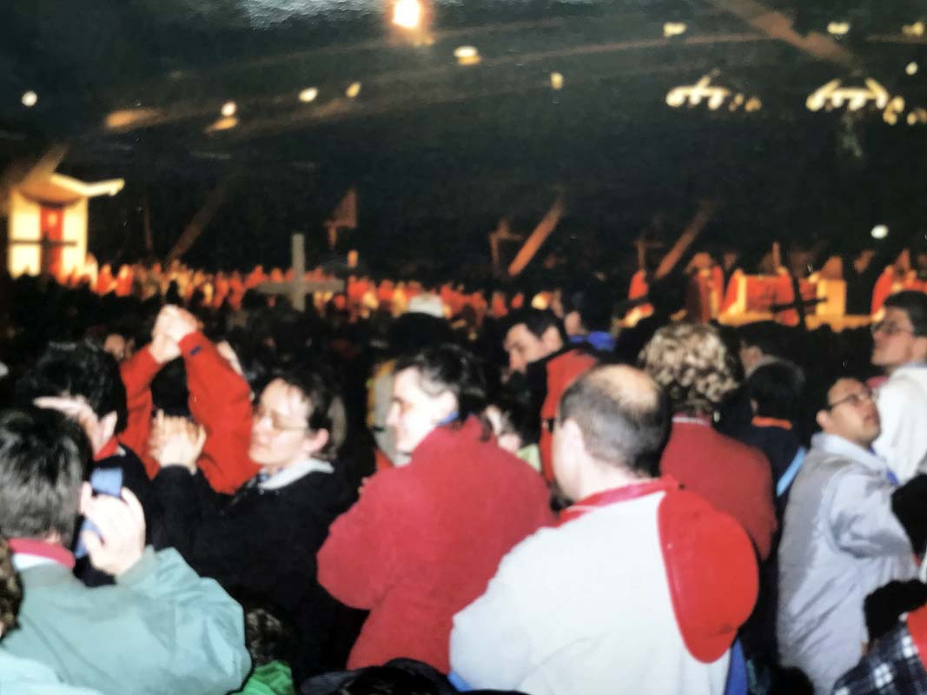
Before the good Friday service began, a group of actors performed a passion play on a raised platform in the middle of the underground worship space. At regular intervals around the space, giant screens projected the scene on the stage. Then we began the service with the Good Friday readings, intentions, Veneration of the Cross and the Eucharist.
Again, I found it difficult to concentrate among so many pilgrims. It was not an interior time.

8:30 pm We had our evening service. There were testimonials of how God has brought light into our darkness, and how God has lifted us out of despair and loneliness.
I told one of my stories of God’s blessings.
When my bible study for teachers at Weaver School, Akron ended, I came to Faith and Light. Our Faith and Light prayer community, Joyful Witness, lived out its name. When I was there sharing my life with my brothers and sisters with handicaps I felt and new and unique joy. I found a joy there that I received and felt nowhere else. These brothers and sisters accepted me unconditionally. They saw behind my mask to my heart, and they loved my heart. I was Kirt, and they listened and spoke and loved.

In between these individual sharings, we sang the Taize song, “Jesus, remember me when You come into Your Kingdom…” As we concluded this sharing, I felt that Jesus had been moving in our midst. His Kingdom was with us already. He had remembered us.
“Jesus, remember us…” was Henry Oden’s favorite song. Henry, Esther his wife, Carol Mary and Joan were their daughters. They had formed the first Faith and Light community in the USA, and called it, Ephrathah, “Be opened.” Esther told us how at the last prayer meeting at their house, Henry quieted people so he could hear his favorite song.
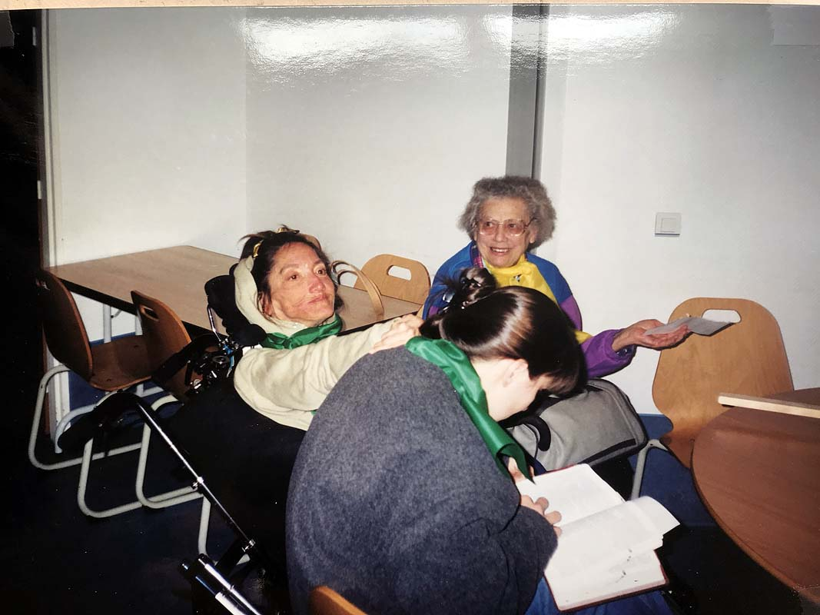
Carol Mary with Joy (reading) and Esther
10:15 pm I went up to the roof of our special hotel, Accueil Notre Dame, after our sharing time ended. There was a beautiful view across the River Gave over to the church built at the Grotto. Bathed in yellow and white light, the reflections were beautiful. I was no more than several hundred feet away from the Grotto. I was filled with longing and appreciation of the scene and the significance of the Grotto. I wanted to share it with my wife, and to keep the scene with me forever. But the river of time flows on. In a few months I would be back in Africa and try to recall just what I saw and how I felt.

Holy Saturday, April 16th
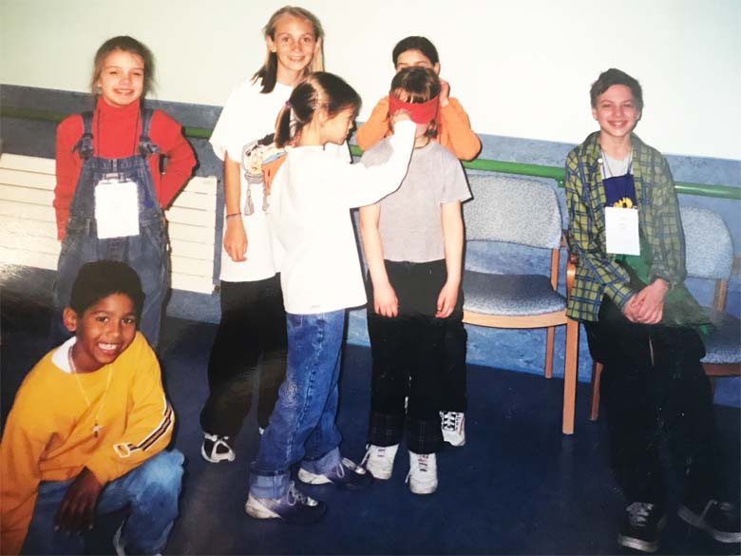
British, American and Russian children of Faith and Light on Pilgrimage with their families

7:50 am I had a restless night. Lights off at 11:15 pm, I tossed and turned until 12:45am. I checked the time again at 1:30 am. Finally, I slept and awoke at 6:00 am, turned over and slept until 7:25 am. I lay still for some minutes. I had had a dream and there were strong emotions lingering. I had felt anger and frustration in the dream over my failure to control a situation. It had to do with someone who was supposed to pick me up at school after a difficult and unusual day. They were delayed. I had to be somewhere and I was powerless.
My emotions started to abate, and my thoughts turned to Faith and Light in Ohio. I was newly discerned as the Vice Provincial Coordinator to accompany communities in Ohio, Pennsylvania, Michigan and West Virginia. I thought of the challenges as many of the original families in those states were growing older and younger leadership was needed. I thought of organizing workshops which offered formation in the spiritual and practical aspects of coordinating a Faith and Light community.
8:02 am The Seven Last Words of Christ
My morning meditation (This is my fountain. I need You, Jesus)
Thank You, Jesus, for protecting me through the night. I come to You now.
“It is finished:” He carries through to the end. Tempted, tired, without human energy, He completes life’s journey with God’s power.
“I am thirsty:” Jesus speaks out His need. He tells the world. He doesn’t keep His feelings and needs secret now. His full humanity is revealed. The Son of God cannot/will not give Himself a drink. He is suffering. He endures thirst without quenching it by His own power. He reveals to us that He is thirsty. He calls us to care for others, to listen to their needs.
Jesus cries out in the needs of the poor when they cry out, “I am thirsty!”
“Father, forgive them for they know not what they do.” This is Jesus’ charity. He is concerned about the eternal salvation of the guilty who crucified them. “Father, forgive them.” Jesus already has forgiven them. He asks the Father to do the same.
11:00 am I have reviewed the schedule of Breakout Sessions planned throughout the day at various sites throughout the town of Lourdes. We are 17,000 Faith and Light pilgrims, and the well-organized committees have planned spiritual and practical workshops for us during morning and afternoon sessions. I have chosen to attend Sessions which have to do with International Faith and Light.
Session One: Europe. The need for more communication between the European countries. The need to seek out younger leaders to replace the original leaders from the 1970s and 1980s.
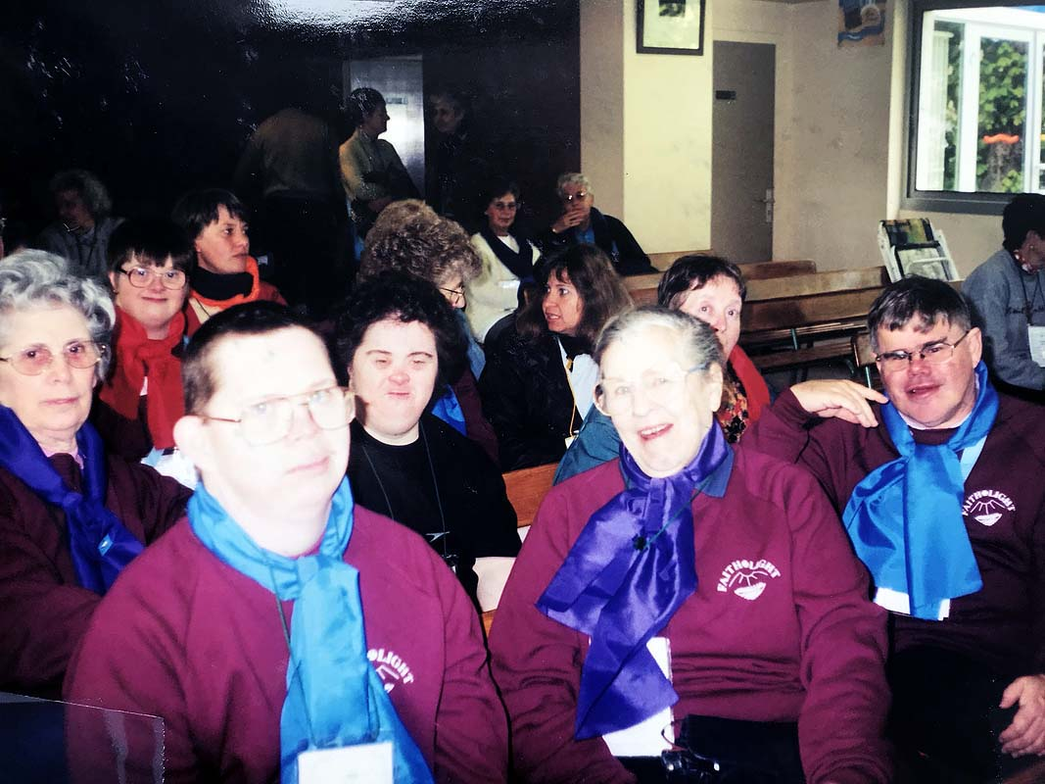
Participants in the discussion of challenges in Europe
Session Two: Faith and Light in the countries of Central and West Africa: Burkina Faso, Angola, Ivory Coast. The reports mention the difficulties: no beds in some hospitals; the disabled are neglected; isolated communities; lack of funds to engage in retreats or to travel to meet other communities; special education has not been thoroughly developed; lack of formation. However, there is a great thirst for the Spirit; there is the capacity to endure hardships in order to have meetings; there is a love for children.
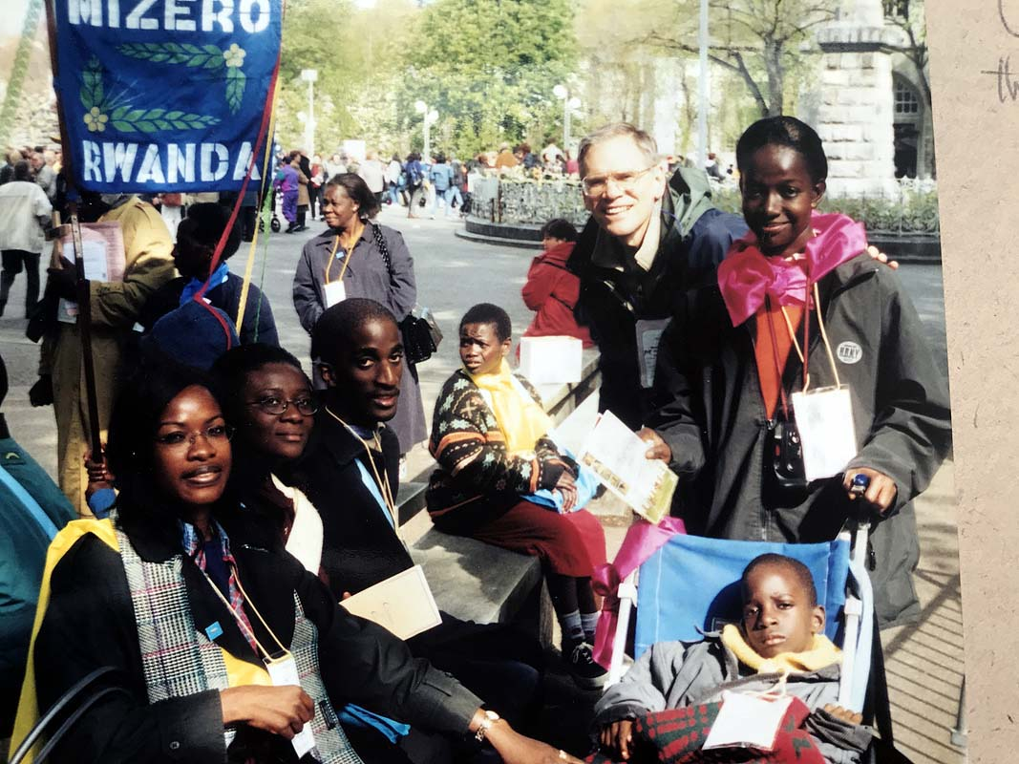
Faith and Light communities in Ivory Coast and Rwanda
Session Three: a talk by the Coordinator of Faith and Light in Zimbabwe. She mentions the challenges: parents don’t attend because they are busy getting funds to feed their family; many welfare organizations from abroad attract members by giving out free things; there are great distances to deal with…members may have to walk 3 miles to get to meetings; communication can be difficult; the challenge of orphans because of HIV/AIDS; the cost of food, board and travel restrict retreats.
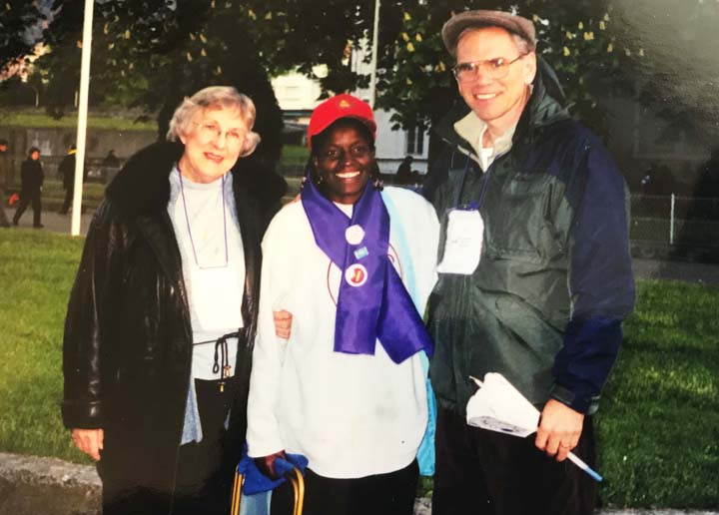
Lucille Sklusacek, and Elinata
10:00 pm Easter Vigil. April 14th Your people praise You, Jesus! You are the One sent by the Faither to redeem all people from sin.
The Glory of the Resurrection The women exclaimed, “I saw. I saw the Risen Christ!”
You, Jesus, are the One from whom all good gifts come!
The love and camaraderie among 17.000 Faith and Light pilgrims is incredible. Kindness and compassion blossom all around us. The gift of music, organizational abilities, loving servanthood as well as the gift of Faith and Light, the beauty hidden in the bruised rose and the trodden grass. The poor and the lowly pray You, and lift up their voices to You. In their poverty they extoll Your Grandeur, and they reveal to us by their faith our spiritual poverty.
Jesus, thank You
My bruised brothers and sisters, thank You!
This morning in the Grotto I prayed for Grace to complete the journey. Notre Dame du Bon Port pray for me. I believe I will arrive safely. God is watching over me.
In service.
In charity.
In selfless devotion with love, which is compassionate and open to all, and receptive to the Holy Spirit’s leading.
Easter April 15th
He is Risen!
7:06 am Awaken 7:20 shower 7:45 am on the balcony taking pictures and videos. A clear sky…one can see the mountains far above us, Le Circe close to Gavernie, very clearly.
8:00 Breakfast…I spoke with Catherine again about making a picnic lunch for us on Monday since we are entitled to lunch at Accueil though we leave mid-morning.
8:15 I leave for Chapel de St Bernadette to practice music for Mass.
8:20 I can’t find the Chapel so I’m back at Accueil. I run into Elizabeth, who tells me that the little girl in Moscow for whom we were praying, died last night. The Russians are badly shaken. I am too. I go around the different tables and shake all their hands…words can’t express the sadness. I then leave for practice, wondering how I can get in an intention. The burdens of the Russians are on my mind.
The practice was confusing. The Mass was to be in English and French since we had the Americans and French Canadians present. We had too many chiefs, each of us trying to be helpful, but pushing our own ideas. I again do a quick letting go with one of the women, inexperienced with the guitar, who is pushing her ideas and songs.
The mass was celebrated without much joy. Our choir had needed more practice. We didn’t do badly, but we weren’t relaxed or confident. The celebrant was very serious and spoke a lot of French without much translation. We had trouble bridging the language difference.
Upon Louise’s request, I led Mass participants out of the Chapel while playing my banjo. It helped clear the space. As I came back in to get my banjo case, the choir for the next mass saw me carrying my banjo and asked me to play with them. I hesitated while I thought about the Russians and my desire to return and comfort them. I concluded that if I postponed my return for an hour, I would still find them in need. The next Mass was for the Irish communities. I quickly excused myself to use the bathroom. On my way back, I saw my friend Barry from Phoenix, Arizona and asked him if he would like to join with me and sing in the choir. His mother gave the O.K. and so we went back into the chapel.
The mass was just beginning when we got there. I introduced Barry to everyone and they were very welcoming. The musicians were prepared. The choir director knew what she was doing. She would tell me the key, and I could fit right in with my banjo. I knew many of the songs. There was an African American Spiritual that I had never heard before, “Over My Head, I Hear Angels in the Air.” Although I’d never heard it nor played it before, being an American I played it like I knew it from heart. It is an amazing thing. Our culture is so rich that we absorb the rhythms and styles like we were born into it. I really enjoyed myself, and Barry did too.
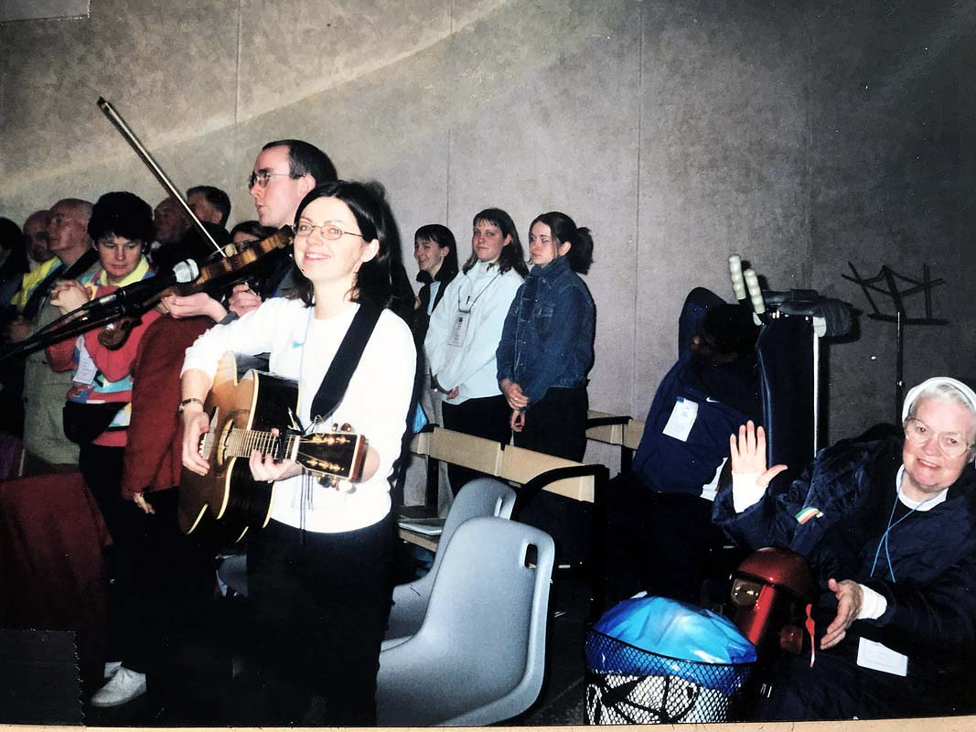
The Music Ministry at the Easter Mass with the Irish community
The celebrant was filled with joy. This added to our inclusion. He welcomed each of the communities there personally, and then included Barry and I from America. The celebrant also took time to honor a group of core members who were wearing long flowing garments such as priests wear. They had processed in with a Bishop and several priests who were concelebrating the Mass.
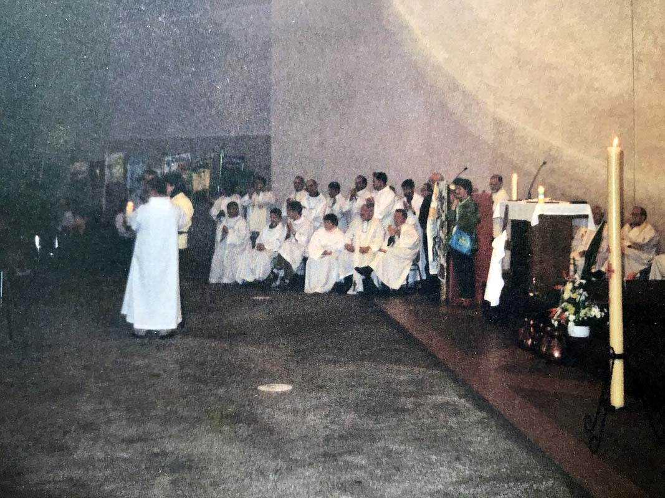
In his homily, the celebrant referred to the wonderful talk Jean Vanier gave on Holy Thursday about this being a time of revelation. The Mass was one of the many memorable experiences I enjoyed on the Pilgrimage. I was so glad I stayed.
After Mass, we were told that a small boy from Wales had gone missing during the mass. Barry and I decided to go and report it at the Information Center serving the Pilgrims. My French was again being useful to us. We made the report so that people could be on the lookout for the missing boy, who was later found. I then walked Barry back to his hotel.
It was lunch by the time I got back. I had been close in prayer with the Russians and decided I wanted to eat lunch with them. I went over and sat by a woman. Ialia (Julia) was her name. she was sitting quietly by herself at one of the lunch tables. I took her hand, and said, “Sorry.” We held hands for a minute. More people came. Saska came over to tell me the name of his community, “Sweecha – vetru,” or in English, “A Candle in the Wind.” Sergei was there and his wife. We had a good lunch. I was seated next to Iouri (Yuri), who drew a picture on a card. He talked in a squeaky voice. It was a ministry of presence, but we did share the names of our communities. We wound up going all over the room to find a translation into Russian from my community, “Joyful Witness.” The time was light-hearted and good. The name of their other community was “Neech e poi” or “Awake and sing.”
Lunch finished and I went to rest, but not for long. Bill Cramsie, the Provincial Co-coordinator for USA East, came to request that I confirm the time that the bus would pick us up tomorrow. So, my “old” friend Patrick the Parisian and I went to try to get this information, unsuccessfully. We went to the Information Center, and after much searching, we found our names, but needed further information from Bill concerning the time our train was supposed to leave so that the bus could coordinate with it.
I set off in search of Bill or his wife, Debbie in order to get the information about the train. While searching I ran into June and Martin again. We shared quick greetings, but Martin was upset. There were too many people in town. There were thousands on the Esplanade in front of the Basilica. June had to move on and find a quiet place for Martin. Not long after that I was able to locate Debbie. She agreed to bring the information to the bus company so I returned to the Accueil. I wanted to spend some time with the Odens. In many ways, they were my home.
I ate more meals with them and assisted them as much as Lucille and Joe, the other members of my triad. I always kept an eye out for Esther, Carol Mary, Joan and Joy.
As I returned from my errand to find information about the train, I passed once more through the crowd on the Esplanade in front of the Basilica. There was rejoicing everywhere. Every once in a while, the music ministry, which performed on the balcony above the Esplanade, would launch into a song and everyone would sing.
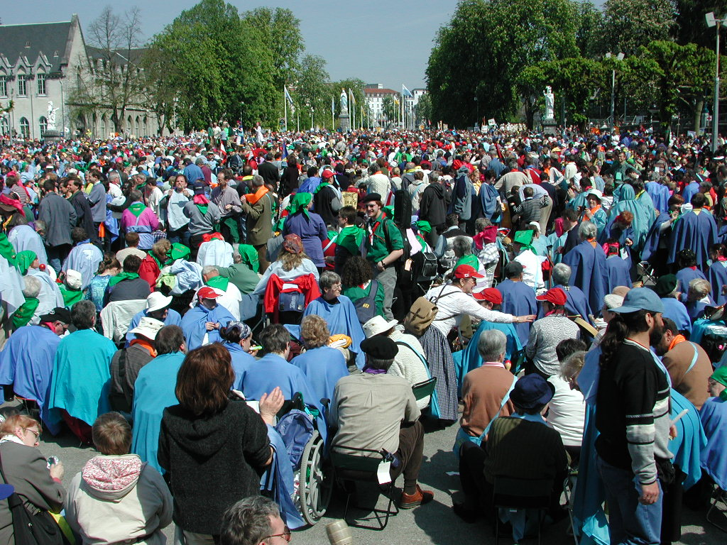
I passed a man who had a 12-foot-long Swiss Mountain Horn. It was made entirely out of wood and played like a bugle by moving your lips. I tried a few nots on it. Emanating from under the balcony, a group of people approached the massive group of people to sprinkle water on them As I moved to meet the people who were sprinkling water, a young man named Bejorn, urgently approached me to tell me that this area was reserved for people with hand handicaps. He told me, “I thought that everyone would know this.” He was quite upset with me. We moved a few feet off and I invited him to sit down and talk. All his hostility melted away. I asked his name and requested that he tell me about his community in Sweden. It was a pleasant time, and confirmed for me that understanding and dialogue can heal relationships. Many barriers can be broken down by the love shared in Faith and Light.
I went a little further and encountered a man from Brussels. He saw the banjo I was carrying and wanted me to play it for him. I sang “Tom Dooley” for him on request. There was music and joy, people and sharing all around. It was a wonderful Easter celebration.
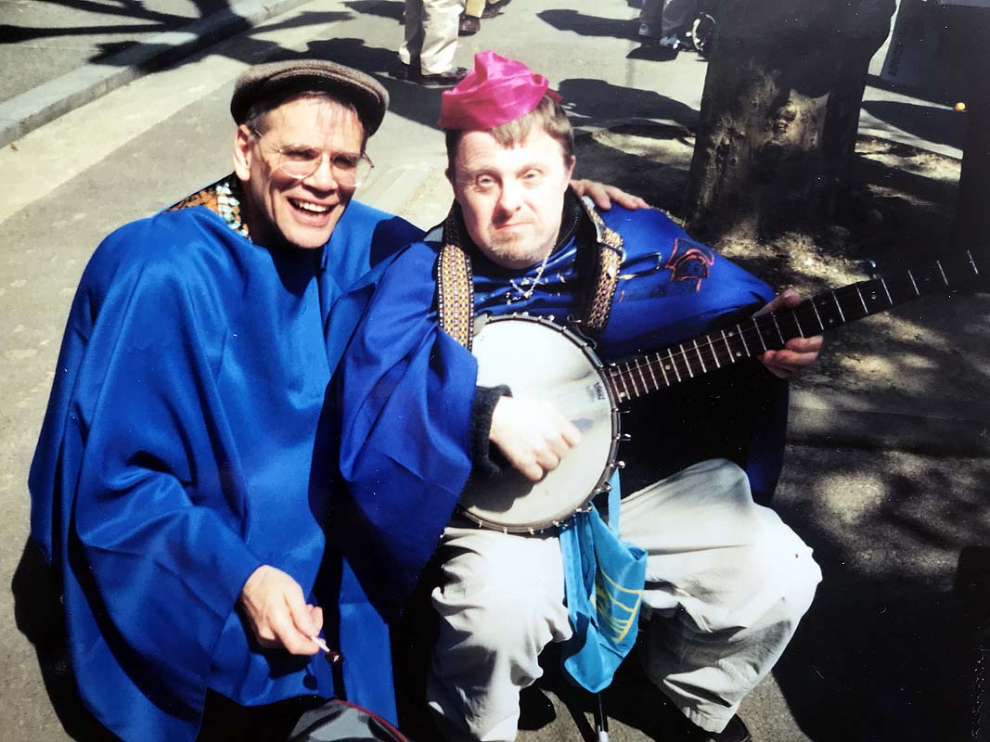
I continued on my way back to the Accueil to see how Carol Mary was. On the way, I met Marie Nowak, who informed me that Lucille’s room had been broken into and her purse stolen while she and Joe were on the Esplanade. I found her in her room, and had it confirmed. Her purse with the wallet, pictures, one credit card and about $100 were stolen. I helped her report it to the security in the building. We were able to call the credit card company and report it lost. At dinner we spoke to the Russian group. They too had been hit the day before. Over $800 dollars’ worth of francs, rubles and US dollars had been taken out of the room of a young lady named Beth. The stolen money was mostly funds that were given them from their Faith and Light zone. I felt a deep sorrow for their loss…the little baby who died while they were here and now their money was stolen. They suffered much and still had deep serenity.
After dinner, Beth, Lucille, Joe and I went to the Lourdes Police Station in the middle of town. It was a simple formality, so that we could have documentation of the loss to show the people at home. None the less, the rather incompetent police officer took an hour each to fill out the form for Beth and Lucille. We left the Police station around 11:00 pm for the chilly walk back to the Accueil. I packed, then slept.

Easter Monday, April 17th
Awake at 6:05 am, I washed and took my 20-minute centering prayer mediation, then left my room. I thought I would fill an empty bottle with water from Lourdes. As I approached the fountains to fill my bottle, I noticed that there was a Mass in the Grotto. I quickly joined the group. There were Faith and Light members from Korea and other nations. The celebrant used English, but he was flanked by 8 other priests. This was at 6:45 am, and our group number over 100 people. After Mass, I walked back across the River Gave, and helped some of the members on our floor to get ready for breakfast.
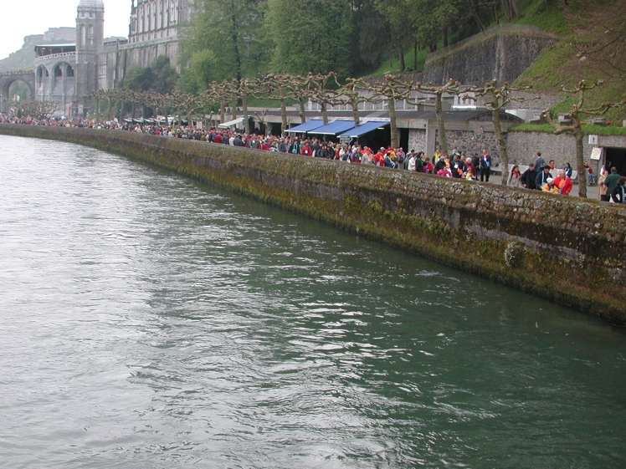
The River Gave, close to the Grotto
We had breakfast and said our final good byes to the Russians. I didn’t see many of the British members, probably they had left already. I said my goodbyes to the French ladies in the kitchen, then with Basil, Trisha and Marie, we loaded our American members’ luggage on the trolley to be taken out to the bus.
Catherine, the cook, came through. We had talked about having a picnic lunch on Monday, and she delivered 19 packed lunches for us to be eaten on the train to Paris. We then loaded the baggage onto the awaiting bus. Trisha collected a donation of dollars for the lady bus driver who had moved two sets of diversion signs so that she could pull her bus up close to our loading place. We then headed off to meet the train to Paris.
10:00 am The express train arrived and we Americans filled up one of the cars. Unfortunately, they could not get Carol Mary’s wheel chair to fit through the narrow passageway into the rail car. There was a space about 6 feet by 6 feet just inside the car’s door which was normally used for luggage. This was where we had to place Carol Mary. She would be much more comfortable to remain in her chair, than have to sit for 6 hours in the stiff rail car seats. I spent most of the travel time with Carol Mary in this luggage space placing my banjo and singing Faith and Light songs.
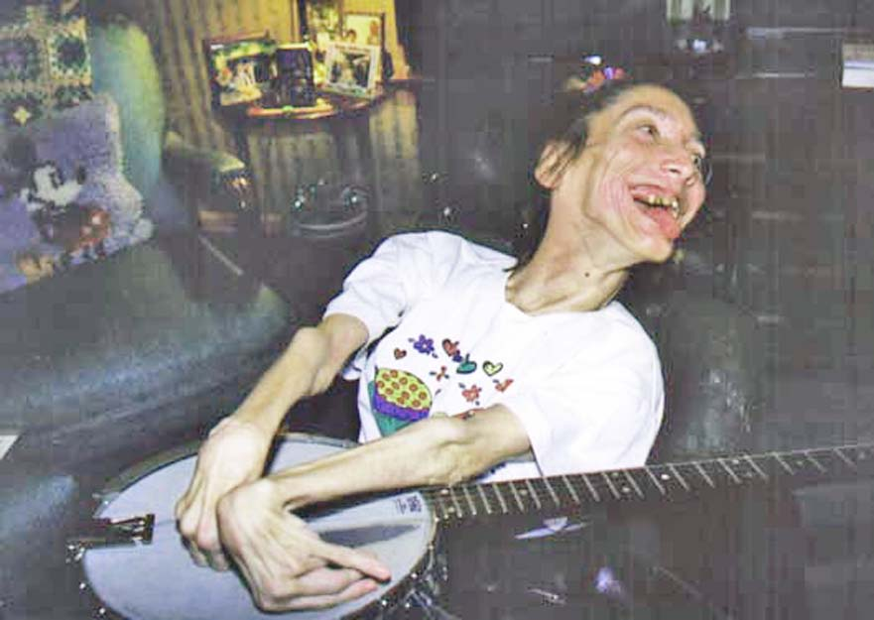
Carol Mary Oden with the banjo from an earlier time
After we arrived in Paris, we transferred to a bus that took us to Chappelle de Saint Vincent de Paul to celebrate a Mass of thanksgiving. It was a beautiful small church. St Vincent’s body was uncorrupted and visible to all in a display case coffin above the altar. It was a very prayerful Mass.
Then we had a boat ride on the Seine, traveling past Notre Dame Cathedral and other Paris sights. Finally, we had a late dinner and then to bed. 12:00 Midnight.
Many times, during the day, and especially at Mass, I re-committed my life anew to Jesus, and asked for His Graces to live a holy life. Notre Dame du Bon Port was a prayer helper since that Wednesday last when I visited her chapel in the high mountains above Lourdes. I fly to her for help so that I may make my journey safely to my final destination…Heaven.
My friends will thank me for this devotion.
I was also moved emotionally as I led the musical worship at Mass. Father John Welch asked me to play the banjo at Mass, so I quickly put the liturgy together. For communion we sang, “Peace is Flowing Like a River” with its last verse of Alleluias. They wanted another hymn, so I challenged them to sing a few hymns with new lyrics; we sang, “Have You Decided to Follow Jesus?”
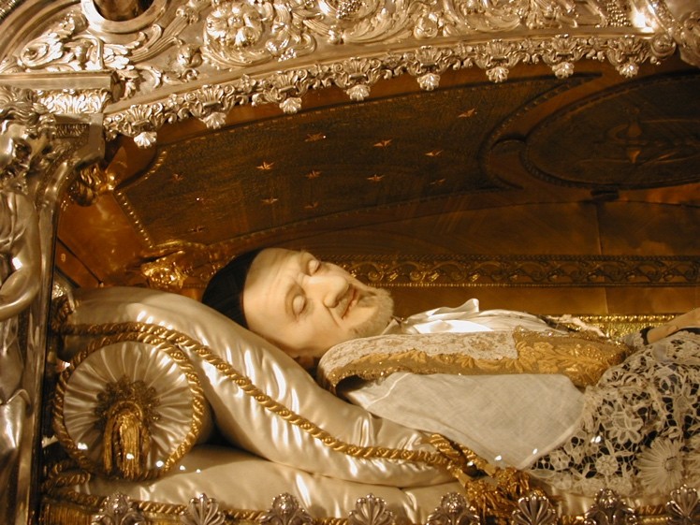
The physical remains of St Vincent de Paul
Our concluding hymn was, “We are Pilgrims of Faith and Light.” People said they really liked the liturgy.
I reflected on the Gospel of John, chapter 20, verse 16. “Jesus said to her, ‘Mary!’ she turned and said to him in Hebrew, ‘Rabbouni, “which means ‘Teacher.’”
Prayer:
LORD, You know the depts of the human heart, the deep precious love we have for other people. And You are strong in Your will. You chose God’s will, and completed Your course. May I complete my course now. You chose Your Father’s will though it meant dying to Your Human desires, emotions and attachments. Give me strength, O LORD, that I may carry my cross to the end.
I have had deep feelings. I am sad. I will surrender the care for my loved ones to You and Your will. These loved ones will thank me in the next life for my devotion to You and Your will. May I be faithful to the end in my vocation, teaching, music ministries, as husband and father. Give me Grace, O LORD.
Notre Dame du Bon Port prie pour moi!
J'aimerais arriver au Port de la Vie Éternelle!
Merci.

Easter Tuesday, April 18th
This was the day of our flight back to the USA. My roommate, Father Bob Malloy, and I got up at 6 am. After praying, Father Bob asked me to prepare some music for a farewell ceremony in the lobby. So, at 7 am probably half of our group gathered in the lobby; we were smaller because we were leaving for the airport at different times. I led the singing of “Come to the Waters,” from the St Louis Jesuits. We had our communal prayers and then we said our good-byes. Then Father Bob and I went up to breakfast.
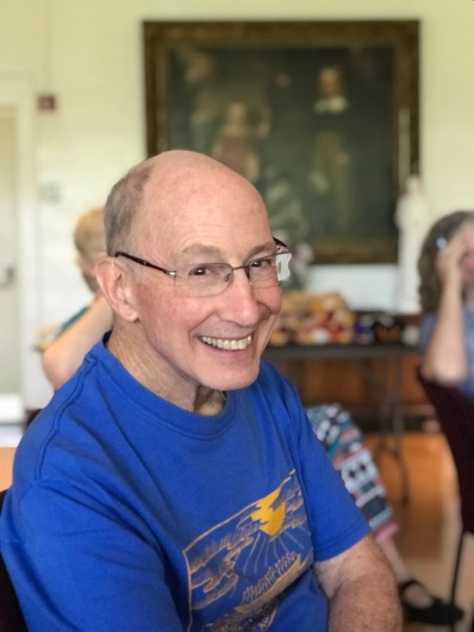
9:30 am I remembered an idea I had the day before to collect left over French francs and send them to the Russians who had $800 stolen form them. Accordingly, as we were boarding buses, I went from bus to bus and to the lobby and asked people for money for the Russians. It all came to $580. I was able to take the French francs and loose change and exchange them for U.S. dollars. I was able later to send transfer this money to them in Moscow.
On board the plane, I dozed off. I was exhausted. It was a long flight and a very quiet one. Most of us needed the rest after this long, socially engaging pilgrimage.
At the Atlanta Airport, I helped Lucille and Joe to pick up their baggage. While we were waiting at the baggage claim for our suitcases, a young lady, Emily, came up and spoke to Lucille. “I have been watching you and how you relate to your son and I just wanted to tell you that I admire you.” Emily and her husband Dave have a 10-month-old boy with developmental disabilities due to a difficult birth. We both told Emily about Faith and Light and left her with materials and phone numbers.
Lucille chided me several times for trying to take care of everybody. Joan also said some similar things. This is one of my character defects, taking care of everyone but myself. This too, I surrender to God!
We finally got to Cleveland at 10 pm. I said my good-byes to the Oden family. I was very tired. Finally, my son came and got me and we arrived back in Akron, Ohio at 11:30.

Sequence from Pentecost 2001
Come, Holy Spirit, and from Heaven direct on all people the rays of Your Light.
Come, Father of the Poor; come giver of God’s gifts; come light or our hearts.
Kindly Paraclete, in Your gracious visits to our sou, You bring relief and consolation.
If it is weary with toil, You bring it ease; In the heat of temptation, Your Grace cools it;
If sorrowful, Your words console it.
Light most blessed, shine on the hearts of Your faithful – even into their darkest corners; for without Your aid one can do nothing good, and everything is sinful.
Wash clean the sinful soul, rain down Your Grace on the parched soul and heal the injured soul. Soften the hard heart, cherish and warm the ice-cold heart, and give direction to the wayward.
Give Your Seven Holy gifts to Your faithful, for their trust is in You.
Give them reward for their virtuous acts; give them a death that ensures salvation; give them unending bliss. Amen. Alleluia!

Destination or Destiny?
A Poem from the Pilgrimage
The Stops along the way, the ports, the paths, the people, the vistas, the golden moments and bright days,
These are but pictures stored in memory and put away somewhere.
They are elements of the destiny, but my destination is Home.
The gifts given, the gifts used, the talents used, the talents squandered,
The time passed, slipped or stolen, the time lost, held or missed,
All are hidden away, perhaps forgotten, perhaps remembered too late.
These are parts of my journey, my choices made, goals achieved, life lived.
They are elements of the destiny, but my destination is Home.

The good deeds, the job well done,
The poems, the paintings, the trips, the compassion shown,
These are good things,
They are elements of the destiny, but my destination is Home.

Not the cry of the crowds on the journey,
But the arms of the Father at last.
Not the acclaim of achieving my destiny,
But the step to the finish line of life.
For the cries of the people grow dim,
And the voices of adulation are weak,
But the grasp of the Father is forever,
And God’s praise, “Well done,” is sweet.
Since the elements of destiny are fleeting,
My destination is Home.

Notre Dame du Bon Port prie pour moi!
Kirt
May 2001

For many years, the Bureau consisted of the two Co-Founders, International Chaplain, International Coordinator International Vice-Coordinators and Secretary General. They have been replaced in the revised 2018 edition of the Charter and Constitution by the Board of Directors and International Coordinating Committee.
Henri entered Eternal Life in 2018. He is greatly missed!

