n
Craven County’s HOPE is a volunteer organization deeply concerned about the impact of substance abuse in our community. The organization brings together a diverse group of individuals and professionals that share a common desire to address the problems of substance abuse on all levels.

Be A Part Of
The Change
You Want
To See!
Contact Us
Craven County’s Hope
156 Perrytown Road
New Bern, NC 28562
Meetings @ Twin Rivers Mall
cravencountyshope@gmail.com
Visit us on the Web:
https://www.cravenhope.org
https://facebook.com/cravencountyshope

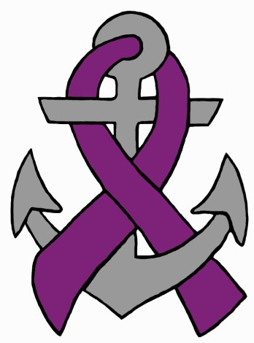

Facilitating real answers and seeking real results to help those struggling with drug/alcohol addictions.

Mission:
To provide awareness, education and treatment options in the battle against Heroin, Opiates, and Alcohol Addiction to those in Craven County. Be a part of the change you want to see.

Who Are We:
Our members include individuals from all sectors of the community, including parents, concerned citizens, local government, law enforcement, school officials and healthcare professionals.

The efforts of Craven County’s H.O.P.E. are focused on :
Prevention Pillar: prevent youth from using drugs and alcohol and provide parents with education and resources about risk factors leading to youth drug use and addiction. Create community awareness about local drug issues, addictions and impacts.
Treatment Pillar: Inspire families and those in need to seek treatment and assure timely, accessible and affordable treatment. Identify resources and information to connect users to treatment services. Provide support to those who have completed treatment to maintain sobriety.
Harm Reduction Pillar: Establish achievable goals which when taken step by step can lead to a healthier lifestyle for drug users, their children, families and communities by reducing infectious diseases and the number of overdoses and deaths.
Law Enforcement Pillar: Assist in drug free lifestyle by holding defendants accountable to bond, release terms. Continue to prosecute heroin dealers. Police officers will continue to work to improve coordination with health services and other agencies that link drug users to immediate medicall care, withdrawal management (detox), treatment and other counseling and prevention services.
Community Communication: Develop a heroin awareness website and utilize the Internet and social media to promote regional overdose prevention, treatment and recovery in general.
Fundraising: Develop a fundraising plan that addresses.
- Grants
- Donations
- Special Events
- Community-Business Partnerships
Craven County’s Hope
Welcomes your participation!
To learn how you can be involved in this worthwhile effort, please email at: cravencountyshope@gmail.com
Resources In New Bern:
www.trilliumHealthResources.org
www.oxfordhouse.org
www.ncdhhs.gov/divisions/dsohf/walter-b-jones
www.revivinglivesministries.com
www.ccsap.org
www.porthealthservices.org
www.nchrc.org (Harm Reduction)
www.celebraterecovery.com
www.cwcnbnc.com (Wellness City)
www.nar-anon.org
www.rhabehavioralhealth.org
www.samhsa.gov
www.projectlazarus.org
www.ncparentresourcecenter.org

