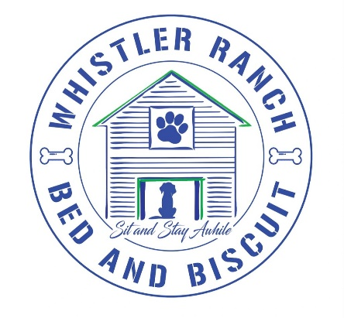

Pet Name(s)_________________________________________________________________________

MEDICAL RELEASE FORM The safety and well-being of your pet(s) is of the highest importance. Insuring that your pet remains safe and well cared for is our first responsibility and as such we take it very seriously. We recommend our pet parents screen for pre-existing health conditions, but some factors may be beyond our control. In the event that a medical emergency arises while a pet is at our facility, or participating in a service that we provide it is imperative that we are immediately able to get them medical treatment at the closest available facility. We will call ahead to client’s vet if unavailable then veterinary offices in closest proximity geographically to us to insure they can handle the emergency present. We will then rush the animal to the closest available facility for treatment. We notify the owner after we have secured a medical treatment center to avoid any delays. Our goal is to get your pet medical attention as quickly as humanly possible, and any distractions may interfere with that process.

I understand in the event that Whistler Ranch Bed and Biscuit, at its sole discretion, deems the need for immediate medical attention by a licensed veterinarian, I authorize recommended care to secure the emergency. I agree and understand that a Whistler Ranch Bed and Biscuit employees, owner, or affiliate will transport my pet to the closest available emergency facility. I further agree that I am financially responsible for any medical treatment my pet(s) receives as a result of a medical emergency while attending services provided by Whistler Ranch.

I am aware that certain diseases and viruses exist among dogs and where large groups of dogs gather. These would include Kennel cough, bordatella, Giardia, Toxedia and Coccidiosis just to name a few. I am aware of the risks and accept any and all financial cost related in allowing my dog to stay at Whistler Ranch Bed and Biscuit that would result in illness, injury or death.

Sign: _____________________________________________

Print: _____________________________________________

Date: ____________________________________________

Preferred Vet:_____________________________________