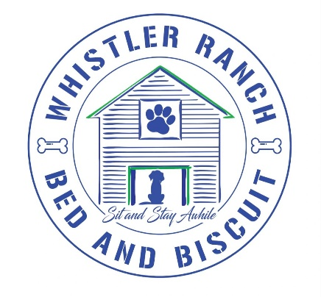

Pet Name(s)______________________________

**BOARDING TERMS & CONDITIONS**

1. I specifically represent to Whistler Ranch bed and biscuit that I am the legal owner of my dog. In addition, my dog is healthy, meets vaccination standards, and has not harmed or shown aggression and/or threatening behavior towards any person(s) or other dog(s) and has not been exposed to any known communicable disease within a 30 day period immediately prior to admission today camp or boarding activities. I further represent that each time my dog is brought to Whistler Ranch bed and biscuit, I will be recertifying that my dog is in good health and has not had any communicable illness of any kind for 14 days prior to admission. I further agree to inform Whistler Ranch bed and biscuit of any changes in my dog’s condition and/or behavior prior to any day camp or boarding visits.

2. I understand and agree that any problems with my dog, behavioral, medical or otherwise will be treated as deemed best by staff of Whistler Ranch bed and biscuit, in their sole discretion, and in what they view as the best interest of the animal. I understand that I assume full financial responsibility and all liability for any and all expenses involved in regards to the behavior and health of my dog.

3. I understand that the owners, staff, and volunteers at Whistler Ranch bed and biscuit will not be liable, financially, or otherwise for injuries or illness to my dog, me, or any property of mine while my dog is participating in activities at the facility.

4. I expressively wave and relinquish any and all claims against Whistler Ranch Bed and biscuit and its employees, staff, volunteers, and representatives for any injury, illness, or harm to my dog. Under no circumstances will Whistler Ranch bed and biscuit be liable for consequential damages.

**5. I understand that there are risks and benefits associated with group socialization of dogs. I agree that the benefits outweigh the risks and that I accept the risk. I desire a socialized environment for my dog while attending services provided by Whistler Ranch Bed and biscuit while in their care. I understand that while the socialization and play is closely and carefully monitored by staff and volunteers to prevent injury, it is still possible that during the course of normal play my dog may receive injury, illness or minor nicks and scratches from socializing with other dogs.**

**\*\*\*\*\*\*I understand that by initial here my dog will remain only with its family pack or independent play. OWNER ____ WHISTLER RANCH ACKNOWLEDGEMENT______ \*\*\*\*\*\*\***

6. I understand that the environment at Whistler Ranch bed and biscuit playyards and indoor lounges provides dogs the opportunity to play in close physical contact, including with their teeth and paws. I acknowledge that no amount of supervision or personalized care by Whistler Ranch bed and biscuit, its employees, staff, volunteer, and representatives, can prevent the possibility of injury or illness to my dog.

7. I understand that my dog must have flea and tick protection as recommended by my veterinarian. I further understand that Whistler Ranch Bed and Biscuit will not be held liable if my dog contracts fleas or ticks while participating in activities at our facility, as it is my sole responsibility to work with my veterinarian on an effective treatment plan. Whistler Ranch bed and biscuit treats all areas associated with kennel on a regular basis. If a dog presents with fleas and tick will be treated immediately at owners expense with flea and tick bath. Owner will be notified immediately

8. I understand that Whistler Ranch Bed and Biscuit is a boarding kennel where large groups of dogs are in contact with each other either thru inside/outside play time or during kennel time. I acknowledge that virus and disease are common in such a social environment. I also understand that stress, anxiety and age can bring on illnesses. Such illness are not limited to but include kennel cough, ghardia, toxedia, coccidia. I accept all responsibility for any financial cost associated with illness or injury in allowing my dog to stay at Whistler Ranch Bed and Biscuit.

SIGN _________________________________ PRINT______________________________

DATE______________________