Transforming Falls Recovery: How the Raizer II is Empowering Single-Handed Carers

Falls are one of the most common and challenging situations faced by occupational therapists, care home staff, and community carers. The response to a fall has traditionally required multiple members of staff, specialist equipment teams, or even emergency services — causing distress to the individual on the floor and placing significant physical strain on those trying to help. Healthcare 21 UK is changing that with the Raizer II, a game-changing solution that puts safe, dignified falls recovery in the hands of a single carer.

What is the Raizer II?
The Raizer II is a quick, simple battery-operated mobile lifting chair requiring minimal training. A single carer can safely raise a fallen person from floor to an almost standing position in just 20 to 30 seconds — with no physical lifting effort required beyond a supportive hand. Its intuitive design, with four identical legs and two identical backrests guided by sound and LED indicators, ensures correct assembly every time, even under pressure.
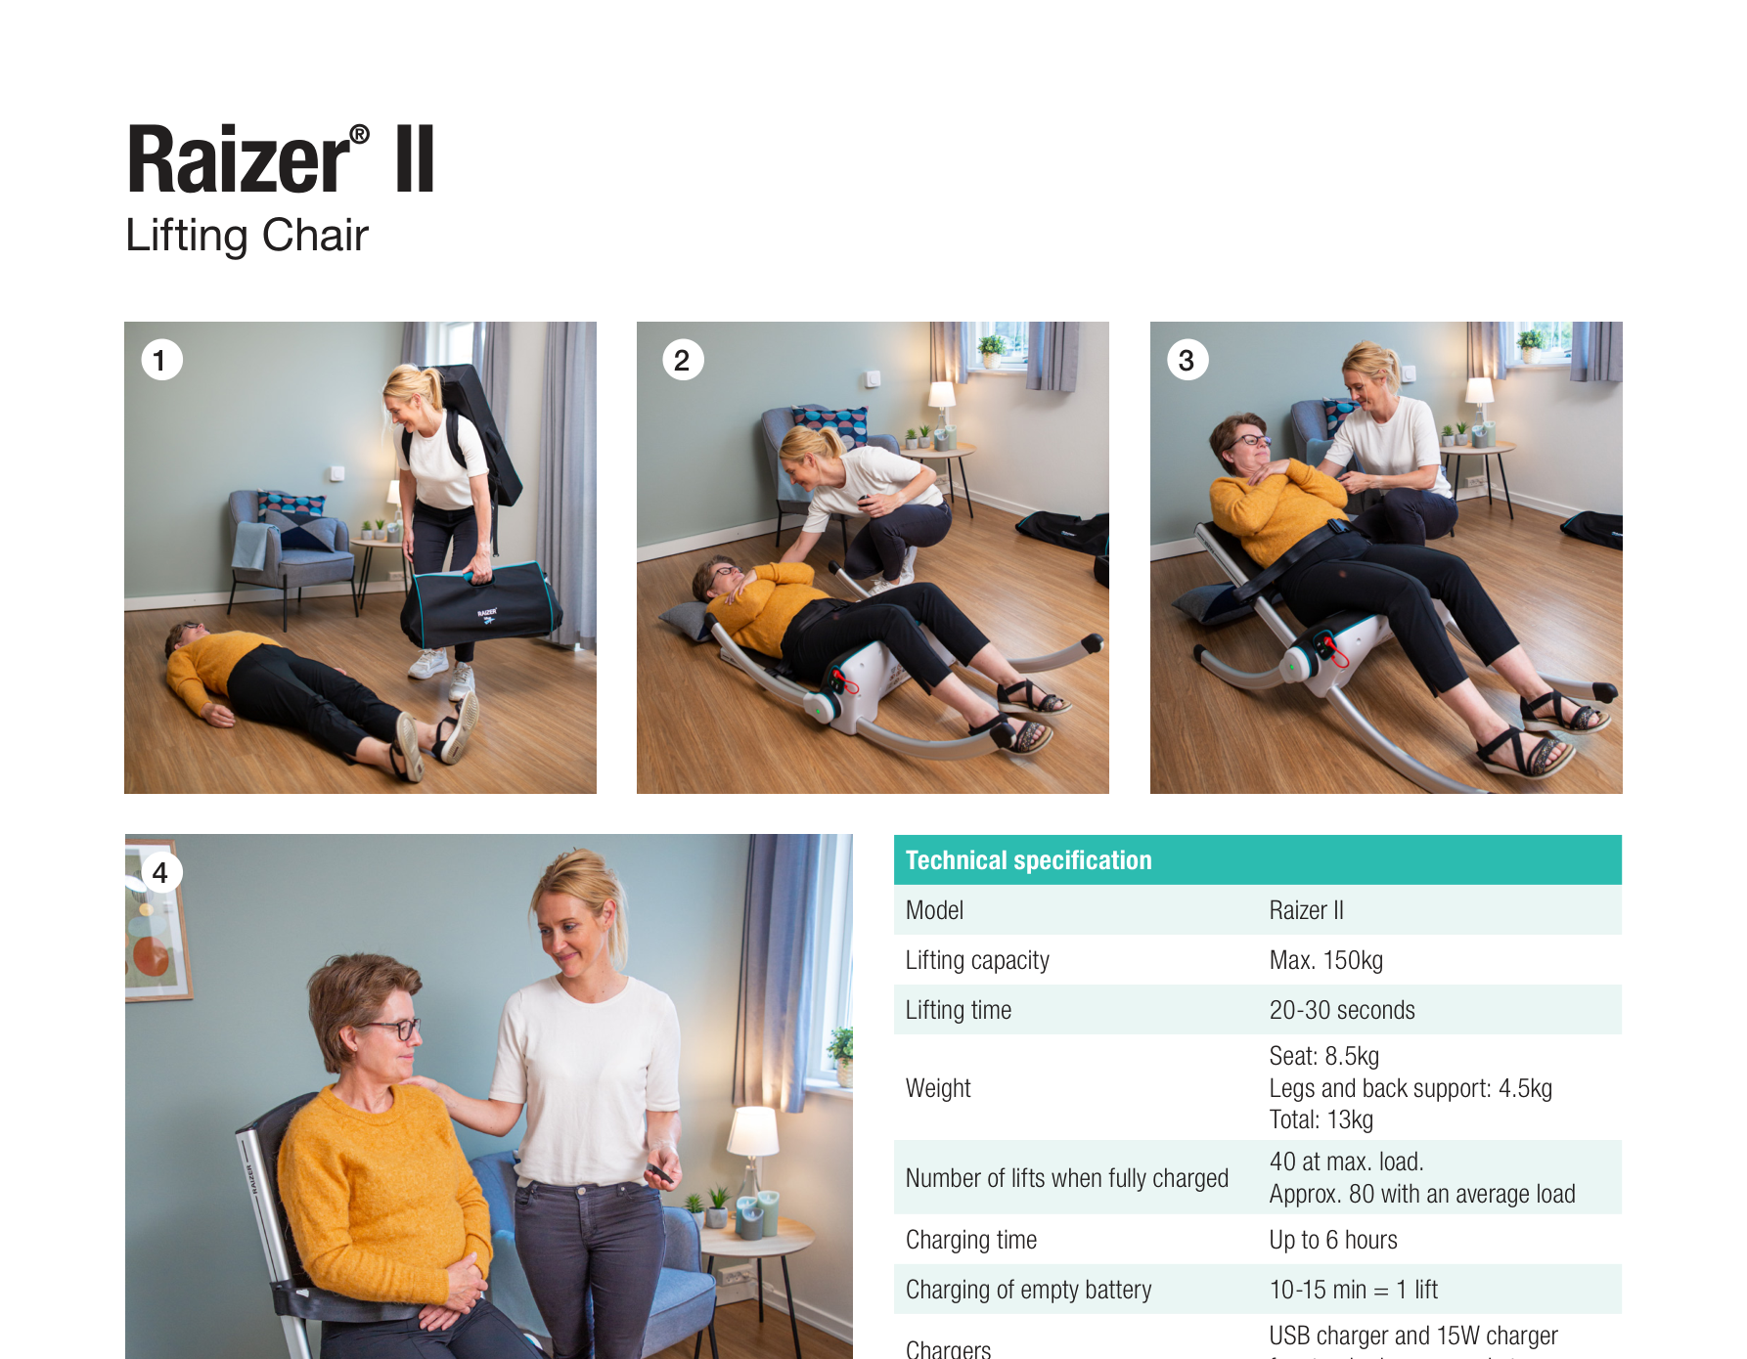
The Raizer II in action: position, assemble, lift, done.

Designed for Real-World Care Settings
Whether in a private home, care home, or community environment, the Raizer II is built for practicality. At just 13kg total, it disassembles into two lightweight carry bags — making it easy to transport in a car, store in a cupboard, or carry up a flight of stairs. The bag design is intuitive: parts are positioned to mirror the sequence of assembly, so carers can set up quickly and confidently.
All surface materials are specified for easy cleaning and disinfection, and optional disposable hygiene covers are available — making infection control straightforward in clinical and care settings alike.

Impressive Performance, All Day Long
With up to 80 lifts on a single battery charge, the Raizer II is well suited to busy care environments where multiple incidents may occur throughout the day. Should the battery run low, just 10–15 minutes of charging delivers enough power for one full lift — so carers are never left without a solution.
- Lifting capacity: up to 150kg
- Lifting time: 20–30 seconds
- Up to 80 lifts per charge (average load)
- Total weight: 13kg across two carry bags
- Operable by a single carer with minimal training required

Supporting OTs and the People They Serve
For occupational therapists, the Raizer II represents a genuinely transformative prescription option. It reduces the risk of carer injury, eliminates the need to wait for additional help to arrive, and — crucially — restores dignity to the person who has fallen by getting them up quickly and calmly. It can be recommended for home use, prescribed via Disabled Facilities Grants, or deployed as part of a care home or NHS falls response toolkit.
Healthcare 21 UK will be showcasing the Raizer II at OTCPD 2026, with live demonstrations so attendees can see — and try — the device for themselves.

Find out more at healthcare21.eu/raizer-ii | Call: 01256 306 506 | Email: raizer@hc21.group

