**Passover on the Prairie**

2024/5784

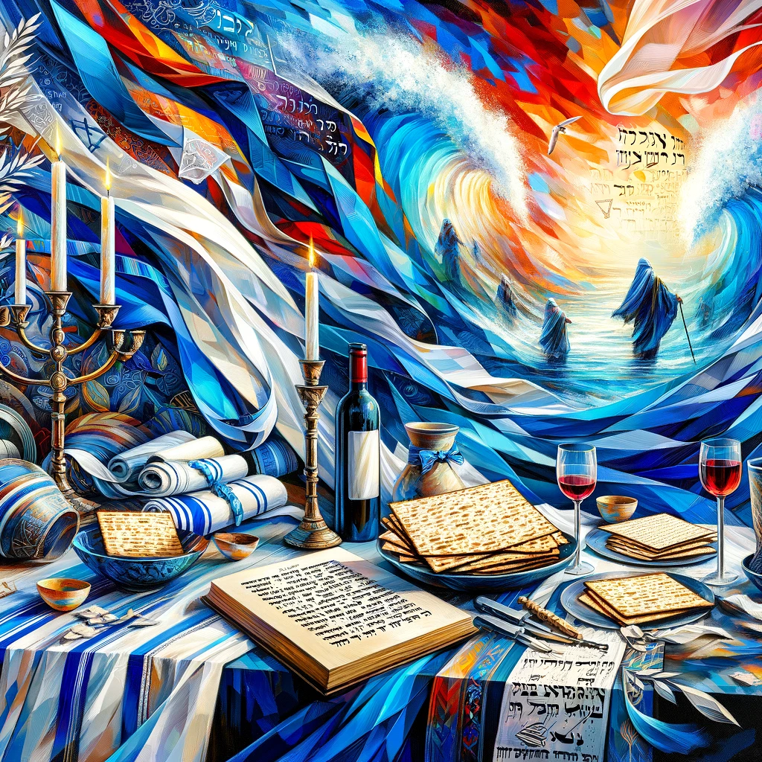

A Messianic Passover Haggadah

***This was a night when Adonai kept vigil to bring them out of the land of Egypt, and this same night continues to be a night when Adonai keeps vigil for all the people of Isra’el through all their generations. (Exodus 12:42)***

***Therefore, when God wanted to demonstrate still more convincingly the unchangeable character of his intentions to those who were to receive what he had promised, he added an oath to the promise. (Hebrews 6:17)***

**Passover Preface**

**Throughout your generations…a permanent ordinance…an everlasting covenant!**  So...What is so special about Passover? Why does the Holy One, blessed be He, tell us in His Word to celebrate it each and every year of our lives and in every generation, forever and ever? This question, along with many others, will hopefully be answered for you this evening.

The Passover is a very special night for us and for God! We will celebrate the oldest celebration of God’s people. We will follow the prescribed order of the traditional Haggadah, but with the unique vantage of a Messianic Jewish perspective.

Passover is the celebration of the national redemption of the people of Israel. Passover is also a celebrated memorial of the Exodus from Egypt and God’s faithfulness to the Jewish people. This service is a beautiful way to relate to the people of Israel, to recollect God’s redemptive truths, and to call to mind the work of the Messiah. As our Master said at his last Seder ***“Do this in remembrance of me”. (Luke 22:19)***

The Passover ceremony, commonly known as the Seder, is probably the most universally celebrated Jewish ritual today. It is the founding ceremony of Israel as a nation, a ceremony based on the centrality of the family as a basic Godly institution. It is also a celebration of freedom of person and of nation.

It cannot be overemphasized as to how foundational Passover is in God’s eternal redemption plan. According to Leviticus 23, Nisan (Aviv) is the first month of God’s calendar. A famous saying of the ancient sages of Israel states “In Nisan our forefathers were redeemed from Egypt, and in Nisan we will be redeemed in the future”. Though other cycles and aspects of life in the Lord are important, it is the sacrifice of the Lamb that gives it all meaning. Without the sacrifice of first Passover lamb and the blood on the doorposts, Israel would have suffered the same fate as the Egyptians. Without the Messiah’s sacrifice on the anniversary of that momentous occasion, we would have no hope and remain dead in our sins.

After the weekly Sabbath, Passover is the first appointed time on God’s calendar as revealed in Leviticus 23. On the first Passover, God told His people to eat the lamb with bitter herbs and unleavened bread. He told them to keep the Passover as a remembrance of their salvation from bondage and slavery. But it was way more than just a remembrance; it was also a rehearsal for something wonderful to come. Fourteen hundred years after the exodus from Egypt, Yeshua (Jesus) went with his disciples to keep the Passover in Jerusalem. As they neared the holy city, Yeshua said ***“My time is near; I am to keep the Passover” (Matthew 26:18).*** As believers keeping the Passover, we can use the annual remembrance of our Savior’s words to “Do this…” as a time for spiritual renewal for our lives in Him.

**The Search for Chametz (Leaven)**

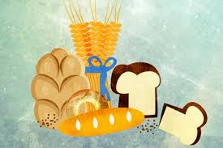

**I**n the days that lead up to Passover, leaven is removed from the home. Items removed include all food that is Chametz or leavened. The traditional interpretation of ‘chametz’ (leaven) is any grain or flour of the five biblical species including – wheat, oats, spelt, barley, and rye – that has been combined with moisture and allowed to sit (ferment) with or without added yeast. This would include normal items such as breads, crackers, pasta or cereal, but also items that contain grain based vinegar or alcohols.

Reader: ***During those seven days, no leaven is to be found in your houses. Whoever eats food with chametz in it is to be cut off from the community of Isra’el —whether he is a foreigner or a citizen of the land. (Exodus 12:19)***

Reader:**Matzah is to be eaten throughout the seven days; neither chametz nor leavening agents are to be seen with you throughout your homes. (Exodus 13:7)**

Blessing for the removal of Chametz:

All: Baurch attah ADONAI eloheinu Melech ha’olam, asher kiddeshanu bemitzvotav, vetzivanu al bi’ur chametz.

All: Blessed are you, LORD our God, King of the universe, Who has sanctified us with His commandments and has commanded us about the removal of chametz. Amen!

**The Festival Lights**

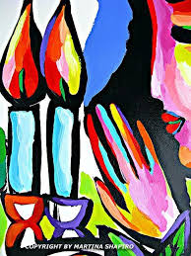

As we kindle the flame for the festival lights, we pray that the Spirit of God may bring illumination to our hearts and great personal meaning to this holy time we have together.

Reader: ***People couldn’t see each other, and no one went anywhere for three days. But all the people of Isra’el had light in their homes. (Exodus 10:23)***

Reader*:* ***Adonai went ahead of them in a column of cloud during the daytime to lead them on their way, and at night in a column of fire to give them light; thus they could travel both by day and by night. (Exodus 13:21)***

All: Baurch attah ADONAI eloheinu Melech ha’olam, asher kiddeshanu bidvaro. V’natan lanu et Yeshua M’shicheinu, v’tzivanu l’hiyot or l’olam.

All: Blessed are You, Lord our God, King of the universe, who has sanctified us with His WORD, and has given us Yeshua our Messiah, and commanded us to be light to the world. Amen!

**Shehecheyanu – Life at this Season**

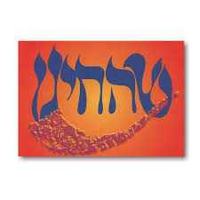

All: Baruch attah ADONAI eloheinu Melech ha’olam, shehecheyanu, vekiyemanu, vehiggianu lazeman hazeh.

All: Blessed are You, LORD our GOD, King of the universe, who has given us life, sustained us , and let us reach this festive season. Amen!

**The Passover Seder Steps – The Set Order**

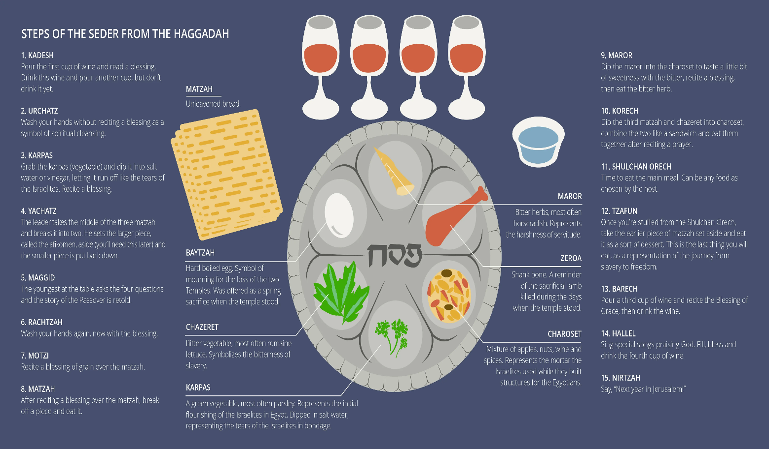

This set order of Passover was developed over thousands of years by the Jewish community. The goal being to utilize our five senses of taste, touch, smell, sight and sound: in order to testify about His redemptive plan, to relive the Exodus experience and to teach the next generation His ways.

Reader: ***“Let the people of Isra’el observe Pesach at its designated time. (Numbers 9:2)***

Reader: ***So they observed Pesach at dusk on the fourteenth day of the month in the Sinai Desert; the people of Isra’el acted in accordance with all that Adonai had ordered Moshe. (Numbers 9:5)***

**The First Cup: Kiddush (Sanctification)**

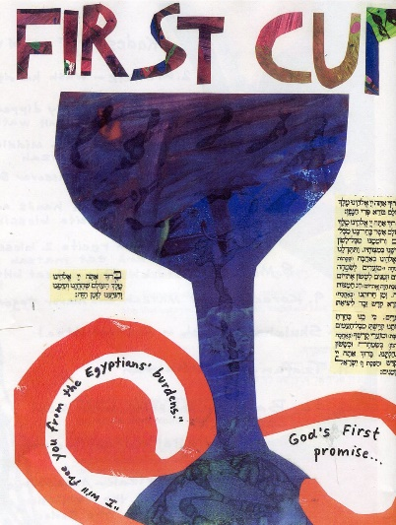

(Pour the 1st cup) The 4 cups of wine are associated with the 4 “I will” statements in Exodus 6:6-7.

Reader: ***“Therefore, say to the people of Isra’el: ‘I am Adonai. I will free you from the forced labor of the Egyptians, I will rescue you from their oppression, and redeem you with an outstretched arm and with great judgments. 7I will take you as my people, and I will be your God. Then you will know that I am Adonai your God, who freed you from the forced labor of the Egyptians.***

ADONAI desired to set Israel apart so that they might enter into a process of sanctification with Him and learn to worship Him in spirit and truth as He desires. Through sanctification, God’s people learn about holiness, purity, and consecration.

Reader: ***Then, taking a cup of wine, he made the blessing and said, “Take this and share it among yourselves. 18For I tell you that from this night, I will not drink the ‘fruit of the vine’ until the Kingdom of God comes.” (Luke 22:17-18)***

As we drink the first cup of wine, we begin the celebration with the Kiddush, which means “Sanctification.” The Kiddush is the traditional blessing that begins the weekly Sabbath on Friday evening and most biblical festivals. With this blessing, we proclaim that we are set apart for Him and His Passover.

All: *We thank You, our Father, for the holy vine of your servant David, that you made known to us through your servant Yeshua. Yours is the glory forever. – Didache 9:2*

All: Baruch attah ADONAI eloheinu Melech ha’olam, bore pri hagafen.

All: Blessed are You, LORD our GOD, King of the universe, Who creates the fruit of the vine. Amen!

**The First Washing – Urchatz (Trust the Process)**

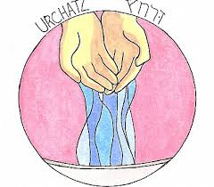

No traditional blessing occurs with this first washing, and is typically done by the leader of the seder.

Reader: ***Who may go up to the mountain of Adonai? Who can stand in his holy place?Those with clean hands and pure hearts, who don’t make vanities the purpose of their lives or swear oaths just to deceive. (Psalm 24:3-4)***

**The First Dip – Karpas (Spring Green in Salt Water)**

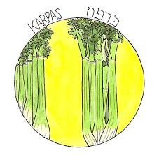

Passover is the quintessential Springtime holiday. New life and salvation sprung forth for the Israelites on this day. The Karpas represents that new life, created and sustained by ADONAI.

At the same time, life in Egypt was filled with bitterness, suffering and tears. The salt water reminds us that life, even new life, is sometimes filled with tears. So we await and look forward to the World to Come when those tears will be wiped away forever.

Reader: ***Sometime during those many years the king of Egypt died, but the people of Isra’el still groaned under the yoke of slavery, and they cried out, and their cry for rescue from slavery came up to God. (Exodus 2:3)***

Reader: ***When evening came, Yeshua reclined with the twelve talmidim; 21and as they were eating, he said, “Yes, I tell you that one of you is going to betray me.” 22They became terribly upset and began asking him, one after the other, “Lord, you don’t mean me, do you?” 23He answered, “The one who dips his hand in the dish with me is the one who will betray me.  (Matthew 26:20-23)***

Blessing for the Fruit of the Earth:

All: Baruch attah ADONAI eloheinu Melech ha’olam, bore pri ha’adamah.

All: Blessed are You, LORD our God, King of the universe, Who creates the fruit of the ground. Amen! (Dip the parsley in salt water and eat)

**Breaking the Matzah – Yachatz**



**The Matzah Tash** is three matzot placed together in a decorative bag for Passover. And then, for some reason, the middle matzah is removed, broken in half, wrapped in a linen cloth and put away for a time, and then revealed during the third part of the seder. There are various explanations for this ceremony. The custom dates back to the early centuries after the death and resurrection of Yeshua. Since the entire Passover service is woven with rich symbolism, it must be asked: “Why three matzot?” The rabbis call these three a “Unity.” Some say its a unity of the patriarchs of our faith – Abraham, Isaac, and Jacob. Others explain it as a unity of worship – the High Priest, the Levites, and the people of Israel. Ultimately, there is no consensus among the Rabbis to explain why the three matzot or why the middle matzah must be broken and put away for a time.

In addition, there is much debate among rabbis concerning the meaning of the word Afikomen. The problem is compounded since Afikomen does not exist in the Hebrew language. Rabbinic consensus usually explains that it means dessert since it is eaten after the meal when a dessert would normally be eaten. Amazingly, Afikomen is the only Greek word in the traditional Passover Haggadah. The word in Greek simply means “That which comes after”. Food for thought!

(Wrap the Afikomen at this time). If the children will cover their eyes, I will hide the Afikomen. (Hide it).

**The Story – Maggid**

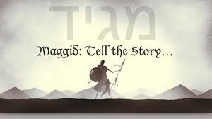

(Lift the Matzot) This is the bread of affliction that our fathers ate in the land of Egypt. Let all who are hungry come and eat! Let all who are needy come and celebrate Passover! Now we are here, but next year may we be in the land of Israel. May we merit to see the redemption and return of the King to establish His kingdom from Jerusalem soon and in our days. Amen!

Reader: ***When your children ask you, “what does this ceremony mean to you?”, then you are to tell them… (Exodus 12:26)***

The Bible informs us that when we observe the Passover, our children will have a natural curiosity about its meaning. So the telling of the Passover story begins with the framing of the meta question, (Child) Why is this night different from all other nights?, followed by the related 4 questions:

1. Why on all others nights we can eat chametz or matzah, but on this night, we eat only matzah?
2. Why on all other nights we can eat other vegetables, but on this night we eat bitter herbs?
3. Why on all other nights we do not dip even once, but this night we dip twice
4. Why on all other nights we can eat either sitting or reclining, but on this night we recline?

Reader: ***You shall say, “It is the Passover to the LORD, who passed over the houses of the sons of Israel in Egypt when he smote the Egyptians, but spared our homes.” And the people bowed low and worshiped. (Exodus 12:27)***

Reader: ***When Isra’el came out of Egypt, the house of Ya‘akov from a people of foreign speech, Y’hudah became [God’s] sanctuary, Isra’el his domain.The sea saw this and fled; the Yarden turned back;the mountains skipped like rams, the hills like young sheep. Why is it, sea, that you flee? Why, Yarden, do you turn back? Why, mountains, do you skip like rams; and you hills like young sheep? Tremble, earth, at the presence of the Lord, at the presence of the God of Ya‘akov, who turned the rock into a pool of water, flint into flowing spring. (Psalm 114)***

Scripture reveals to us a God who works directly in the lives of His people. He is a covenant-faithful God who promises, guides, sets apart, and gives freedom to His chosen ones. The children of Israel were unable to serve ADONAI with all their being, they were in bondage to a cruel system that held them captive. They were oppressed, tired, and weak, but God brought them their freedom. Throughout the Exodus story, we continually hear the appeal “Let My people go”, followed by the passionate, inviting statement, “that they may serve Me”. This is a story of a God whose goal is to sanctify, deliver, and redeem His people.

**The Ten Plagues**

(Fill the second cup) A full cup is a symbol of joy and indeed on this occasion we are filled with joy by remembering God’s mighty deliverance. But let us also remember the great cost at which redemption was purchased. Lives were lost to bring about the release of God’s people from the slavery of Egypt. And yet even a far greater price was paid for our personal redemption from slavery to sin and death – the willing sacrificial death of Yeshua on the tree. Therefore, as our joy is reduced by their loss, so is our cup reduced by ten drops of wine, one for each of the plagues that they suffered. It is traditional to name the plagues at this point in the Seder. As we recount each plague, let us dip a little finger into the cup, allowing a drop of juice to fall, reducing the fullness of our cup of joy this night.

**All**: Recite each plague while removing a drop of wine for each one.

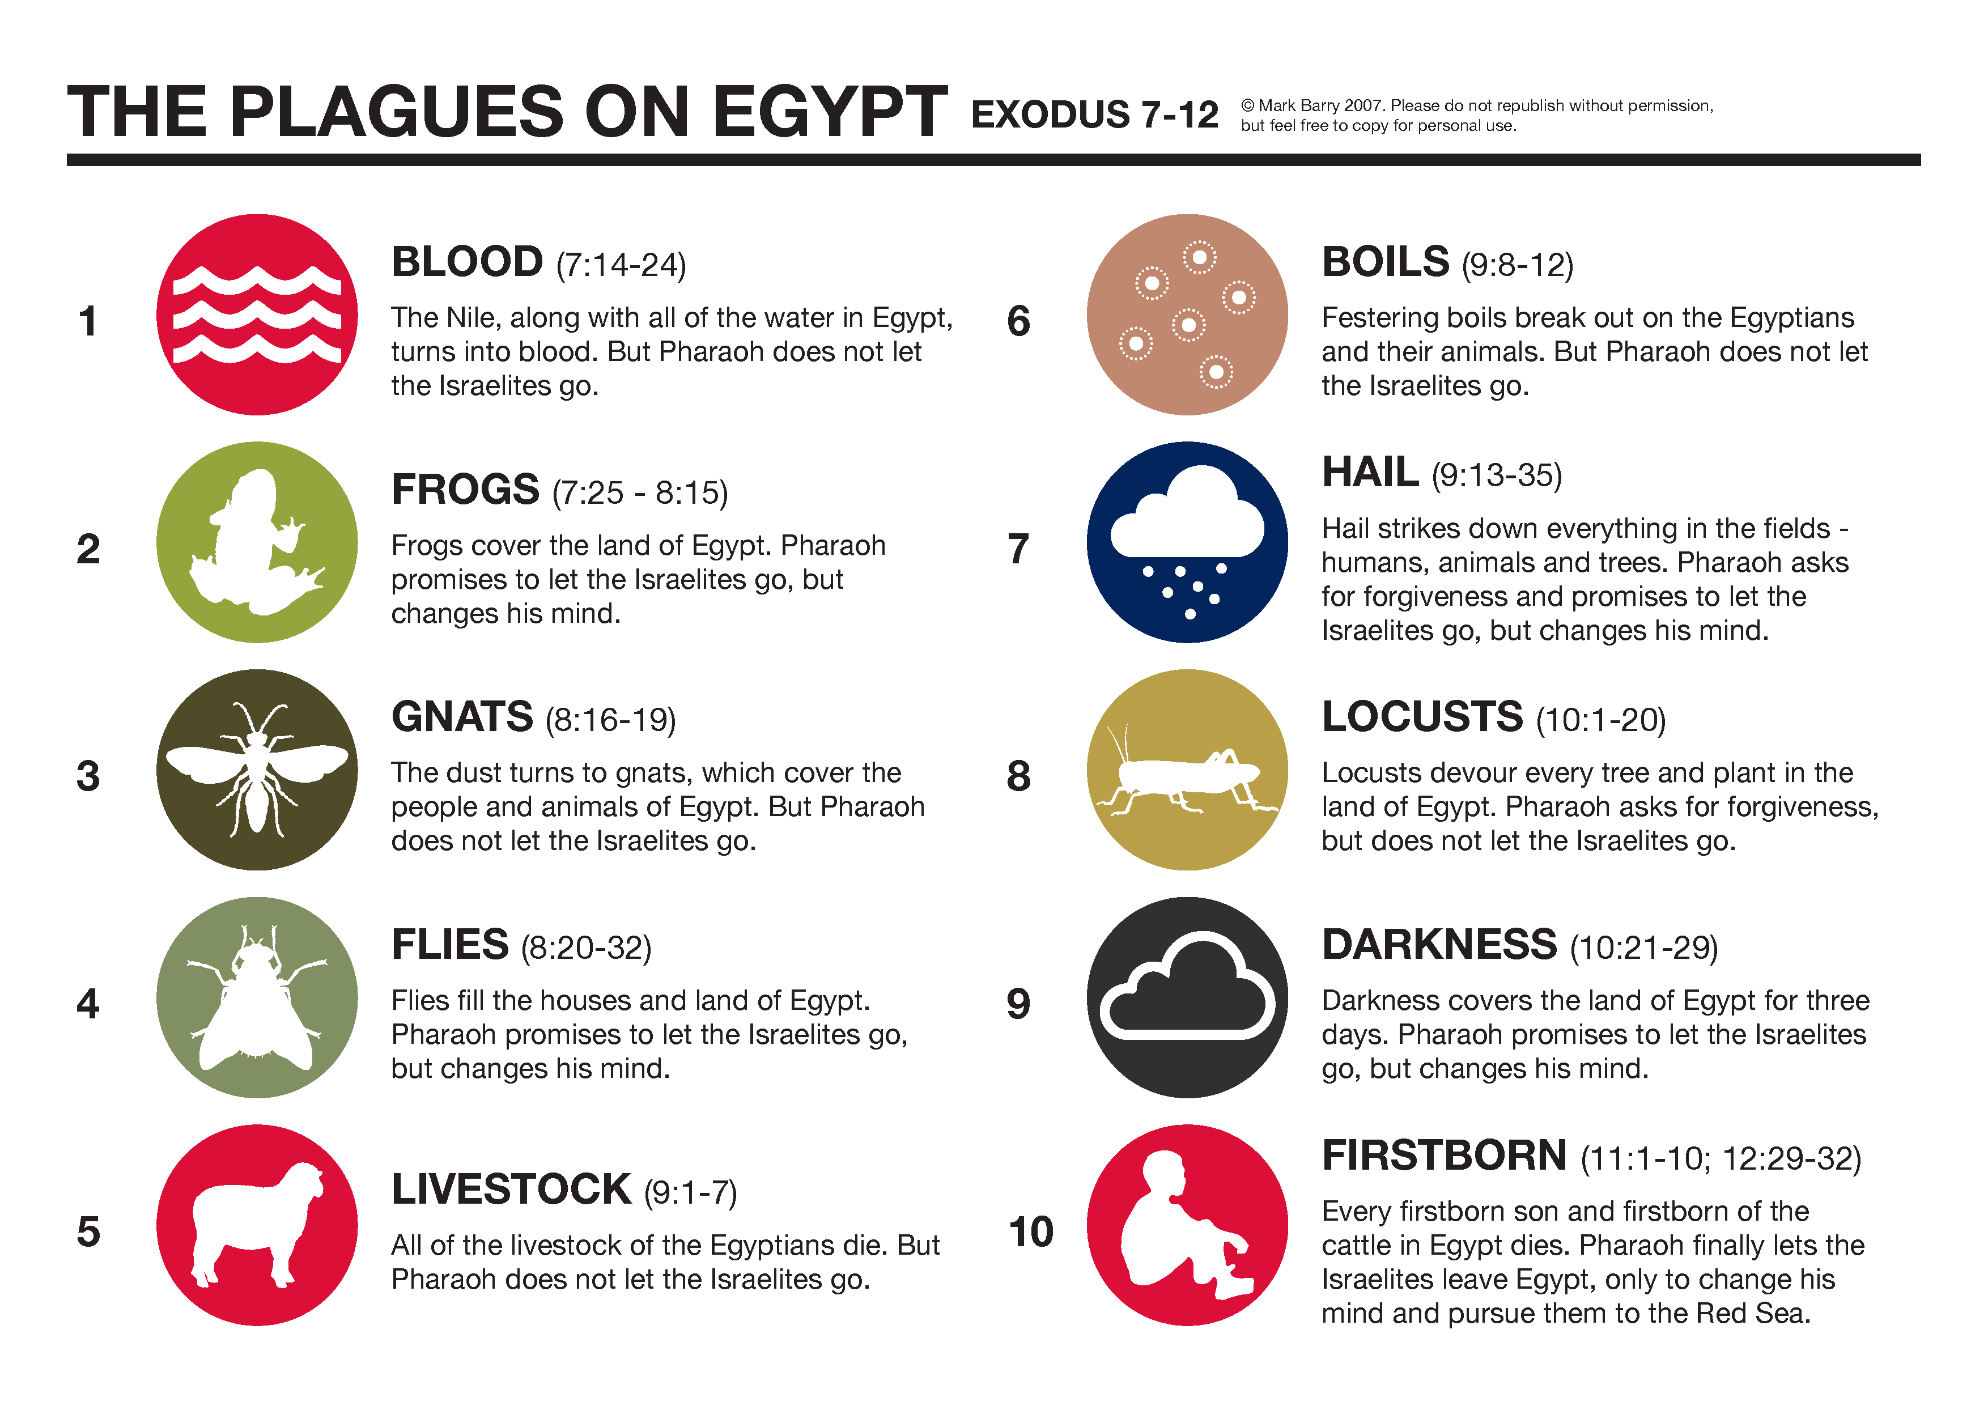

Song: Dayenu (It is Enough)

Reader: ***Or has God ever tried to go and take for himself a nation from the very bowels of another nation, by means of ordeals, signs, wonders, war, a mighty hand, an outstretched arm and great terrors — like all that Adonai your God did for you in Egypt before your very eyes? (Deuteronomy 4:34)***

**Three Important Things**

Rabbi Gamliel (the Apostle Paul’s teacher) used to say, whoever does not mention; The Passover Offering, Unleavened Bread and the Bitter Herbs has not fulfilled his obligation to “teach his children” about the Passover.

**Lamb Shank Bone (Zeroa)**

The Passover offering that would be eaten during the times of the Temple, what is the reason for it? It is because the Holy One, blessed is He, passed over the homes of the Israelites in Egypt.

Reader: ***The blood will be a sign for you upon the homes where you are. I will see the blood and pass over you, There will not be any plague to destroy you when I strike the land of Egypt. (Exodus 12:13)***

Reader*:* ***Our Passover Offering, which has been sacrificed on our behalf is the Messiah. (1 Corinthians 5:7)***

Reader: ***Like a lamb that is led to the slaughter, and like a sheep before her shearers is silent, he will not open his mouth. (Isaiah 53:7)***

Reader: ***You were ransomed…with the precious blood of an unblemished lamb without defect, with the blood of the Messiah. (1 Peter 1:18-19)***

**Unleavened Bread (Matzah)**

This Unleavened Bread that we eat, what is the

reason for it? It is because there was not enough

time for the dough of the Israelites to rise.

Reader: ***They baked the dough that they brought out from Egypt into***

***Unleavened cakes, since it had not become leavened; for they had been***

***driven out from Egypt, and they were not able to delay nor had they made provisions for themselves. (Exodus 12:39)***

 Reader: ***“Clean out the old leaven so that you may be a new lump, just as you are in fact unleavened. For Messiah our Passover also has been sacrificed. Therefore, let us celebrate the feast, not with old leaven, nor with the leaven of malice and wickedness, but with the unleavened bread of sincerity and truth.”***

***(1 Corinthians 5:7-8)***

Look at your matzah, closely! It is without leaven; it has spots and bruises. It is striped, and if you hold it up to the light, you will see that it is pierced. This matzah is a great picture of our Messiah! It is both the bread of affliction and the bread of life.

The Gospel according to Isaiah:

Reader: ***There is no beauty that we should desire him. He is despised and rejected by men, a Man of sorrows and acquainted with grief. And we hid, as it were, our faces from Him; He was despised, and we did not esteem Him. Surely He has borne our grief and carried our sorrows; yet we esteemed Him stricken, smitten by God, and afflicted.* *But he was wounded for our transgressions, he was bruised for our iniquities: the punishment of our peace was upon him; and by his stripes we are healed. (Isaiah 53:2-5)***

Song: By His Wounds

**Bitter Herbs (Maror)**

The Bitter Herbs that we eat, what is the reason for it?

It is because the Egyptians made our fathers’ lives bitter in Egypt.

Reader: ***They made their lives bitter with harsh labor through mortar and bricks, with all kinds of field labor; with all their labor they ruthlessly enslaved them. (Exodus 1:14)***

Reader: ***He said to them, “My soul is bitterly troubled to the point of death. Stay here and keep watch with me.” (Matthew 26:38)***

Reader: ***For it is a man’s credit if he is satisfied with bitter herbs, and afflicted baselessly for the sake of the knowledge of God. (1 Peter 2:19)***

**The Second Cup – Deliverance**

“I am the LORD, and I will deliver you from their bondage.”

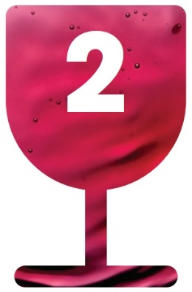

(Pour the 2nd Cup)

**We Were Also Delivered**

The sages say, in every single generation, each person is obligated to see himself as if he had personally gone out from Egypt.

Reader: ***You shall tell your son on that day, saying “On account of this that the LORD did for me, taking me out of Egypt.” (Exodus 13:8)***

Reader: ***For I do not want you to be ignorant of the fact, brothers and sisters, that our ancestors were all under the cloud and that they all passed through the sea. (1 Corinthians 10:1)***

 For these reasons, we are obligated to give thanks, to praise, to acclaim, to glorify, to uplift, to honor, to bless, to elevate, and to applaud the One that did all of these miracles for our fathers and for us; bringing us out of slavery to freedom, from sorrow to joy, from mourning to festivity, from gloom to bright light, from subservience to redemption. And let us offer Him a new song – Halleluyah!

All: Baruch attah ADONAI Eloheinu Melech Ha’olam bore pri hagafen.

Blessed are you, LORD our God, King of the Universe, who creates the fruit of the vine. Amen!

**The Second Washing (Rachtzah)**

Reader: ***“After that, he poured water into a basin and began to wash his disciples’ feet, drying them with the towel that was wrapped around him...Do you understand what I have done for you? He asked them. You call me Teacher and Lord, and rightly so, for that is what I am. Now that I, your Lord and Teacher, have washed your feet, you also should wash one another’s feet.” (John 13:5, 12-14)***

Let us now offer the bowl of water to one another and share in this hand-washing ceremony. Let us also reflect upon the gesture of humility and the lesson of commitment made by our Messiah when, on that night, he laid aside his garments and girded himself with a towel. (Pour the water over your neighbors' hands as a symbolic gesture)

**Blessing Over Bread (Motzi)**

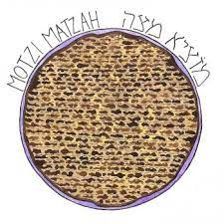

*We thank You, our Father, for the life and knowledge that you made known to us through your servant Yeshua. Yours is the glory forever. Just as this piece of bread was scattered over the mountains and gathered together, so may your assembly be gathered from the ends of the earth into your kingdom. For yours is the glory and the power and the majesty through Yeshua forever! Didache 9:3-4*

All:Baruch attah ADONAI, Eloheinu Melech ha’olam, ha’motzi lechem min ha’aretz.

All: Blessed are You, LORD, our God, King of the universe, who brings forth bread from the earth. Amen! (Don’t eat the matzah just yet)

**Blessing Over Unleavened Bread (Matzah)**

Reader: ***I am the living bread that came down from heaven. One who eats this bread will live forever; but the bread that I will give is my flesh, which I will give on behalf of the life of the world. (John 6:51)***

Reader: ***Also, taking a piece of matzah, he made the blessing, broke it, gave it to them and said, “This is my body, which is being given for you; do this in memory of me.”( Luke 22:19)***

All:Baruch attah ADONAI Eloheinu Melech ha’olam, asher kidshanu b’mitzvotav al akhilat Matzah.

All: Blessed are You, LORD our God, King of the universe, who has sanctified us with His commandments and commanded us concerning the eating of Matzah.

(Eat the Matzah)

**Blessing Over Bitter Herbs (Maror)**

(Lifting the matzah with the maror) As we scoop some maror onto a piece of matzah, let us call to mind with compassion for the sorrow that our ancestors have known throughout the ages and anyone here this evening or anyone of God’s people throughout the world who is suffering tonight.

Reader: ***You shall eat it with unleavened bread and bitter herbs. (Numbers 9:11)***

All:Baruch attah ADONAI Eloheinu Melech ha’olam, asher kidshanu bidevaro v’tzivanu al akhilat maror.

All: Blessed are You, LORD our God, King of the universe, who has set us apart by His Word and commanded us to eat bitter herbs. Amen!

(Eat the Matzah with Bitter Herbs)

**The Mortar (Charoset)**

(Lifting the charoset) The children of Israel toiled to make treasure cities for Pharaoh, working to make brick. We remember this task in a mixture called charoset, made from chopped apples, honey, nuts, and wine. We call to mind, that this life is bittersweet. Yet, even the most bitter of circumstances can be sweetened by the hope we have in God. One day, the LORD will turn all of our mourning into joy and our weeping into dancing!

**Hillel Sandwich (Korech)**

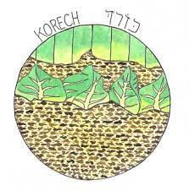

 This is what Rabbi Hillel would do during the days of the Temple; He would combine the Passover Lamb, Matzah and Bitter Herbs and eat them together.

(Eat Matzah, Maror and Charoset together)

**The Fellowship Meal (SHULCHAN ORECH)**

Let us and our conversation remain in the spirit of the evening.

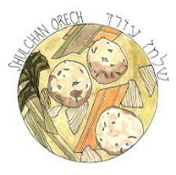

Song: Chad Gadya (One Little Goat)

**The Afikomen (Tzafun)**

At the end of the meal, the Afikomen is returned to the table. How it gets there is another interesting lesson of Passover. A tradition has developed that allows the children, as soon as they clean their plates, to go search for the Afikomen. When it is found, it is brought to the father. Before it is returned to him so the service may be completed, the triumphant child asks, “Chesid, b’vak ashah.” (Money, if you please)! You see, this bread that was broken, wrapped in linen and hidden away until this, the third part of the Seder, must be bought with a price. As it is returned, the service continues at the place we read of in the Gospel.

Reader: ***“While they were eating, Yeshua took some bread, and after a blessing, He broke it and gave it to the disciples, and said, “Take, eat; this is My body.” (Matthew 26:26)***

And so it was in that upper room, two thousand years ago, that Yeshua revealed that His body would be broken. Then His body would be wrapped in linen, and His body would become the Bread of Life that God would, indeed, bring forth from the earth. He is the answer to all of the world’s debates over God’s purpose and He is the answer and the amen of all prayers. Let us now eat the lastmatzah of the seder, and in fact, the final food of the service.

Reader: ***So you will eat and be satisfied, and you will bless Adonai your God for the good land he has given you. (Deuteronomy 8:10)*** (Take, distribute, and eat the matzah).

**The Third Cup: Redemption**

“I will redeem you with an outstretched arm…”

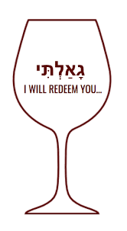

(Pour the third cup) This is the cup of redemption, symbolizing the blood of the Passover lamb. It was the cup “after supper,” with which Messiah identified himself.

Reader: ***“And when He had taken a cup and given thanks, He gave it to them, saying, “Drink from it, all of you; for this is My blood of the covenant, which is poured out for many for forgiveness of sins.”***

Reader: ***Yeshua lifted the cup, saying, “This cup is the new covenant in my blood, which is poured out for you.” (Luke 22:20)***

Yeshua revealed Himself as our redemption. He came to die as the acceptable sacrifice unto the LORD, and to ratify the word of God to His people, Israel.

Reader: ***“Take this and divide it among you. For I tell you I will not drink again the fruit of the vine until the kingdom of God comes.” (Luke 22:17-18)***

Just as the blood of the lamb brought salvation in Egypt, so Messiah’s atoning death can bring salvation to all who believe.

All:Baruch attah ADONAI, Eloheinu Melech ha’olam, bore pri hagafen.

All: Blessed are You, Lord our God, King of the universe, who creates the fruit of vine. Amen!

**Song**: Tasting Forgiveness

**The Prophet Elijah (Eliyahu HaNavi)**

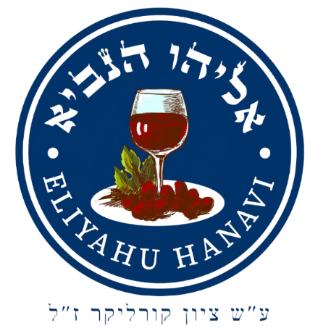

(Pour and Lift Elijah’s Cup) This cup is for Elijah the Prophet, Eliyahu HaNavi. Elijah did not see death but was taken up into the Presence of God in a chariot of fire. So at Passover, we anticipate his return. Scripture tells us that Elijah must come before the Day of the Lord.

Reader: ***“See, I will send you the prophet Elijah before that great and dreadful day of the Lord comes.” (Malachi 4:5)***

Reader: ***A psalm of Asaf:***

***God, the pagans have entered your heritage. They have defiled your holy temple***  
***and turned Yerushalayim into rubble.They have given the corpses of your servants as food for the birds in the air, yes, the flesh of those faithful to you***  
***for the wild animals of the earth.All around Yerushalayim***  
***they have shed their blood like water, and no one is left to bury them.***  
***We suffer the taunts of our neighbors, we are mocked and scorned by those around us.How long, Adonai? Will you be angry forever? How long will your jealousy burn like fire? Pour out your wrath on the nations that don’t know you,***  
***on the kingdoms that don’t call out your name; for they have devoured Ya‘akov***  
***and left his home a waste.Don’t count past iniquities against us,***  
***but let your compassion come quickly to meet us, for we have been brought very low.Help us, God of our salvation, for the sake of the glory of your name.***  
***Deliver us, forgive our sins, for your name’s sake.Why should the nations ask,***  
***“Where is their God?” Let the vengeance taken on your servants’ shed blood***  
***be known among the nations before our eyes. Let the groaning of the captives come before you; by your great strength save those condemned to death.***

***Repay our neighbors sevenfold where they can feel it***  
***for the insults they inflicted on you, Adonai. Then we, your people and the flock in your pasture, will give you thanks forever. From generation to generation***  
***we will proclaim your praise. (Psalm 79)***

 In Jewish homes all over the world, a place is set for Elijah at each Passover table. Elijah will yet announce the return of the Messiah Yeshua, Son of David!

John came in the spirit of Elijah to herald the first coming. And yet, what has been will be again. Elijah the Prophet will come at the appointed time in the future to announce the arrival of the King of Kings and Lord of Lords!

At this time let one of the children open the door to welcome Elijah to our Seder.

*(A child opens the door – Sing Eliyahu HaNavi)*

**Song**: Elijah the Prophet (Eliyahu HaNavi)

**The Fourth Cup: Praise (Hallel)**

“I will take you as my own people and I will be your God.”

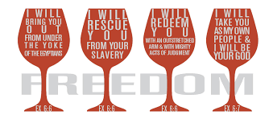

Let us fill our cups for the fourth and final time tonight and give thanks to God, our great Redeemer and King. As we partake of this cup, we look forward to that great Messianic banquet of which Yeshua and Isaiah both prophesied about.

Reader: ***“I tell you, many will come from all the nations of the east and the west to recline at the table with Abraham, Isaac & Jacob in the Kingdom of Heaven.” (Matthew 8:11)***

Reader: ***“On this mountain the LORD Almighty will prepare a feast of rich food for all the nations, a banquet of aged wine, the best of meats and the finest of wines.” (Isaiah 25:6)***

**Zechariah’s Prayer of Praise:**

Reader: ***“Praised be Adonai, the God of Isra’el, because he has visited and made a ransom to liberate his peopleby raising up for us a mighty Deliverer who is a descendant of his servant David. It is just as he has spoken through the mouth of the prophets from the very beginning —that we should be delivered from our enemies and from the power of all who hate us.“This has happened so that he might show the mercy promised to our fathers — that he would remember his holy covenant, the oath he swore before Avraham avinu to grant us that we, freed from our enemies, would serve him without fear, in holiness and righteousness before him all our days. (Luke 1:68-75)***

**Psalm 136 - All: Call and Response**

***Give thanks to Adonai, for he is good,***  
***for his grace continues forever.***  
***Give thanks to the God of gods,***  
***for his grace continues forever.***  
***Give thanks to the Lord of lords,***  
***for his grace continues forever;***

***to him who alone has done great wonders,***  
***for his grace continues forever;***  
***to him who skillfully made the heavens,***  
***for his grace continues forever;***  
***to him who spread out the earth on the water,***  
***for his grace continues forever;***  
***to him who made the great lights,***  
***for his grace continues forever;***  
***the sun to rule the day,***  
***for his grace continues forever;***  
***the moon and stars to rule the night,***  
***for his grace continues forever;***

***to him who struck down Egypt’s firstborn,***  
***for his grace continues forever;***  
***and brought Isra’el out from among them,***  
***for his grace continues forever;***  
***with a mighty hand and an outstretched arm,***  
***for his grace continues forever;***

***to him who split apart the Sea of Suf,***  
***for his grace continues forever;***  
***and made Isra’el cross right through it,***  
***for his grace continues forever;***  
***but swept Pharaoh and his army into the Sea of Suf,***  
***for his grace continues forever;***

***to him who led his people through the desert,***  
***for his grace continues forever;***  
***to him who struck down great kings,***  
***for his grace continues forever;***  
***yes, he slaughtered powerful kings,***  
***for his grace continues forever;***  
***Sichon king of the Emori,***  
***for his grace continues forever;***  
***and ‘Og king of Bashan,***  
***for his grace continues forever;***

***then he gave their land as a heritage,***  
***for his grace continues forever;***  
***to be possessed by Isra’el his servant,***  
***for his grace continues forever;***

***who remembers us whenever we are brought low,***  
***for his grace continues forever;***  
***and rescues us from our enemies,***  
***for his grace continues forever;***

***who provides food for every living creature,***  
***for his grace continues forever.***

***Give thanks to the God of heaven,***  
***for his grace continues forever.***

(Lifting the 4th cup) Let us lift our cups and bless the Name of the Lord! Now, let us drink of the fourth cup together in anticipation of that great and glorious day when we can drink it anew with Yeshua in the Kingdom.

All: Baruch attah ADONAI, Eloheinu Melech ha’olam, bore pri hagafen.

All: Blessed are You, LORD our God, King of the universe, who creates the fruit of the vine. Amen!

**Acceptable Closing (Nirtzah)**

Our Passover Seder is now complete in accordance with all its law, ordinances and statutes, just as our redemption is forever complete. We have proclaimed the story to tell, and may we merit to carry it out as well. Pure One who dwells in the heavens above, gather together your people in your love. Soon, take your plantings and lead them along, ransomed to Zion with a spirited song!

Let us conclude with the traditional wish that we may celebrate Passover next year in Jerusalem!

**ALL: L’SHANA HABA’AH BI’YERUSALAYIM** 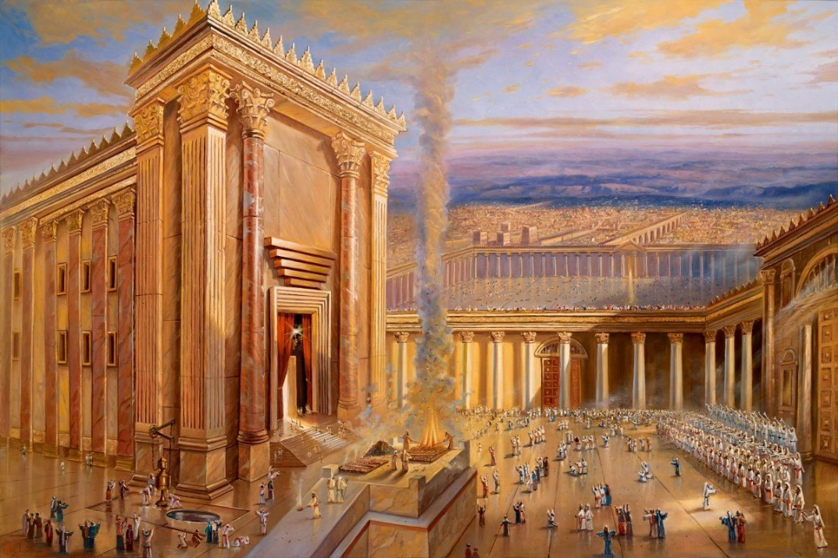

**The Promise and the Oath**

Your promise hangs over the earth tonight like a sacred vow that always shines  
Your living word stands secure, while the moon endures  
How long O Lord until you come again? when you ride the wings of the whirling wind?  
When the voice of the archangel cries and you split the sky  
  
Oh the promise and the oath You swore  
Have been painted red over my door  
When You come again You will reward those  
Who have bound their hearts to You  
  
I love the day when You will appear, the sun will rise and the darkness clears  
The sons and daughters of the light are wide awake through the night  
I follow the king who was nailed down, who carried the cross before the crown  
Traveling on ‘til the break of day, who can sleep anyway?

**Dayenu (It Is Enough)**

Had He led us out of Egypt, only led us out of Egypt, Had He led us out of Egypt, Dayenu, Dai, Dayenu x3

Dayenu Dayenu

Had He granted us the Sabbath, only granted us the Sabbath, Had He granted us the Sabbath, Dayenu, Dai, Dayenu x3

Dayenu Dayenu

Had He given us the Torah, only given us the Torah, Had He given us the Torah, Dayenu, Dai, Dayenu x3

Dayenu Dayenu

Had He given us Yeshua, only given us Yeshua, Had He given us Yeshua, Dayenu, Dai, Dayenu x3

Dayenu Dayenu

**By His Wounds**

He was pierced for our transgressions  
He was crushed for our sins  
The punishment that brought us peace was upon Him

And by His wounds  
By His wounds, we are healed

He was pierced for our transgressions  
He was crushed for our sins  
The punishment that brought us peace was upon Him

And by His wounds  
By His wounds, we are healed

We are healed by Your sacrifice  
And the life that You gave  
We are healed for You paid the price  
By Your grace, we are saved  
We are saved

**Chad Gadya (One Little Goat)**

That Father bought for two zuzim, Chad gadya. Chad gadya.

Then came a cat and ate the goat, That Father bought for two zuzim, Chad gadya. Chad gadya.

Then came a dog and bit the cat, that ate the goat, That Father bought for two zuzim, Chad gadya. Chad gadya.

Then came a stick and beat the dog, that bit the cat, that ate the goat, That Father bought for two zuzim, Chad gadya. Chad gadya.

Then came fire and burnt the stick, that beat the dog, that bit the cat, that ate the goat, That Father bought for two zuzim, Chad gadya. Chad gadya.

Then came water and quenched the fire, that burnt the stick, that beat the dog, that bit the cat, that ate the goat, That Father bought for two zuzim, Chad gadya. Chad gadya.

Then came the ox and drank the water, that quenched the fire, that burnt the stick, that beat the dog, that bit the cat, that ate the goat, That Father bought for two zuzim, Chad gadya. Chad gadya.

Then came the butcher and slaughtered the ox, that drank the water, that quenched the fire, that burnt the stick, that beat the dog, that bit the cat, that ate the goat, That Father bought for two zuzim, Chad gadya. Chad gadya.

Then came the Angel of Death and killed the butcher, that slaughtered the ox, that drank the water, that quenched the fire, that burnt the stick, that beat the dog, that bit the cat, that ate the goat, That Father bought for two zuzim, Chad gadya. Chad gadya.

Then came the Holy One, Blessed be He and slew the the Angel of Death, that killed the butcher, that slaughtered the ox, that drank the water, that quenched the fire, that burnt the stick, that beat the dog, that bit the cat, that ate the goat, That Father bought for two zuzim, Chad gadya. Chad gadya.

**Tasting Forgiveness**

I'm pleading my innocence here  
Exposing my arrogance all the while  
Hoping that nobody sees  
Especially You  
  
I've yielded to all that has cost me  
And thrown to the side what is free  
And I'm lying if I say that I've figured it out  
  
But maybe this time  
The bread and the wine  
Will be more than food on my lips  
  
I'm tasting forgiveness  
And drinking of mercy  
I feast on redemption  
Tasting forgiveness

**Eliyahu HaNavi (Elijah the Prophet)**

Eliyahu Hanavi, Eliyahu Hatishbi,

Eli Eliyahu, Eliyahu Hagiladi

Bimhera yavo Eleynu, Im Mashiach, Mashiach ben David

Bimhera yavo Eleynu, Im Mashiach, Mashiach ben David