G4 Hand Power Input As Supplemental Torque and Work
Supplemental Torque Input
The G4 Bike structure is configured to apply rider hand force on the handgrips as supplemental propulsive hand power in the form of additional torque applied to the foot pedal crankshaft when;
- hand force applied to the right and left handgrip creates a torque about the steering axis which is transmitted by the handlebar, fork and crankset to the attached crankshaft, and results in lateral force at the crankshaft endpoints,
- the crankshaft lateral force is applied to the crankarm at the crankshaft-to-crankarm connection point, which is at the opposite end of the crankarm from which rider foot force is applied to the pedal to cause rotation of the crankshaft,
- the hand and foot induced forces on the crankarm are at opposite ends of the crankarm length and, as coordinated by the rider’s timing of forces input to the handgrip, are directed in opposition to one another,
- the hand and foot induced forces on the crankarm result in a rotational torque applied by the crankarm to the crankshaft that is greater than that due to the foot pedal input by an amount that is proportional to hand force input, so that hand force input is converted, transmitted and applied at the foot pedal crankshaft as increased propulsive rotational torque.
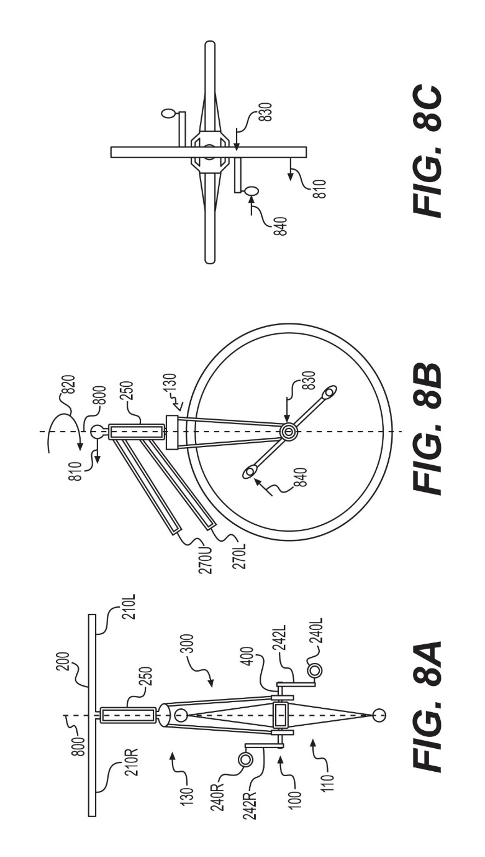
Supplemental Work Input
The G4 Bike structure is configured to apply rider hand force and displacement of the handgrips as supplemental propulsive power in the form of hand induced torque and hand induced work when;
- hand force induced movement of the right and left handgrips about the steering axis results in a lateral force and displacement at the crankshaft endpoints,
- the crankshaft lateral force and displacement is applied to the crankarm at the crankshaft-to-crankarm connection point,
- rider foot force is applied to the pedal connected at the opposite end of the crankarm causing rotation of the crankshaft,
- the hand induced crankshaft displacement and the foot force input is applied in coordinated opposition, typically such that the rider simultaneously pulls the handgrip while pushing the foot pedal located on the same side of the bicycle,
- the lateral motion of the crankshaft endpoint moves the axis about which the crankarm rotates during rotation of the foot pedal,
- when the axis of rotation is shifted in a coordinated way by rider handgrip inputs during foot pedal rotation, the perimeter distance traveled by the rider’s foot during rotation of the pedal is reduced because of the hand work input,
- supplemental hand power is thereby input both as hand force induced increased torque and as hand work; hand work input is proportional to the reduction in perimeter distance traveled by the riders foot during rotation of the pedal about the crankshaft as compared to the perimeter distance that would have been traveled if the crankshaft endpoint and pedal center of rotation had not been displaced by hand work,

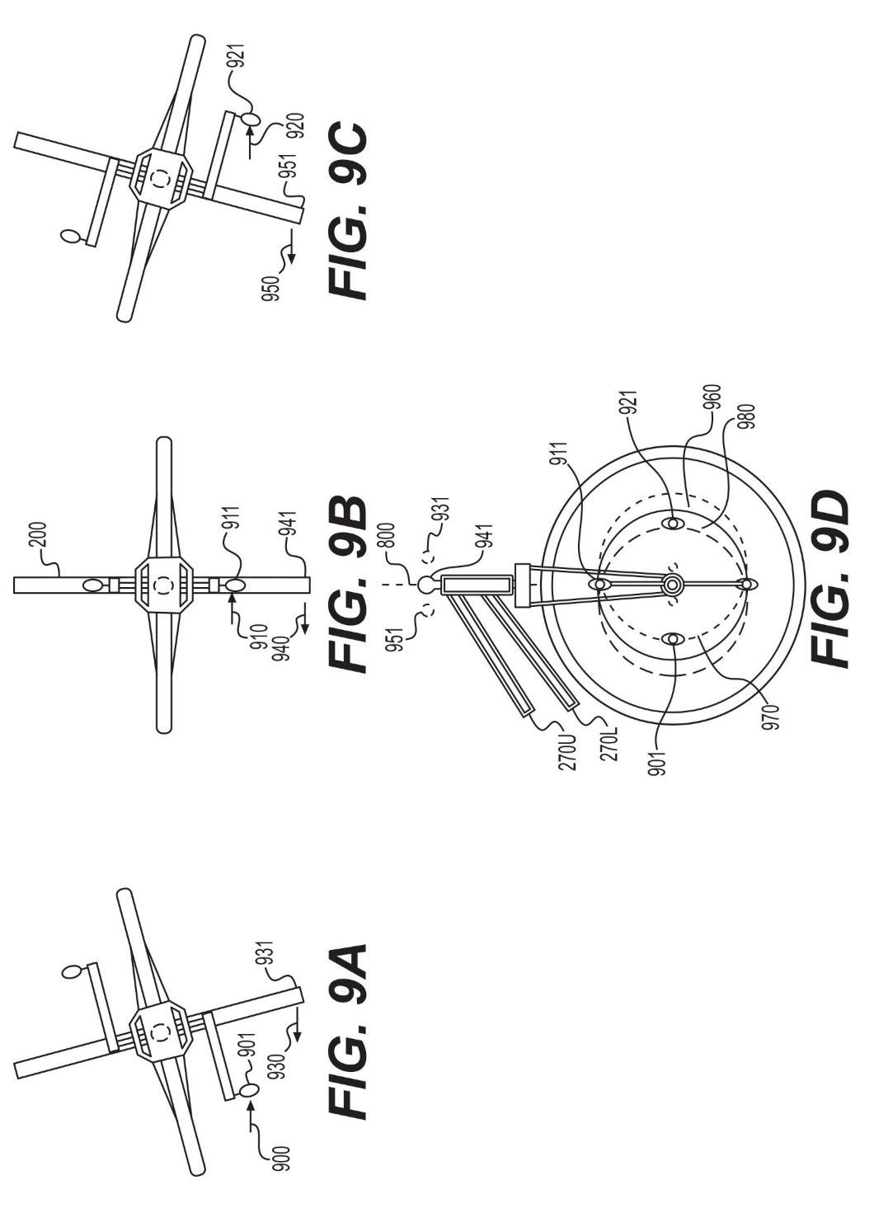

Empirically, hand induced pivot of the front fork assembly about the steering axis of plus and minus about 15 degrees is practical, the effective range of angular displacement decreases with increasing ground speed, total torque and work based hand power input may approach 50 percent of foot power input, hand power input can routinely be applied over many successive right and left foot pedal strokes, the number of which is often limited by rider’s cardiovascular capacity.

