**EWCA Minutes for 15 January 2024 Meeting**

Members in attendance: Frank Sheridan, Claudia DeCicco, Tom Kennedy.

The meeting began at 9:10 pm via Facetime

**Annual Meeting Preparation**

**The Board scheduled the annual HOA meeting for February 5, 2025, at 7:30 pm in the Oakton High School Library, though the school sometimes shifts us to a different room. We will relay any change of room, but the date and time are set.**

The 3 officers agreed to serve another term. The position of Secretary remains unfilled and must be filled at the annual meeting if no one else steps up before then. If you cannot attend, please submit this proxy:

Edgelea Woods Community Association

2025 Annual Meeting

Wednesday, February 5, 7:30 pm

Oakton High School

2025 Annual Meeting Proxy Statement

If you cannot attend the meeting, please use the form below to give your proxy to another member of the community to vote on your behalf. Proxy forms should be returned to EWCA President Frank Sheridan at 9916 Oleander Avenue, Vienna VA 22181 or mailed to: EWCA

PO Box 652

Oakton VA 22124

Date:\_\_\_\_\_\_\_\_\_\_\_\_\_\_\_\_\_\_\_\_\_\_\_\_\_\_

I,\_\_\_\_\_\_\_\_\_\_\_\_\_\_\_\_\_\_\_\_\_\_\_\_\_\_\_\_\_\_\_\_\_\_\_\_\_\_\_\_\_\_\_\_\_\_\_\_\_\_

(PRINT name and address above)

(SIGN name above)

hereby authorize:

\_\_\_\_\_\_\_\_\_\_\_\_\_\_\_\_\_\_\_\_\_\_\_\_\_\_\_\_\_\_\_\_\_\_\_\_\_\_\_\_\_\_\_\_\_\_\_\_\_\_\_\_\_\_(PRINT name of your proxy above) \_\_\_

to vote on my behalf during the Edgelea Woods Community Association 2025 annual meeting.

**Treasurer’s Report**

Claudia prepared a draft 2025 budget (included below) for discussion at the December Board meeting. The Board discussed the budget.

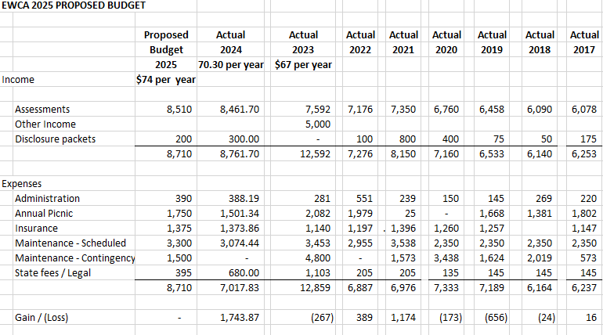

**Motion:** Claudia DiCicco motioned to adopt the proposed budget for 2025. Tom Kennedy seconded, and the motion was passed unanimously.

**Meeting Dates for 2025:**

All meetings are open to the EWCA membership. They will be held at 9916 Oleander Ave at about 9:10 pm unless otherwise noted.

2/5 at the OHS Library

3/19

4/16

5/14

6/18

7/16

8/20

9/17

10/15

11/19

12/17

**Plowing**

The Board discussed the ramshackle job that was done plowing the neighborhood roads. Perhaps the VDOT contractors are out of practice because we’ve had so little snow over the past few years? Please shovel your sidewalk asap after the snow falls: it is a safety issue particularly for the kids who walk to school or the bus stop. If you cannot shovel your property, please contact the BoD and we’ll help.

**Casino Proposed for Tyson’s Corner**

A casino proposal is in the works for Tyson’s Corner. The Board suspects that the effect of a casino in the already dense area will be to add yet more congestion and unwanted traffic through Vienna. If you’d like to advocate against the casino, please contact the following:

**State Senator Saddam Salim:**

Office phone: [(804) 698-7537](tel:+18046987537)  
Office email: [senatorsalim@senate.virginia.gov](mailto:senatorsalim@senate.virginia.gov)

State Rep Holly Siebold:

Office phone: [(804) 698-1012](tel:+18046981012)  
Office email: [DelHSeibold@house.virginia.gov](mailto:DelHSeibold@house.virginia.gov)

The meeting adjourned at 9:25

**General Reminders**

* Please keep in mind that EWCA rules prohibit long-term parking of commercial vehicles in the neighborhood.

**CareRing Program**

"We all need someone to whom to talk. If you live alone and would like to start your day talking to a friendly voice, then please consider connecting with the Fairfax County program called CareRing. CareRing is a daily outbound calling telephone program designed to help individuals who are living alone, aged, disabled, or chronically ill. Clients in this program are provided the additional support and community connection to help them remain independent and living a connected and safe life. If you, or a loved one you know, are interested, then please call Allegra Joffe at 703-400-9523 or email [ajoffe@prsinc.org](mailto:ajoffe@prsinc.org)."

**Street Lights**

To report an outdoor lighting concern, submit a concern to Dominion Energy at: <https://www.dominionenergy.com/virginia/report-outage-or-emergency/streetlight-outages>

**Street Sign Issues**

To report any issues with street signs, contact Fairfax County Department of Public Works and Environment Services. Call M-F 8-4:30 at 703-877-2800 or submit a maintenance form at: <https://www.fairfaxcounty.gov/public> works/street-name-sign-maintenance-form

**Stop Sign Visibility Issues**

To report a problematic visual obstruction of a stop sign, call V-DOT at 703-259-0243 or go to  [https://virginiadot.org](https://virginiadot.org/) You can place a maintenance request online. Click the associated tab at the top of the main page labeled, “to report a road problem.”

**Oakton High School Facility Issues**

To report any facility concerns regarding Oakton High School, such as dangerous trees or vine growth, contact the FCPS Facilities Leadership team at:<https://www.fcps.edu/contact-us>

**Feeding Wildlife in Our Community**- Please do not feed the foxes.  They are a vector for rabies.  Fairfax County Animal Control has said that they will not trap or remove them as they are a natural occurring species.  If you see an aggressive fox, it could be a sign of illness.  You can call (703) 691-2131 to report aggressive behavior.

**Potholes**

To report potholes in roads or any other issues related to roads contact the Virginia Department of Transportation (VDOT) here: [https://my.vdot.virginia.govor](https://my.vdot.virginia.govor/) call 1-800-FOR-ROAD.  Once reported, VDOT typically repairs the pothole within 72 hours.

**Seller’s Packets**

Recently, several homeowners selling their properties have contacted the EWCA at the last minute asking for seller’s packets.   The seller’s packet is homeowner’s association documentation provided to the buyer by the seller. It includes information such as proof of HOA insurance, annual dues, ARC compliance, confirmation that the HOA does not have a lien on the property, etc. The Virginia Code requires that a property seller supply this information to the buyer through the HOA.

The packet requires some work on the part of the Board and is impossible to deliver overnight.   If you are thinking about putting your house on the market, please reach out to the Board Immediately. You'll drop off a check for $100 which will start the process.  If you would like the seller’s packet expedited, there is an additional $70 fee associated with a rush job. The EWCA VP will gather the documents, the ARC will do a walk past the exterior of the house to affirm compliance with ARC guidelines, and then the packet will be assembled and sent out.

Starting early allows you and the ARC Board to resolve any issues that might remain unsettled before the crush of a closing date makes everything hectic. Doing so also allows the volunteers who do the work time to do it well.

**Contact info for the BoD:**

Frank Sheridan President: [fsheridan@verizon.net](mailto:fsheridan@verizon.net)

Tom Kennedy, Vice President: [tkennedy26@cox.net](mailto:tkennedy26@cox.net)

Claudia DeCicco, Treasurer [wadecicco@gmail.](mailto:wadecicco@gmail.com" \t "_blank)

Chris Lee ARC Chair [edgeleawoodsarc@gmail.com](mailto:edgeleawoodsarc@gmail.com)

Be sure to check our website for docs, old minutes, info on getting ARC approval for your home projects, etc:<http://edgeleawoods.com/>

**HOME SALE & HOME OWNER ASSOCIATION DOCUMENT ACQUISITION**

Here the steps involving the acquisition of ARC documents,

1) Pay a $100 fee c/o EWCA to acquire an EWCA Seller Packet.

            -Checks with a written request to receive an EWCA seller packet can be mailed or hand delivered to:

9916 Oleander Avenue

c/o Frank Sheridan

Vienna, VA  22181

2) The Board needs three weeks for the completion of HOA documents in order to,

            -Complete an ARC walk-through of the outside of the home.

            -Gather homeowner policy insurance information, EWCA budget information, lien info, and fill out the State of Virginia HOA Disclosure Packet.

**ARCHITECTURAL REVIEW BY-LAWS REGARDING EXTERIOR CHANGES TO YOUR HOME**

Please be aware that before you do any kind of work or improvement to the outside your house it needs to be reviewed first by our Architectural Review Committee (ARC).  These are by-laws as they pertain to advance approval for changes to the exterior of the home.  If you have any questions, you can drop an e-mail to our ARC Chair.

            "No building, fence, wall or other structure shall be commenced, erected, or maintained upon the properties, nor shall any exterior addition to or change or alteration therein be made until the plans and specifications showing the nature, kind, shape, height, materials, and location of the same shall have been submitted to and approved in writing as to harmony of external design and location in relation to surrounding structures and topography by the Board of Directors of the Association, or by an Architectural Committee composed of three (3) or more representatives appointed by the Board."

ANY CHANGE to the exterior appearance of a property lot within the Edgelea Woods neighborhood requires the approval of the Association’s Architectural Review committee (ARC). Requests for changes/modifications to lots within the community must be presented to the ARC in writing using the prescribed form from the homeowner's manual. The ARC will review requests within 30 days of the receipt of the request.  Reply to the applicant will be in writing.  Whenever possible, the ARC will try   to provide initial notification by telephone/in person prior to the delivery of written reply to allow for the expeditious scheduling of work.