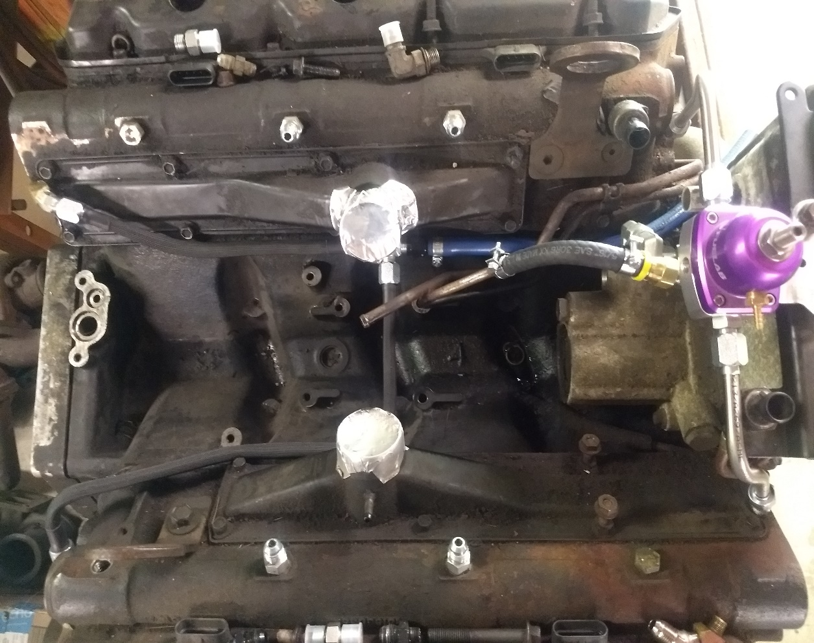444fab Obs Installed Pictures

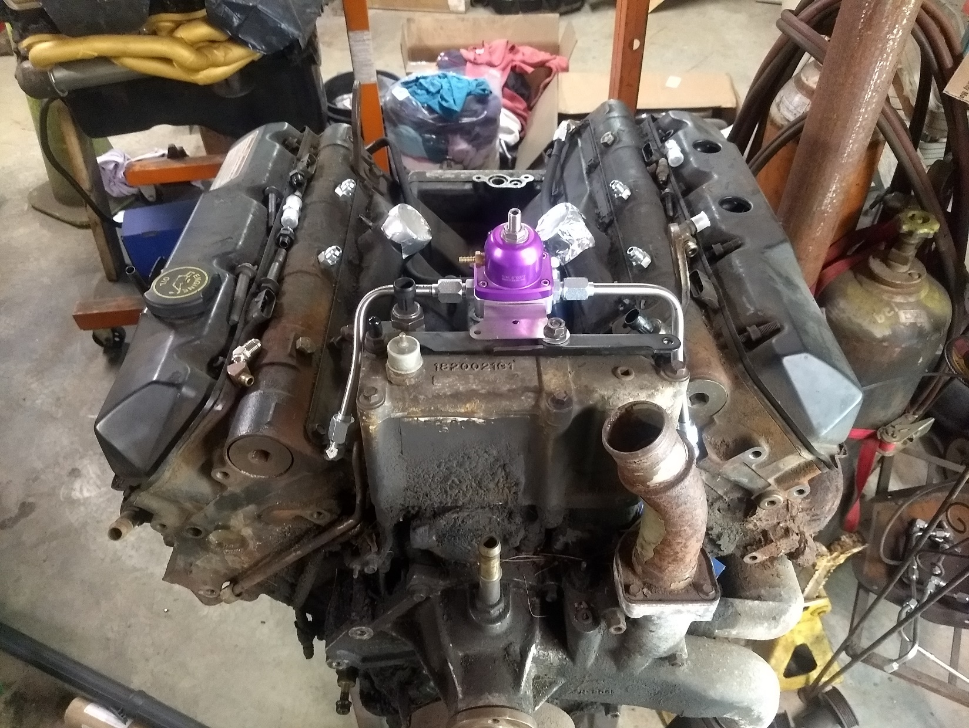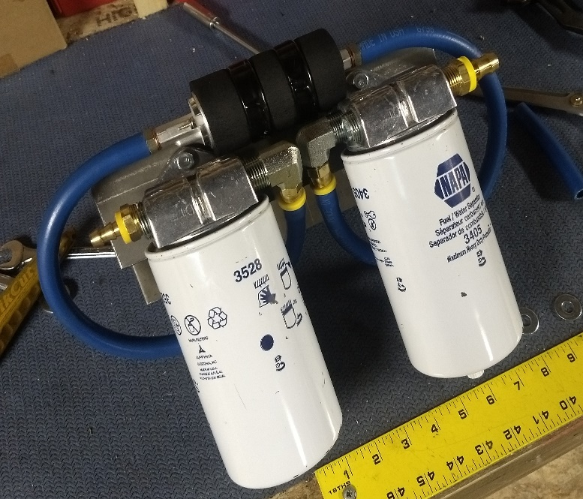

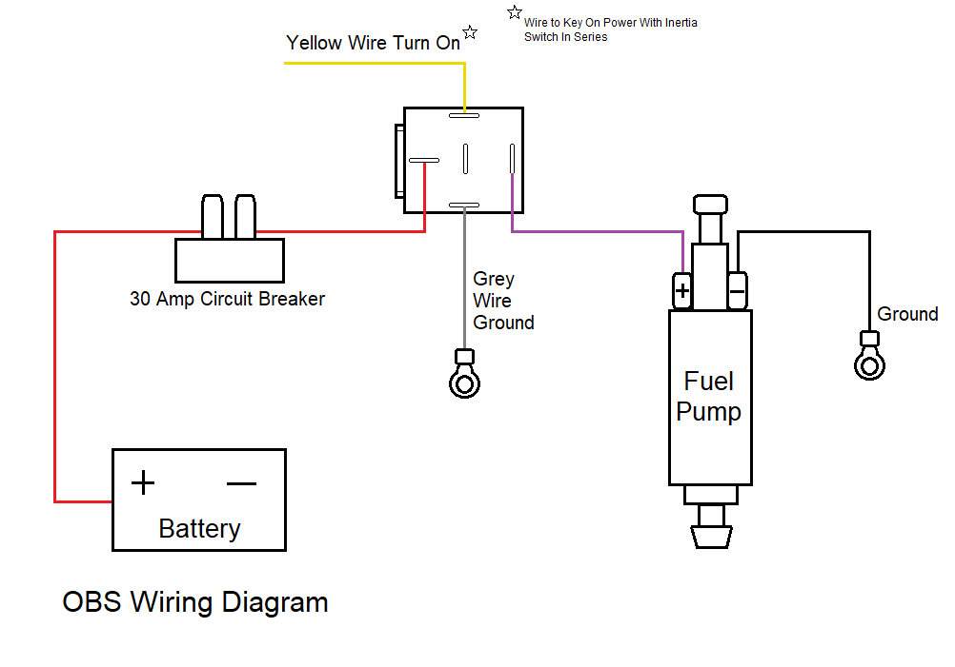

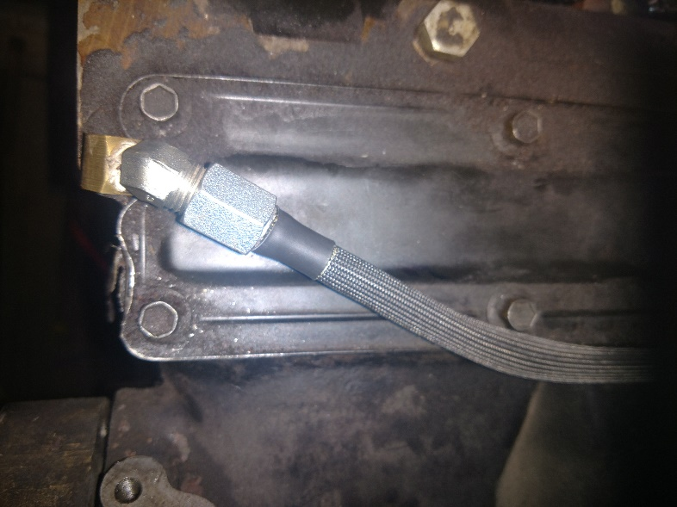

NOTE THE CRITICAL ANGLE OF THESE FITTINGS AT DRIVERS REAR

