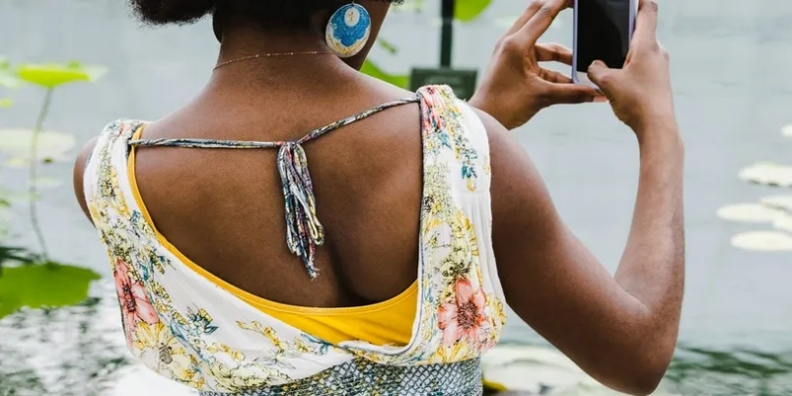

**Exhilarating Inc. Presents – A photography/ creative writing program.**

We are partnering with 100cameras to implement a photography program. This program is for females who have had challenging experiences. We will teach the girls how to process and tell their stories through photography in a way that impacts how they view themselves and their role in the community. Through their perspectives and community contributions being uplifted onto a global platform, teens are showing themselves that today and always, they are the bigger picture. We will be hosting an 8-week program for females ages 13 – 17, who would like to learn to use a camera tell their story through art. Upon completion of the program all participants will be awarded a camera. This program is free, but space is limited.

**Date: Fridays (only) March 18, 2022 – April 29, 2022**

**Time: 5:30 – 7:30 Location: TBA**

Name: ________________________ D.O. B: ___________ Age: _______

Race: __________ Gender: ____ Language: ______________________

Address: _______________________________________________________________

Phone: ____________________ Cell: ____________________

Email: _________________________________________________________________

**PARTICIPANT WAIVER**

As the above-named participant, I hereby give my approval for my participation in the photography program. I hereby release, absolve, indemnify, and hold harmless Exhilarating Inc., in the event of injury to myself, and waive all claims against them. As the above-named participant, I affirm that I’m in the proper physical condition to participate in the program listed below and that I have no disease, medical condition or injury that would prevent me from participation in the Program. I further understand that Exhilarating Inc. will **not** provide any form of medical insurance coverage and Exhilarating Inc. will not be responsible for any expenses incurred due to any injury to me during participation in the Program. The undersigned further grants permission to allow my picture or likeness to appear in any photograph, advertisement, or television coverage without compensation to them.

IN WITNESS WHEREOF, the undersigned has hereunto placed his/her hand this day of , 2022

Signature: _______________________________________ Date: ______________

Parent / Legal guardian_____________________________ Date: ______________