# Stonehenge

Stonehenge is a 5000-year-old much visited world heritage site full of mystery. Although much has been discovered about the site, there are still many unanswered questions.

## Your visit to Stonehenge

We will arrive at the Visitor Centre where we will check into the site. You can now browse the visitor centre and its facilities and then catch a minibus to the stones where you can wander at your leisure (you are not able to enter the stone rings) or you can use the services of your guide to take you round the main features of the visitor centre before accompanying the guide to the stones.

## Where is Stonehenge?

Stonehenge is located on Salisbury Plain in Wiltshire approximately eight miles north of Salisbury and two miles west of Amesbury.



## A brief history of Stonehenge

It appears the monument was constructed in three main phases. The first stage to be built was around 3000 BC with the construction of a ditch and bank with a ring of 56 Aubrey holes inside it and with two round barrows on opposite sides of the circle. The Aubrey holes are named after a 17th century academic John Aubrey, who discovered them. Their purpose is not clear, but it has been suggested that originally, they held stones or wooden posts, but were later used for burials for some of the 200 burials found at the site. To date, just over half the Aubrey holes have not been excavated.

Just outside the circular ditch and bank to the northeast is the heel stone.

The second phase of construction was around 2500 BC when a ring of 30 stones called Sarsens weighing 22 metric tonnes was added which were quarried just north of Marlborough, 15 miles (24km) away.

Later during this phase five stone arches were added inside the circle. The arches are made from bluestone which was quarried in Pembrokeshire in Wales some 140 miles (225 km) away. It is difficult to understand how these stones weighing around 3.6 metric tonnes could be moved this far. The favourite theory is they were mounted on sledges and moved using tree logs as rollers. Rafts floating on waterways could also have been used.

The final phase of construction happened around 2200 BC when the stones were rearranged and some ditching out to the heel stone was added forming the Avenue.

There must have been work done at other times, but the three phases illustrated above are the most significant.

A better impression of Stonehenge is given in the following illustration created by Adamson in 2012.



The numbers on the illustration refer to the following.

1 is the Altar stone made of green sandstone from Wales.

2 is a round barrow but does not have a burial.

3 is a round barrow with burial.

4 is the Slaughter Stone.

5 is the Heel Stone.

6 these are the remaining two station stones of the original four.

7 is the ditch.

8 is the inner bank.

9 is the outer bank.

10 is the Avenue made with a pair of ditches leading to the River Avon approximately 2 miles away.

11 is a ring of 30 pits known as the Y Holes.

12 is a ring of 29 pits known as the Z Holes.

13 is a ring of 56 pits known as the Aubrey Holes.

14 is the southern entrance.

In modern times, the monument fell into a ruin as shown by the following photograph taken towards the end of the 19th century.

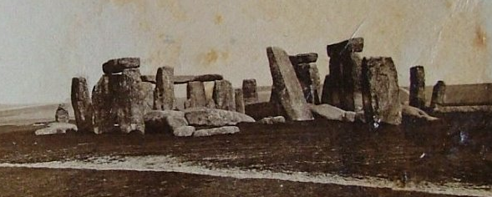

Renovation was carried out in 1909 and then again in 1919. In 1958, the monument was dismantled and rebuilt in the form seen today which is an approximation of what the original monument looked like.

You must marvel at the skill and dedication of the monument’s creators. To be able to quarry and move stones weighing 3.6 metric tonnes for the bluestones and 22 metric tonnes for the sarsens using primitive hand tools is amazing. The uprights and cross pieces of the trilithons have mortise and tenon joints holding them together so there was a good knowledge of stonemasonry. Raising the stones to the vertical must have been a huge challenge. Historians and researchers have posed many theories of how it could have been done. It is all part of the magical mystery of Stonehenge. The precision of the construction suggests a good understanding of some key mathematical principles.

What was the purpose of Stonehenge and why would so much energy have been expended to create the monument? Was it a religious temple perhaps to the gods of the sun and moon? The sun rises directly over the Heel Stone on 21st June each year and on the shortest day of the year suggesting it might be some sort of calendar. Today, around 20,000 people gather to watch the sunrise on the solstice and the Druids hold religious ceremonies. It is certainly a burial site with burials in the immediate vicinity of the monument and more in the surrounding area, which is dotted with burial mounds, mainly round barrows. Who was buried here and why? What special status did they have?

A good book to read. “Stonehenge” by Bernard Cornwell. A fictional book that explores many of the issues the builders of Stonehenge faced.

|  |
| --- |
|  |
| [shirste.documetation@gmx.co.uk](mailto:shirste.documetation@gmx.co.uk)  +447969469543 |