

Town of South Kingstown, Rhode Island

Town Manager’s proposed

Funding Utilization of Federal Assistance under

The American Rescue Plan Act of 2021

June 1, 2021

The following funding utilization plan presents the staff-level recommendations for spending the estimated nine million dollars ($9M) the Town of South Kingstown expects to receive under the American Rescue Plan Act of 2021. The projects proposed herein are those that the Town’s administrative leadership team believes align with the guidelines that have be promulgated at the federal level and would best advance the objectives of the Act – to respond to the economic consequences of the COVID-19 pandemic. These recommendations reflect the administration’s belief revitalization of South Kingstown’s local and tourism dependent industries is particularly important to helping local businesses and residents return to pre-pandemic levels of income and economic activity. The Interim Final Rule that outlines how the federal grants funds can be spent provides that municipalities can undertake programs and activities that:

1. Response to the public health emergency or its negative economic impacts including assistance to:
   1. Households,
   2. Small businesses,
   3. Non-profits, or
   4. Impacted industries such as tourism, travel, and hospitality.
2. Response to workers performing essential work during the COVID-19 public health emergency by providing premium pay to eligible workers.
3. Provider of government services to the extent of the reduction in revenue due to the COVID-19.
4. Make necessary investments in water, sewer, or broadband infrastructure.

Based on our understanding of the Interim Final Rule, the administrative leadership team proposes the following uses of Rescue Plan funding over the next three years.

**Supporting Recovery of the Travel, Tourism and Hospitality Sector**

South Kingstown is a vibrant community and tourist destination on Atlantic coast of the State of Rhode Island. The town hosts a major state beach, a municipal beach and numerous shore-front restaurants, marinas, parks, fishing venues and businesses. The Town also hosts the largest number of freshwater ponds in the state and offers a large number of fishing, kayaking and camping opportunities. Prior to the pandemic a large number of businesses that catered to tourists had been well-established or recently emerged, including art galleries, theaters and music venues. During the COVID-19 pandemic, tourism in South Kingstown declined significantly. Despite the efforts of local businesses, the Chamber of Commerce and the Town, hotel and campground occupancies were reduced to near zero during the early months of the pandemic and tourist-serving businesses suffered near catastrophic losses.

In order to facilitate the rapid revitalization of the venues and neighborhoods that have historically attracted tourists, Rescue Plan funds are proposed to be used to make strategic community (village) investments to the extent permitted by Treasury Department guidance, as well as enter into public private partnerships (matching grant program), designed to restore economic activity and promote economic growth throughout the Town. Programs would be centered around tourism, hospitality, household services, and small business support/activation, which shall include, but not be limited to, funding for efforts and initiatives to improve the business climate on key commercial corridors within South Kingstown’s Villages, with a focus on Wakefield, Peace Dale, West Kingston, Matunuck Beach and Lower Tower Hill. Funding is proposed to pprovide direct support for small businesses through loans and grants, and marketing and promotion of the Town to assist with the economic recovery. Efforts include, but are not limited to:

* Façade improvements:
  + Matching Grants – (develop standards and matching percentage).
  + Signage – (Develop standards and matching percentage).
* Fencing
* Lighting
* Architectural Services (consultations)
* Streetscape improvements (general place making):
  + Wayfinding/signage (contact sensitive design for village scale)
  + Business signage
  + Lighting (with banner/flower baskets ability)
  + Landscaping (Street Tree replacement and expansion, flower baskets/boxes)
  + Hard goods (benches, trash/recycling receptacles)
  + Sidewalk/Crosswalks improvements and expansion
  + Fencing
  + Historic Plaques
  + Multi-purpose Trail markers and feature structures at major cross roads (i.e., introduction of mile makers on the Trails)
  + Traffic calming
* Park/recreational improvements
* Creation of pocket park(s), green space opportunities
* Village place making:
  + Distinct and themed signage identifying limits of area (welcome to the Village of Peacedale etc.) in an effort to build brand identity associated with South Kingstown. South Kingstown is a resilient Town supported by its villages.
  + Traffic calming/complete streets
* Technology IT/Broadband Improvements
  + Wifi in downtown areas.
* Enhancement of youth services and mental health programing
* Enhancement of para/medical service

**Helping the Most Vulnerable Get Back on Their Feet**

Housing

The COVID-19 pandemic hit low-income families hard and contributed significantly to housing insecurity in South Kingstown because housing prices are well above the state and national averages. To address the harm caused to low- and moderate-income households in South Kingstown, a portion of Rescue Plan funding should be dedicated to a program focused on housing affordability, which shall include, but not be limited to, funding for non-profit entities working to create affordable housing opportunities and expand the quality housing opportunities in South Kingstown’s villages with a particular focus on promoting homeownership.

* Matching grants for creation of new affordable units meeting the RI State guidelines for affordability (Goal to create 20 new/rehabbed units in a walkable setting – Matching grants up to $20,000 per unit
  + Rehab
  + New construction

Social Service Programs and Services.

The biggest challenges facing low- and moderate income families as they prepare to return to post-pandemic work involve addressing the day-to-day challenges of childcare, transportation and managing household finances. The Town’s administrative leadership team believes it will be necessary to support local nonprofit organizations with established childcare and domestic-assistance programs (such as utility and rental assistance programs).

* Non-Profit Child care (low/moderate households)
* Non-Profit Grants Social Service (competitive) serving low and moderate household

Community Para-medicine and Mental Health Program

COVID-19 aaffected the mental health of our community members in multiple ways. As an example, the persistently mentally ill were unable to receive the ongoing outpatient and/or community care that provides stability to remain within the community due to so many providers and various agencies going to telehealth only. In addition, the significant isolation made the generally stable and more of the “worried well” type individuals who may have required meds or only on an as-needed isbasis, increasingly symptomatic to the point where they require consistent treatment, certification or hospitalization when they have either no history of mental health or very little.

The South Kingstown Community Paramedic Program would work to implement integrated behavioral health care to the citizens of South Kingstown with the following goals:

* Bridge the divide between the mental health needs of the community and appropriate care
* Implement change in patient outcomes and reduce health care costs
* Chronic disease management which can coincide with mental health
* Reducing non-emergent 911 calls
* Reducing non-emergent emergency room visits

South Kingstown Emergency Management Agency (EMA) was also charged with the implementation and operation of COVID-19 vaccine clinics for South Kingstown and with other regional partners in South County. Duties included establishing and managing MEDPOD’s since December of 2020 through today and into the future. In addition to managing MEDPOD operations, significant administrative work has been required to facilitate reimbursement from state and federal agencies such Rhode Island Emergency Management Agency (RIEMA), Rhode Island Department of Health (RIDOH) and Federal Emergency Management Agency (FEMA). The aforementioned duties are currently carried out by the Chief of EMS and an administrative Captain with South Kingstown Police Department (SKPD). Workload was increased from regular duties of the two positions. During events such as a public health emergency (COVID-19), natural disasters or man-made disasters, significant administrative work is required prior and post event. Having administrative staff allows the department to dedicate a staff member to handle the appropriate documentation required for planning events, continued review of response plans, coordination of Community Emergency Response Team (CERT) volunteers, maintenance of records/inventory of equipment dedicated for disaster response and required documentation for reimbursement.

Mental Health in Policing

Because of COVID many citizens suffered from mental health related problems. Many who had pre-existing mental health issues saw their symptoms become exacerbated during the pandemic and others that had no previous mental health problems found themselves experiencing symptoms. Clearly, mental health issues in our community have grown due to the pandemic and as a result, our police department has seen an increase in mental health related calls for service. The South Kingstown Police Department recognizes this problem and is committed to being guardians of the community. These specified police roles will be non-enforcement positions that focus on the overall social service needs of the community and also focus on community engagement which will ultimately bring our police department closer to the citizens we serve.

Mental Health Supports for Young People

Because of Covid-19 it is anticipated that there will be a higher level of need related to mental health and behavioral challenges as a result of prolonged isolation and reduced social interaction among children.

$40,000 is proposed to fund a part time, temporary, mental health/behavioral health specialist for staffing the Recreation Department youth Day Camp program and "School's Out" Vacation camps to address needs of all campers especially those with behavioral challenges.

**Responded to COVID by Building Pandemic-Resilient Government Services**

Location Resilience

During the pandemic, staff was forced to work remotely and the need to share files increased. The Town would have greatly benefitted from having Office 365 (O365) in order to collaboratively work on projects, documents and files. Also, O365 would include additional cloud storage and Teams, which could replace Zoom as a more secure meeting platform. The cost to implement is $50,000.

Digital Democracy Resilience

The Town’s ability to offer remote programs and meeting access have been severely limited due to strained resources surrounding the delivery of services to the community. Upgrading the town’s software and audio/visual capabilities will relieve pressure on the community as it relates to in person meetings.

During the pandemic, remote meetings via Zoom were the norm. These meetings included Town Council, various boards and committees, staff meetings and departmental meetings. As we return to in-person, we need to incorporate a “hybrid” meeting model with some in-person and some remote participation. This will require an upgrade to our audio visual equipment in the chambers as well as setting up several smaller conference rooms with audio equipment where currently there is none.

The estimated cost for upgraded equipment and new purchases is $200,000. We have been in contact with 2 vendors on the State of RI Master Purchasing Agreement to assess the current upgrade along with future needs to incorporate a hybrid meeting.

Potential conference room locations:

1. Guild conference room

2. Library conference room

3. Police conference room

4. Public Services conference room

5. Recreation Center conference room

6. Senior Center conference room

7. Town Hall conference room

Recreation Programs that Adjust to Pandemic Demands

Because of Covid-19, organized athletic activities and community programs that typically take place at Old Mountain Field were cancelled between March 2020 and October 2020. The cancellation of the Ocean State Waves baseball season directly impacted the Waves as a non-profit, community-based organization which attracts residents and visitors as an affordable entertainment option during the summer season. The shutdown of organized activity in the park also directly impacted the park concession operation and the local food vendor who is contracted through Waves. Additionally, the cancellation of the Town’s 4th of July Celebration, Fishing Derby, Easter egg hunts, and outside facility rentals negatively impacted a variety of vendors including entertainers, outside concessionaires, and production services, that are contracted for these types of events. The Old Mountain Field rehabilitation project, particularly the design and construction of a new concession/restroom building will contribute to reviving and increasing the economic activity within the park. Local sports leagues and community programs at Old Mountain have and will continue to attract visitors who contribute to economic activity in downtown Wakefield. $300,000 in ARPA funding is proposed to allocate towards the Old Mountain Field CIP project, specifically to contribute to an enhanced concession facility and restroom to support park activities and contracted vendors for the next twenty to thirty years.

As the Town’s oldest and one of its most active community parks, OMF sees diverse athletic and passive activities year-round. It features an exceptional skate park, four tennis courts, a basketball court, nature trails, a softball field, and the baseball field - home field of the SKHS 2020 state championship baseball team; and the NE Collegiate Baseball League’s, Ocean State Waves. It is located in a designated low/mod income area and within walking distance of the Main Street business district, the high school, and Broad Rock Middle School. The Town’s ability to increase funding for this capital project, would result in a significant and impactful improvement and increase the speed of implementation.

Library Services/Resources

The community’s library services have been limited in the past 18 months due to access to the town’s brick and mortar facilities. A mobile library would allow a portion of the community which was must affected by the pandemic to have access to services that are presently only served by the communities fixed assets. Having the ability to have mobile services allows the town to reach a population that was underserved during COVID-19 and could benefit from these expanded services.

Natural Resources Officer/Harbormaster

Because of the Covid-19 pandemic South Kingstown saw an increase in recreational activities that allowed people to socially distance themselves. The Town experienced a significant increase in boating activity in local waters – Potter Pond, Pt. Judith Pond and Narrow River. The harbormaster role in recent years, and especially last summer, has become more critical in ensuring public safety on town waters; and local boating activity is expected to only increase. Other recreational resources impacted and highlighted by the pandemic, with increase in activity where people could socially distance, were the town’s public access Rights of Way to the shore, nature trails, bike paths, the disc golf course, and park picnic areas. As these passive recreational resources have been (re)discovered by residents and visitors alike, they are equally as important as playgrounds, athletic fields, and active recreational venues. The combination of higher level harbormaster activity and the need for dedicated attention to the Town’s natural resources supports the idea of a full time Natural Resource Officer/Harbormaster position. $180,000 in ARPA funds is proposed to support this full time position for two years.

Grant Management

It is anticipated that a grant/contract manager will be necessary to manage programs affiliated with the COVID-19 utilization plan.

ATTACHMENT A:

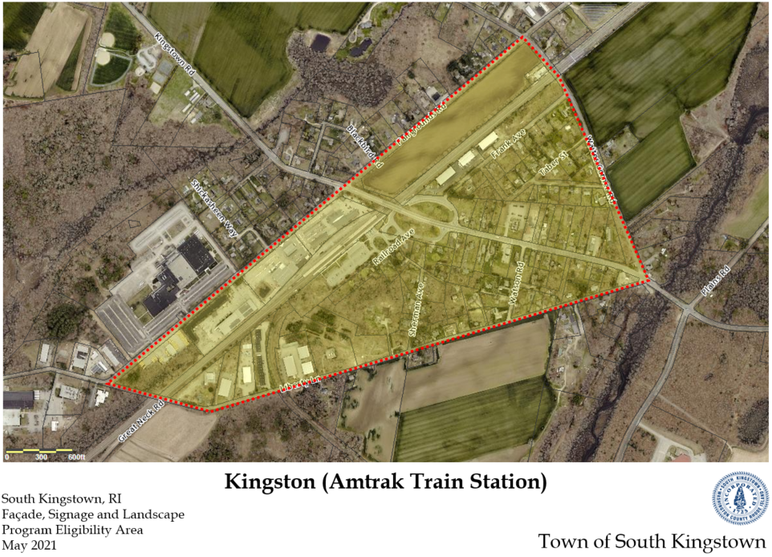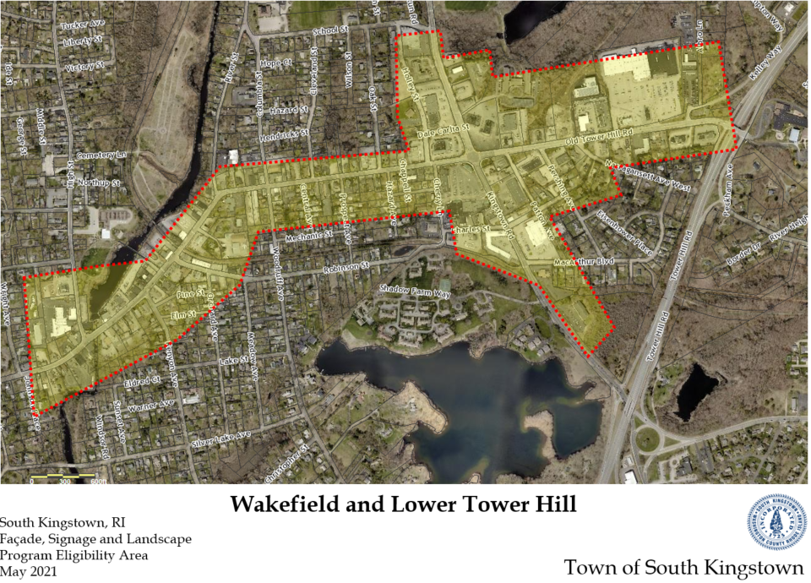**Draft** - Eligibility Areas (Also could include projects that are located with a ½ mile from areas shown if they meet given objectives)

