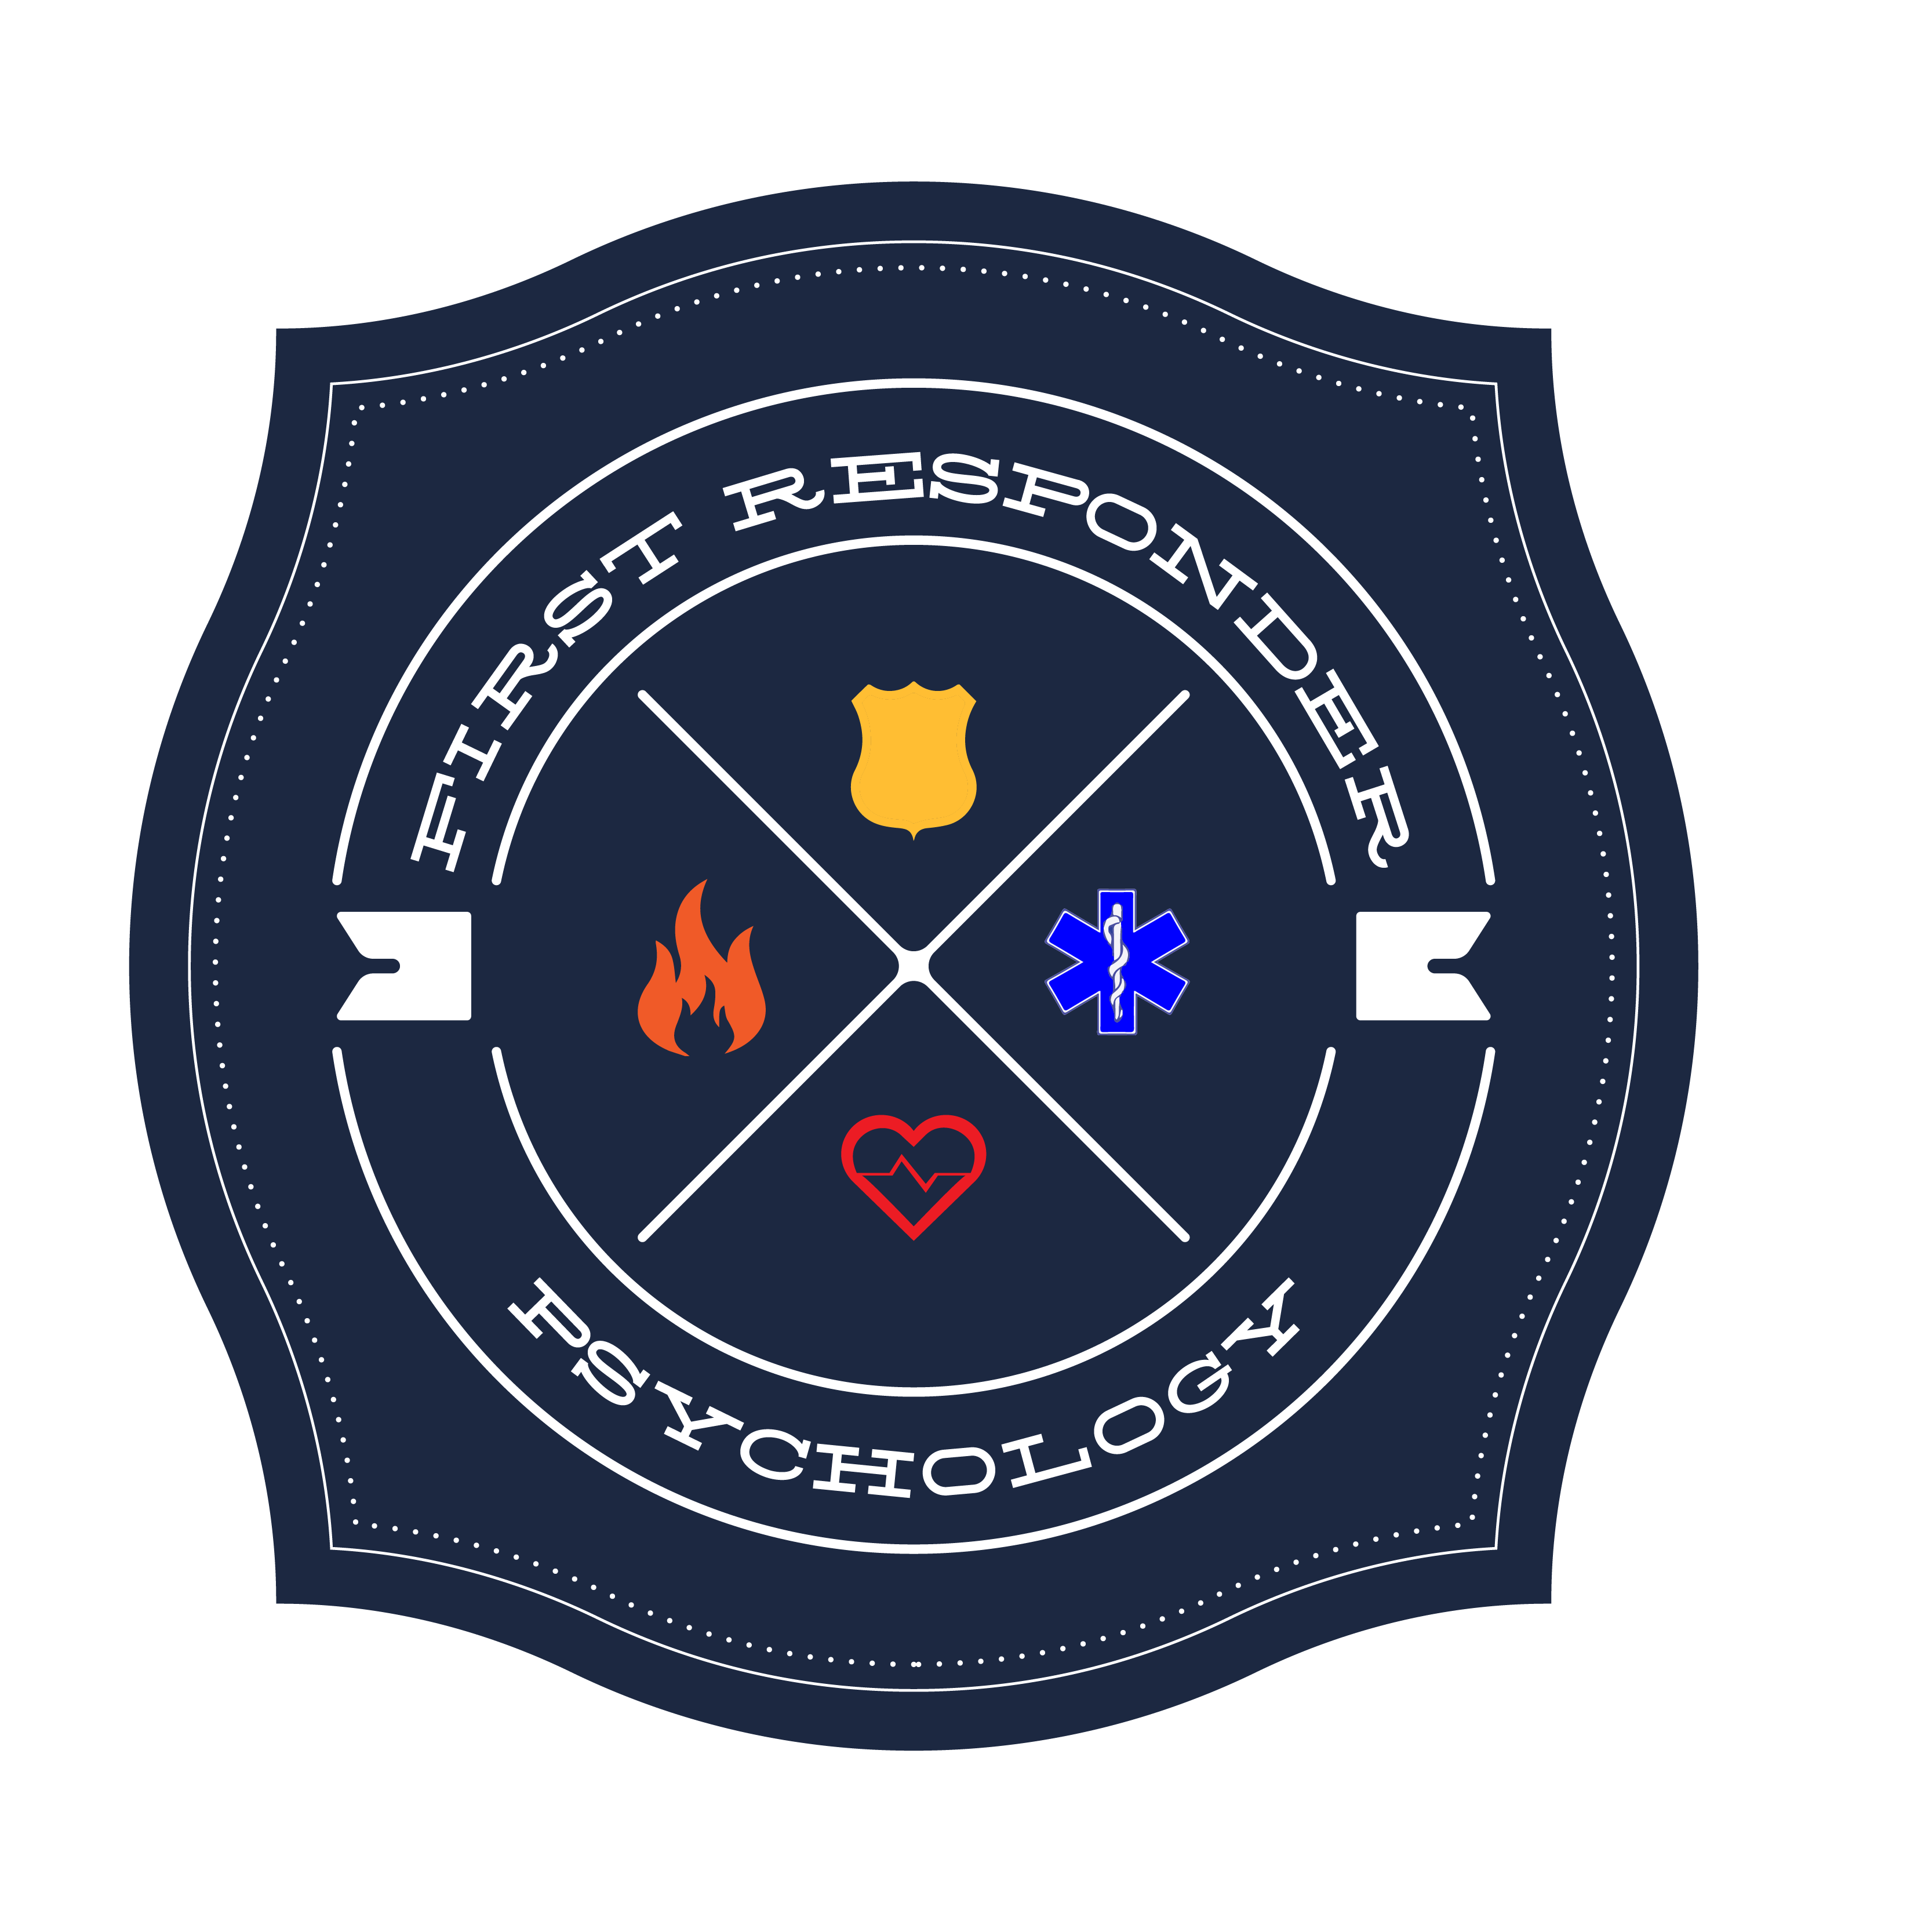
FIRST RESPONDER PSYCHOLOGY
Dr. Stephanie M. Conn, Licensed Psychologist 2825
CLIENT INTAKE FORM

Please provide the following information for our records. Leave blank any question you would rather not answer, or would prefer to discuss with your therapist. Information you provide here is held to the same standards of confidentiality as our therapy.

Date: ______________ Name: ___________________________________
Date of Birth: ___________________ Preferred Name: ____________________
Address: __________________________________________________________
Phone Number: __________________________________ home / cell/ other
Okay to leave a message? Yes / No Text? Yes / No
Email address: ___________________________________
Emergency Contact Name: ________________________________________
Emergency Contact Number: ______________________________________
Insurance Provider: __________________________________________________
Insurance ID: __________________________ Group # _____________________
How came to FRP: Internet Referral Training Other _____________
TREATMENT HISTORY

Are you currently receiving psychiatric services, professional counseling or psychotherapy elsewhere? ( ) yes ( ) no

Have you had previous psychotherapy?
( ) no
( ) yes, with (previous therapist’s name)____________________________________

Are you currently taking prescribed psychiatric medication (antidepressants or others)? ( ) yes ( ) no

If yes, please list: ______________________________________________________

Prescribed by: ________________________________________________________

This confidential information is provided to you in accord with State and Federal laws and regulations including but not limited to applicable Welfare and Institutions Code, Civil Code and HIPPA Privacy Standards. Duplication of this information for further disclosure is prohibited without prior written authorization of the client/ authorized representative to who it pertains unless other permitted by law.
For Office Use Only: Co-pay / Rate: __________________________
HEALTH AND SOCIAL INFORMATION

Do you currently have a primary physician? ( ) yes ( ) no

If yes, who is it? _______________________________________________________

Are you currently seeing more than one medical health specialist? ( ) yes ( ) no

If yes, please list: ______________________________________________________

When was your last physical? ____________________________________________

Please list any persistent physical symptoms or health concerns (e.g. chronic pain, headaches, hypertension, diabetes, etc.: _______________________________________

________________________________________________________________________

Are you currently on medication to manage a physical health concern? If yes, please list: _________________________________________________________________
____________________________________________________________________

Are you having any problems with your sleep habits? ( ) yes ( ) no

If yes, check where applicable:
( ) Sleeping too little ( ) Sleeping too much ( ) Poor quality sleep
( ) Disturbing dreams ( ) other _______________________________

How many times per week do you exercise? ______________

Approximately how long each time? _____________________

Are you having any difficulty with appetite or eating habits? ( ) no ( ) yes

If yes, check where applicable: ( ) Eating less ( ) Eating more ( ) Bingeing
( ) Restricting

Have you experienced significant weight change in the last 2 months? ( ) no ( ) yes

Do you regularly use alcohol? ( ) no ( ) yes

In a typical month, how often do you have 4 or more drinks in a 24 hour period?

____________________________________________________________________

This confidential information is provided to you in accord with State and Federal laws and regulations including but not limited to applicable Welfare and Institutions Code, Civil Code and HIPPA Privacy Standards. Duplication of this information for further disclosure is prohibited without prior written authorization of the client/ authorized representative to who it pertains unless other permitted by law.
How often do you engage recreational drug use? ( ) daily ( ) weekly ( ) monthly
( ) rarely ( ) never
Do you smoke cigarettes or use other tobacco products? ( ) yes ( ) no

Have you had suicidal thoughts recently?
( ) frequently ( ) sometimes ( ) rarely ( ) never

Have you had them in the past?
( ) frequently ( ) sometimes ( ) rarely ( ) never

Are you currently in a romantic relationship? ( ) no ( ) yes

If yes, how long have you been in this relationship? _______________________

On a scale of 1-10 (10 being the highest quality), how would you rate your current relationship? ________

In the last year, have you experienced any significant life changes or stressors? If yes, please explain: ________________________________________________________

____________________________________________________________________

Have you ever experienced any of the following?

Extreme depressed mood | Yes / No
Dramatic mood swings | Yes / No
Rapid speech | Yes / No
Extreme anxiety | Yes / No
Panic attacks | Yes / No
Phobias | Yes / No
Sleep disturbances | Yes / No
Hallucinations | Yes / No
Unexplained losses of time | Yes / No
Unexplained memory lapses | Yes / No
Alcohol/substance abuse | Yes / No
Frequent body complaints | Yes / No
Eating disorder | Yes / No
Body image problems | Yes / No
Repetitive thoughts (e.g. obsessions) | Yes / No
Repetitive behaviors (e.g. frequent checking, hand washing | Yes / No
Homicidal thoughts | Yes / No
Suicidal attempts | Yes / No If yes, when?

This confidential information is provided to you in accord with State and Federal laws and regulations including but not limited to applicable Welfare and Institutions Code, Civil Code and HIPPA Privacy Standards. Duplication of this information for further disclosure is prohibited without prior written authorization of the client/ authorized representative to who it pertains unless other permitted by law.
OCCUPATIONAL INFORMATION

Are you currently employed? ( ) no ( ) yes

If yes, who is your currently employer/position? ___________________________

If yes, are you happy with your current position? __________________________

Please list any work-related stressors, if any __________________________________

______________________________________________________________________

______________________________________________________________________

RELIGIOUS/SPIRITUAL INFORMATION

Do you consider yourself to be religious? ( ) no ( ) yes

If yes, what is your faith? ____________________________

If no, do you consider yourself to be spiritual? ( ) no ( ) yes

FAMILY MENTAL HEALTH HISTORY

Has anyone in your family (either immediate family members or relatives) experienced difficulties with the following? (circle any that apply and list family member, e.g. sibling parent, uncle, etc.)

Difficulty | Yes / No | Family member
Depression | Yes / No
Bipolar disorder | Yes / No
Anxiety disorder | Yes / No
Panic attacks | Yes / No
Schizophrenia | Yes / No
Alcohol/substance abuse | Yes / No
Eating disorders | Yes / No
Learning disabilities | Yes / No
Trauma history | Yes / No
Suicide attempts | Yes / No
Chronic illness | Yes / No

This confidential information is provided to you in accord with State and Federal laws and regulations including but not limited to applicable Welfare and Institutions Code, Civil Code and HIPPA Privacy Standards. Duplication of this information for further disclosure is prohibited without prior written authorization of the client/ authorized representative to who it pertains unless other permitted by law.

OTHER INFORMATION

What do you consider to be your strengths? ___________________________________

_______________________________________________________________________
_______________________________________________________________________

What do you like most about yourself? _______________________________________
_______________________________________________________________________

What are effective coping strategies that you have learned? _______________________

_______________________________________________________________________

_______________________________________________________________________

What are your goals for therapy?

________________________________________________________________________

________________________________________________________________________

________________________________________________________________________

________________________________________________________________________

This confidential information is provided to you in accord with State and Federal laws and regulations including but not limited to applicable Welfare and Institutions Code, Civil Code and HIPPA Privacy Standards. Duplication of this information for further disclosure is prohibited without prior written authorization of the client/ authorized representative to who it pertains unless other permitted by law.

