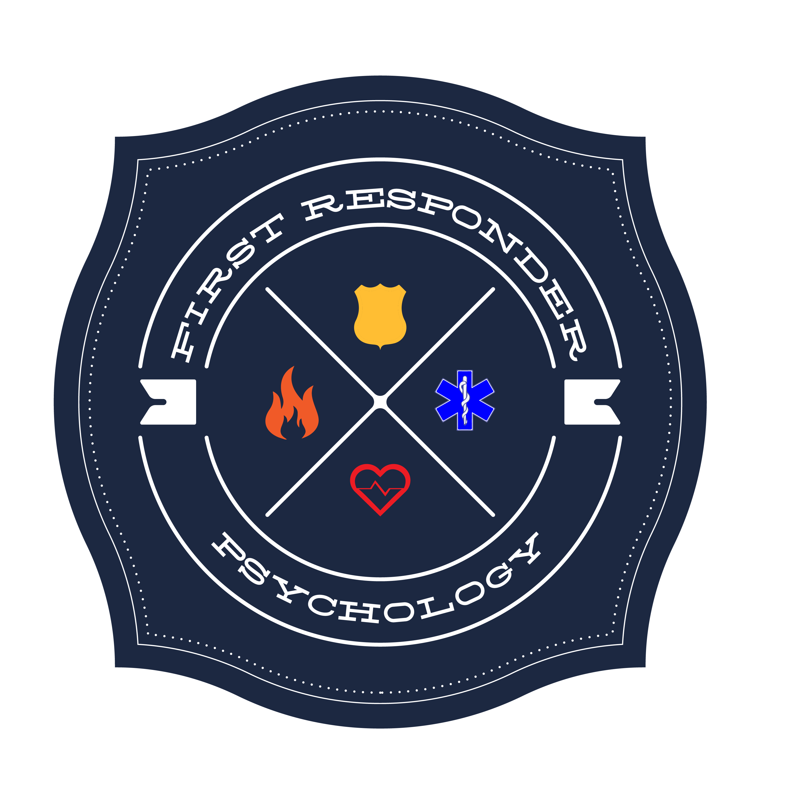
FIRST RESPONDER PSYCHOLOGY
Becky Edmonds, LMFT #T2051
CLIENT INTAKE FORM

Please provide the following information for our records. Leave blank any question you would rather not answer, or would prefer to discuss with your therapist. Information you provide here is held to the same standards of confidentiality as our therapy.

Partner 1:
Date: ______________
Name: ___________________________________ Date of Birth: ____________
Address: __________________________________________________________
Phone Number: __________________________________ home / cell/ other
Okay to leave a message? Yes / No
Email address: ___________________________________
Emergency Contact Name: ________________________________________
Emergency Contact Number: ______________________________________
How came to CCC: Internet Referral Training Other ________________

Partner 2:
Name: ___________________________________ Date of Birth: ____________
Address: __________________________________________________________
Phone Number: __________________________________ home / cell/ other
Okay to leave a message? Yes / No
Email address: ___________________________________
Emergency Contact Name: ________________________________________
Emergency Contact Number: ______________________________________
How came to FRP: Internet Referral Training Other ________________
For Office Use Only: Rate: __________________________
PARTNER 1 PLEASE COMPLETE PAGES 2-4

PARTNER 1: PLEASE COMPLETE PAGES 2-3
Have you had counseling before as a couple? YES / NO
If yes, when? __________________________________________________________________
For how long? __________________________________________________________________
Did it help? Why or why not?
__________________________________________________________________________________________________________________________________________
Have you had individual counseling before? YES / NO
If yes, when? _________________________________________________________
For how long? _____________________________________________________________________
Did it help? Why or why not?
__________________________________________________________________________________________________________________________________________
What brings you to counseling?
_______________________________________________________________________________________________________________________________________________________________________________________________________________
Why now?
__________________________________________________________________________________________________________________________________________
How long have you had this concern?
__________________________________________________________________________________________________________________________________________
How have you been managing this?
_______________________________________________________________________________________________________________________________________________________________________________________________________________

What are your goals for counseling?
______________________________________________________________________________________________________________________________________________________________________________________________________________
What do you like about your relationship?
_________________________________________________________________________________________________________________________________________
What do you like about your partner?
__________________________________________________________________________________________________________________________________________

What are your relationship challenges?
__________________________________________________________________________________________________________________________________________
What would you like to change about your relationship?
__________________________________________________________________________________________________________________________________________
Is there anything else that is important for me to know?
__________________________________________________________________________________________________________________________________________
_____________________________________________________________________

PARTNER 2: PLEASE COMPLETE PAGES 4-5
Have you had counseling before as a couple? YES / NO
If yes, when? ___________________________________________________________________
For how long? ___________________________________________________________________
Did it help? Why or why not?
__________________________________________________________________________________________________________________________________________
Have you had individual counseling before? YES / NO
If yes, when? _________________________________________________________
For how long? ____________________________________________________________________
Did it help? Why or why not?
__________________________________________________________________________________________________________________________________________
What brings you to counseling?
_______________________________________________________________________________________________________________________________________________________________________________________________________________
Why now?
__________________________________________________________________________________________________________________________________________
How long have you had this concern?
__________________________________________________________________________________________________________________________________________
How have you been managing this?
_______________________________________________________________________________________________________________________________________________________________________________________________________________
What are your goals for counseling?
_______________________________________________________________________________________________________________________________________________________________________________________________________________
What do you like about your relationship?
__________________________________________________________________________________________________________________________________________
What do you like about your partner?
__________________________________________________________________________________________________________________________________________

What are your relationship challenges?
__________________________________________________________________________________________________________________________________________
What would you like to change about your relationship?
__________________________________________________________________________________________________________________________________________
Is there anything else that is important for me to know?
_______________________________________________________________________________________________________________________________________________________________________________________________________________

