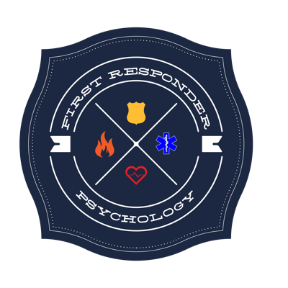

Will Coker Marriage Couples, Family, Counseling

First Responder Families Intern

12725 SW Millikan Way, Suite 300

Beaverton, Oregon 97005

Phone: 971-330-0058

Consent for Release of Information

I, ____________________________________________, authorize my psychologist, Stephanie M. Conn, to release to:
Name: _________________________________________________________________
Address: ______________________________________________________________________________________________
Phone Number: ______________________________________________________________________________________
The following information
( ) A summary of counseling sessions and progress
( ) Session dates and fees
( ) Diagnoses
( ) Other, specify ____________________________________________________________________________________
_________________________________________________________________________________________________________
This authorization is valid until ___________________________________. I understand that I may cancel or revoke this permission at any time in writing.

Client Name: ____________________________________________ Psychologist Name: Stephanie M. Conn
Signature: _______________________________________________ Signature: ______________________________
Date: _____________________________________________________ Date: _____________________________________

