Will Coker Marriage Couples, Family, Counseling

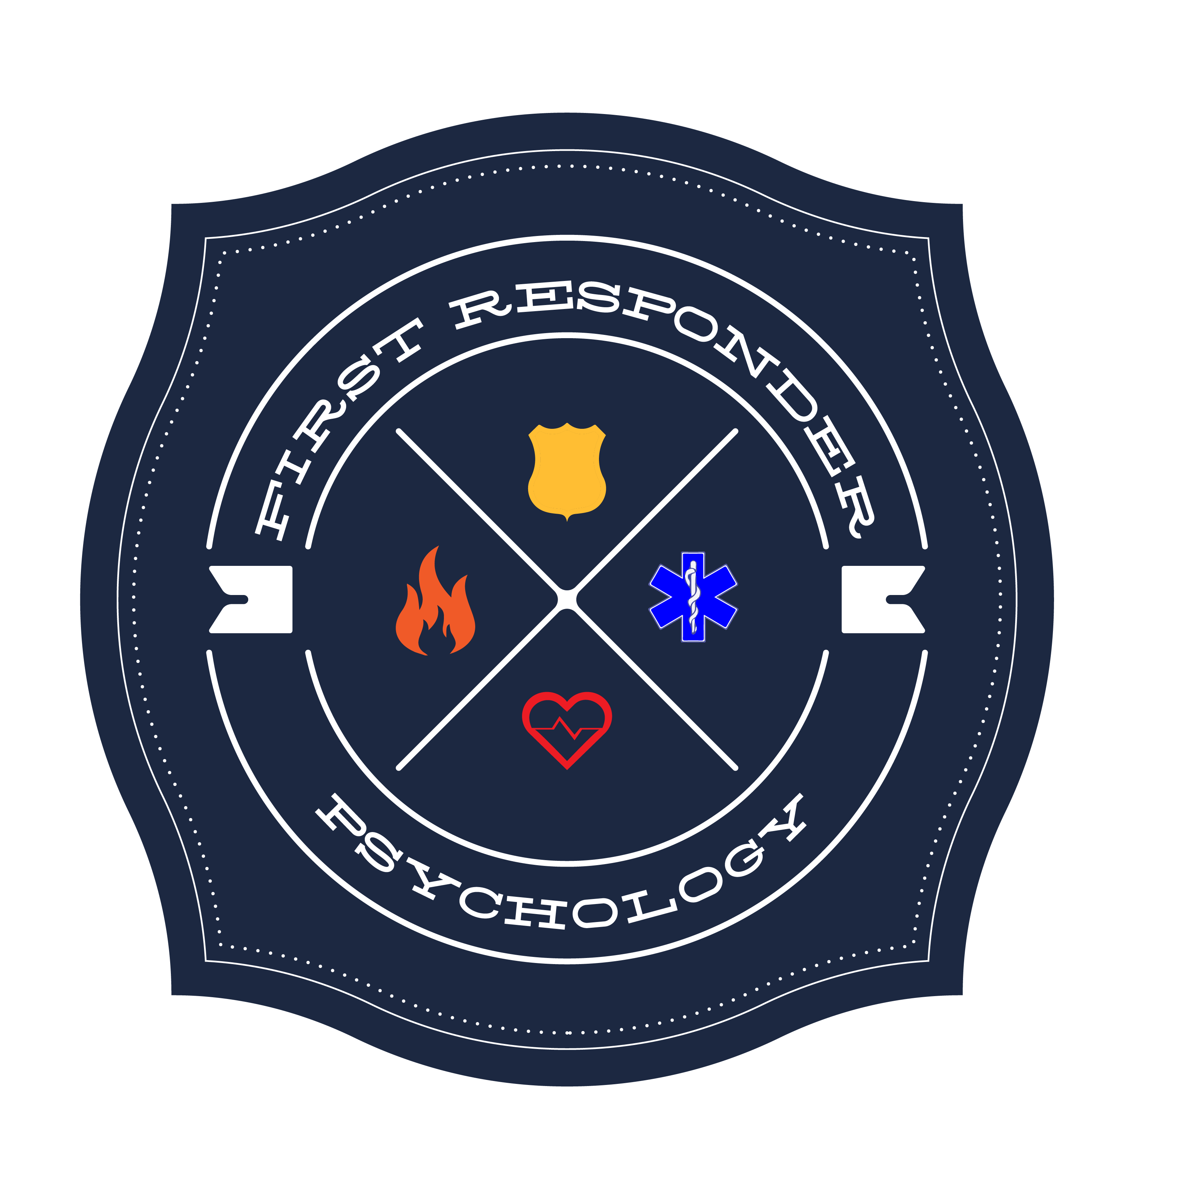
First Responder Families Intern

12725 SW Millikan Way, Suite 300

Beaverton, Oregon 97005

Phone: 971-330-0058

Post-Incident Intervention

Purpose:
The purpose of this intervention is to give you an opportunity to talk about a call in your work that was potentially traumatizing. In discussing this call, it is hoped that you will gain more clarity about your thoughts and reactions to the event as well as how, if at all, it has impacted you. I will ask you to share your story of the event. I will ask you questions relating to how you have been since the event occurred. This includes questions about daily activities such as eating, sleeping, exercising, relating to others, and your work. This is NOT a fitness for duty evaluation but, rather, a check-in for your benefit.
Your Role:
You can disclose as much or as little as you like. However, the more you disclose, the better informed I am to make helpful recommendations. If you would rather not disclose something, say that instead of saying what you think is expected of you.
My Role:
I am here to hear your story and provide information relating to traumatic responses. My hope is that I will be able to normalize your responses and offer you recommendations for recovering from the event. I will provide materials for you to take with you to read and consider. I would recommend that you share these with significant others, as they are important parts of the recovery process. If I believe you would benefit from additional professional support, I will share that with you. It will remain up to you to follow through with this and other recommendations.

