Dr. Stephanie M. Conn, Licensed Psychologist #2825

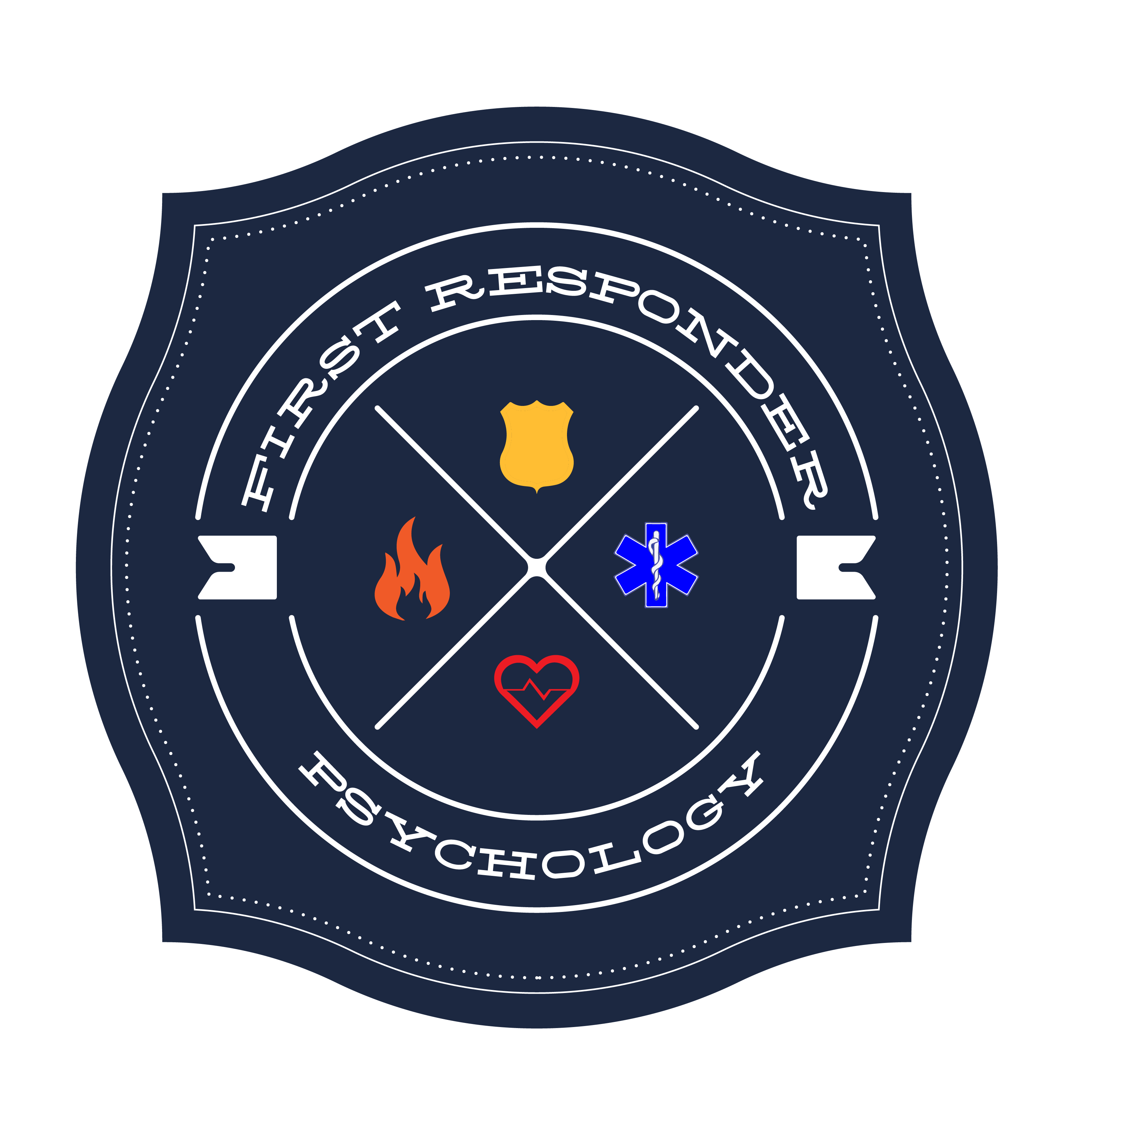
First Responder Psychology

12725 SW Millikan Way, Suite 300

Beaverton, Oregon 97005

Phone: 971-250-1519

ANNUAL WELLNESS CHECK
Purpose:
The purpose of this check is to give you an opportunity to talk about your overall well-being, and your goals for improving it. We will be able to identify strategies for achieving your wellness goals and methods for assessing if you are on track. The check will include questions about daily activities such as eating, sleeping, exercising, relating to others, and your work. This is NOT a fitness for duty evaluation but, rather, a check-in for your benefit.
Your Role:
You can disclose as much or as little as you like. However, the more you disclose, the better informed I am to make helpful recommendations. If you would rather not disclose something, say that instead of saying what you think is expected of you.
My Role:
I am here to help you assess your well-being and provide information to promote resilience. I may provide materials for you to take with you to read and consider. If I do, I would recommend that you share these with significant others, as they are important parts of your resilience plan. If I believe you would benefit from additional professional support, I will share that with you. It will remain up to you to follow through with this and other recommendations.

