Dr. Stephanie M. Conn, Licensed Psychologist #2825

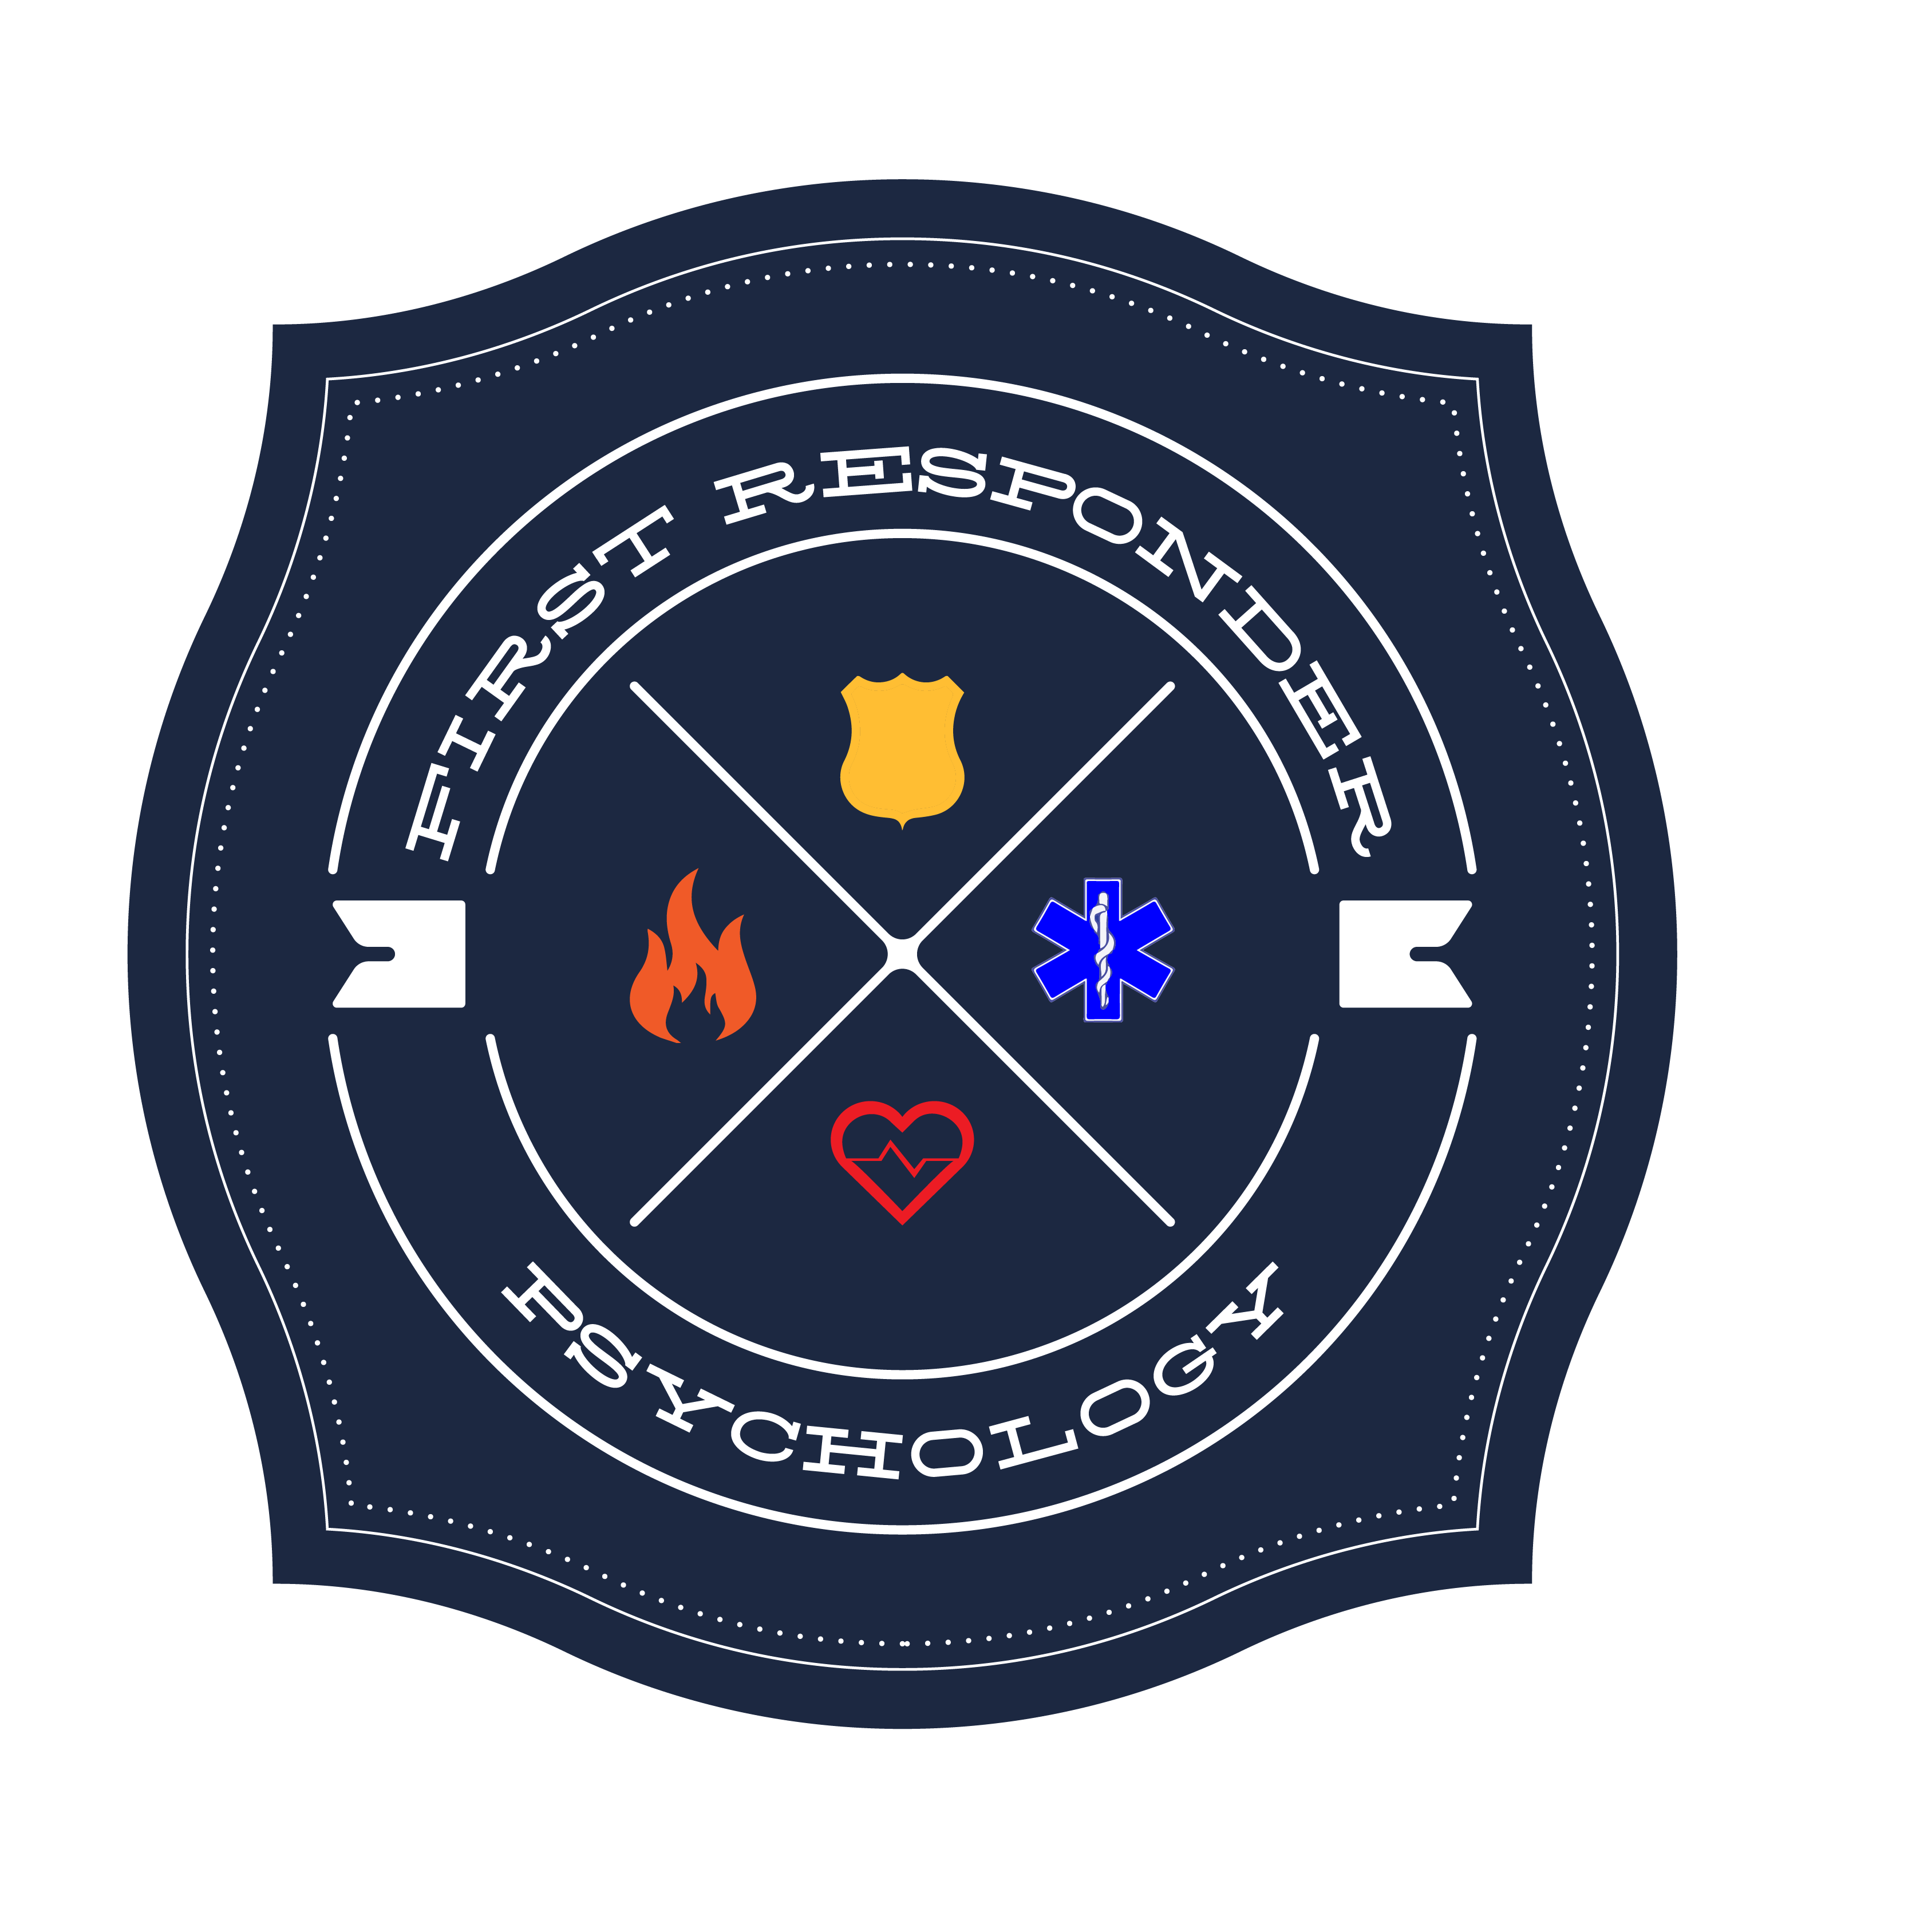
First Responder Psychology

12725 SW Millikan Way, Suite 300

Beaverton, Oregon 97005

Phone: 971-250-1519

CONSENT to PARTICIPATE in a POST-INCIDENT INTERVENTION
I do hereby seek and consent to take part in the post-incident treatment by Dr. Stephanie M. Conn. I acknowledge that I have received information about this treatment and have had all my questions answered fully.

I understand that although I may have been mandated by my employer to receive this intervention and that I am not responsible for payment, anything that I may communicate within the session is confidential and privileged under law, with certain exceptions as detailed below. I understand that the therapist will not make any determination as to my fitness for duty. I understand that Dr. Conn will relay to my department that I have attended this appointment.

This intervention has both benefits and risks. Risks may include experiencing uncomfortable feelings, such as sadness, guilt, anxiety, anger, frustration, and helplessness, However, these interventions have been shown to have benefits for individuals who undertake it. It often leads to a significant reduction in feelings of distress and increased skills for managing stress and recovering from a critical incident. However, there are no guarantees about what will happen.

I understand that Dr. Conn may confidentially consult with other professionals as part of her clinical practice. I also understand that certain limits exist to therapist-client confidentiality under law. Exceptions to this protection of confidentiality would occur if it were learned that I am a danger to myself or others. Should this happen, the appropriate authorities would be notified as required by law. Although the law does not mandate that a report be made if it is learned within the context of therapy that a child or elder has been abused or neglected, it is the policy of this therapist to report any reasonable suspicion of child or elder abuse to the appropriate authorities.

My signature below shows that I understand and agree with all of these statements. I understand that I will be given a copy of this consent form to keep and that this agreement will become part of my record of treatment.

__________________________________________________________________________
Signature of client Date

______________________________________________________
Printed name

I, the therapist, have discussed the issues above with the client.

____________________________________________________________________________
Signature of therapist

