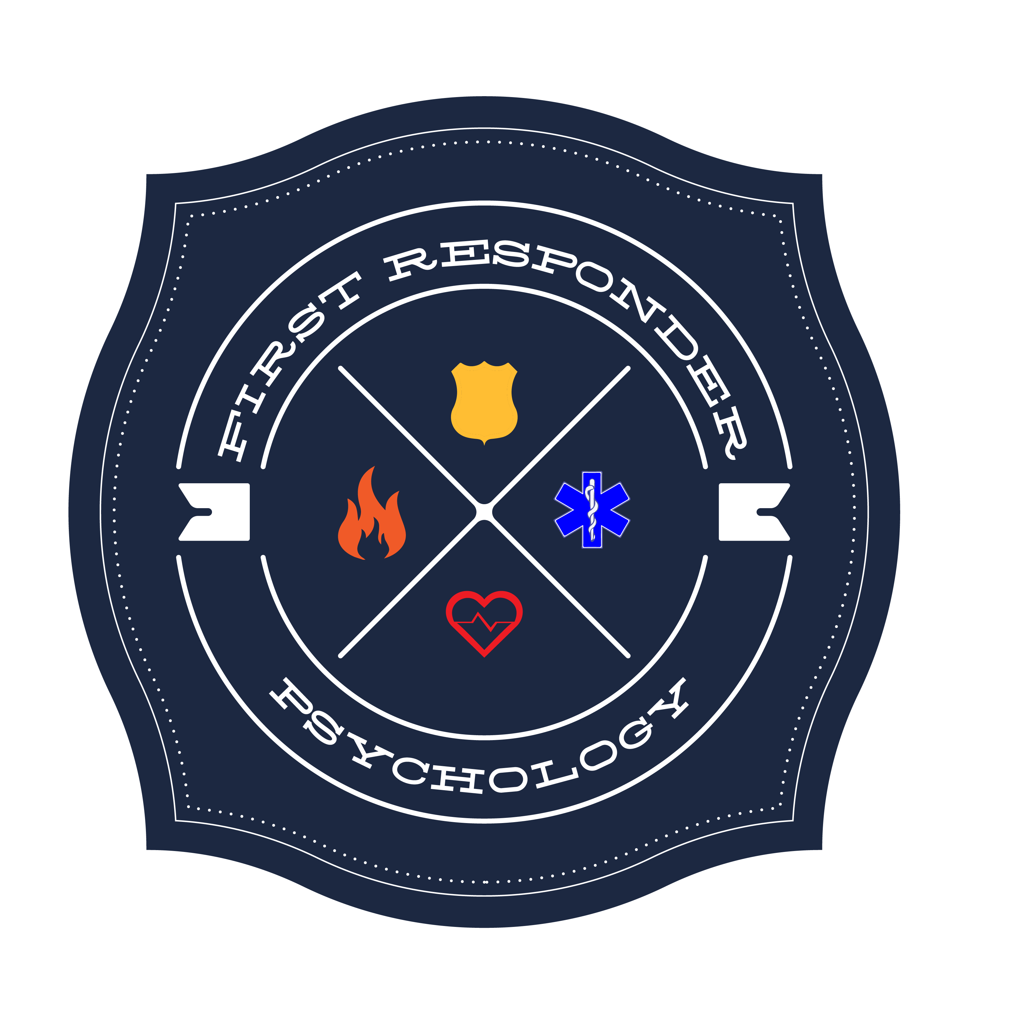
First Responder Psychology

Stephanie M. Conn, PhD,

Licensed Psychologist OR #2825

Health Insurance Portability and Accountability Act (HIPAA)
Notice of Privacy Practices (2016)
THIS NOTICE DESCRIBES HOW PSYCHOLOGICAL AND MEDICAL INFORMATION ABOUT YOU MAY BE USED AND DISCLOSED AND HOW YOU CAN GET ACCESS TO THIS INFORMATION. PLEASE REVIEW IT CAREFULLY.
I. Uses and Disclosures for Treatment, Payment and Healthcare Operations
I may use or disclose your protected health information (PHI) for treatment, payment, and healthcare operation purposes with your consent. To help clarify these terms, here are some definitions:
• “PHI” refers to individual identifiable health information. PHI includes any identifiable health information received or created by my office or me.
• “Treatment, Payment and Healthcare Operations”
Treatment is when I provide, coordinate or manage your healthcare and other services related to your healthcare. An example of treatment would be when I consult with another healthcare provider, such as your family physician or another psychologist. Payment is when I obtain reimbursement for your healthcare. Examples of payment are when I disclose your PHI to your health insurer to obtain reimbursement for your healthcare or to determine eligibility or coverage. Healthcare Operations are activities that relate to the performance and operation of my practice. Examples of healthcare operations are a quality assessment and improvement activities, business-related matters such as audits and administrative services, and case management and care coordination. “Use” applied only to activities within my [office, clinic, practice group, etc.] such as sharing, employing, applying, utilizing, examining, and analyzing information that identifies you. “Disclosure” applies to activities outside of my [office, clinic, practice group, etc.] such as releasing, transferring, or providing access to information about you or other parties. “Health Information” is information in any form that relates to any past, present, or future health of an individual.

II. Uses and Disclosures Requiring Authorization
I may use or disclose confidential information (including but not limited to PHI) for purposes of treatment, payment, and healthcare operations when your written informed consent is obtained. I may use or disclose PHI for purposes outside of treatment, payment, and healthcare operations when your appropriate written authorization is obtained. An “authorization” is written permission above and beyond the general consent that permits only specific disclosures. In those instances when I am asked for information for purposes outside of treatment, payment and healthcare operations, I will obtain an authorization from you before releasing this information. I will also need to obtain an authorization before releasing your psychotherapy notes. “Psychotherapy notes” are notes I have made about our conversation during a private, group, joint, or family counseling session, which I have kept separate from the rest of your medical record. These notes are given a greater degree of protection than PHI.
You may revoke all such authorizations (of PHI or psychotherapy notes) at any time, provided each revocation is in writing. You may not revoke an authorization to the extent that: 1) I have relied on that authorization. 2) If the authorization was obtained as a condition of obtaining insurance coverage, and the law provides the insurer the right to contest the claim under the policy.
Notice of Privacy Practices
III. Uses and Disclosures with Neither Consent nor Authorization
I may use or disclose PHI without your consent or authorization in the following circumstances:
• Child Abuse: If I have reasonable cause to believe that a child with whom I have had contact has been abused I may be required to report the abuse. Additionally, I if have reasonable cause to believe that an adult with whom I have had contact has abused a child, I may be required to report the abuse. In any child abuse investigation, I may be compelled to turn over PHI. Regardless of whether I am required to disclose PHI or to release documents, I also have an ethical obligation to prevent harm to my clients and others. I will use my professional judgment to determine whether it is appropriate to disclose PHI to prevent harm. • Mentally Ill or Developmentally Disabled Adults: If I have reasonable cause to believe that a mentally ill or developmentally disabled adult, who receives services from a community program or facility has been abused, I may be required to report the abuse. Additionally, if I have reasonable cause to believe that any person with whom I come into contact has abused a mentally ill or developmentally disabled adult, I may be required to report the abuse. Regardless of whether I am required to disclose PHI or to release documents, I also have an ethical obligation to prevent harm to my clients and others. I will use my professional judgment to determine whether it is appropriate to disclose PHI to prevent harm.
• Other Abuse: I may have an ethical obligation to disclose your PHI to prevent harm to you or others.
• Health Oversight: The Oregon State Board of Psychologist Examiners may subpoena relevant records from me should I be the subject of a complaint.
• Judicial or Administrative Proceedings: Your PHI may become subject to disclosure if any of the following occur: If you become involved in a lawsuit, and your mental or emotional condition is an element of your claim, or a court orders your PHI to be released, or orders your mental evaluation.
• Serious Threat to Health or Safety: I may disclose confidential information when I judge that disclosure is necessary to protect against a clear and substantial risk of imminent serious harm being inflicted by you on yourself or another person. I must limit disclosure of the otherwise confidential information to only those persons and only that content which would be consistent with standards of the professional in addressing such problems.
• Worker’s Compensation: If you file a Worker’s Compensation claim, this constitutes authorization for me to release your relevant mental health records to involved parties and officials. This would include a past history of complaints or treatment of a condition similar to that involved in the Worker’s Compensation claim.

IV. Client’s Rights and Psychologist’s Duties
Client’s Rights:
• Right to Request Restrictions – You have the right to request restrictions on certain uses and disclosures of protected health information about you; however, I am not required to agree to a restriction you request.
• Right to Receive Confidential Communications by Alternative Means and at Alternative Locations – You have the right to request and receive confidential communications of PHI by alternative means and at alternative locations. (For example, you may not want a family member to know that you are seeing me. Upon your request, I will send your bills to another address.)
• Right to Inspect and Copy – You have the right to inspect or obtain a copy (or both) of PHI and psychotherapy notes in my mental health and billing records used to make decisions about you
for as long as the PHI is maintained in the record. I may deny your access to PHI under certain circumstances, but in some cases, you may have this decision reviewed on your request, I will discuss with you the details of the request and denial process.
• Right to Amend – You have the right to request an amendment of PHI for as long as the PHI is maintained in the record. I may deny your request. On your request, I will discuss with you the details of the amendment process.
• Right to an Accounting – You generally have the right to receive an accounting of disclosures of PHI for which you have neither provided consent nor authorization (as described in Section III of this Notice). On your request, I will discuss with you the details of the accounting process.
• Right to a Paper Copy – You have the right to obtain a paper copy of the notice from me upon request, even if you have agreed to receive the notice electronically.
Psychologist’s Duties:
• I am required by law to maintain the privacy of PHI and to provide you with a notice of my legal duties and privacy practices with respect to PHI.
• I reserve the right to change the privacy policies and practices described in this notice. Unless I notify you of such changes, however, I am required to abide by the terms currently in effect.
• If I revise my policies and procedures I will post a summary of the current notice in the office with its effective date clearly shown at the top. You are entitled to a copy of the notice currently in effect.
• I am required to inspect your official photo identification (driver’s license or other identification) to protect you against identity theft.
• I will contact you only via means by which you give me permission (phone numbers, e-mail) and I may occasionally call you to remind you of appointment times at your designated number or e-mail.

V. Complaints
If you are concerned that I have violated your privacy rights, or you disagree with a decision I made about access to your records, you may file a complaint with me at my office.
You may also send a written complaint to the Secretary of the U.S. Department of Health and Human Services, 2201 Sixth Avenue, Suite 900, Seattle WA, 98121-1831 (Phone (206)615-2287, FAX (206)615- 2297, TDD (206)615-2296. You will not be penalized for filing a complaint.

