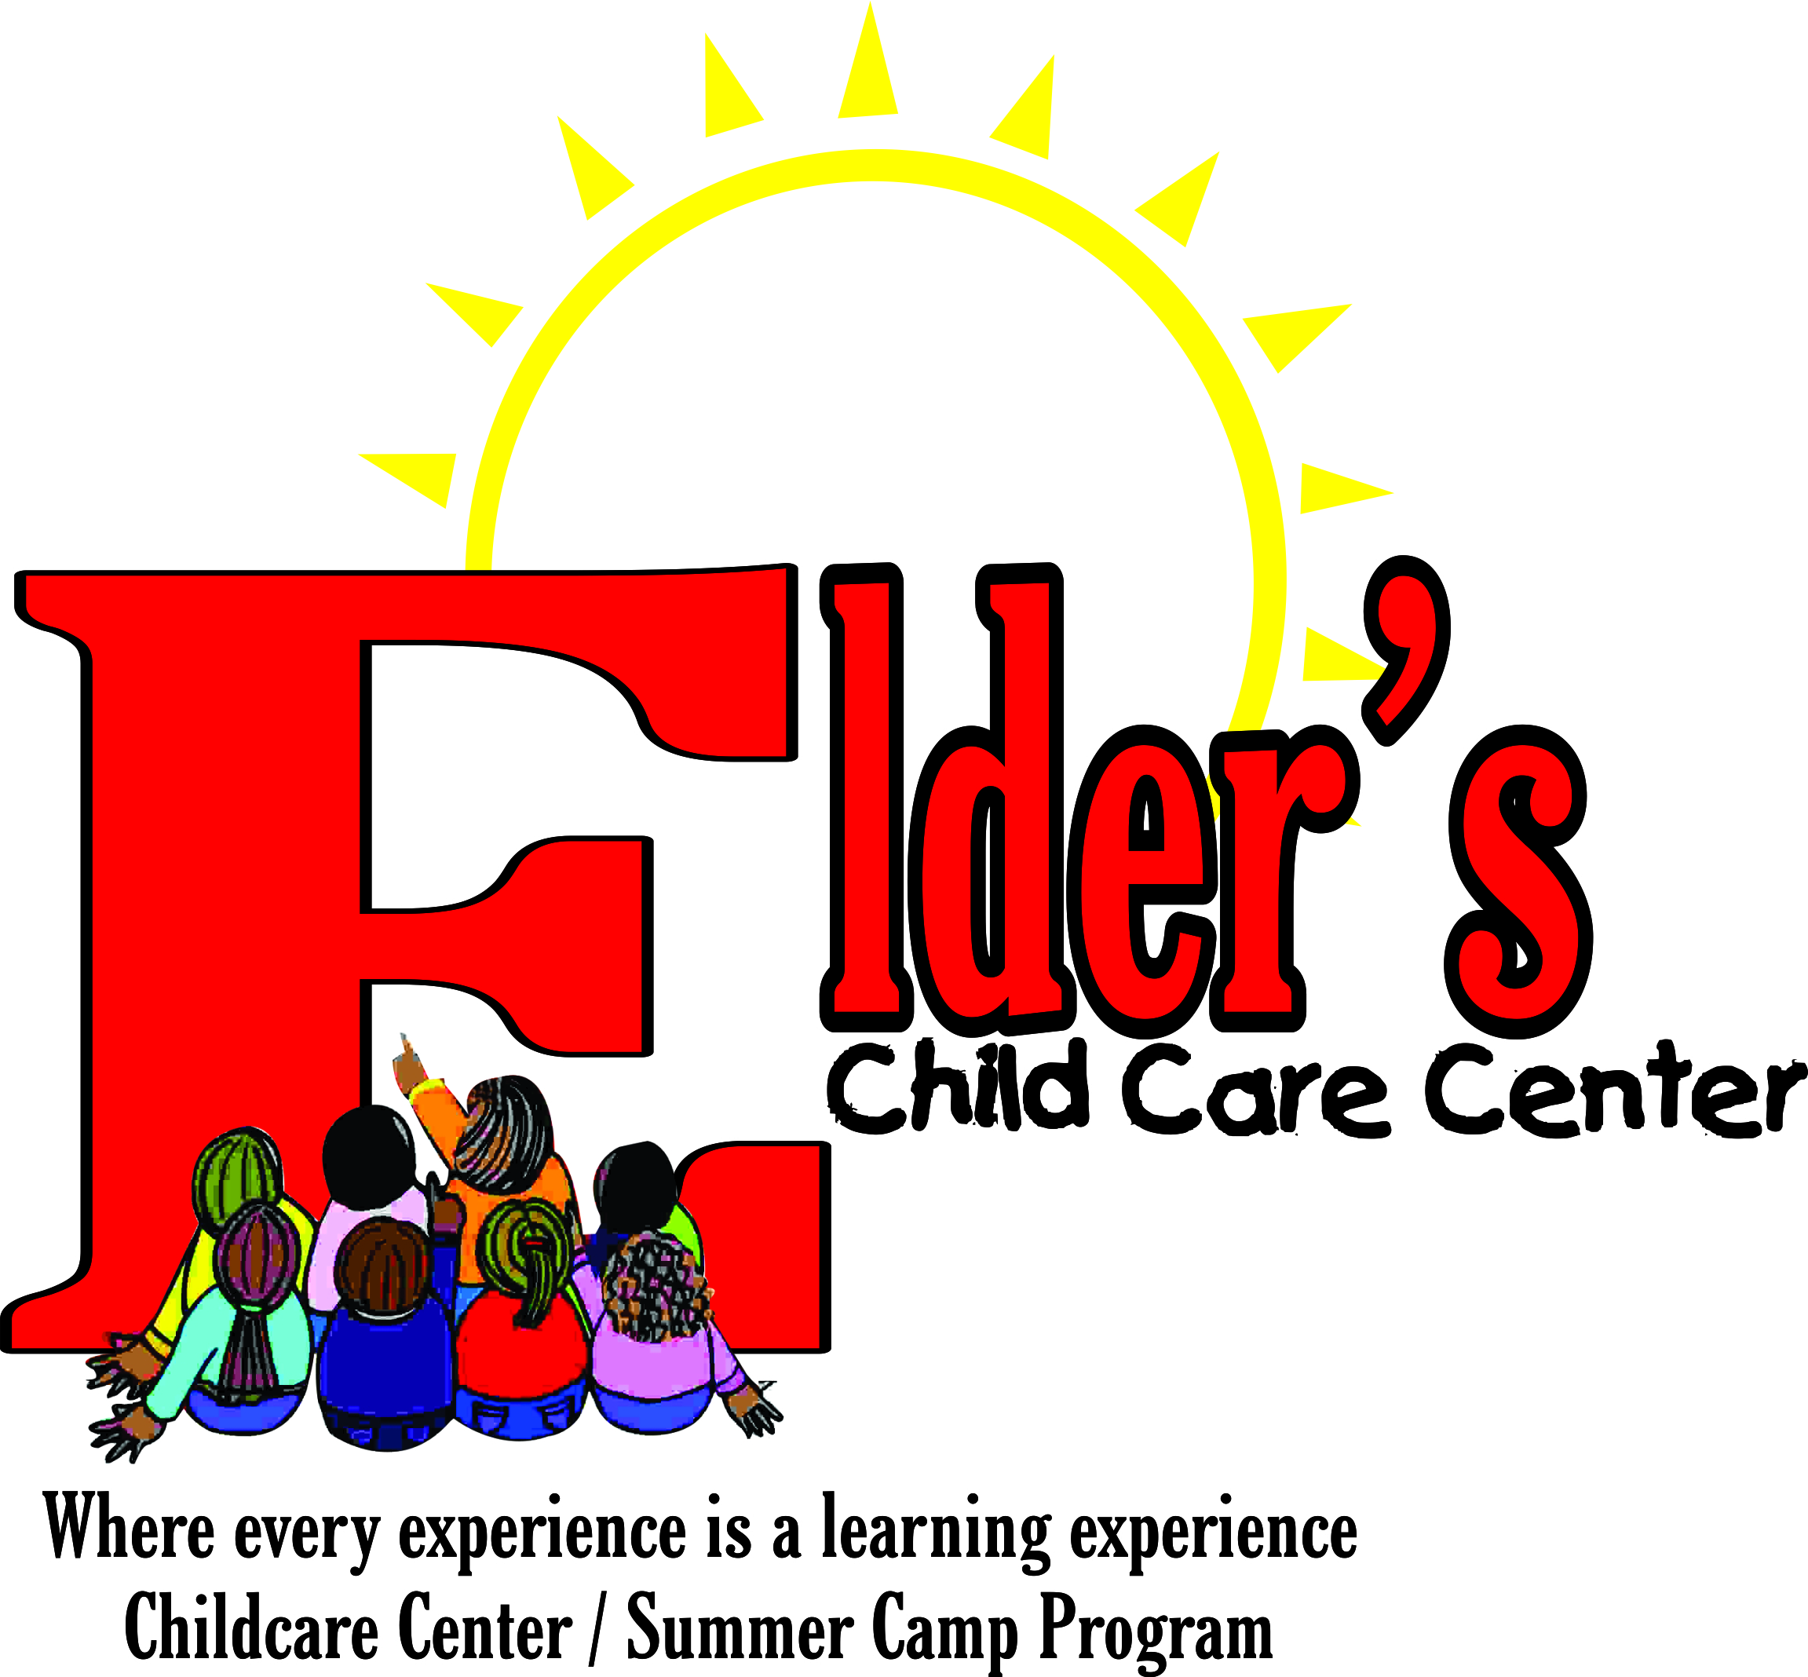

Elder’s Childcare Center

School Supply List

- Each student will need the following school supplies:

Quantity: | Items:
3 | Boxes of Kleenex Tissues (ages 2 - 5 year old)
2 | Boxes of 8 Ct. Jumbo Size Crayola Crayons (ages 2 - 5 year old)
1 | Pair of Safety Scissors (ages 3 - 5 year old)
1 | Pack 3x5 Index Cards (ages 2-5 year old)
5 | Big Pencil (ages 3 - 5 year old)
1 | Pack Large Freezer Zip Lock Bags (ages 2-5 year old)
1 | Pack Magic Markers (ages 3-5 year old)
2 | Bottle of Elmer’s glue (ages 3 - 5 year old)
2 | Disinfect wipes (ages 2 - 5 year old)
5 | Packs of Baby Wipes (ages 2 - 5 year old)
1 | Complete change of clothing (ages 2 - 5 year old)
2 | Pocket Folders (ages 2-5 year old)
1 | Pack Computer Paper (ages 2-5 year old)
1 | Black & White Composition Book (ages 2-5 years old)

Note: Please label all items with your child’s first and last name.

