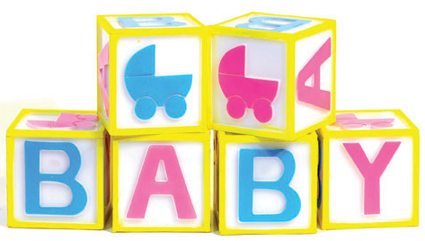

Elder’s Childcare Center Infant Supply List

☐Prepared bottles
☐Pacifiers
☐Baby food and cereal when age appropriate
☐Diapers
☐Wipes
☐Diaper ointment
☐Extra Clothes
☐Extra formula (for emergency use only)
☐Diaper bag (large enough to store empty bottles and clothes that may be sent home)

Please Remember:

- Please label all items with child’s first and last name.

- All creams and sunscreens to be applied require a completed medical authorization form and must be kept in their original containers with your child’s full name on it.

- All prescriptions must be in the original containers with the patient’s name, dosage and prescribed time to be given. The doctor must complete a medical form before medication can be administered.

- Any over the counter medications (Tylenol, Motrin, etc.) require a permission form from your doctor which must include the proper dosage for your child’s weight, age and the reason why it is to be administered.

