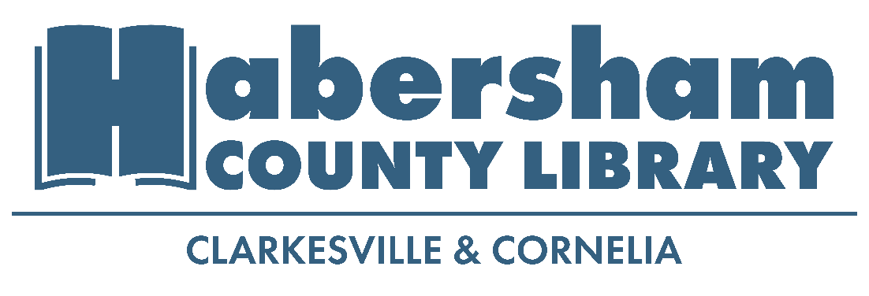
POSITION: Library Circulation Assistant, Part Time
LOCATION: Cornelia, GA
APPLICATION DEADLINE: Open Until Filled

Description: The Library Circulation assistant helps with the day to day operations of the library, assists with special events, and offers exceptional customer service to patrons.
The responsibilities include assisting patrons at the circulation desk, answering patron questions in person and over the phone, re-shelving library items, helping maintain cleanliness and order in the library, assisting with events including story times and crafts, and other duties as necessary.

Qualifications:
- High school diploma preferred, or in process of completing high school diploma
- Experiences in customer service
- Computer, smart phone, tablet proficiency required
- Experience with G-Suite programs and Microsoft Suite preferred
- Strong public relations and people skills preferred
- Strong planning and Organizational skills required
- Proficiency in Spanish a plus

Salary/Benefits: $12/hour, 12 hours per week
Application Procedure:
Submit a resume and application by email or in person. Please do not call to apply for position. Include names and contact information for at least three professional references.
How to apply:

Application Packets | Email Application To:
To download an application visit www.cornelialibrary.org  Or pick up a paper copy at the Cornelia Library | Josh Smith-Cornelia Library Manager  jsmith@negeorgialibraries.org  Subject: Cornelia Library Circulation Assistant

