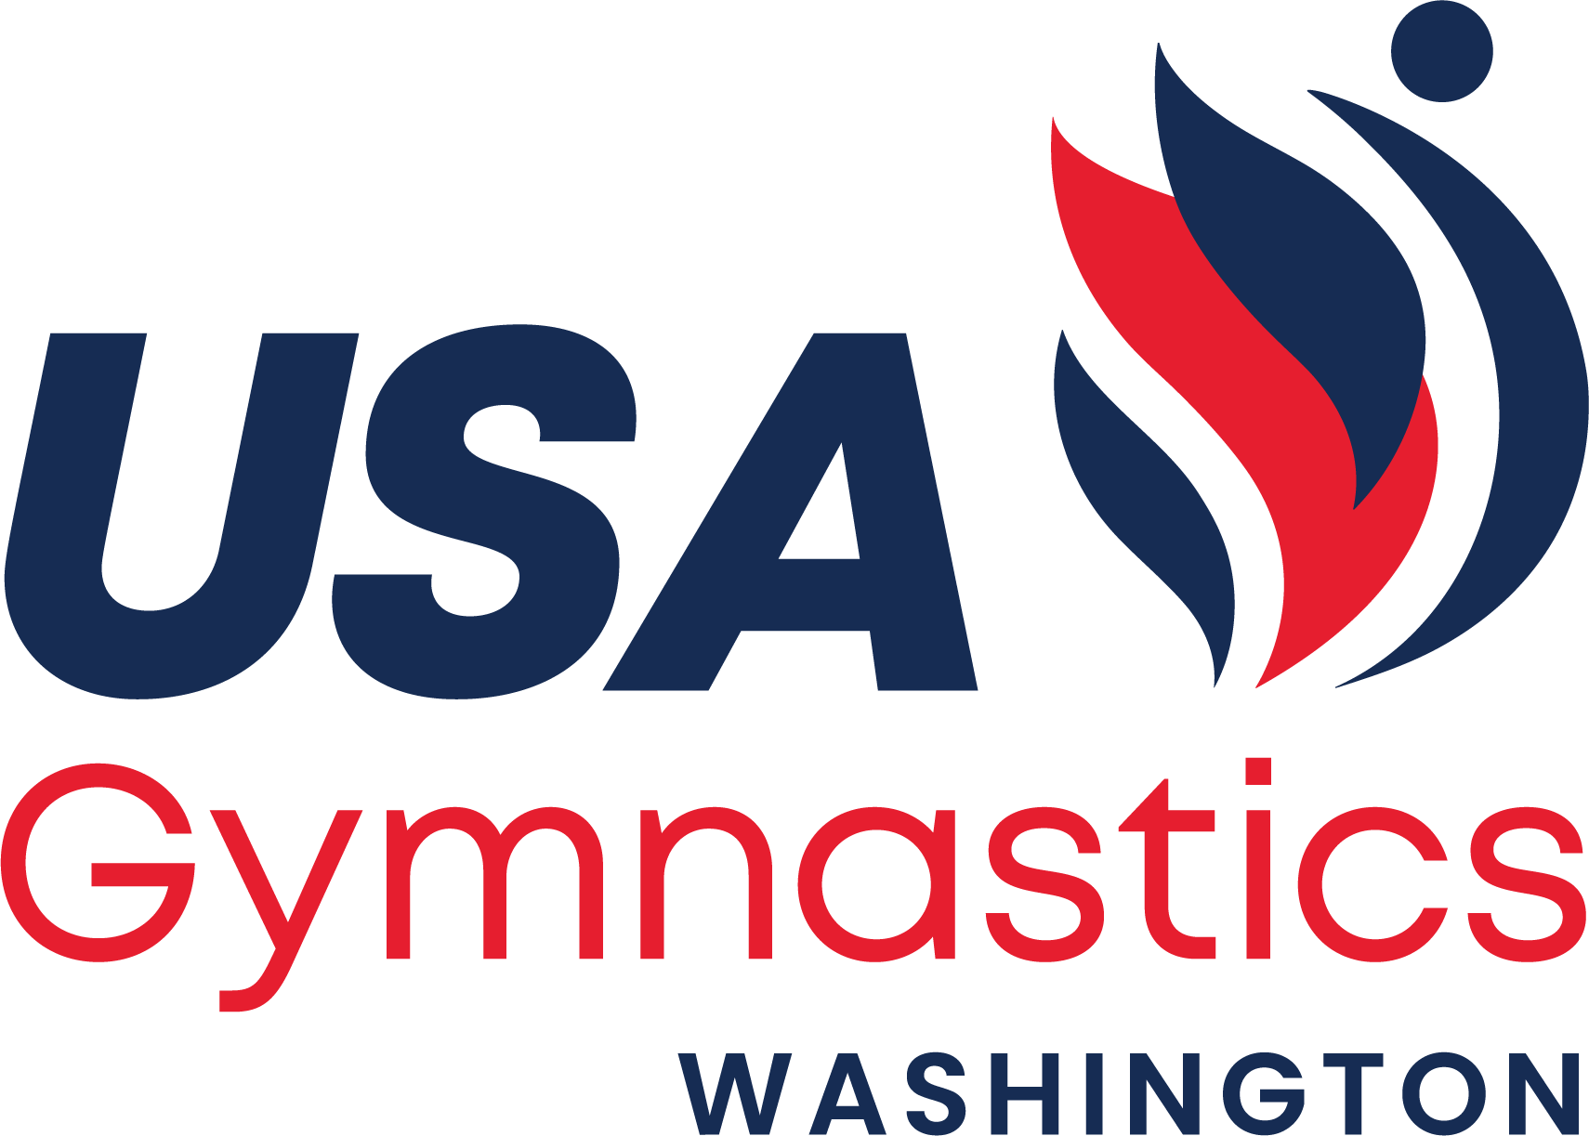

**State Administrator Committee Minutes**

June 23rd, 2023  
Emerald City Gymnastics Academy  
8:00am

**Committee Members – In attendance**

Sandy Flores (ecgaowner@gmail.com)  
Yulia Hancheroff (yuliavh@mac.com)  
Jen Huffman (jen.huffman@yahoo.com)

Bekah Robitaille ([bekah@northcoastgym.com](mailto:bekah@northcoastgym.com))

Kim Thomson (kim@gymeast.com)

Stephanie Renggli ([advantagegym@outlook.com](mailto:advantagegym@outlook.com))

Delsa Dislers (delsak@comcast.com)

Sarah Flores ([sarah03flores05@gmail.com](mailto:sarah03flores05@gmail.com))

Adana Harris (dynamicgymnastics1@yahoo.com)

Patty Ames (pames7@aol.com)

**Committee Members – not present**

Tori Smieja ([hermyluvsron123@yahoo.com](mailto:hermyluvsron123@yahoo.com))

Denise Green (green.bill.denise@gmail.com)

**Welcome/SAC Report**

**State Congress Update**Update on clinicians, wanting feedback on how to get more clubs/athletes involved.

September 13th -15th 2024 Temporary dates

**Committee Update**

Sandy Flores is taking over as Regional Chair & Kim Thomson is taking over State Chair

**New Business**  
Xcel State 2024 Host’s venue is no longer available and the only other bid received for that meet was Garland’s and they still have the venue.

Motion to accept Garland’s at the host of the 2024 venue: Sarah Flores second: Bekah Robitaille

& Motion passed unanimously  
  
**Motion to accept the 2025-2026 State Championship Hosts**

Motion Delsa, Second Yulia & Motion passed unanimously

*2025 State Calendar* March 21-23 – Dev State Gym East  
 March 28-30 – Xcel State Reg 2 Fundraiser – more info coming

*2026 State Calendar*March 20-22 – Dev State Emerald City  
 March 27-29 – Xcel State North Coast

Motion to adjurn 6/23/23 at 8:57pm Sarah Flores