# 2022 - 2023

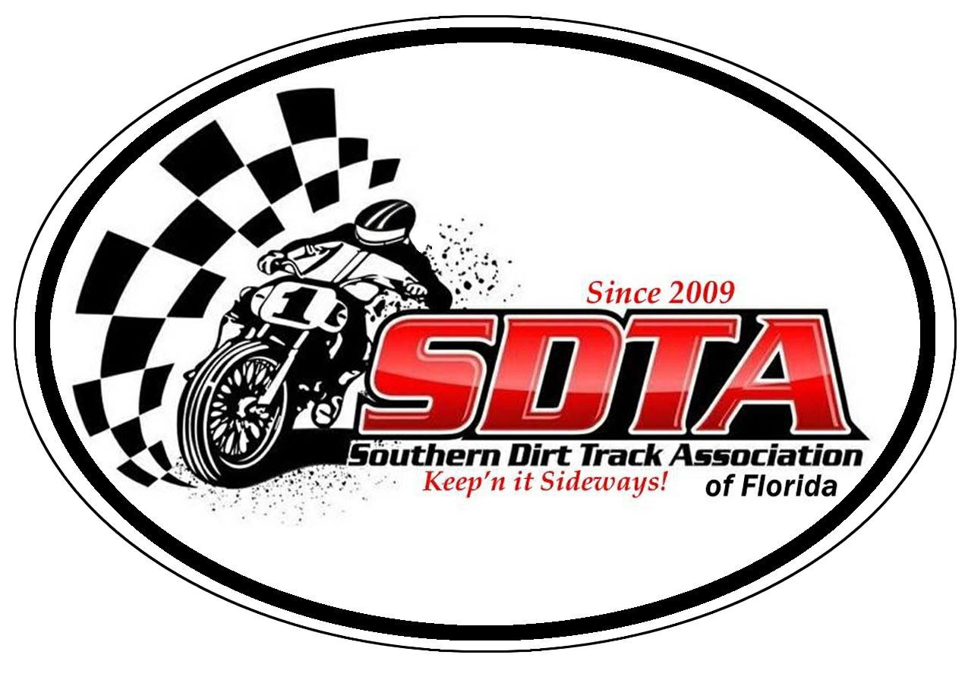

**Rules and Regulations**

**(Revised 9/2022)**

The purpose of this document is to provide guidance for a safe, fair, and smooth-running racing event.

All riders’ ages are as of the date of the race. Any rider under the age of 18 must have his/her entry form signed by his/her parent or legal guardian.

The rider must be of adequate size and maturity to keep his/her machine under control at all times. This includes riding, stopping, standing still, mounting, and dismounting the machine.

Riders under the age of 12 are limited to riding machines of less than 125cc displacement for two-stroke and 200cc displacement for four-stroke (can be overrode by SDTA partners).  Other age restrictions apply as listed for specific classes.

A front brake is not allowed unless specifically mentioned for a class. All motorcycles must have a functional and effective rear brake unless a specific brakeless class is created for the event.

All fuel must be either pump gasoline or commercially available racing gasoline. For 2-stroke engines the addition of lubricating oil to the fuel is allowed. Methanol (methyl alcohol) is not allowed.

If you need to change motorcycles at any time during an event you must come back to sign up and complete a change request form, if you change bikes & or #’s and do not have a change form you will not be scored and a refund will not be given.

Unless noted, knobby tires are not allowed.

**CLASSES:**

***IF YOU RIDE OPEN PRO THE ONLY OTHER CLASS YOU CAN RUN IS PRO AM***

**50cc Open-** (0cc-51cc) 2 or 4 stroke: automatic/clutch single or multi-speed (Ages 4-8) Knobbies are allowed.

**50cc Shaft -** (0cc-51cc) 2 or 4 stroke: automatic/shaft drive (Ages 4-8) Knobbies are allowed.

**WILL COMBINED 50cc classes to 50cc open if not enough racers**

**65cc -** (50cc-110cc) 2 or 4 stroke (No 85cc 2 Strokes), (Ages 6 -11) Knobbies are allowed.

**85cc -** (65cc-85cc)-2 stroke or (70cc – 200cc)-4 stroke, (Ages 6 -14) Knobbies are allowed.

**Youth Open –** (85cc-125cc)-2 stroke or (80cc-200cc) 4 stroke (Ages 9-14) - This class is designed as the stepping stone for Youth riders to continue racing with other Youth before moving on to an adult class.

**250cc Amateur -**  85cc – 250cc (2 - 4 stk) (age 12+) Up and coming Youth Riders are allowed. No Knobbies

**Mad Dawg Open** – (0cc-200cc) Air-cooled 2 or 4 strokes (Min Age is 18): This class is intended to be a fun class with very close tight racing, open to all riders, Knobbies are allowed but street/flat track tires are encouraged. If you ride Open pro you can’t ride this class.

**Open Novice – (**125cc – Open) - 2 or 4 stroke, (Min age is 13) the minimum rim diameter is 17”. **This class is for riders who are new to flat track racing** and need to gain experience, top 3 from prior season will be promoted to Open Amateur. Vintage bikes are eligible for this class. Must have flat track tires. If you ride Open pro you can’t ride this class. Kids moving from 85cc/250cc do not qualify as Novice.

**Open Amateur -** **(**125cc – Open) - 2 or 4 stroke, (Min age is 13) the minimum rim diameter is 17”. This class is not open to current professionals. Vintage bikes are eligible for this class. Must have flat track tires. If you ride Open pro you can’t ride this class.

**30+ - (125cc – Open)** - 2 or 4 stroke, (Min age is 30) Must have flat track tires. If you ride Open pro you can’t ride this class.

**50+ -** **(**125cc – Open) - 2 or 4 stroke, (Min age is 50) Must have flat track tires. If you ride Open pro you can’t ride this class.

**60+ -** **(**125cc – Open) - 2 or 4 stroke,(Min age is 60) Must have flat track tires. If you ride Open pro you can’t ride this class.

**Vintage 250 - (**125cc – 250cc 2-stroke or 310cc 4 stroke) - (Min age is 18) Motorcycles must be from 1992 or earlier, Rims must be minimum diameter of 17”. Specialized flat track racing frames are allowed. If you ride Open pro you can’t ride this class.

**Vintage Open - (**125cc – OPEN) - 2 or 4 stroke, (Min age is 18) Motorcycles must be from 1992 or earlier, Rotax engines are allowed. Rims must be minimum diameter of 17”. Multi-cylinder engines are allowed. Specialized flat track racing frames are allowed. If you ride Open pro you can’t ride this class.

**Vintage Twin / Hooligan - (**Twin Motor 500CC +) - 2 or 4 (Min age is 18) Vintage Twin Motorcycles must be from 1992 or earlier race frames allowed. Hooligan - Street Bike that can be registered as a street bike. Aftermarket modifications can be made, stock frames. If you ride Open pro you can’t ride this class

**Pro-Am Singles $$ (**250cc – Open) - 2 or 4 stroke, (Min age is 13) the intent of this class is to allow the faster experienced Open Amateur riders the chance to compete with the professionals. The minimum wheel size is 17”. Since this is an “open singles” class, there is no upper limit on engine displacement. Engine, frame, and suspension modifications are allowed. Specialized flat track racing frames are allowed, Must have flat track tires. Payout is 80% based on entry fees only. Top half of the class to be paid (Class of 10 payout to the top 5).

**Open Pro $$:** All riders must be at least 14 years of age (Younger Age can be discussed with SDTA Exec and Pro riders at sign-up). The minimum wheel size is 17”. The minimum engine displacement is 250cc. Since this is an “open” class, there is no upper limit on engine displacement. Engine, frame, and suspension modifications are allowed. Specialized flat track racing frames are allowed. Engines may be of either 2-stroke or 4-stroke configuration. Must have flat track tires. If you ride Open Pro or Carry a valid Pro License you cannot ride any other classes other than Pro-Am singles and Pro Twins.

**Mini TT:** (50cc – 65cc see class rules above) 2 or 4 stroke, (Ages 6 -11) Knobbies are allowed.

**Youth Open TT –** (85cc-125cc)-2 stroke or (80cc-200cc) 4 stroke (Ages 9-14) - This class is designed as the stepping stone for Youth riders to continue racing with other Youth before moving on to an adult class.

**Mad Dawg TT:** (0cc-200cc) Air-cooled 2 or 4 strokes (Min Age is 13): This class is intended to be a fun class with very close tight racing, open to all riders, Knobbies are allowed but street/flat track tires are encouraged

**Open Amateur TT -** **(**125cc – Open) - 2 or 4 stroke, (Min age is 13) the minimum rim diameter is 17”. This class is not open to current professionals. Vintage bikes are eligible for this class. Must have flat track tires. If you ride Open pro you can’t ride this class.

**Pro-Am Singles $$ TT (**250cc – Open) - 2 or 4 stroke, (Min age is 13) the intent of this class is to allow the faster experienced Open Amateur riders the chance to compete with the professionals. The minimum wheel size is 17”. Since this is an “open singles” class, there is no upper limit on engine displacement. Engine, frame, and suspension modifications are allowed. Specialized flat track racing frames are allowed, Must have flat track tires.

**Youth Quad FT/TT: (**max engine 2 stroke 200cc, 250cc 4 stroke) (ages 5-14) all ATV’s are to be production based and sold commercially. ATV chassis and engine are to be from the original unit no engine swaps from other ATV’s or motorcycles. Flat track tires are not required but highly encouraged. Must have working factory kill switch. Must have front and rear number plates.

**Open Quad FT/TT:** open engine displacement maximum of 2 cylinders. (Min age is 14) unlimited chassis and suspension modifications. Must have flat track type tires, working tether kill switch and nerf bars. Must have front and rear number plates.

**Hooligan:** Age Limit 18 – Street Bike that can be registered as a street bike. Aftermarket modifications can be made.

**Pro Twins:** Any twin cylinder machine, this class will only be offered at tracks 3/8 mile in length and larger. Must carry a Pro license or approved by SDTA Executives.

**Protest:**

If a rider wants to protest the engine cc displacement rule they may file an official protest form that must be handed to an SDTA official and pay the $300 tear down fee, accused rider is responsible for disassembly of the engine to a point where the piston diameter can be measured, removal of the head is sufficient to accomplish this task. If the engine is deemed legal per the cc upper limit the $300 fee will be awarded to the accused rider, if the engine is illegal the rider will be disqualified from that event and points from that race will not be earned. Tear down fee will be returned to the protestor if engine is illegal. If accused rider does not agree to tear down engine the rider will be disqualified from that race and suspended for 5 races, points will not be awarded.

**Flag Communications**

Flags are used by track officials to relay important information to the riders. They indicate track condition, the remaining duration of the race, and other critical factors. Riders are required to know what every flag indicates.

Flags have the following meanings:

**Green:** This flag indicates the start of the race. The track is clear at least until the next flag station to the best knowledge of the person holding the flag.

**Green and white flags furled and crossed:** This indicates that half of the laps have been completed. It may or may not be displayed during a race.

**Yellow, displayed open:** Caution! There is something on the track that requires the rider’s attention to avoid it. When a yellow flag is displayed, riders must ride cautiously with no passing of other competitors until they have passed the incident that caused the flag. It is not required to slow down. Lap counting continues.

**Yellow waving:** There is a serious situation that may require the rider to slow down for avoidance. No passing is allowed until after the incident has been passed. Lap counting continues.

**Blue:** There is at least one faster rider approaching you from behind. Hold your line and do not impede their progress. May or may not be displayed.

**White:** There is one lap left to complete the race.

**Black and white checkered:** This signifies the end of the race. Slow down in a safe manner taking into consideration the riders behind you.

**Red:** When this flag is displayed the race is being stopped for an emergency situation. The riders’ left hand should be raised to warn riders behind. Safely move off the racing line and come to a stop near the beginning of the front straight while taking into consideration the riders behind you and emergency personnel who may be entering the track. Do not race back to the line. Scoring has been suspended at the completion of the previous lap.

**Black, furled:** When pointed at a competitor that competitor is being watched closely by race officials. It is a warning that the rider is doing something of which the officials do not approve and those actions must end immediately.

**Black, displayed open:** The rider to whom the flag was displayed must pull off the track in a safe manner to an area near the officials. Lap counting for that rider has ended. The rider will soon have a polite discussion with the referee regarding the rules infraction. The location must be such that it does not interfere with the ability of the officials to run the race. Their primary responsibility is to the riders who are still on the track. A black flag may be displayed if your motorcycle is in need of repair, leaking fluids or other potential hazardous conditions exist.

**Race Procedures**

**Track Inspection**

Inspect the the track before the event is encouraged. It is important and a safe practice to inspect the surface and escape routes before riding the track at speed. Inspection can be done on foot or on pit bike at a safe low speed.

**Riders’ Meeting:**

Attendance for all riders is mandatory. It is important that all riders understand the procedures of the day, which can change from one event to another. Failure to appear may result in penalties including entry withdrawal at the discretion of the referee or SDTA Exec members.

The number of laps that will be run will be announced at this meeting. The number of laps may be changed later for time limit or track durability reasons at the discretion of the officials. If there is a change in the number of laps after the riders’ meeting, riders will be informed before the start of the race or possibly on the line from the starter. New Riders are required to meet with the race director prior to the event. Parents are responsible for reading the rules and teaching their kids.

**Starting Procedure**

There will be at least three starting lines. The distance between these lines will, depending on the size of the track, usually be 24 feet, but will have a minimum spacing of 15 feet. The front edge of the front tire must remain stationary behind the line before the green flag or light is displayed.

The start may be indicated by either a green flag or a green light. Do not move your machine until the green light comes on or the green flag is waved.

A Jump Start is defined as any forward movement prior to the green light; jumping the start will result in being moved back to the first line available for which there are no penalized riders. A second jumped start by the same rider will result in being moved back to the next line. If there is no line that far back, a new line farther back located by the starter or referee will be created and the rider must start from there

A rider not present at the starting line for the original start may not start in any subsequent restarts of that race.

**Red Flag Conditions and Restarts**

If any rider falls before the lead rider completes the first lap in the mains only, there will be a restart indicated by the displaying of the red flag and/or light by the starter. All riders will go back to the starting positions that they had when the race started. If they had been penalized for jumping the start, then they will return to those penalized positions. The rider who fell or was otherwise judged to be the cause of the restart will be penalized by having to start at the first line available for which there are no un-penalized riders. The restart position for this rider must be at least one line back from where that rider was positioned for the previous start. Riders who, in the judgment of the starter or referee, fell as the result of an action by another or to avoid another rider who was already down, will not be penalized. Once an action occurs that is determined by the starter to be the reason for a restart, an independent fall by another rider is not cause for a penalty to that rider since scoring for that race has been effectively stopped. However, if a rider forces another down or off of the track after the initial cause for a restart, the starter reserves the right to penalize that rider for endangering others.

After the completion of the first lap by the lead rider, the track will go into the red condition only if it is judged by the starter or referee that there is a dangerous situation on the track that requires the race to be stopped such as, oil on the track, weather, the need for medical attention for a hurt rider, or, a section of the track is blocked and racing cannot continue in a safe manner.

If a restart is required before the completion of the second lap by the lead rider, the restarting positions will be single file based on scoring from lap one. Corrections to those starting positions may be made by the starter or referee based on penalties for causing the restart.

If a restart is required after the completion of the second lap by the lead rider, there will be a “fan” style restart. The lead rider lines up on the inside of the racing groove. The next rider will start behind and to the outside of the lead rider. This same pattern will be followed by all until the last available position is available. Once the last outside position is filled, the “fan” style restart pattern will resume towards the inside. The front of a rider’s front tire must be at least three feet behind the back of the back edge of the rear tire of the rider in front and three feet over. Jumping the start will result in being moved to the back of the line.

**Mechanical Difficulties**

If a rider is having a mechanical difficulty before the start or restart of a race, that rider or a member of the rider’s crew can notify the starter. The starter will allow that rider a maximum of two minutes to make repairs before the race will be started. If a different bike is used you must fill out a change form and start from the furthest penalty line.

**Laps Required for an Official Race**

A race may be shortened due to weather or other reasons. A complete race for scoring purposes requires the completion of at least 80% of the schedule laps by the lead rider.

**Sign up:**

Closes 10 minutes prior to start of riders meeting, late sign up fee is $5.00 per class. If you know you be late call an SDTA Exec to enter you into your classes and pay upon arrival.

**Rain out policy:**

If all of the heats are completed then the race event becomes official & scored according to finishing order from those heats, points and $$ are paid out. If the event is rained out prior to the first round of heats being completed & the race can not be resumed that same day credits will given for entries only, gate fees are the responsibility of the track. Make sure you keep your wristbands.

**Scoring**

A points system is used to determine the season championship, points will be awarded according to the table below.

**Position Points Position Points**

1 30 11 8

2 27 12 7

3 25 13 6

4 23 14 5

5 21 15 4

6 19 16 3

7 17 17 2

8 15 18 1

9 13

10 11

**Trophies are only awarded to classes with a min of 3 riders. All 50cc-85cc classes will payout top 3 in trophies.**

Points are awarded only for main events. Minimum of three riders required to receive points. Points are not awarded for heat races unless the Rain policy comes into effect. A rider must start, but is not required to complete, the main event to earn points. “DNF” (did not finish) for the main event results in a position of last place and score the points associated with that position. If the rider does not take to the track and start either the main or the heat, no points are earned. Year – End Championship Trophies are only awarded to classes that raced at least 50% of the season with the minimum of 3 riders in it.

Lap counting stops with respect to scoring that rider when a rider receives a black flag. This applies whether or not the rider pulls off of the track. The rider will receive zero points for the event if the infraction was for riding in a manner that endangers others. The rider will receive points based on the finishing position with the laps completed if the infraction is based on a mechanical issue that occurs after the start of that race.

For a race to count with respect to scoring points, at least 50% of the scheduled laps must be completed. If a main event race is stopped after 50% of the laps have been completed and cannot be restarted, the official finishing order will be the order in which the riders came across the start/finish line at the end of the last scored lap.

If the main events cannot be completed and that event cannot be restarted, the official finishing order will be determined from the heat races. The class winner will be the winner of the fastest heat race. Second place will be awarded to the winner of the second fastest heat race in that class. Third place will be awarded to the winner of the third fastest heat race. This pattern will continue through all of the heats.

**Unsportsmanlike Conduct**

Unsportsmanlike conduct is any action or threat of action jeopardizing the safety of another rider or other person at the event. Flat track racing is a non-contact sport. Offenses include but are not limited to:

1. Intentionally or recklessly hitting another rider on the track.
2. Intentionally or recklessly running another rider off of the track.
3. Causing bodily harm to another rider or anyone else while off of the track, such as in the pits.
4. Intentionally or recklessly damaging the property of another.
5. Threatening any of the above-listed actions.

Riders are responsible for the actions of their crews.

Penalties are at the sole discretion of the event referee or SDTA Official, are not subject to protest, and do not grant the offender any rights to monetary refund. The severity of the penalty will be based on actions required to protect the safety of others and to prevent such actions from reoccurring. Typical penalties for riders include:

**Minor infraction, first offense of season:** The rider is given a warning and is placed on probation.

**Minor infraction, second offense of season:** The entry will be scratched. No points will be earned that day. There will be no refund of entry, track, or other fees. The rider is placed on probation for the rest of the season.

**Major infraction, first offense of season:** The entry will be scratched. No points will be earned that day. There will be no refund of entry, track, or other fees. The rider is placed on probation or suspended for the rest of the season.

**Major infraction, second offense of season:**  The entry will be scratched. No points will be earned that day. There will be no refund of entry, track, or other fees. The rider is forbidden from entering the next SDTA race and will be on probation for the remainder of the season.

**Repeated offenses:** Riders may be suspended for the rest of the season and, in extreme cases, for life or until it is in the judgment of the Board that this rider is no longer a threat to others.

**The black flag** can be shown to a rider if it is in the judgment of the race officials that the rider is endangering others.

**Equipment**

**Rider Responsibility**

It is the responsibility of the rider to select appropriate safety gear that will provide adequate protection. The rider (or parent / guardian) must rely on their own judgment in the selection of helmet and apparel for protection and durability. Motorcycle racing is an inherently dangerous sport and each rider must assume the risk of competition.

**Helmets**

The SDTA suggestsall helmets must be of the full-face design and display DOT approval and/or Snell M2015 which is race certified. It is encouraged but not required that the following information be displayed on the helmet. Name, date of birth, blood type, allergies, important medical problems, emergency contact name and telephone number.

**Other Safety Apparel**

Boots must extend above the ankles. Leathers are encouraged but not required. MX style jersey long sleeves, MX style pants, eye protection and gloves are required. Body armor, neck brace or chest protectors are strongly encouraged. At any track larger than ¼ mile, the use of a leather suit is encouraged.

**Sharp Protruding Objects**

Motorcycles must be free of sharp items that could harm riders in the event of a fall or contact. If in doubt ask the referee.

**Pit Riding**:

This activity is very disappointing to track owners; No rider at any time should use the pit area as a practice track. Please only ride to and from the track entrance/exit in 1st gear. No riding in front of stand or track viewing areas. The SDTA has zero tolerance for this activity. Rider will receive 1 warning and this will be listed at the SDTA sign-up area. The 2nd infraction will result in disqualification for that day’s race and will NOT receive a refund.

**Slower riders:**

Maintain you’re racing line and the faster rider will go around you. It is always the faster rider’s job to safely pass you, hold your racing line at all times.

**Number Plates & Numbers:**

Must be clearly visible and contrasting colors, if more than one number exists in the same class, one rider will be asked to add an X. If scorers can not easily read your number, you will not be scored and no refund will be given.

**SDTA Executive clause:**

SDTA officials reserve the right to change, modify, delete or add rules based on a majority vote from the advisory committee.