Afton Arts & Crafts Festival

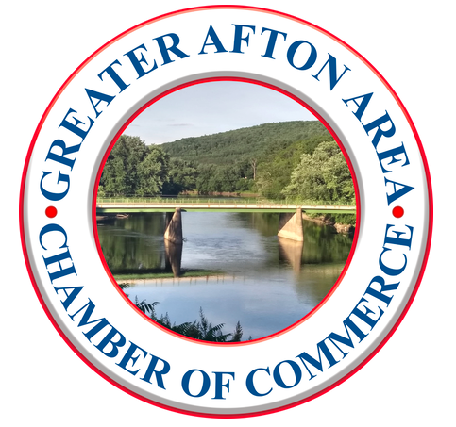
Vendor Application Form
Sponsored by: Greater Afton Area Chamber of Commerce
P.O. Box 243 • Afton, NY 13730 • GreaterAftonAreaCoC@gmail.com
Event Date | Sat., Aug 22, 2026 | Rain Date | Sun., Aug 23, 2026
Location | Main St., Afton NY | Event Hours | 9:00 AM – 3:00 PM
Booth Size | 10 x 10 | Vendor Fee | $40 per space

Vendor Name: __________________________________________________________________________________________________________________
Business / Organization: _____________________________________________________________________________________________________
Address: ________________________________________________________________________________________________________________________
City / State / Zip: ______________________________________________________________________________________________________________
Phone: __________________________________________________________________________________________________________________________
Email: ____________________________________________________________________________________________________________________________
Description of Items: _________________________________________________________________________________________________________
____________________________________________________________________________________________________________________________________
Booth Spaces Requested: ☐ 1 ☐ 2 ☐ 3 ☐ Other _______________________________________________________________________
Payment Method: ☐ Check Enclosed ☐ Paid online at GreaterAftonAreaCoC.com
Mail to: Greater Afton Area Chamber of Commerce, P.O. Box 243, Afton NY 13730
Questions? Email: GreaterAftonAreaCoC@gmail.com call: 607-765-6507
Vendor Agreement: Booth fee is non‑refundable.
The Chamber and Festival are not responsible for loss, theft, or injury.

Signature: ________________________________________________________________ Date: _________________________________________

Application Deadline: August 8, 2026
Check us out on Facebook @ AftonNYArtsandCraftsFestival, or at www.GreaterAftonAreaCoC.com/Festival

Vendor Information & Rules
- Payment in full must accompany the application. Booth fees are non-refundable, including due to weather.
- This is an outdoor event. Vendors must provide their own tents, tables, chairs, and displays.
- Booths must be fully set up before 9:00 AM and may not be broken down before 3:00 PM.
- Vendors are responsible for securing their tents and displays in case of wind or rain.
- Vendors are responsible for collecting and paying all applicable New York State sales tax.
- Booth displays should be neat and appropriate for a family-friendly community event.
- No pets are permitted in vendor booths.
- Children must be supervised at all times.
- Vendors are responsible for cleaning their space before leaving.
- The Chamber reserves the right to remove items or displays deemed inappropriate.

Liability
The Greater Afton Area Chamber of Commerce and the Afton Arts & Crafts Festival cannot be held liable for loss, damage, theft, or injury.
Food vendors must provide a Certificate of Insurance, and insurance is strongly encouraged for all vendors.

