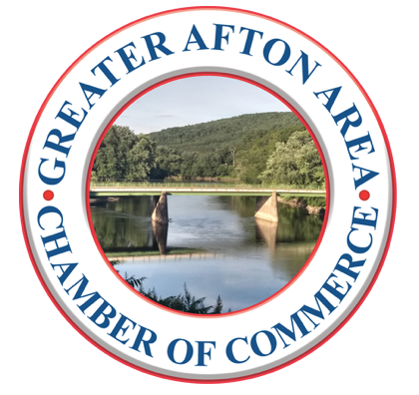

**The Greater Afton Area Chamber of Commerce**

***“Building a Bridge to the Future”***

Dear Business Owner,

The 8th Annual Golf Tournament will be held June 24th at the Afton Golf Club located at   
175 Afton Lake Road in Afton, New York 13730. Registration begins at 12:30pm and the Shotgun Start at 1:30pm, with teams of four to hit the greens. As this is a vital fundraiser we deeply appreciate your support for this event. The Chamber represents businesses and organizations and is dedicated to *building a bridge to the future*by uniting business and community members to advance the economic growth, civic involvement and quality of life   
in the Afton and surrounding areas.

Please consider sponsoring a hole during this tournament. For a $100 sponsorship your business name/logo will be displayed at a select hole on the golf course. This is a double-sided 24”x18” yard sign promoting YOUR business! Say YES – and Thank You in advance for your support!

**___________________________________________________________________________________________**

GOLF TOURNAMENT HOLE SPONSORSHIP

BUSINESS/SPONSOR NAME: ________________________________________________________________________

CONTACT NAME: _________________________________________________________________________________

MAILING ADDRESS: _______________________________________________________________________________

PHYSICAL ADDRESS: _______________________________________________________________________________

EMAIL: _________________________________________________________________________________________

PHONE NUMBER: _________________________________________________________________________________

* ATTACH DESIRED SIGN or LOGO ARTWORK *(or email to* info@GreaterAftonAreaCoC.com*)*
* HOLE SIGN FEE $100, with check made payable to GAACOC

**Mail to:** Greater Afton Area Chamber of Commerce, P.O. Box 243, Afton, NY 13730

**Or pay online** at https:// GreaterAftonAreaCoC.com

**Questions?** [info@GreaterAftonAreaCoC.com](mailto:info@GreaterAftonAreaCoC.com), or call Judy Hinman, 607-288-2392

***Thank you for your continued support!***