Sponsor Partner
The Greater Afton Area Chamber of Commerce
“Building a Bridge to the Future”

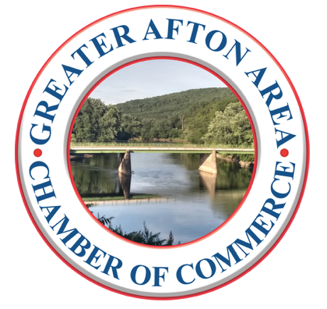
8th Annual
Captain & Crew Golf Tournament
Saturday, June 24, 2023

Afton Golf Club, 175 Afton Lake Road, Afton, NY 13730
Registration at Noon • Shot Gun Start at 1:00pm

TEAM NAME:______________________________________________________

PLAYER NAME: CONTACT # and EMAIL: (at least 1 per team)
1) _______________________________ /_________________________________
2) _______________________________ /_________________________________
3) _______________________________ /_________________________________
4) _______________________________/ _________________________________

Non-Golf Club Members: $75 per person/ $300 per team … $70 when paid by June 3/ $280 per team
Golf Club Members: $65 per person /$260 per team … $60 when paid by June 3/ $240 per team

Mail to: Greater Afton Area Chamber of Commerce, P.O. Box 243, Afton, NY 13730
Or pay online at https:// GreaterAftonAreaCoC.com

Questions? info@GreaterAftonAreaCoC.com, or call Judy Hinman, 607-288-2392

Thank you for your continued support!

